Calculating the volume of a solid of revolution

Example 1
Find the volume of solid generated when the region between the line $y=x$ and the curve $y=x^{2}$ is rotated by $360º$ about the $x$-axis.
[Refer to the interactive Geogebra file volumes-of-revolution-1.ggb]
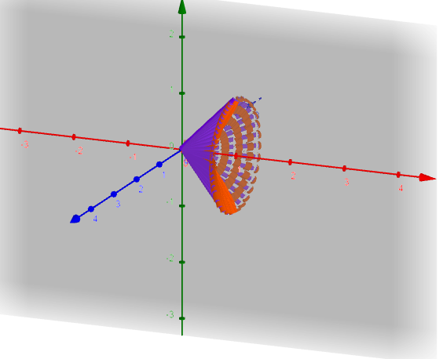
$$Volume=π\int_{0}^{1}{\left\{{\left(x\right)}^{2}-{\left(x^{2}\right)}^{2}\right\}.dx}$$

$$=π\int_{0}^{1}{\left\{x^{2}-x^{4}\right\}.dx}$$
$$=π{\left[\frac{x^{3}}{3}-\frac{x^{5}}{5}\right]}_{0}^{1}$$
$$Volume=\frac{2π}{15} units^{3}$$

Example 2
Find the volume of solid generated when the region between the line $y=x$ and the curve $y=x^{2}$ is rotated by $360°$ about the y-axis.
[Refer to the interactive Geogebra file volumes-of-revolution-2.ggb]

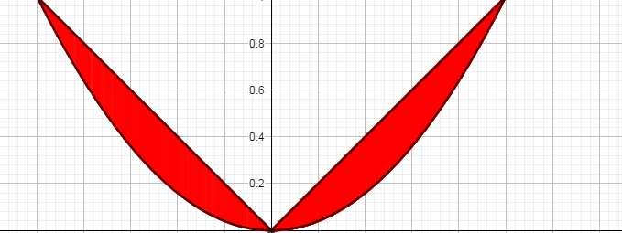
$$x=\sqrt{y}$$

$$x=y$$

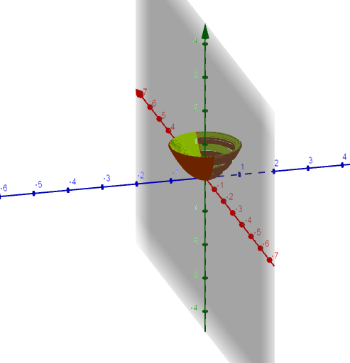
$$Volume=π\int_{y=0}^{y=1}{\{{\left(\sqrt{y}\right)}^{2}-{\left(y\right)}^{2}\}}.dy$$
$$=π\int_{y=0}^{y=1}{\{y-y^{2}\}}.dy$$
$$=π{\left[\frac{y^{2}}{2}-\frac{y^{3}}{3}\right]}_{0}^{1}$$
$$Volume=\frac{π}{6} units^{3}$$

