Modelling music trends
During this activity students will investigate the life times of innovative online services or apps from 2004 onwards. Students will use data generated by the Google Trends website to determine the relative interest of each service or app. The relative interest is a measure of the number of searches for the app as a percentage against the peak interest value. Students will develop skills to create mathematical models to explain the levels of interest. The main focus of this activity is to develop students’ analytical and interpretation skills.

Is it the end for iTunes?
During this part of the activity, students will analyse the life time of iTunes, Apple Inc. Students are encouraged to research the latest plans and developments associated with ITunes and relate it to their findings.
- Open Google Trends https://trends.google.com/trends/?geo=US
- Search for “iTunes”
- Adjust the timeframe to “2004 – present”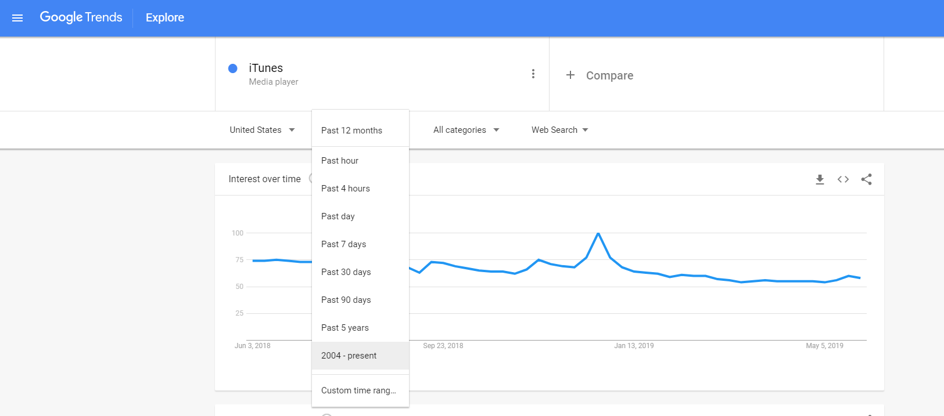
- Download the data to a .csv file by clicking on the download icon

- Add a column C to represent the number of months after 1/2004 (in this case)
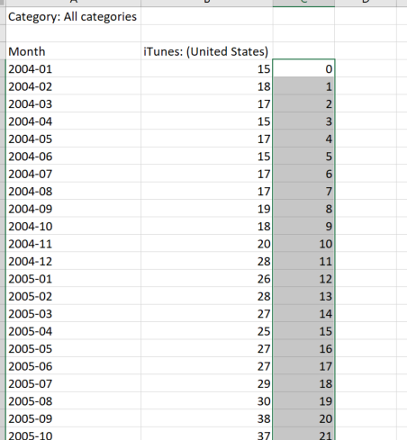
- Add a column D for the cumulative number of time using the formula shown and then copying cell D5 down
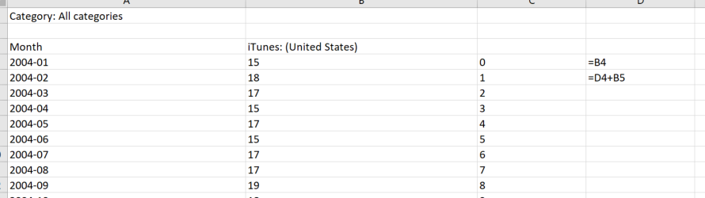
- Copy the data from columns C and D
- Open Desmos https://www.desmos.com/
- Paste the data into Desmos using ctrl-v
- Enter the expression $y_{1}\sim \frac{C_{1}}{1+P_{1}e^{-k_{1}x_{1}}}+h_{1}$ to develop the model below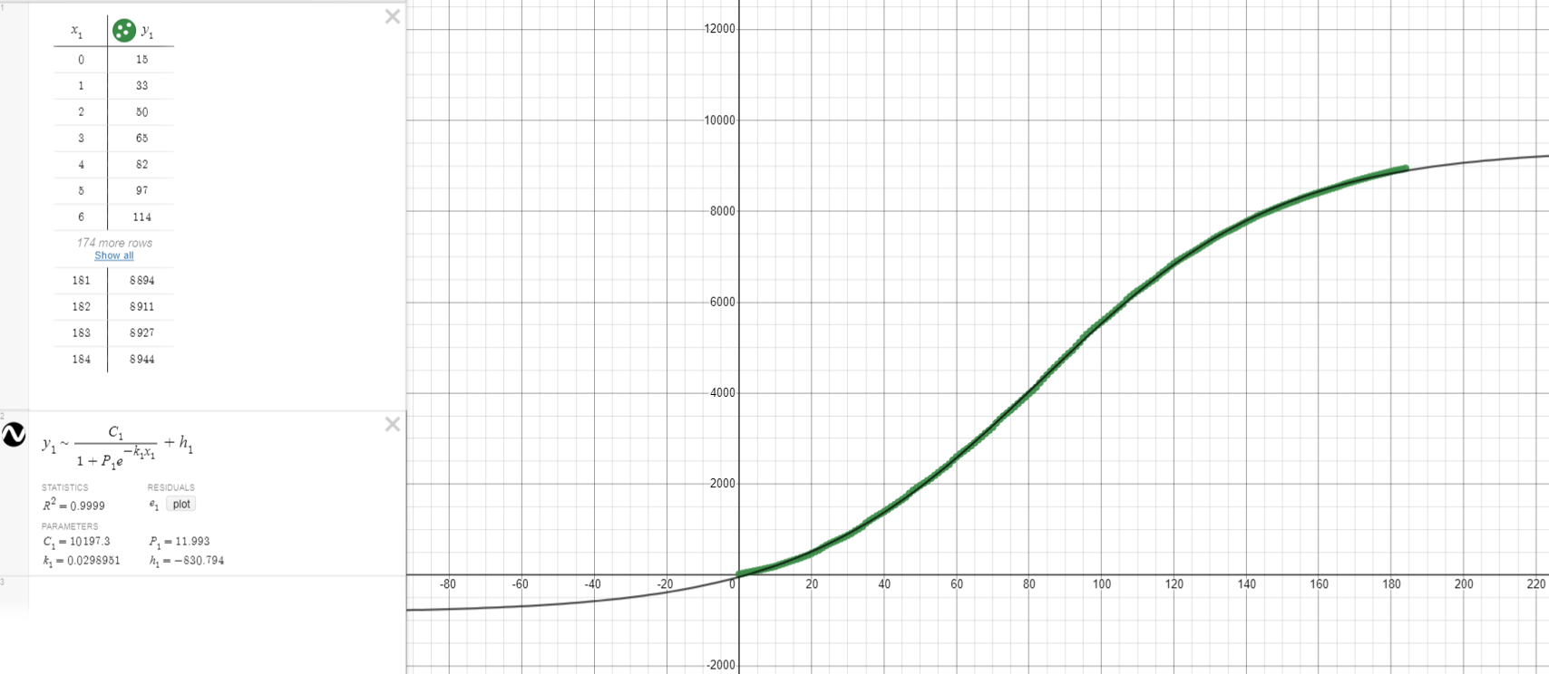
The model above may be accessed here https://www.desmos.com/calculator/rmduvapzfe

Investigate music trends
Using the skills demonstrated in the first part of this activity, investigate logistic models for

- Napster
- Pandora radio
- IHeart radio
- Spotify
- Google play

Interpret your findings to draw conclusions regarding music trends and how people are accessing music.

