Finding the derivatives
for inverse trigonometric functions
This resource has been developed to support teachers understand the technique of for differentiating inverse trigonometric functions.
- Find $\frac{d}{dx}(\sin^{-1}{x)}⁡$
Let $y=\sin^{-1}{x}$
$$∴\sin{y}=x$$
Think of $\sin{y}=\frac{x}{1}$ and represent this as a right-angled triangle, shown below.
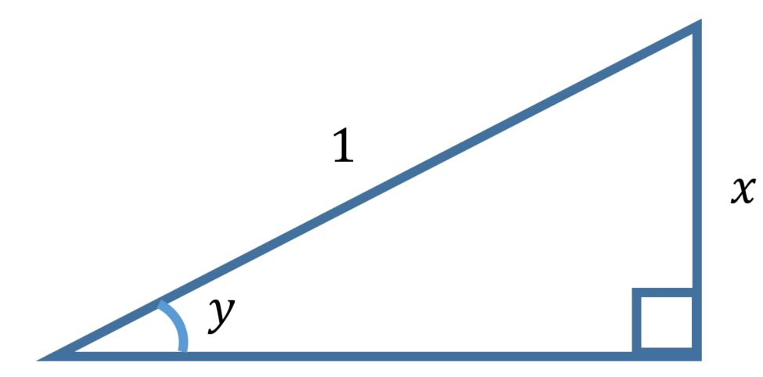
Find the missing side by using Pythagoras’ theorem and interpret results for $\cos{y}$ and $\tan{y}$.
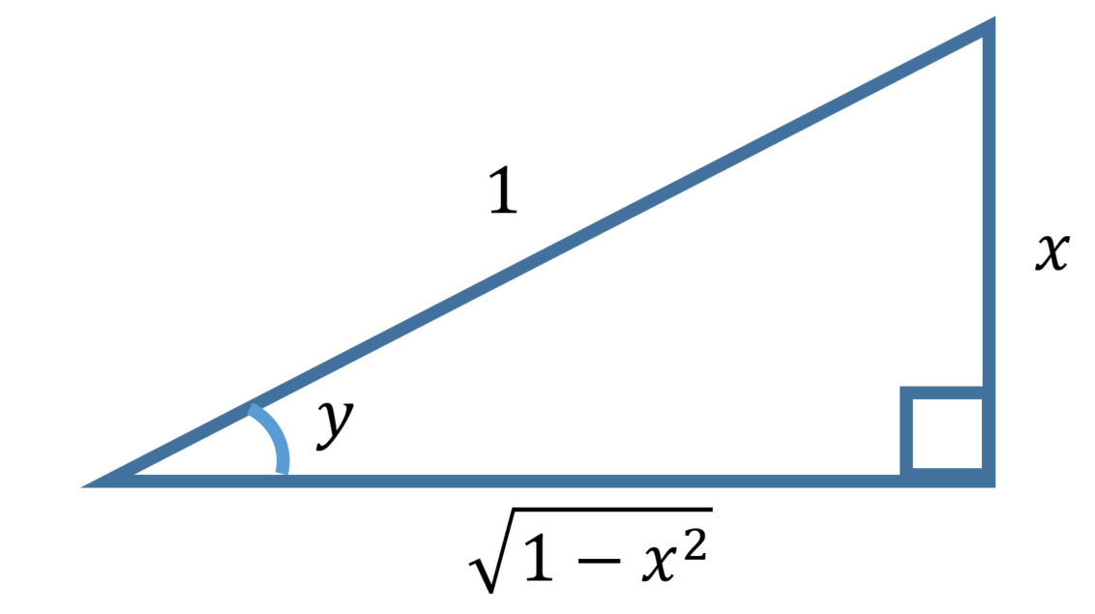
$\cos{y} = \sqrt{1-x^{2}}$
and $\tan{y} =\frac{x}{\sqrt{1-x^{2}}}$
From $∴\sin{y}=x$,
$$\frac{dx}{dy}=\cos{y}$$
and using the result $\cos{y} = \sqrt{1-x^{2}}$ gives
$$\frac{dx}{dy}=\sqrt{1-x^{2}}$$
$$∴\frac{dy}{dx}=\frac{1}{\sqrt{1-x^{2}}}$$

Therefore $\frac{d}{dx}(\sin^{-1}{x)}=\frac{1}{\sqrt{1-x^{2}}}⁡$

- Using a similar technique to the one outlined above show that
  - $\frac{d}{dx}(\cos^{-1} x{)}=-\frac{1}{\sqrt{1-x^{2}}}$
  - and $\frac{d}{dx}(\tan^{-1} x{)}=\frac{1}{1+x^{2}}$

