Year 11 Extension 1 course
This document references the Mathematics Extension 1 Stage 6 Syllabus© NSW Education Standards Authority (NESA) for and on behalf of the Crown in the right of the State of New South Wales, 2017

Assessment task
Rates of change

Driving questions
Can speed be measured perfectly?

Outcomes
- ME11-1 uses algebraic and graphical concepts in the modelling and solving of problems involving functions and their inverses
- ME11-4 applies understanding of the concept of a derivative in the solution of problems, including rates of change, exponential growth and decay and related rates of change
- ME11-2 manipulates algebraic expressions and graphical functions to solve problems
- ME11-6 uses appropriate technology to investigate, organise and interpret information to solve problems in a range of contexts
- ME11-7 communicates making comprehensive use of mathematical language, notation, diagrams and graphs

Learning across the curriculum

Cross-curriculum priorities
- Sustainability

General capabilities
- Critical and creative thinking
- Ethical understanding
- Information and communication technology capability
- Intercultural understanding
- Literacy
- Numeracy
- Personal and social capability

Other areas of learning
- Civics and citizenship
- Difference and diversity
- Work and enterprise

Task
During this task, students will be exposed to and experience a commercially acknowledged method of mathematical modelling called Regression Analysis. Students will develop and apply mathematical models to analyse a real-world scenario, through calculus techniques.
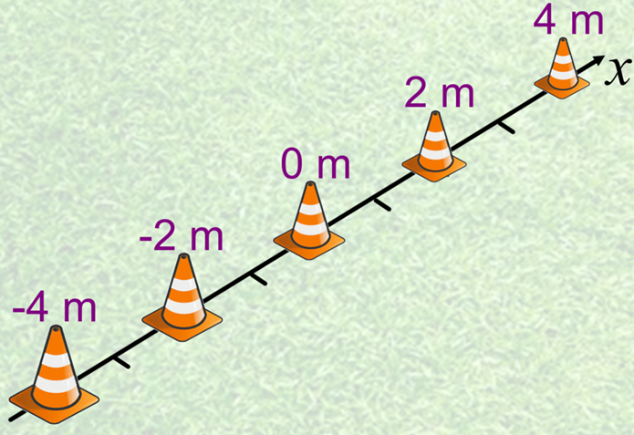
Students will need to design a straight line running track marked with set displacements. An example is shown above. A nominated participant will perform a shuttle run, which requires starting from the origin and running to a set sequence of cones or marked points on the track, until finally returning to the origin. Students will need to design a method for recording the time it takes to reach each cone or marked point on the track and record the data. Students will then analyse the data by generating a Polynomial Model and use calculus techniques to draw conclusions regarding the shuttle run.
Staff are encouraged to administer the assignment using Google Classroom, or something similar, as students may want to utilise many media formats; although, this is not necessary.

- Design the experiment: Students are to design a straight line running track by marking set displacements on a straight line using cones or something suitable. The set displacements need to contain positive and negative displacements within a range of -10 metres to 10 metres.
Each student needs to generate a unique sequence for the shuttle run. The sequence must start and end at the origin and contain a random sequence of 5 or more other displacements determined by the cones. Students need to describe how to measure the time it takes to reach each of the cones. Students may consider using mobile devices to record each shuttle run.
Below is an example of a shuttle run sequence, shown in the displacement column, and a table for recording the time taken to reach each cone.

Time duration (seconds) | Displacement (metres)
0 | 0
 | 3
 | -1
 | 1
 | -5
 | 4
 | 0

- Perform the experiment: Students will need to work in pairs or groups. One student will be nominated to run the shuttle run, while the other team members will measure and record the time taken to reach each point in the shuttle run. Students need to provide evidence of the experiment being performed.
- Display your Results: Students need to show the data using a suitable graph or chart. Students need to describe the reasons for their choice of graph or chart.
- Generate a Model: Students will need to research a suitable online application, use Microsoft Excel or Geogebra to generate a Polynomial Model to fit and describe the data recorded. Examples of online applications are:
  - Polynominal Regression Data Fit from P. Lutus
  - Calculator – Desmos
  - Online Polynomial Regression from Xuru's website
Students will need to develop a Polynomial Model of order equal to or greater than 6. Students need to describe why the Polynomial Model needs to be of the order specified.
- Display your Model: Students need to show the model and the data using a suitable graph or chart.
- Analysing the Model: Students need to interpret the graph and use calculus skills to provide answers to the following questions
  - When do you think the participant had the greatest speed? Give reasons for your response.
  - Using calculus skills, determine the greatest speed of the participant during the shuttle run.
  - From the model, which times was the participant accelerating? And find the greatest acceleration. Justify your answer with mathematics.
  - From the model, determine when the participant was decelerating. Justify your answer with mathematics.
- Researching Regression Analysis.This experiment is a simple example of regression analysis to develop a regression model. Students need to research applications of regression analysis in commercial contexts. Students need to describe 3 examples of applications of regression analysis in their own words. Students do not need to explain how regression models are calculated.
- Evaluation – Can speed be measured perfectly?
Students need to structure a response that refers to the modelling and mathematical methods or concepts detailed in this assessment.
Their response should evaluate two components
  - The modelling technique
  - The concept of Calculus
As part of the evaluation, students should provide
  - A description of each component: What it is? How is it calculated? Why is it important?
  - An exhausted list of pros versus cons for each component, with references made to examples in the assessment. Any limitations of the component should be listed here.
  - A generalised statement that summarises the findings from the pros versus cons for the component.
  - Suggestions for improvement, if they exist, justified by mathematics.
The final justification statement should answer the driving question by referencing the evaluation statements above.

What to submit
- Evidence of an authentic experiment. This may take the form of a video or photos of the experiment. Alternatively, staff may like to run the experiment during class time.
- All data measured and recorded from the experiment presented using appropriate tables and graphs.
- Screenshots or files showing the relevant application of software during the assessment. These should clearly include information relevant to the experiment.
- All working and calculations required, either written by hand or typed.
- All reasoning and justification, either written by hand or typed.

Success criteria
Fluency, understanding and communication | Problem solving, reasoning and justification

Criteria | Working towards developing | Developing | Developed | Well developed | Highly developed
1. Design the experiment  (MA11-6) | Student provides accurate details for all aspects of the experiment, including the participant roles, resources, mechanisms for accurately measuring the times and how the data is recorded and collated.
2. Perform the experiment  (ME11-6) | Student performs the experiment, records the results and provides evidence of the experiment being performed.
3. Display your results  (ME11-7) | Student displays the data using an appropriate chart or graph. | Student displays the data using an appropriate chart or graph and provides reasons for their choice of chart or graph.
4. Generate a model  (ME11-1) | Student generates a model. | Student generates a model; sources are acknowledged and provides reasons why the Polynomial Model is of the specified order.
5. Display your model  (ME11-6) | Student displays the data and the model using an appropriate chart or graph. | Student displays the data and the model using an appropriate chart or graph and provides reasons for their choice of chart or graph.
6. Analysing the model  (ME11-2 ME11-4) | Student is able to interpret velocity and acceleration informally from features of the graph, without the use of calculus skills. | Student is able to interpret gradients and concavity on curves using calculus skills to describe velocity and acceleration. | Student is able to interpret gradients and concavity on curves using calculus skills to describe velocity and acceleration.  Student is able to apply calculus skills in an attempt to determine the maximum velocity and acceleration
7. Researching Regression Analysis  (ME11-1) | Student is able to clearly describe some commercial applications for regression analysis but sources are not acknowledged. | Student is able to clearly describe some commercial applications for regression analysis and sources are acknowledged. | Student is able to suggest their own context in which regression analysis may be applied. | Student is able to plan the application of regression analysis within their given context.
8. Evaluation  (ME11-4) | Student describes aspects and features of calculus. | Student describes how speed is calculated by referring to the concept of calculus, highlighting clear examples from and links to the assignment. | Student describes the accuracy of the model generated in the experiment and provides suggestions for improvement. Student provides an example for an improved model. | Student describes any limitations, if any, with the concept of calculus and the model generated in the experiment. | Student provides a clear and accurate response to the driving question by evaluating all aspects of the process to justify their response.
Note – Any non-attempt in a section will be deemed zero. Marks can only be attributed to attempted responses.

Note to staff
The success criteria above has been designed for students and staff alike to use. Students should be presented the rubric as part of the assessment task package. Students and staff follow the process of the task downwards through the rubric and the depth of responses, for each element, across the rubric. Students should be encouraged to use the rubric to self-assess their progress as an assessment-as-learning strategy.
The aim of the assessment task is to develop students’ deep content knowledge. This is reflected in the descriptors, working towards developing through to highly developed. The level of skill and understanding required in each part of the task is different; some parts require highly developed or well-developed skills, other parts only capture a developing skill set.
None of the working mathematically elements are distinct and when demonstrating one element, you are invariably demonstrating another. As an example, communication runs concurrently through all the other working mathematically elements. Students cannot respond to this assessment without communicating in some form. However, it is envisaged that there is a general progression through the working mathematically elements, starting with fluency and leading to understanding, problem solving, reasoning and justification, with increasingly higher levels of communication accompanying each element. Careful consideration has been given to the position of the success criteria statements so they reflect the working mathematically elements demonstrated.
This assessment task has been designed to illuminate the style of questions and the types of responses needed to elicit deep content knowledge, however, staff are encouraged to use and adapt the assessment task and the success criteria to their school context. Staff may like to enhance or amend sections of the task. Staff may like to adapt the rubric to assign marks to the descriptors in order to differentiate between responses that address the same statement. All changes are the responsibility of the staff using the assessment.

