Year 11 mathematics advanced
MA-S1 Probability and discrete probability distributions | Unit duration
The topic Statistical Analysis involves the exploration, display, analysis and interpretation of data to identify and communicate key information. A knowledge of statistical analysis enables careful interpretation of situations and an awareness of the contributing factors when presented with information by third parties, including its possible misrepresentation. The study of statistical analysis is important in developing students' ability to recognise, describe and apply statistical techniques in order to analyse current situations or to predict future outcomes. It also develops an awareness of how conclusions drawn from data can be used to inform decisions made by groups such as scientific investigators, business people and policy-makers. | 5 weeks

Subtopic focus | Outcomes
The principal focus of this subtopic is to introduce the concepts of conditional probability and independence and develop an understanding of discrete random variables and their uses in modelling random processes involving chance. Students develop their skills related to probability, its language and visual representations, and use these skills to solve practical problems. They develop an understanding of probability distributions and associated statistical analysis methods and their use in modelling binomial events. These concepts play an important role in later studies of statistics, particularly in beginning to understand the concept of statistical significance. Within this subtopic, schools have the opportunity to identify areas of Stage 5 content which may need to be reviewed to meet the needs of students. | A student:  - uses concepts and techniques from probability to present and interpret data and solve problems in a variety of contexts, including the use of probability distributions MA11-7  - uses appropriate technology to investigate, organise, model and interpret information in a range of contexts MA11-8  - provides reasoning to support conclusions which are appropriate to the context MA11-9

Prerequisite knowledge | Assessment strategies
This topic will build on the Stage 5 topics of Single Variable Data Analysis§ and Probability◊ | - Students could conduct an investigation, use Excel to collate the data, present the data as a Venn diagram. Students could then develop a visual presentation of the diagrams alongside the correct set notation for the following: probability of A, probability of B, complement of A, complement of B, probability of A and B, probability of A or B.
All outcomes referred to in this unit come from Mathematics Advanced Syllabus
© NSW Education Standards Authority (NESA) for and on behalf of the Crown in right of the State of New South Wales, 2017

Glossary of terms
Term | Description
continuous random variable | A continuous random variable is a numerical variable that can take any value along a continuum.
discrete random variable | A discrete random variable is a numerical variable whose values can be listed.
distribution | A distribution is a table or display showing all possible outcomes of a random variable and their respective frequencies or probabilities.
independent events (independence) | In probability, two events are independent of each other if the occurrence of one does not affect the probability of the occurrence of the other. Independent events can occur simultaneously, whereas mutually exclusive events cannot.
mutually exclusive events | Two events $A°$and $B°$ are mutually exclusive if one is incompatible with the other; that is, if they cannot be simultaneous outcomes in the same chance experiment.  For example, when a fair coin is tossed twice, the events $HH$ and$TT$ cannot occur at the same time and are, therefore, mutually exclusive.  In a Venn diagram, as shown below, mutually exclusive events do not overlap.  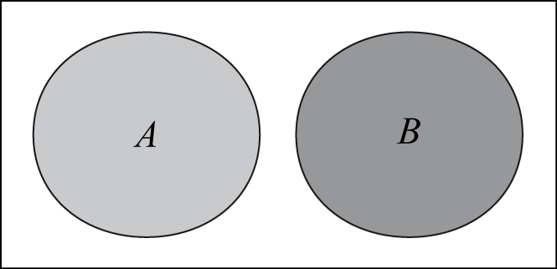
point estimate | A single value given as an estimate of a parameter of a population.
set language and notation | A set is a collection of distinct objects called elements.  The language and notation used in the study of sets includes:  A set is a collection of objects, for example ‘$A$ is the set of the numbers 1, 3 and 5’ is written as $A=\{1, 3, 5\}$.  Each object is an element or member of a set, for example ‘1 is an element of set $A$’ is written as $1∈A$.  The number of elements in set $A=\left\{1, 3, 5\right\}$ is written as $n\left(A\right)=3$, or  $\left|A\right|=3$.  The empty set is the set with no members and is written as $\{ \}$ or $∅$.  The universal set contains all elements involved in a particular problem.  $B$ is a subset of $A$ if every member of $B$ is a member of $A$ and is written as $B⊂A$, ie ‘$B$ is a subset of $A$’. $B$ may also be equal to $A$ in this scenario, and we can therefore write $B⊆A$.  The complement of a set $A$ is the set of all elements in the universal set that are not in $A$ and is written as $\overline{A}$ or $A^{c}$.  The intersection of sets $A$ and $B$ is the set of elements which are in both $A$ and $B$ and is written as $A∩B$, for example, ‘$A$ intersection$B$’.  The union of sets $A$ and $B$ is the set of elements which are in $A$ or $B$ or both and is written as $A∪B$, for example, ‘$A$ union $B$’.
uniform random variable | Each possible outcome of a uniform random variable has an equal probability.
variance  | Variance is a measure of spread closely associated with the standard deviation. Variance is the average square distance of each data point from the mean.
Venn diagram | A Venn diagram is a graphical representation of the extent to which two or more events, for example $A°$ and $B$, are mutually inclusive (overlap) or mutually exclusive (do not overlap).  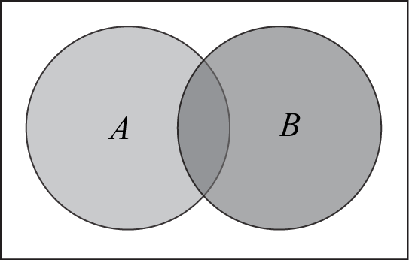

Lesson sequence | Content  Students learn to: | Suggested teaching strategies and resources | Date and initial | Comments, feedback, additional resources used
Review of concepts, language and notations associated with probability  (1 lesson) | S1.1: Probability and Venn diagrams  - understand and use the concepts and language associated with theoretical probability, relative frequency and the probability scale | Stage 5 review  - Review of the following may be needed to meet the needs of students:  - determining and representing the outcomes of two- and three-step chance experiment data with and without replacement  - assigning and determining probabilities for events (both simple and compound) for two- and three-step chance experiments  - the language of probability such as sample space, ‘if…then’, ‘given’, ‘of’, etc.
Generate experimental probabilities  (1 – 2 lessons) | - solve problems involving simulations or trials of experiments in a variety of contexts AAM  - identify factors that could complicate the simulation of real-world events (ACMEM153)  - use relative frequencies obtained from data as point estimates of probabilities (ACMMM055) | Calculating probability experiments and simulations  - Students should have the opportunity to conduct probability experiments and determine the relative frequencies of particular events. NESA suggested applications include:  - Data could be generated from simple experiments, and also obtained from other sources, for example weather and sporting statistics from newspapers. Other data is available from Australian Bureau of Statistics (ABS) Yearbooks, and various websites.  - Experiments could be carried out in which the probability is not intuitively obvious, for example the probability of a drawing pin landing point up.  - Examine the birth notices on a particular day in a major daily newspaper. Record the number of boys and the number of girls. On this basis, estimate the probability that a child born is (a) male, (b) female. Compare these results with those published by the Australian Bureau of Statistics (ABS).
Solving problems for multi-stage events  (3 lessons) | - use arrays and tree diagrams to determine the outcomes and probabilities for multi-stage experiments (ACMEM156) AAM  - use the multiplication law  $P(A∩B)=P(A)P(B)$ for independent events $A$ and $B$ and recognise the symmetry of independence in simple probability situations (ACMMM059) | Representing multi-stage events in probability  - Students should be exposed to a number of different visual representations of probability events. These should include arrays, tables, tree diagrams and probability trees.  - Students should consider the dependence or independence of the outcomes in an event and should consider this when assigning probabilities to a probability tree.  NESA exemplar questions  - Six girls’ names and five boys’ names are placed in a hat. Two names are drawn without replacement. What is the probability that a girl’s and a boy’s name are chosen?  - In a raffle, 30 tickets are sold and there are two prizes. John buys five tickets. What is the probability that John wins at least one prize?  - In Australia, approximately 9% of the population has the blood type O negative. If three people are chosen at random from the population, find the probability that  - none has O negative blood  - at least one has O negative blood.  - Lou and Ali are on a fitness program for one month. The probability that Lou will finish the program successfully is 0.7, while the probability that Ali will finish it successfully is 0.6. The probability tree diagram shows this information.  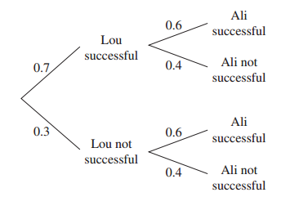  - What is the probability that only one of Lou and Ali will be successful?
Introduction to set language, notation and representation  (1 lesson) | - use Venn diagrams, set language and notation for events, including $\overline{A}$ (or $A^{'}$or $A^{c}$) for the complement of an event $A$, $A∩B$ for ‘$A$ and $B$’, the intersection of events $A$ and $B$, and $A∪B$ for ‘$A$ or $B$’, the union of events $A$ and $B$, and recognise mutually exclusive events (ACMMM050) AAM  - use everyday occurrences to illustrate set descriptions and representations of events and set operations (ACMMM051)  - use the rules: $P\left(\overline{A}\right)=1-P(A)$ and $P\left(A∪B\right)=P\left(A\right)+P\left(B\right)-P(A∩B)$ (ACMMM054) AAM | Venn diagrams and set notation  - Students will need to be introduced to set notation and exposed to the application of set notation to a variety of contexts and scenarios.  - Students could conduct an investigation with results that could appropriately be represented using a Venn diagram as follows: Use technology to survey at least 30 participants, use Excel to collate the data, present the data as a Venn diagram. Students could then present a visual presentation alongside the correct set notation for the following: probability of A, probability of B, complement of A, complement of B, probability of A and B, probability of A or B. Students could show for their scenario that $P(A’) = 1 - P(A)$,  $P(A ∪ B) = P(A) + P(B) - P(A ∩B)$. They should also consider why or how this data might be useful.
Understanding conditional probability  (2 lessons) | - understand the notion of conditional probability and recognise and use language that indicates conditionality (ACMMM056)  - use the notation $P(A|B)$ and the formula $P\left(A|B\right)=\frac{P(A∩B)}{P(B)}, P\left(B\right)≠0$ for conditional probability (ACMMM057) AAM  - understand the notion of independence of an event $A$ from an event $B$, as defined by  $P\left(A | B\right)=P\left(A\right)$ (ACMMM058) | Introducing conditional probability  - The concept of conditional probability could be explored using tree diagrams, Venn diagrams or tables in a variety of contexts. Where possible, these should be related to the students’ experience. For example, students could explore the Monty Hall problem.  Resource: introducing-conditional-probability.DOCX  Solving problems involving conditional probability  - Students should be exposed to a variety of examples of problems involving conditional probability.  NESA exemplar questions  - A bag contains two red balls, one black ball, and one white ball. Andrew selects one ball from the bag and keeps it hidden. He then selects a second ball, also keeping it hidden.  - Draw a tree diagram to show all the possible outcomes.  - Find the probability that both the selected balls are red.  - Find the probability that at least one of the selected balls is red.  - Andrew reveals that one of the selected balls is red. What is the probability that the ball that is still hidden is also red?  - The manager of a team notices that the team has a probability of $\frac{2}{3}$ of winning the game if it is raining and if it is dry, the probability of the team winning is $\frac{1}{5}$. The probability that it will rain on a day when they play is $\frac{1}{4}.$  - Find the probability that they will not win.  - Given that the team has won a game, calculate the probability that it rained on the day of the match.

Lesson sequence | Content  Students learn to: | Suggested teaching strategies and resources | Date and initial | Comments, feedback, additional resources used
Introduction to random variables  (1 lesson) | S1.2: Discrete probability distributions  - define and categorise random variables  - know that a random variable describes some aspect in a population from which samples can be drawn  - know the difference between a discrete random variable and a continuous random variable | Introduction to discrete probability distributions  - Teachers can use the online resource Discrete probability distributions to support the study of this component of the course.  - Students will need to be introduced to the concept of a random variable and teachers should take some time to define the important terms within the unit, linking the ideas to prior learning wherever it is possible to do so.
Introducing and generating discrete probability distributions  (1 – 2 lessons) | - use discrete random variables and associated probabilities to solve practical problems (ACMMM142) AAM  - recognise uniform random variables and use them to model random phenomena with equally likely outcomes (ACMMM138)  - examine simple examples of non-uniform discrete random variables, and recognise that for any random variable, X, the sum of the probabilities is 1 (ACMMM139)  - use relative frequencies obtained from data to obtain point estimates of probabilities associated with a discrete random variable (ACMMM137) | Introduction to a discrete probability distribution  - Students to explore the notion of a discrete probability distribution as the listing of the possible values for X and their associated probabilities is called a probability distribution.  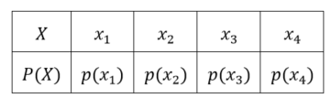  Examples  - Consider the discrete probability distribution for uniform random variables such as rolling a dice. In these distributions, the events are all equally likely  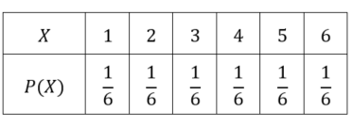  - Create the probability distribution for the total number of heads obtained in three tosses of a fair coin.  Consider the sample space: $TTT$, $TTH$, $THT$, $HTT, HHT$, $HTH$, $THH$, $HHH$. The discrete probability distribution is:  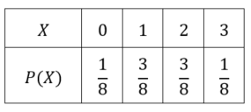  - Verify that in each case that the sum of the probabilities in the distribution is 1.  Generating probability distributions  - Students should be introduced to the idea that an analysis of what has happened in the past (for example, relative frequency) can provide a best estimate of what is going to happen in the future (for example, calculating the probability of a future event) for a random process with random variables.  NESA exemplar questions  - Find the probability distribution of the random variable describing the outcomes when rolling an $x$-sided die.  - Find the probability distribution of the random variable describing the number of heads that turn up when a coin is flipped four times  - There are five boxes having 10 pens in each. A box is rejected by a retailer if it contains more than three defective pens. Model this situation using a random variable, by assigning a probability to the likelihood that any one pen is defective, and state the values the random variable could attain.
Defining and using the concept of expectation to calculate the mean  (2 lessons) | - use discrete random variables and associated probabilities to solve practical problems (ACMMM142) AAM  - recognise the mean or expected value, $E\left(X\right)=μ$, of a discrete random variable $X$as a measure of centre, and evaluate it in simple cases (ACMMM140) | Expected value and the mean  - The expected value or mean of random variable X is its weighted average. It is found by multiplying each value of X by its probability, then adding all the products.  i.e. The expected value of $X$ is:  $${E\left(X\right)=x}_{1}P\left(x_{1}\right)+x_{2}P\left(x_{2}\right)+…+x_{n}P\left(x_{n}\right)$$  - In the probability distribution for number of heads in three coin tosses, the expected value or mean is:  $E\left(X\right)=0×\frac{1}{8}+1×\frac{3}{8}+2×\frac{3}{8}+3×\frac{1}{8}$  $E\left(X\right)=1.5$ or $μ=1.5$  - The letter $μ$ is used to represent the mean because it is a population distribution.  - The calculation of expected value should be explicitly linked to the calculation of the mean using statistical calculations. In the example of the number of heads in three coin tosses, the sample space of the number of heads can be represented as 0, 1, 1, 1, 2, 2, 2, 3.  $$μ=\frac{0+1+1+1+2+2+2+3}{8} \\ =0×\frac{1}{8}+1×\frac{3}{8}+2×\frac{3}{8}+3×\frac{1}{8} \\ =1.5$$  Expectation theorems  - Students should consider that $E\left(X\right)$behaves like a function. Just as $E\left(X\right)$ can be found, the expected value of any other variable amount can be found. $E\left(X\right)$ has a specific meaning in each context because it is the mean of that particular probability distribution. $E\left(X^{2}\right)$ does not have a specific meaning, it is just useful in a result we will explore further in the study of variance. It is the expected value of the variable squared occurring. It means multiplying each variable-squared by the probability of that variable occurring. In the example of the number of heads in three coin tosses:  $$E\left(X\right)=0^{2}×\frac{1}{8}+1^{2}×\frac{3}{8}+2^{2}×\frac{3}{8}+3^{2}×\frac{1}{8} \\ =3$$
Introduction to and calculation of the variance and standard deviation  (1 – 2 lessons) | - recognise the variance, $Var(X)$, and standard deviation ($σ$) of a discrete random variable as measures of spread, and evaluate them in simple cases (ACMMM141)  - use $Var\left(X\right)=E\left({\left(X-μ\right)}^{2}\right)=E\left(X^{2}\right)-μ^{2}$ for a continuous random variable and $Var\left(x\right)=σ^{2}$ for a dataset | Introducing and calculating variance  - Variance is a measure of spread of the distribution. In statistics it is calculated by finding the sum of the squared distances of each score from the mean. In the study of discrete random variables, variance is the expectation of the squared deviation of a random variable from its mean.  V$ar(X)=E({\left(X-μ\right)}^{2}$) where $μ=E(X)$  In the example of the number of heads in three coin tosses:  $Var\left(X\right)={\left(0-1.5\right)}^{2}×\frac{1}{8}+{\left(1-1.5\right)}^{2}×\frac{3}{8}+$ ${\left(2-1.5\right)}^{2}×\frac{3}{8}+{\left(3-1.5\right)}^{2}×\frac{1}{8}$$$=0.75$$  - Students should complete several examples requiring the calculation of variance as an expectation.  - Students should consider the proof of a useful result to simplify the calculation of the variance, and thus the standard deviation.  - Proof of $Var\left(X\right)=E\left({\left(X-μ\right)}^{2}\right)=E(X^{2}$) -$μ^{2}$  $$=E\left(X^{2}-2μX+μ^{2}\right)$$  $$=E(X^{2})-E(2μX)+{E(μ}^{2})$$  $=E\left(X^{2}\right)-2μE\left(X\right)+μ^{2}$,  $$=\sum{x^{2}p\left(x\right)-2μ\sum{xp\left(x\right)}+μ^{2}}\sum{p(x)}$$  = $E(X^{2})-2μE(X)+μ^{2}×1$  $=E(X^{2})-2μ^{2}+μ^{2}$, as $E\left(X\right)=μ$  $$=E\left(X^{2}\right)-μ^{2}$$  In the example of the number of heads in three coin tosses:  $$Var\left(X\right)=E\left(X^{2}\right)-μ^{2}$$  $$Var\left(X\right)=3-{1.5}^{2}$$  $$Var(X)=0.75$$  Calculating the standard deviation  - The syllabus denotes the relationship between variance and standard deviation as $Var\left(x\right)=σ^{2}$. Standard deviation in the scope of this course is population standard deviation because it is a calculation on the full probability distribution.  In the example of the number of heads in three coin tosses:  V$ar\left(X\right)=0.75$  $$σ=\sqrt{0.75}$$  $σ=0.866$(to nearest thousandth)  NESA exemplar question  - The total number of cars to be sold next week is described by the following probability distribution  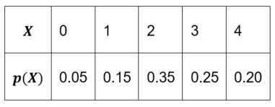  - Determine the expected value and standard deviation of $X$, the number of cars sold.
Analysing samples as an estimate of the population  (1 lesson) | - understand that a sample mean, $\overline{x}$, is an estimate of the associated population mean $μ$, and that the sample standard deviation, $s$, is an estimate of the associated population standard deviation, $σ$, and that these estimates get better as the sample size increases and when we have independent observations | NESA exemplar question  - Select a range of samples from a fixed population and record the characteristics of each sample. Compare the mean and standard deviation of samples with the mean and standard deviation of the fixed population.

Reflection and evaluation
Please include feedback about the engagement of the students and the difficulty of the content included in this section. You may also refer to the sequencing of the lessons and the placement of the topic within the scope and sequence. All ICT, literacy, numeracy and group activities should be recorded in the ‘comments, feedback, additional resources used’ section.

