Year 12 Mathematics Advanced
MA-C3 Applications of differentiation | Unit duration
The topic Calculus involves the study of how things change and provides a framework for developing quantitative models of change and deducing their consequences. It involves the development of two key aspects of calculus, namely differentiation and integration. The study of calculus is important in developing students’ capacity to operate with and model situations involving change, using algebraic and graphical techniques to describe and solve problems and to predict outcomes in fields such as biomathematics, economics, engineering and the construction industry. | 4 weeks

Subtopic focus | Outcomes
The principal focus of this subtopic is to introduce the second derivative, its meanings and applications to the behaviour of graphs and functions, such as stationary points and the concavity of the graph. Students develop an understanding of the interconnectedness of topics from across the syllabus and the use of calculus to help solve problems such as optimisation, from each topic. The solution of optimisation problems is an important area of applied Mathematics and involves the location of the maximum or minimum values of a function. | A student:  - applies calculus techniques to model and solve problems MA12-3  - applies appropriate differentiation methods to solve problems MA12-6  - chooses and uses appropriate technology effectively in a range of contexts, models and applies critical thinking to recognise appropriate times for such use MA12-9  - constructs arguments to prove and justify results and provides reasoning to support conclusions which are appropriate to the context MA12-10

Prerequisite knowledge | Assessment strategies
The material in this topic builds on content from the Year 11 Mathematics Advanced topics of MA-F1 Working with Functions, MA-C1 Introduction to Differentiation and MA-C2 Differential Calculus. | - Formative assessment: Students to use practical, online graphing tools and pen-and-paper methods to demonstrate optimisation proofs. Students might find it useful to keep a learning journal to annotate the common errors in these types of problems and highlight various representations of the solutions to consolidate their understanding.
All outcomes referred to in this unit come from Mathematics Advanced Syllabus
© NSW Education Standards Authority (NESA) for and on behalf of the Crown in right of the State of New South Wales, 2017

Glossary of terms
Term | Description
asymptote  | An asymptote is a line.  - A horizontal asymptote is a horizontal line whose distance from the function f(x) becomes as small as we please for all large values of x.  - The line x=a is a vertical asymptote if the function f is not defined at x=a and values of f(x) become as large as we please (positive or negative) as x approaches a.
concavity | If a function $f(x)$ is a differentiable function on a given interval, $I$, then:  - $f(x)$ is concave up on $I$ if and only if $f'(x)$ is increasing on $I$. Graphically if the tangent at $x=a$ lies below the curve (locally), then the function is concave up at $x=a$.  - $f(x)$ is concave down on $I$ if and only if $f'(x)$ is decreasing on $I$. Graphically if the tangent at $x=a$ lies above the curve (locally), then the function is concave down at $x=a$.  If $f(x)$ is doubly differentiable at $x=a$ then the second derivative can be used to identify concavity in the following way:  - If $f''(a)$ is positive then the curve is concave up at $x=a$  - If $f''(a)$ is negative then the curve is concave down at $x=a$  If $f''(a)$ is zero then the curve could be concave up, concave down or a point of inflection and further work is required to determine which one of these three cases applies at $x=a$.
instantaneous rate of change  | The instantaneous rate of change is the rate of change at a particular moment. For a differentiable function, the instantaneous rate of change at a point is the same as the gradient of the tangent to the curve at that point. This is defined to be the value of the derivative at that particular point.
local and global maximum and minimum | $f(x_{0})$ is a local maximum of the function $f(x)$ if $f(x)≤f(x_{0})$ for all values of $x$ near $x_{0}.$We say that $f(x_{0})$ is a global maximum of the function $f(x)$ if $f(x)≤f(x_{0})$ for all values of $x$ in the domain of $f$.  $f(x_{0})$ is a local minimum of the function $f(x)$ if $f(x)≥f(x_{0})$ for all values of $x$ near $x_{0}.$We say that $f(x_{0})$ is a global minimum of the function $f(x)$ if $f(x)≥f(x_{0})$ for all values of $x$ in the domain of $f$.

Lesson sequence | Content | Suggested teaching strategies and resources | Date and initial | Comments, feedback, additional resources used
Understanding the first derivative and stationary points  (2-3 lessons) | C3.1 The first and second derivatives  - use the first derivative to investigate the shape of the graph of a function  - deduce from the sign of the first derivative whether a function is increasing, decreasing or stationary at a given point or in a given interval  - use the first derivative to find intervals over which a function is increasing or decreasing, and where its stationary points are located  - use the first derivative to investigate a stationary point of a function over a given domain, classifying it as a local maximum, local minimum or neither  - determine the greatest or least value of a function over a given domain (if the domain is not given, the natural domain of the function is assumed) and distinguish between local and global minima and maxima | The first derivative and stationary points  - Students need to understand the first derivative is the gradient or rate of change of the function. The gradient of a function at a point is defined as the gradient of the tangent at this point. A number of applets assist students to understand the relationship between the gradient of a curve and tangents to the curve as well as the derivative function. Some suggestions are listed below.  - GeoGebra: Gradient of a tangent to sketch the derivative  - GeoGebra: The derivative as a function  - Youtube: local minima and maxima (duration 1:25)  - Suggested functions to sketch and discuss their shape and how the gradient of the curve changes as x changes: $y = (x – 1)(x + 2)(x – 3)$ ; $y = {\left(x – 1\right)}^{3}+2$ ; $y=\frac{1}{x+2}$  - Students should then be given practice finding the values of x for which the function is increasing, decreasing or stationary for functions given in either algebraic form or as a graphical representation. In addition to determining their solution algebraically, teachers are encouraged to use different colours to trace over increasing and decreasing sections of the graph so that students develop a deeper understanding of the concept.  - Students should then be given practice finding the stationary points on a curve and using the first derivative to determine their nature (maximum, minimum or point of inflexion).  - Consideration should then be given to finding a global maxima or minima so that students fully understand the difference between local and global maxima/minima.  - Examples:  - Find the minimum value of the function  $y = 4x^{3} – 32x^{2} + 64x$ in the domain $1 £ x £ 3$ or find the any maximum turning points as well as the maximum value of the function in the domain  $$0 £ x £ 6$$  - Find the minimum/maximum values of the function $d=\sqrt{61t^{2}-200t+16}$ in the domain $0 £ t £ 3$  - Find the minimum value of the function  $C=10v+\frac{4300}{v}$ in the domain $80 £ v £ 100$  - Once students have an understanding of the first derivative and stationary points teachers should then guide students in applying this knowledge to trigonometric, exponential and logarithmic functions.
Understanding the second derivative and concavity  (2 or 3 lessons) | - define and interpret the concept of the second derivative as the rate of change of the first derivative function in a variety of contexts, for example recognise acceleration as the second derivative of displacement with respect to time (ACMMM108, ACMMM109) AAM  - understand the concepts of concavity and points of inflection and their relationship with the second derivative (ACMMM110)  - use the second derivative to determine concavity and the nature of stationary points  - understand that when the second derivative is equal to 0 this does not necessarily represent a point of inflection | The second derivative and concavity  - Students should be familiar with the different notation used for the second derivative: $f''(x)$ or $y''$ or $\frac{d^{2}y}{dx^{2}}$  - Students need to understand the second derivative is the rate of change in the gradient of the curve. A number of applets assist students to understand the relationship between the function and its first and second derivative. Some applets are listed below.  - Youtube: Higher order derivatives (duration 5:48)  - GeoGebra: Stationary points  - GeoGebra: The first and second derivative  - Youtube: Calculus - slope, concavity, max, min and points of inflexion (duration 5:40)  - Youtube: Amazing way to graph the gradient function (duration 11:28)  - Wootube: Prologue to motion(duration 7:07)  - Desmos activity: Position, velocity and acceleration  - Youtube: Motion graphs explained (duration 7:12)  - Teachers at this point should elaborate on the concepts from C1.4 from the Year 11 course on position, velocity and acceleration. Students need to connect velocity as the rate of change in position (so $f'(x)$ or $\overset{.}{x}$) and acceleration as the rate of change in the velocity (so $f''(x)$ or $\overset{..}{x}$)  - Youtube: I will Derive! (duration 3:16)  - Students should be given practice sketching the first and second derivative from diagrams of various functions and vice versa.  - Wootube: Visual approach to derivatives 1(duration 7:38)  - Wootube: Visual approach to derivatives 2 (duration 4:04)  - Use the second derivative to:  - 1. determine concavity  - 2. find points of inflexion  - 3. determine the nature of stationary points  - Examples  Investigate each of these curves:  $y = 2x^{3} – 6x^{2} + 7x + 9$; $y = x^{4} ; y = x^{4}(x + 5)$ by considering the values of x for which the curves are concave up/down and finding any points at which$f"(x)$. Sketch these functions using Desmos or GeoGebra and discuss what is happening at the point at which $f"(x)$. (Teachers should emphasise the need to test concavity to confirm a point of inflexion.)  - Once students have an understanding of the second derivative and concavity teachers should then guide students in applying this knowledge to trigonometric, exponential and logarithmic functions.
Solving derivative problems  (2 lessons) | C3.2 Applications of the derivative  - use any of the functions covered in the scope of this syllabus and their derivatives to solve practical and abstract problems AAM | Solving derivative problems  - The teacher reviews the concept of how the derivative allows us to find the gradient of a function at any point.  - Following this, the teacher provides examples using the derivative to  - Describe the gradient at various points on a graph  - Sketch a graph which satisfies certain criteria regarding the provided  - Some example questions are included below.  1. From the diagram, list the points which have:  - $f^{'}\left(x\right)>0$  - $f^{'}\left(x\right)<0$  - $f^{'}\left(x\right)=0"$  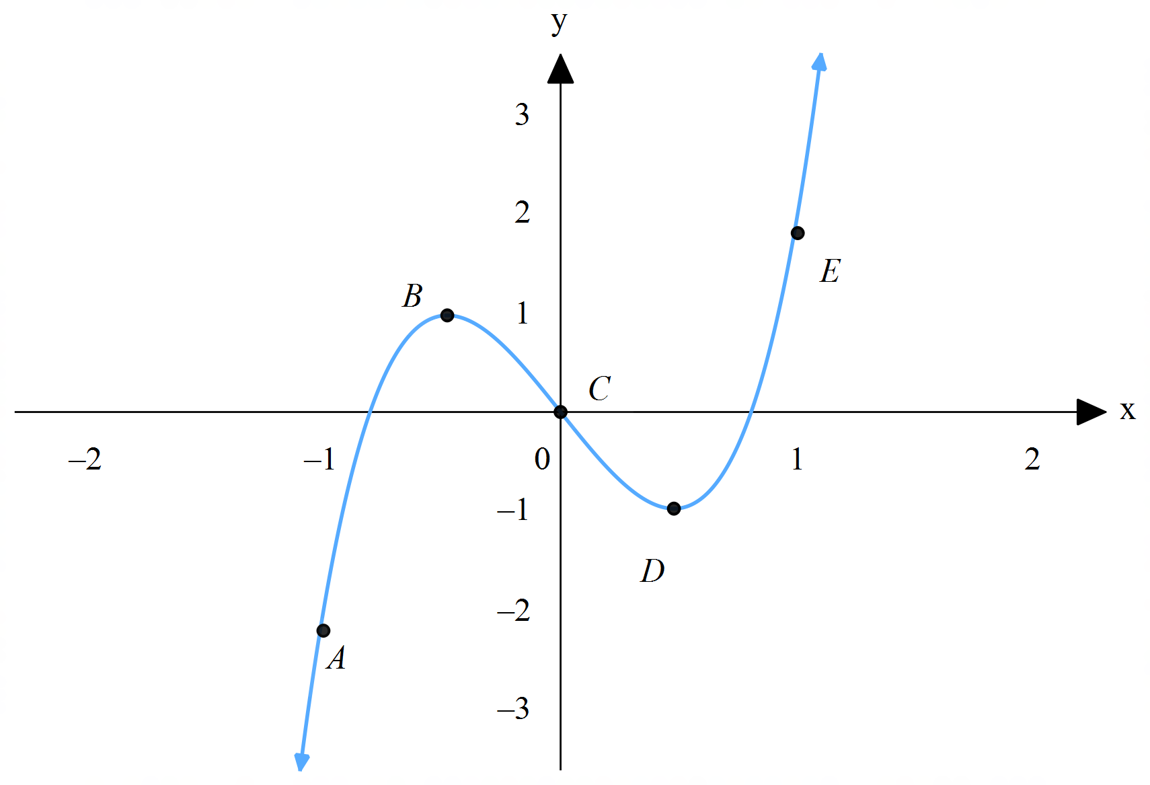  2. Sketch a graph of f(x) such that  - $f\left(-1\right)=2$  - $f^{'}\left(-1\right)=0$  - $f\left(0\right)=0$  - $f\left(1\right)=-2$  - $f^{'}\left(1\right)=0$  These questions can also be extended to the second derivative  - Common functions which can be applied to practical problems should be introduced. This may include questions involving:  - The exponential function to represent exponential growth or decay and identify rates of change at specific times (often modelling population change or cooling temperatures). What is an Exponential Growth Rate? (duration 6:01) demonstrates what the exponential growth rate is.  - Sound pressure equations involve logarithms to represent the difference in decibels between two sounds. This activity from www3.nd.edu describes how logarithms are used to define decibels.  - The sine and cosine functions can be used to model changing tidal levels over a period, the derivative can be used to calculate the rate at which water levels are changing.
Curve sketching (using calculus)  (1 lesson) | - use calculus to determine and verify the nature of stationary points, find local and global maxima and minima and points of inflection (horizontal or otherwise), examine behaviour of a function as $x→∞$ and $x→-∞$ and hence sketch the graph of the function (ACMMM095) | - While sketching simple graphs of functions can be achieved through familiarity, more complex functions (e.g. involving higher powers) require a different approach.  A helpful strategy in curve sketching is to “look at the big picture, and then zoom in” by identifying general features of a curve, and then plotting specific details:  - Domain and range restrictions (identify any vertical asymptotes)  - Symmetry (odd, even, neither)  - Intercepts ($x$ and $y$ if they exist)  - Extreme values (as $x→ ±∞$, this will identify any horizontal asymptotes)  - Find stationary points using the first derivative  - Classify stationary points using the second derivative  - Staff may like to use this resource to help curve sketching from the Australian Mathematical Sciences Institute.
Solve optimisation problems (constructing functions)  (2 or 3 lessons) | - solve optimisation problems for any of the functions covered in the scope of this syllabus, in a wide variety of contexts including displacement, velocity, acceleration, area, volume, business, finance and growth and decay AAM  - define variables and construct functions to represent the relationships between variables related to contexts involving optimisation, sketching diagrams or completing diagrams if necessary  - use calculus to establish the location of local and global maxima and minima, including checking endpoints of an interval if required  - evaluate solutions and their reasonableness given the constraints of the domain and formulate appropriate conclusions to optimisation problems | Solving optimisation problems  - Defining variables and constructing functions can be a challenging task for students. Teachers could introduce this skill by first having students solve optimisation problems using tangible examples without the use of calculus:  - “What is the largest rectangle you can create (in terms of area) using a 40cm pipe cleaner or wire?” Maxima and Minima (Developing an Expression: Pipe Cleaner Rectangle) (duration 11:37) gives a demonstration of this lesson.  - “What is the largest box you can create (in terms of volume) using an A4 sheet of paper?”  - Students should also be shown the geometrical representation of their functions which can assist in solving optimisation problems.  - Teachers can engage in classroom discussion with students by using the technology to model various scenarios regarding optimisation. This can help serve as a tool for students to help them better understand a question when required to construct functions.  - Staff may like to use this resources on Maxima and Minima problems from the Australian Mathematical Sciences Institute.  Additional considerations  - Students need to be made aware of the importance of classifying stationary points when approaching optimisation questions. For example, if a question involves finding the minimum value, yet the stationary point found is a maximum, then the end points need to be checked to see which produces the minimum value.  - Teachers should emphasise the importance of “error-checking” solutions for reasonableness. This can assist students in avoiding making careless mistakes, identifying solutions outside a domain, or checking endpoints of an interval.

Reflection and evaluation
Please include feedback about the engagement of the students and the difficulty of the content included in this section. You may also refer to the sequencing of the lessons and the placement of the topic within the scope and sequence. All ICT, literacy, numeracy and group activities should be recorded in the ‘Comments, feedback, additional resources used’ section.

