Transformations of trigonometric functions

Activity 1 –amplitude
For each equation, state its amplitude and range, then sketch the graph on the Cartesian plane.
- $y=2sin x$
Amplitude =
Range =
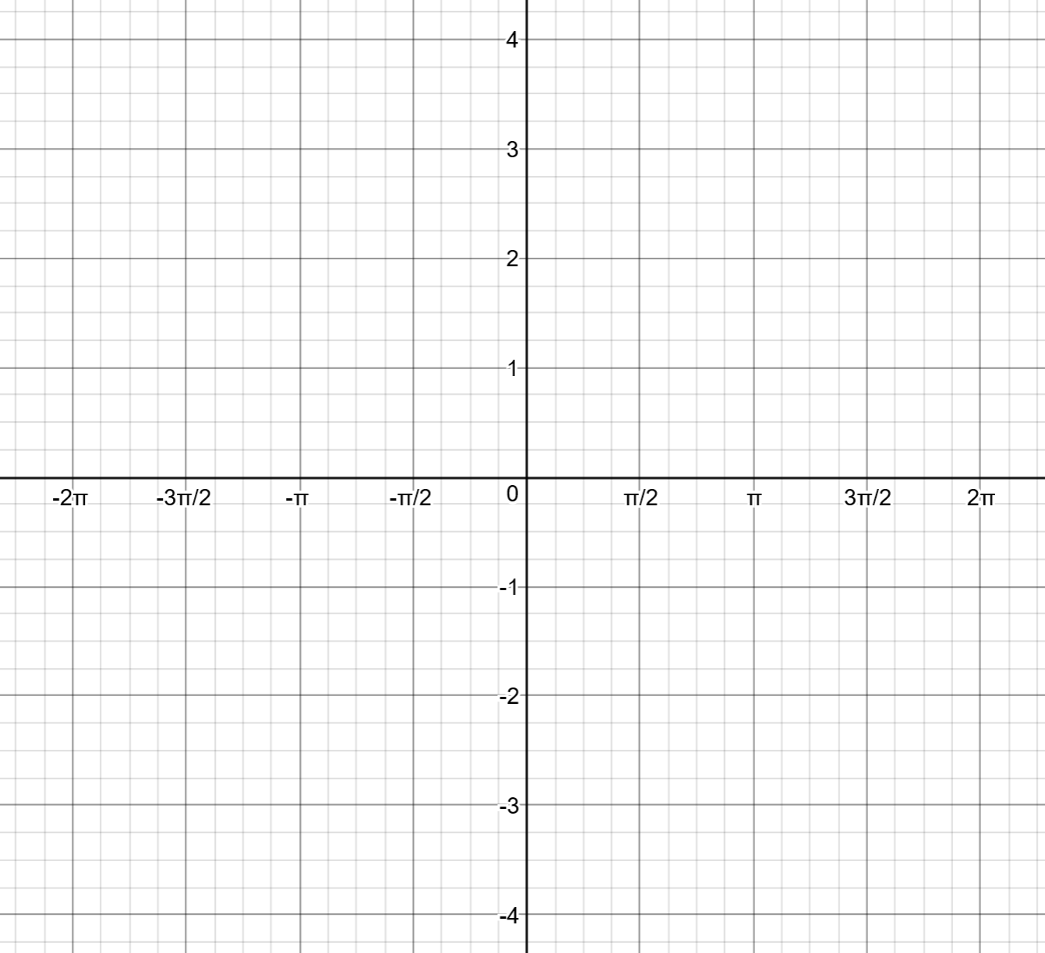
- $y=\frac{1}{2}cos x$
Amplitude =
Range =

- $y=-5sin x$
Amplitude =
Range =
- $y=3tan x$
Amplitude =
Range =

Activity 2 – period
For each equation, state its period, then sketch the graph on the Cartesian plane.
- $y=sin 3x$
Period =
- $y=cos 2x$
Period =

- $y=sin \frac{3x}{2}$
Period =
- $y=tan \frac{x}{2}$
Period =

Activity 3 – vertical shift
For each equation, state its vertical shift and range, then sketch the graph on the Cartesian plane.
- $y=sin x-1$
Vertical shift =
Range =
- $y=cos x-2$
Vertical shift =
Range =

- $y=sin x+2$
Vertical shift =
Range =
- $y=tan x+0.5$
Vertical shift =
Range =

Activity 4 – phase
- $y=sin \left(x-\frac{π}{2}\right)$
Horizontal shift =
- $y=cos \left(x+\frac{π}{4}\right)$
Horizontal shift =

- $y=tan \left(x+\frac{π}{2}\right)$
Horizontal shift =
- $y=sin \left(x+2π\right)$
Horizontal shift =

Activity 5 – composite transformations
Students complete the table for the trigonometric equation then graph the function.
2 sample questions are provided.
Copy the page and change the equation to create additional questions.

Question 1
Equation: $y=2sin \left(x-\frac{π}{2}\right)-1$
Amplitude =
Period =
Vertical shift =
Phase =
Range =
k =
a =
c =
b =
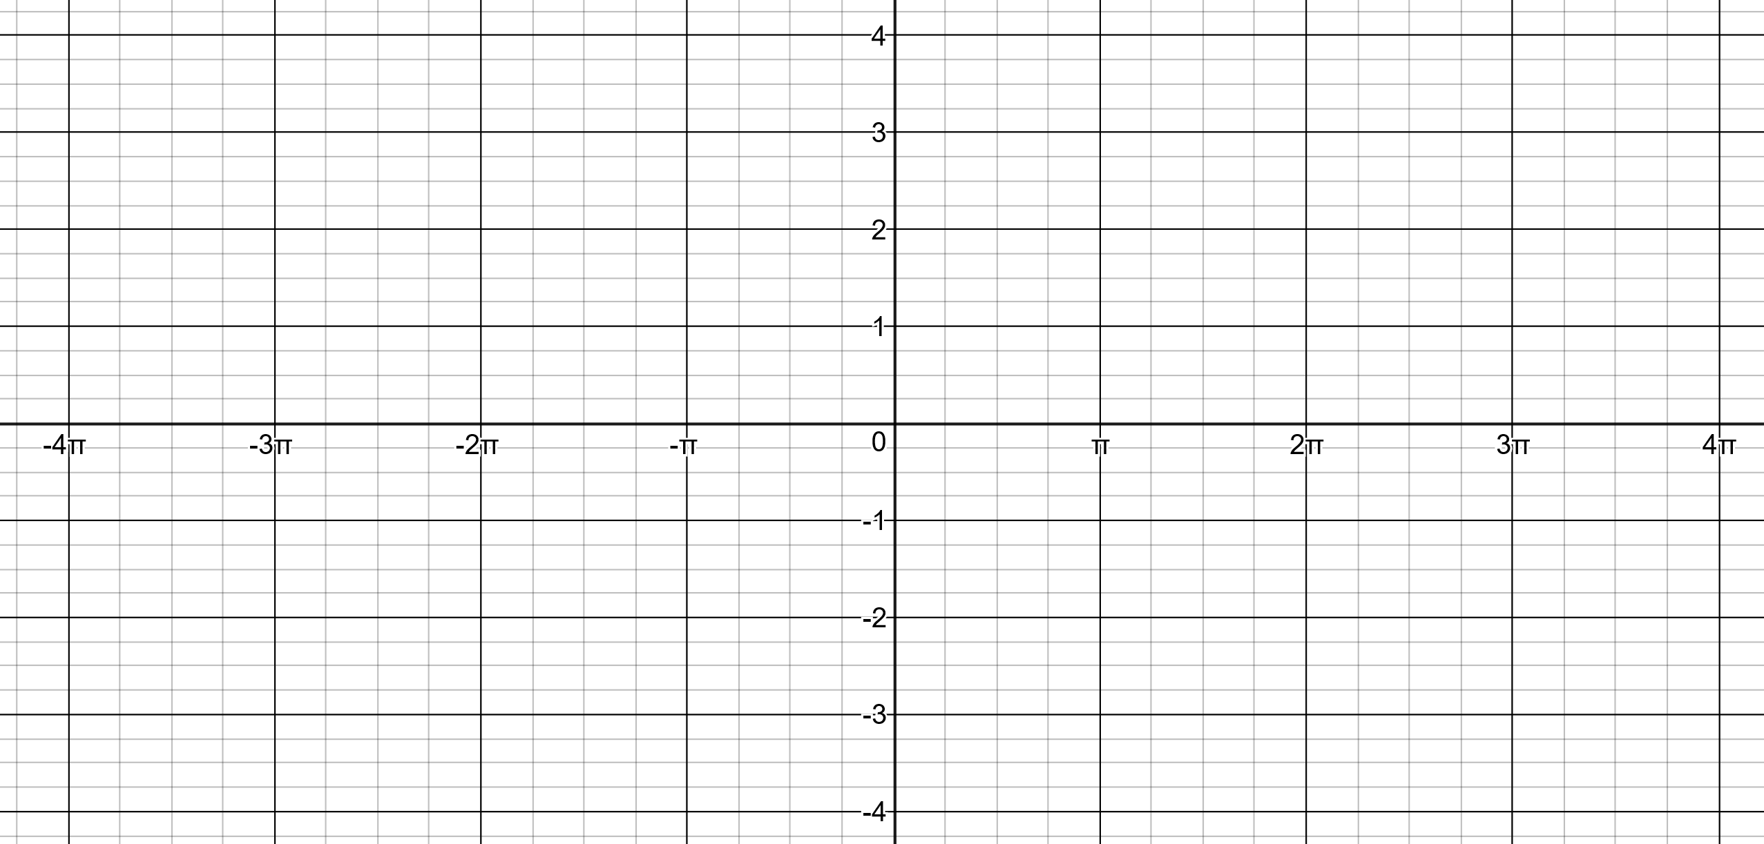

Question 2
Equation: $3cos\left[2\left(x+\frac{π}{2}\right)\right]+1$
Amplitude =
Period =
Vertical shift =
Phase =
Range =
k =
a =
c =
b =

Activity 6 – composite transformations – paired activity
- A trigonometric equation is given to Student 1.
- Student 2 is given the graph / recording template found on the next page.
- Student 1 informs Student 2 which trigonometric function they are using. Sine, Cosine or Tangent.
- Student 1 describes all transformations within their equation. For example:
  - If the equation was sin 2x, they may state that the period is pi.
  - If the equation was sin 5x, they may state the amplitude is 5.
- Student 2 uses the information to complete the missing information, sketch the graph and states the equation.
- The students use graphing software to check the solution.
- The students swap roles.
Sample equation cards:
$$y=3sinx$$ | $$y=4cosx$$ | $$y=\frac{1}{2}sinx$$ | $$y=\frac{5cosx}{2}$$
$$y=sin2x$$ | $$y=cos3x$$ | $$y=tan2x$$ | $$y=cos\frac{x}{4}$$
$$y=sinx+3$$ | $$y=sinx-2$$ | $$y=cosx+1$$ | $$y=tanx-2$$
$$y=sin⁡(x+\frac{π}{2})$$ | $$y=cos⁡(x+π)$$ | $$y=sin⁡(x-π)$$ | y$=tan⁡(x+\frac{π}{4})$
$$y=2\cos\left(x+\frac{π}{4}\right)-1$$ | $$y=3\sin\left(x+\frac{π}{2}\right)+1$$ | $$y=\tan\left(x+\frac{π}{4}\right)+1$$ | $$y=2\sin{3\left(x+\frac{π}{2}\right)}+2$$

Student recording template
Amplitude =
Period =
Vertical shift =
Phase =
Range =
k =
a =
c =
b =
Equation: $y=kf(a(x+b))+c$
Graph:

Activity 7 – graph to an equation
Transformations of sine in desmos
Transformations of cosine in desmos
Transformations of tangent in desmos

Graph 1
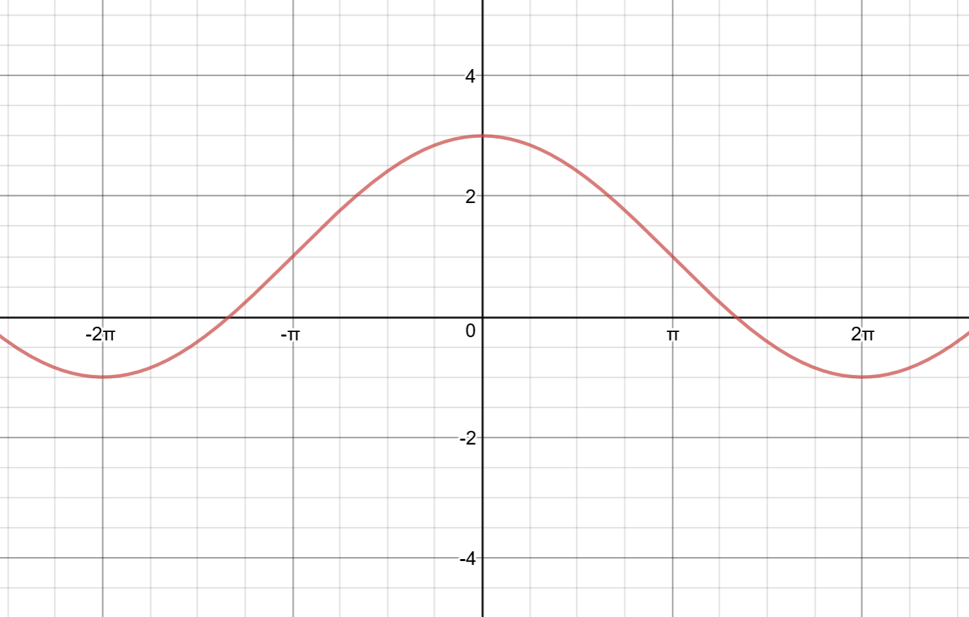
Amplitude =
Period =
Vertical shift =
Phase =
Range =
k =
a =
c =
b =
Equation:

Graph 2
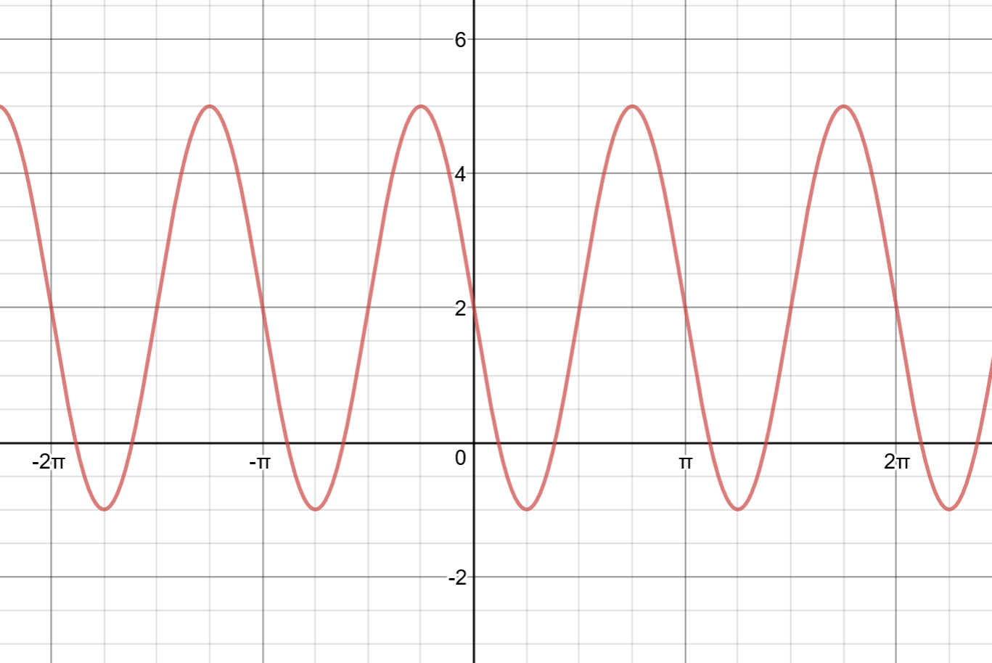
Amplitude =
Period =
Vertical shift =
Phase =
Range =
k =
a =
c =
b =
Equation:

Graph 3
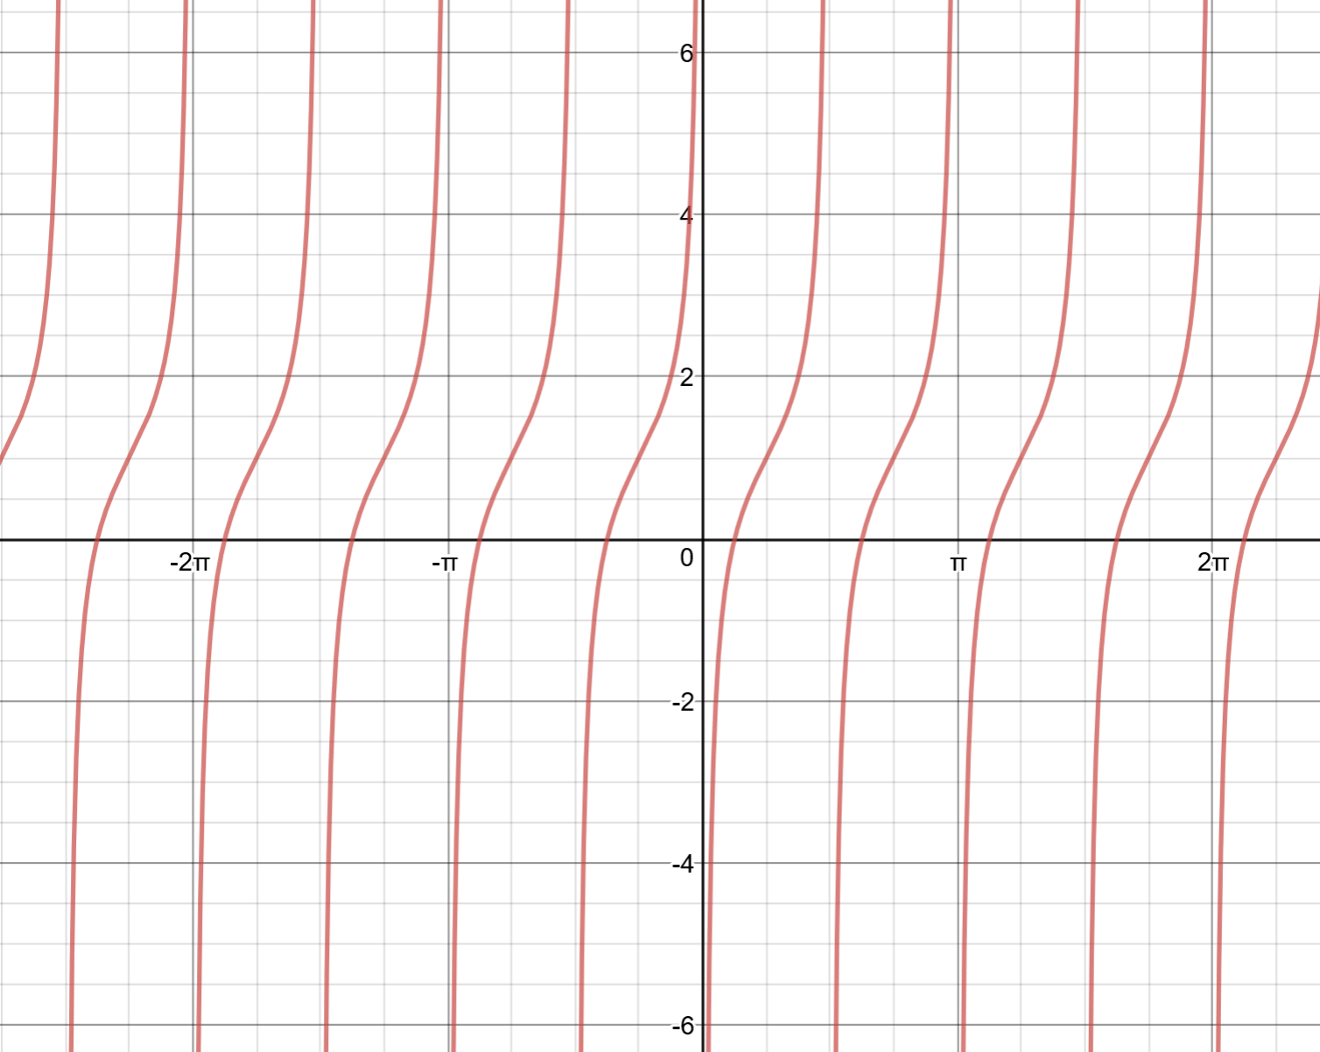
Amplitude =
Period =
Vertical shift =
Phase =
Range =
k =
a =
c =
b =
Equation:
Graph 1
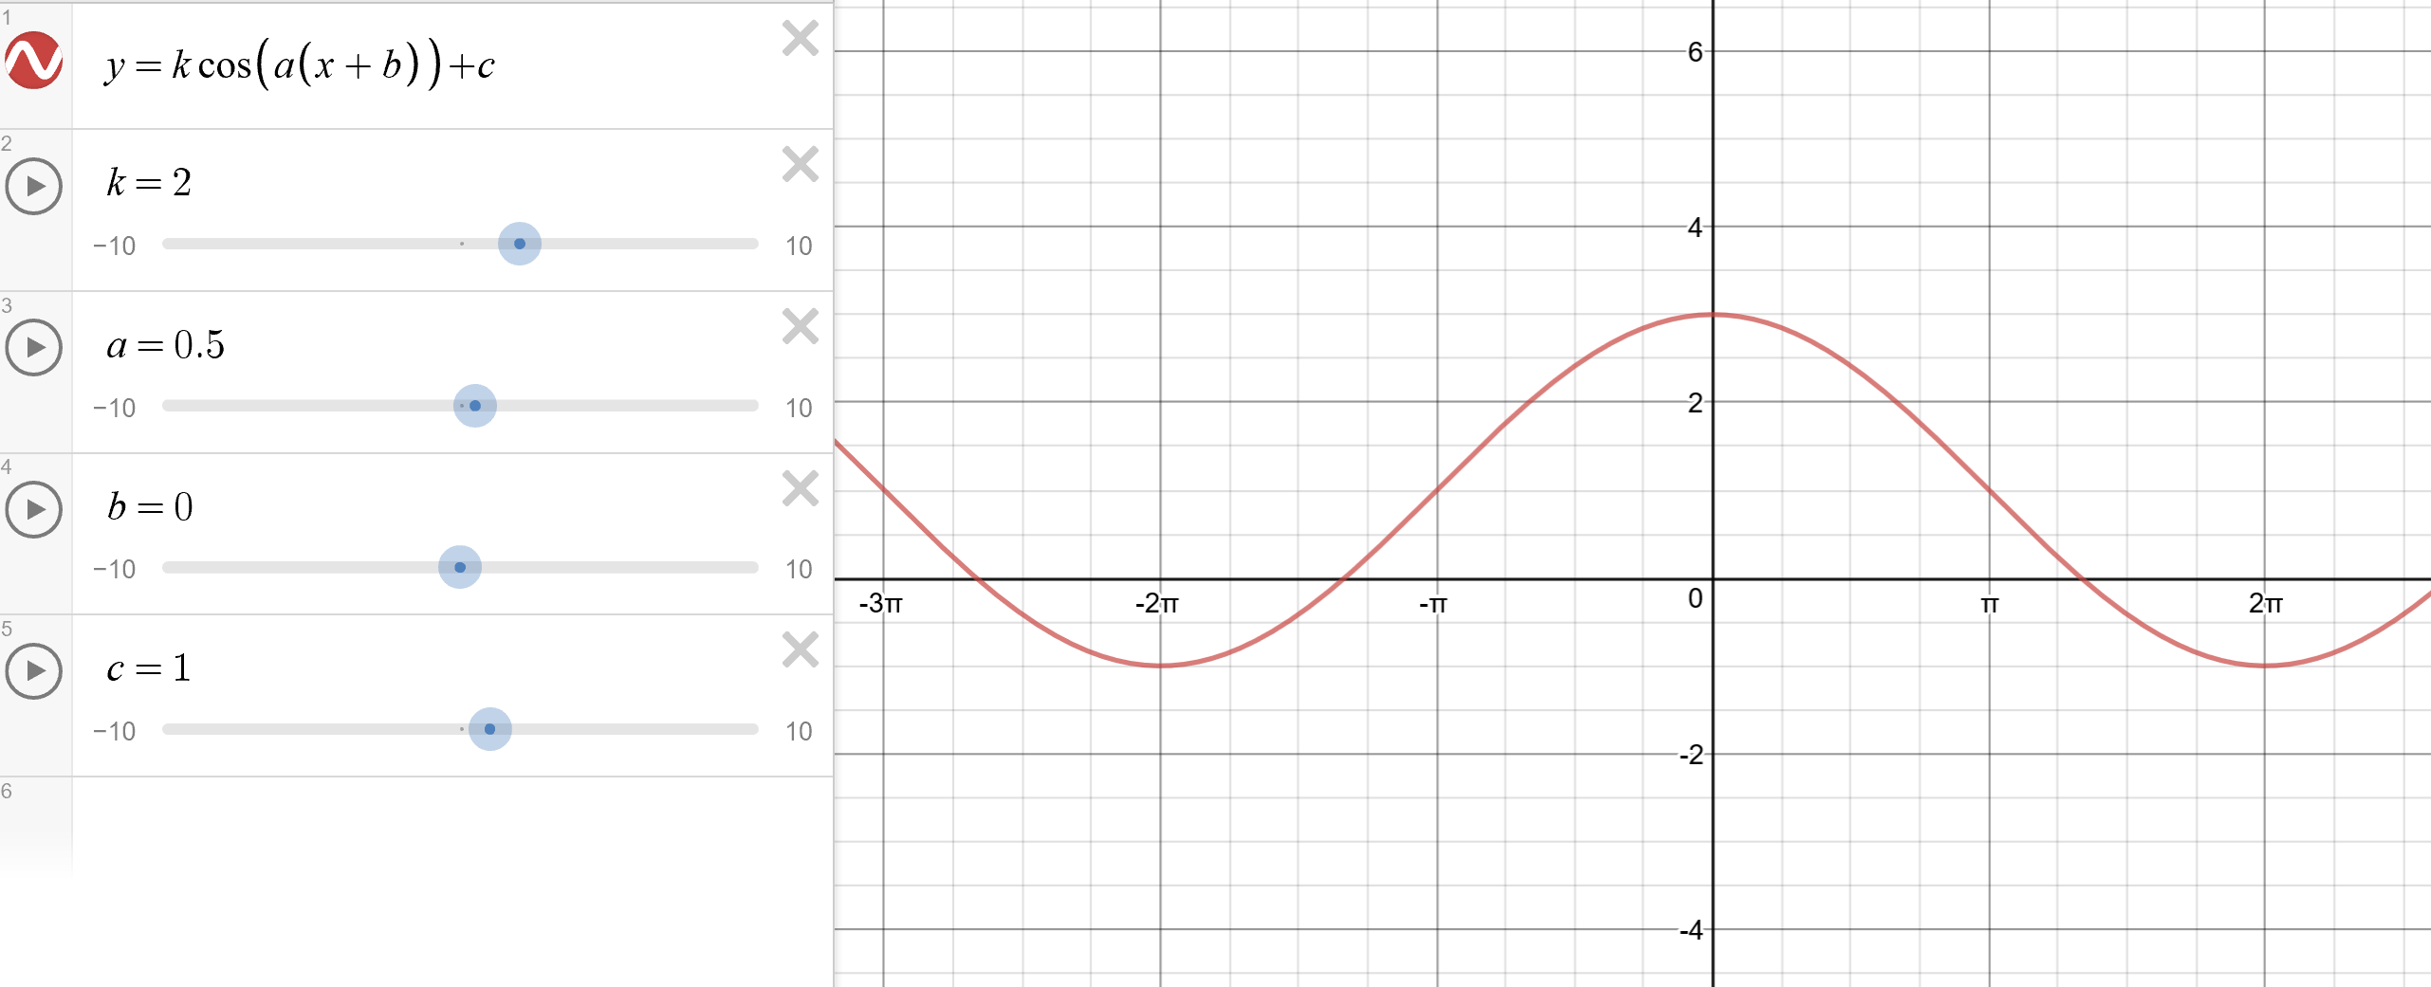
Graph 2
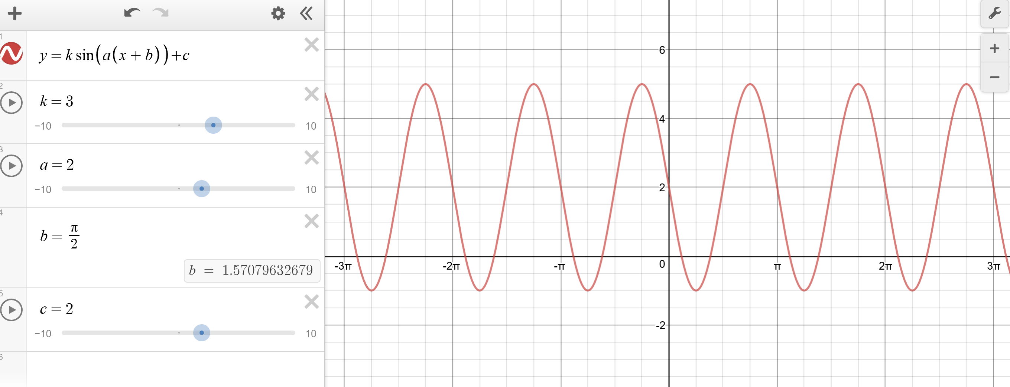
Graph 3
