Modelling periodic phenomena
The study of trigonometric functions is important in developing an understanding of periodic functions. Utilising the properties of periodic functions, mathematical models have been developed that describe the behaviour of many naturally occurring periodic phenomena, such as vibrations or waves, as well as oscillatory behaviour found in pendulums, electric currents and radio signals.
This document contains 3 methods of modelling periodic phenomena using trigonometric functions followed by various ways of sourcing data.

Method 1 – modelling with a single trigonometric function
The following was modelled using the raw data in the resource Newcastle-tidal-data.ggb.
In the spreadsheet view, Column A is the hours elapsed from the first recorded high tide, column B is the height of the tide.
By examining points A and B, a potential model may have the following features:
Maximum Value $= 1.63$
Minimum value $= 0.64$
Amplitude $= \frac{1.63-0.64}{2}=0.495$ (k)
Vertical shift (centre of the motion) $= \frac{1.63+0.64}{2}=1.135$ (c)
Period $= 12.2$ (Point A to C)
Frequency $=\frac{2π}{12.2}=\frac{π}{6.1}$ (a)
A potential equation to model the tidal data given is:
$$f\left(x\right)=0.495\cos\left(\frac{πx}{6.1}\right)+1.135$$
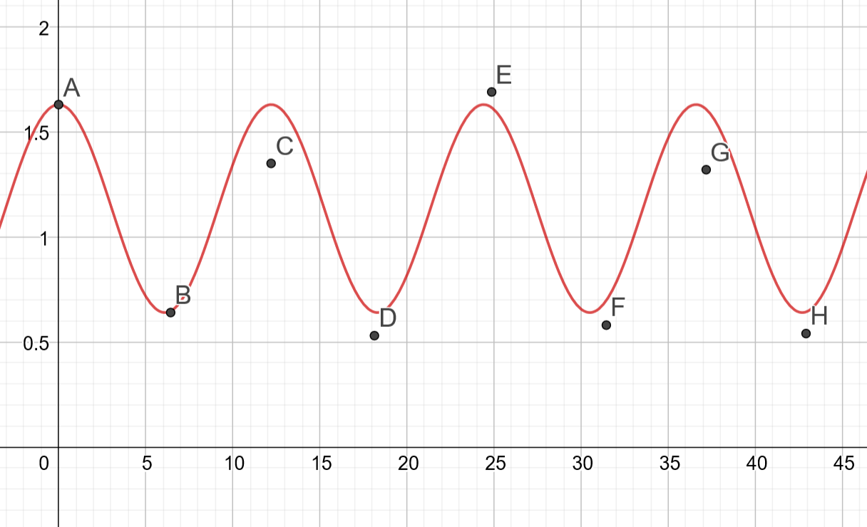
Upon inspection of the graph we can observe points C and G are not accurately captured by the model.

Method 2 – with multiple functions: two or more trigonometric functions
To try and capture these points accurately, we can overlay an additional trigonometric function with a period equal to the distance between C and G. This is approximately twice the period of the original function.
Period $=2×12.2=24.4$
Frequency = $=\frac{2π}{24.4}=\frac{π}{12.2}$
We now have an incomplete new model represented by a combination of cosine functions:
$$g\left(x\right)=k\cos\left(\frac{πx}{6.1}\right)+q\cos\left(\frac{πx}{12.2}\right)+c$$
We have 3 unknowns, by selecting 3 points, A, B and C and adjusting their horizontal positions to reflect the peaks and troughs of the trigonometric functions, we can form 3 equations:
$1.63 = k+q+c$
$$0.64 = -k+c$$
$$1.35 = k-q+c$$
Solving simultaneously we obtain:
$$k=0.425$$
$$q=0.14$$
$$C=1.065$$
The new model is:
$$g\left(x\right)=0.425\cos\left(\frac{πx}{6.1}\right)+0.14\cos\left(\frac{πx}{12.2}\right)+1.065$$
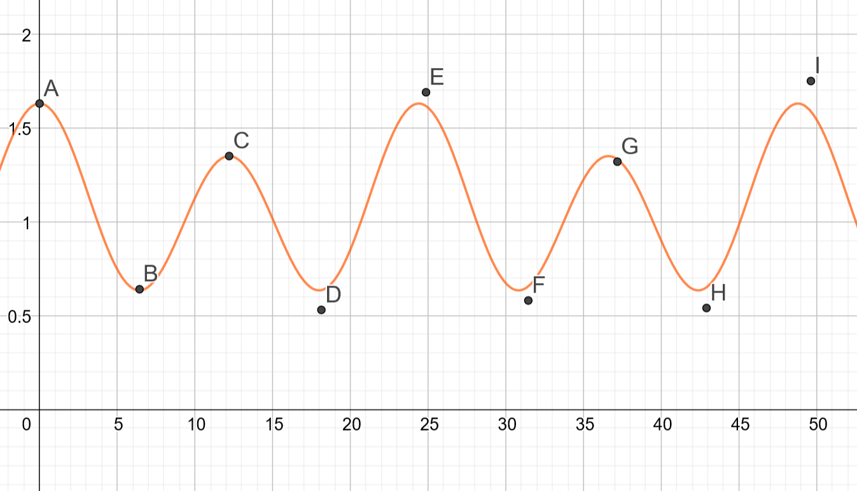
Upon further observation, points C and G are now more accurately modelled.

Method 3 – modelling a linear or exponential trend
This is appropriate for a range of scenarios such as when the data follow a linear trend or there is a change in the amplitude which reflects a function.
Examples:
- A linear trend.
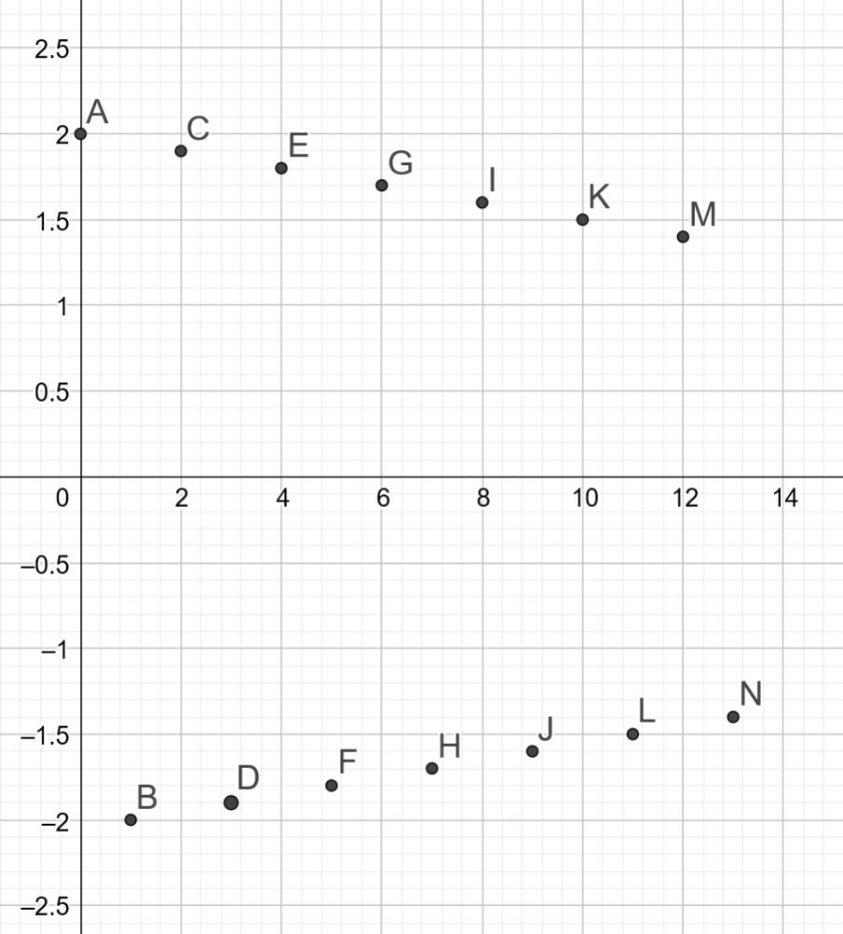
Despite following a periodic pattern, the points can be observed to be decreasing linearly towards zero.
The equation of the line through A and M is $y=2-\frac{0.6}{13}x$
The period of the function is $2, a=π$
We can fit the function: $f\left(x\right)=\left(2-\frac{0.6}{13}x\right)cos⁡(πx)$
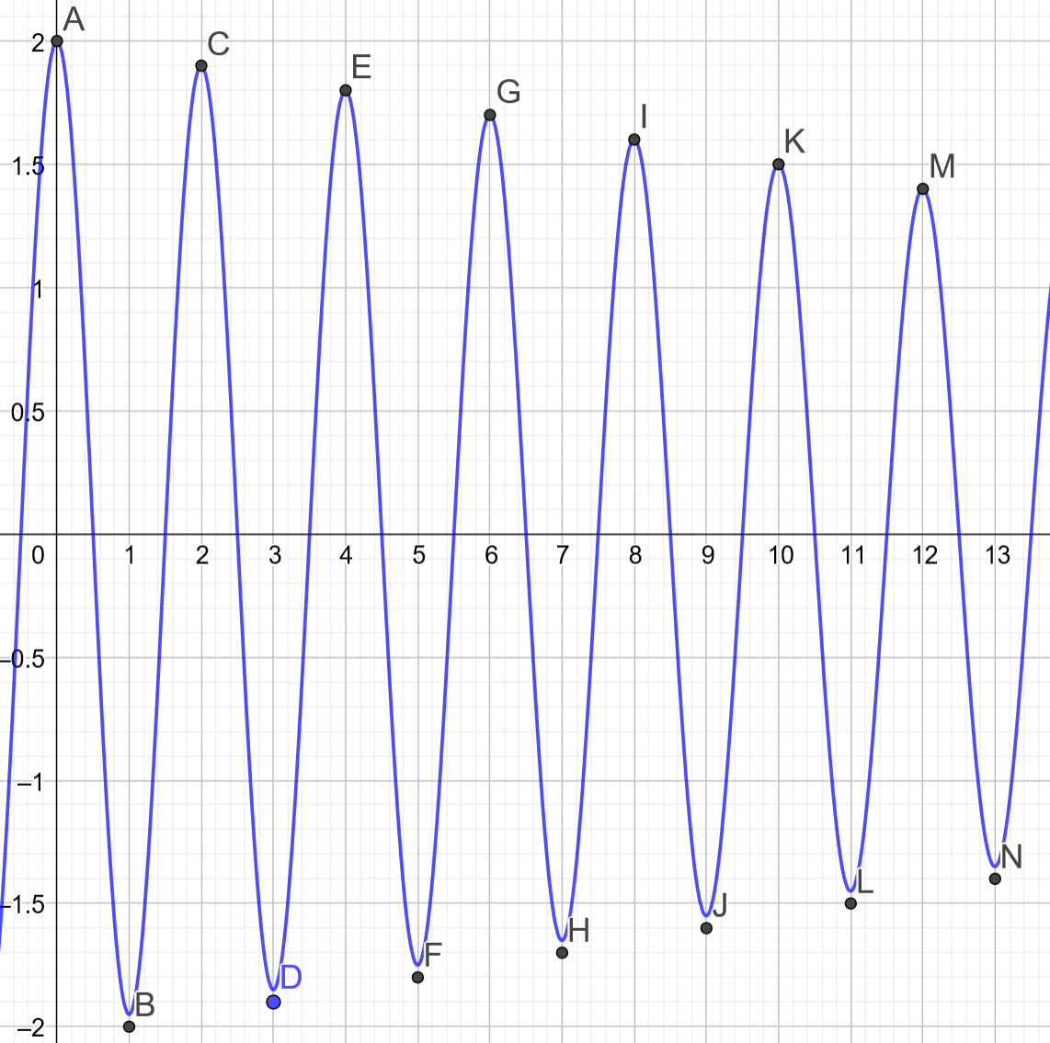

- A linear trend example 2.
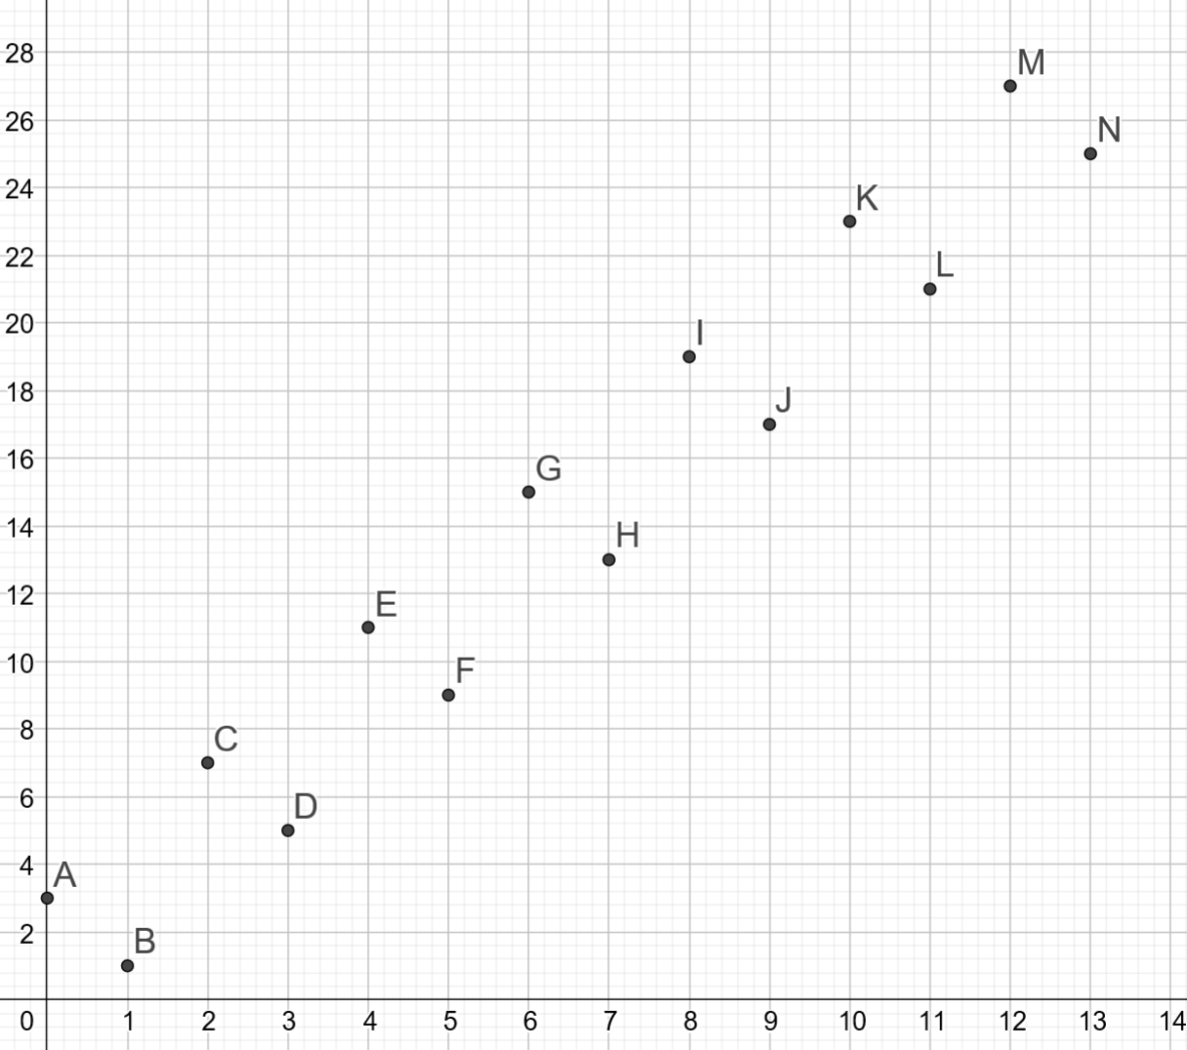
Consider the data above.
The data follows a periodic pattern, but the points can be observed to be increasing linearly.
The equation of the line through A and M is $y=2x+3$
The equation of the line through B and N is $y=2x-1$
The average line (centre of the motion) is $y=2x+1$
The period of the function is $2, a=π$
The amplitude is $2$, given the distance from A to the line $y=2x+1$
We can fit the function: $f\left(x\right)=\left(2x+1\right)+2cos\left(πx\right)$

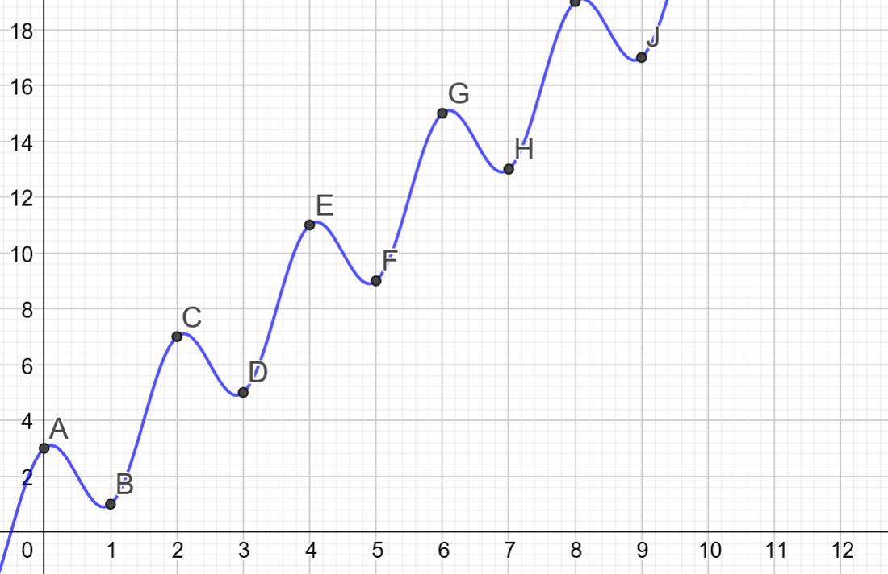
Note: This data fits this trend perfectly. This may not always be the case.

- A decreasing trend.
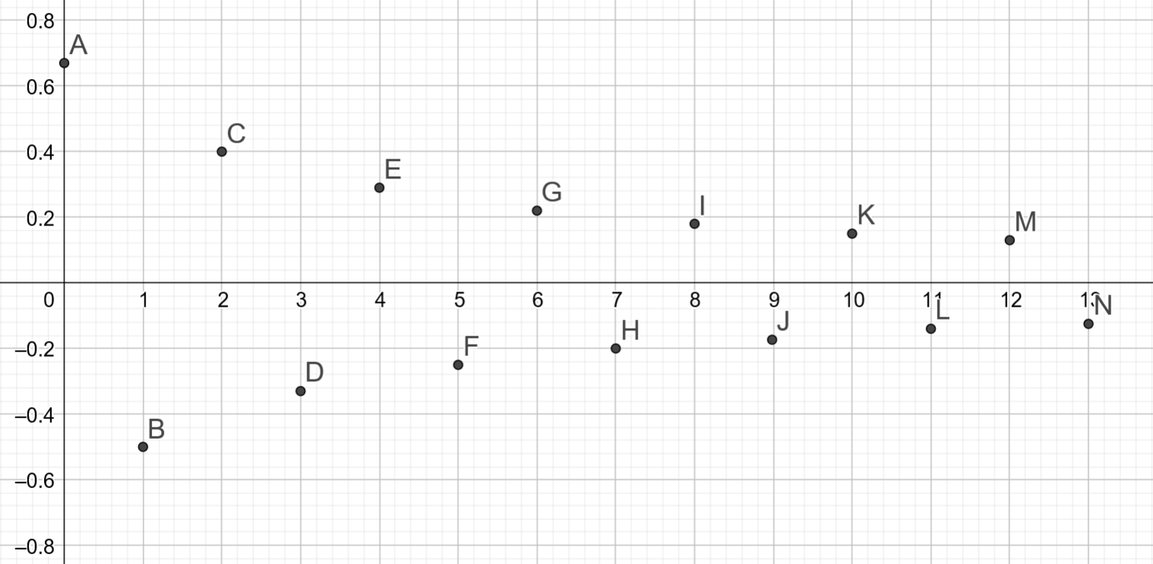
The data follows a periodic patter, but the points can be observed to be decreasing towards zero.
Consider the function through A and C, which is of the form $y=\frac{a}{x+b}$
By substituting the points $\left(0,\frac{2}{3}\right)$ and $\left(2,\frac{2}{5}\right)$, we obtain $a=2$ and $b=3$
The period of the function is $2, a=π$
We can fit the function: $f\left(x\right)=\left(\frac{2}{x+3}\right)cos⁡(πx)$
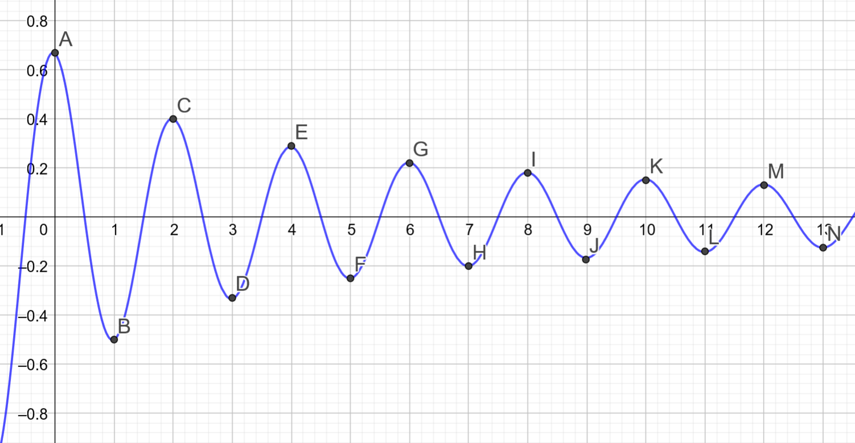

Sourcing data
Tidal data: Graph tide height verse elapsed time.
Many websites contain tidal data.
Willyweather has a graph and table of historical and future high and low tides.
When analysing tides, you will need to set on a starting time zero (possibly a high, low or mid tide). All tide times will need to be adjusted to be the time elapsed in hours.
Example: There is 5 hours and 58 minutes from 12:50am to 6:48am or 5.97 hours.
Tide | Elapsed Time (hours) (2 d.p.) | Height (m)
High tide at 12:50am | 0 | 1.33m
Low tide at 6:48 am | 5.97 | 0.31m
Pendulum: Graph horizontal displacement verse elapsed time.
Data for the elapsed time and horizontal displacement of a pendulum could be collected using a go pro, android or IOS application that takes photos at regular intervals, every second, 2 seconds etc.
Alternatively, the University of Colorado, Boulder, has interactive simulations for science and mathematics. One simulation is the Pendulum.
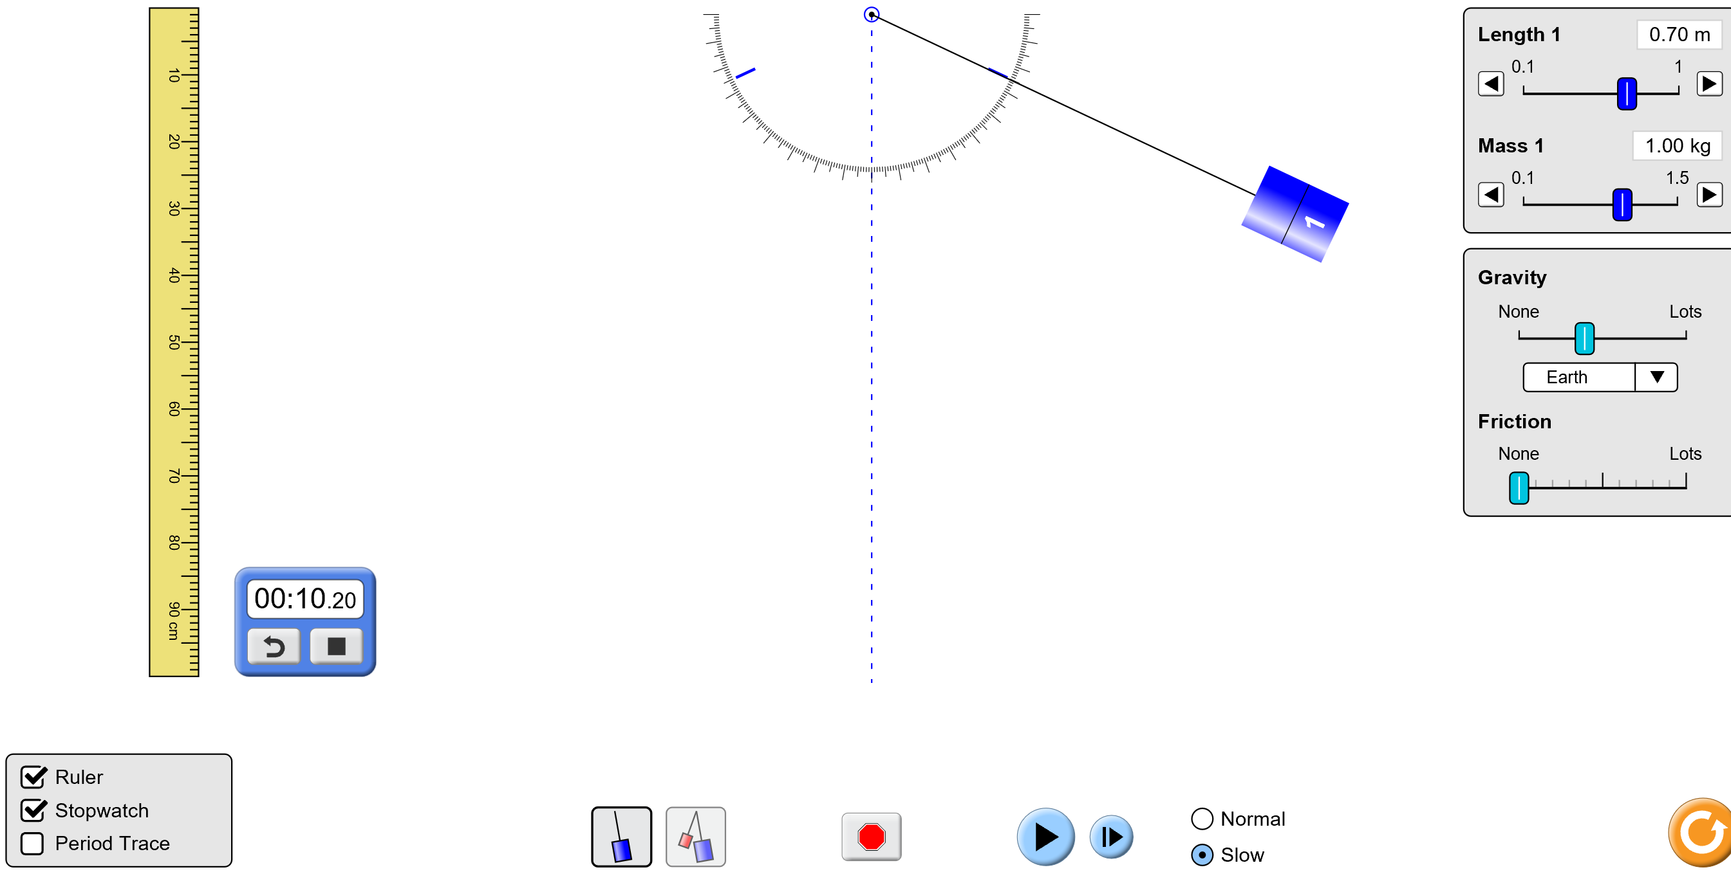
Ensure the simulation is run on slow and the stopwatch is activated. Record the times the pendulum is at its maximum and minimum heights for several repetitions. Note: You may need to pause to record times.
If friction is applied, the pendulum will gradually slow down. You will need to pause at each maximum and minimum to record the height obtained.

