Normal Distribution Primary Data Investigation

Randomly occurring events
In nature, the results of an experiment, repeated many times, should be normally distributed so long as that experiment is free of outside factors that could influence its outcome.

To verify this, we need to design an experiment and take a large sample of data.

For this sample experiment, you need to drop a dice and measure its final distance from its landing point.

Method:
- On a flat, preferably carpeted surface, measure 30cm up from the ground.
- Have one person watching to mark where the dice will land.
- The other person drop the dice from 30cm high
- Once the dice has come to rest, use a tape measure to record its distance from its original landing position.
- Repeat this experiment, at least 100 times, recording your results in an Excel Spreadsheet.
- You will need to group your data as all measurements will be different. Establish groups and create a frequency table in your spreadsheets.
- Create Class Centres for your groups and add this as a column to your graph.
- Use the instructions provided on the “Creating a Histogram in Microsoft Excel” worksheet to construct a Histogram.
- Use the formula “=average()” to calculate the mean of your data.
- Use the formula “=stdev.p()” to calculate the standard deviation of your data.

The Normal Distribution
When data is “Normally Distributed”, it is symmetrical, with the mean at the centre. It then follows a pattern as our data values move out by standard deviations, as shown below.
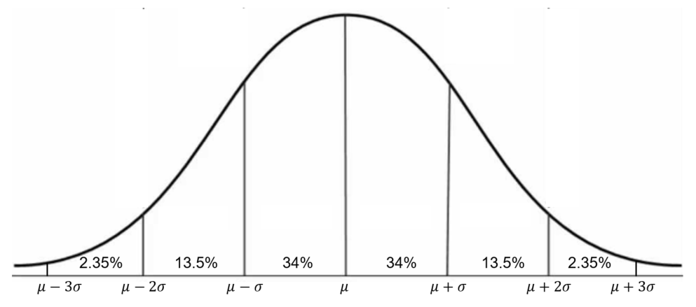
Certain percentages of the data are located within each section, for example, with a mean of 60 and a standard deviation of 10, we would expect 34% of our data to be between 60 and 70(from the mean to one standard deviation above the mean.

Your Data
Looking at your histogram, is your data symmetrical about the mean?
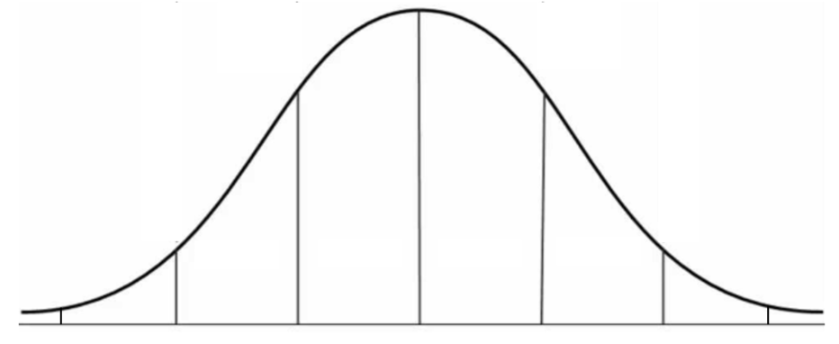
Write the values of the mean, and then $μ+σ$ , $μ+σ$ etc under this graph. Calculate the percentages of your data that lands within each section of the graph above and write it in.
What are the similarities between the data you collect and normally distributed data?
________________________________________________________________________________________________________________________________________________________________
________________________________________________________________________________________________________________________________________________________________
________________________________________________________________________________________________________________________________________________________________

What are the differences between the data you collected and normally distributed data?
________________________________________________________________________________________________________________________________________________________________________________________________________________________________________________
________________________________________________________________________________________________________________________________________________________________
________________________________________________________________________________________________________________________________________________________________________________________________________________________________________________
What factors could affect your experiment compared to someone else performing the same experiment? What could make your results different?
________________________________________________________________________________________________________________________________________________________________________________________________________________________________________________
________________________________________________________________________________________________________________________________________________________________________________________________________________________________________________
________________________________________________________________________________________________________________________________________________________________

Z-Scores
Compare your 80th results with the 80th results of other groups in your class.
- Who had the shortest distance? ___________________________
- Who had the distance that was closest to their mean? ____________________
- Who had the result that was the fewest standard deviations from their mean? ___________________________________________________________________
For question (iii), if my mean was 10cm, and my standard deviation was 4, then a score of 14 is exactly 1 standard deviation from the mean. If my score was 12, I am exactly 0.5 standard deviations from the mean (2).

This value is called a $z$-score, and if the previous paragraph was a little confusing, this language is designed to simplify the whole process.

To find a score that is 2 standard deviations above the mean, we use the formula

$$x=μ+2×σ$$

We get the mean and add the standard deviation twice.
If we wanted a score 1 standard deviation below the mean, we would use

$$x=μ-1×σ$$

There is clear benefit in having the number of standard deviations be the variable. So replacing this with z we get:
$$x=μ+z×σ$$

Rearrange this equation to find a formula for the z-score given the score, mean and standard deviation.
____________________________________________________________________________________________________________________________________________________________________________________________________________________________________________________________________________________________________________________

Now go through your spreadsheet and make a formula to find the z-scores of all of your data.
By comparing z-scores with other groups, who has the best:
15th score? ________________________
34th score? ________________________
99th score? ________________________

