Steps to Construct a Frequency Histogram in Microsoft Excel
- Input your data into two columns.

- Highlighting your data, click “Insert” and “PivotChart”, then “PivotChart”

- When you are given options, simply click OK.

- In your new Sheet, on the right hand side, drag your x – variable into the AXIS box at the bottom. Drag the Frequency into the VALUES box at the bottom.
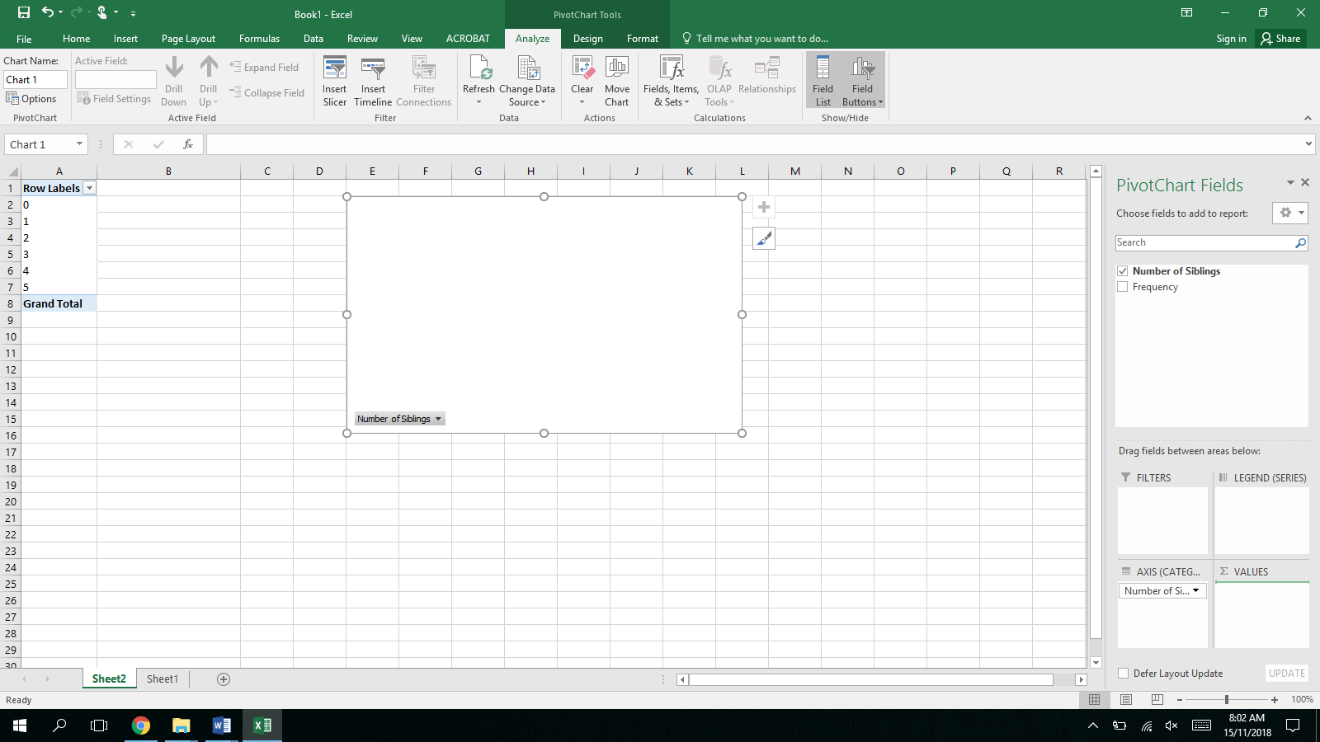

- To make your new column graph into a Histogram, go to “Design” at the top of your screen, go to “Quick Layout” and select the Histogram.

- To make clear outlines on your columns and axes, right click on what you want and click “Format Data Series”. Click “Border” and select a solid line and colour. You can also do this to your axes by clicking “Format Axis”.
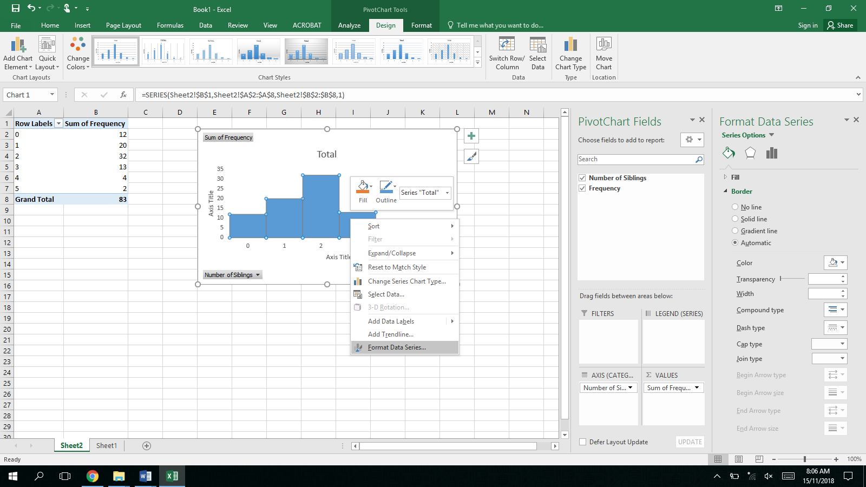

- You can right click on your graph and copy into Microsoft Word, where the graph can still be editable. Edit your title and axes titles by double clicking on them.

