Correlation matching activity
Data | Definition | Word | Example | Non-examples
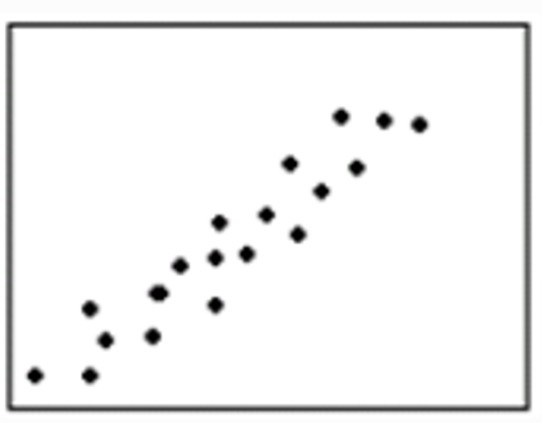

Data | Definition | Word | Example | Non-example
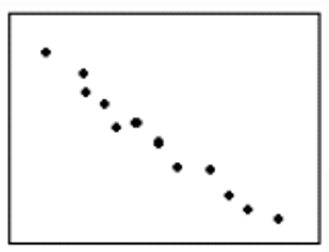

Data | Definition | Word | Example | Non-example
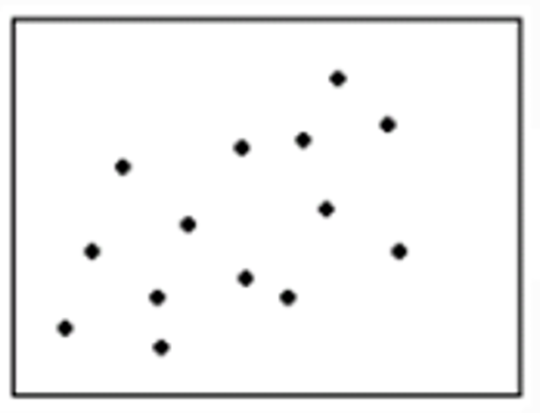

Data | Definition | Word | Example | Non-example
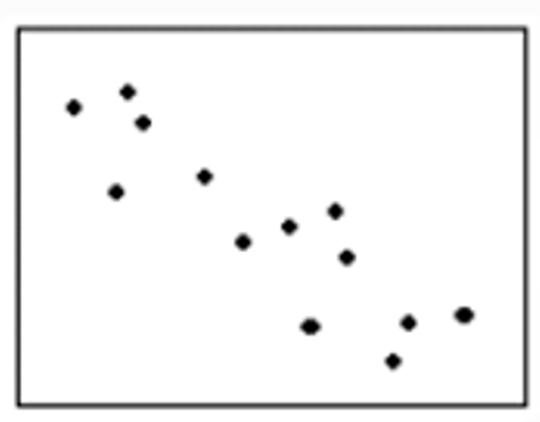

Data | Definition | Word | Example | Non-example
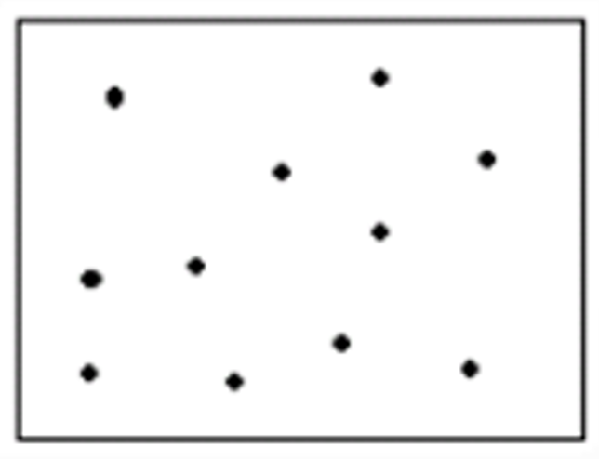

Data | Definition | Word | Example | Non-example
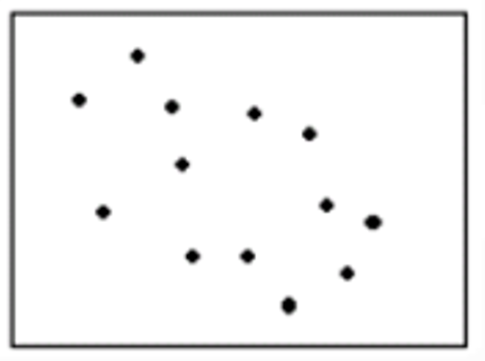

Data | Definition | Word | Example | Non-example

Data | Definition | Word | Example | Non-example

Word cards | Definition cards
Strong positive | As one set of values increases, the other set increases.
Strong negative | As one set of values increases, the other set decreases.

Weak positive

Moderate negative
No correlation | The points are scattered randomly with no visible pattern.

Weak negative
Linear | When the relationship between two sets of variables can be represented with a line.
Non-linear | When the relationship between two sets of variable cannot be represented with a line.

