nth term of an arithmetic sequence
The activities below lead students to discover the relationship between the n_{th} term, $T_{n}$, the first term, $a$, and common difference, $d$.

Activity 1 – using graphing software.
- Students to construct the first $5$ terms of an arithmetic sequence by defining a first term, $a$, and common difference $d$.
Example: Let $a=2$ and $d=3$, then the sequence is $2, 5, 8, 11, 14…$
n | 1 | 2 | 3 | 4 | 5
$$T_{n}$$ | 2 | 5 | 8 | 11 | 14
- Student to use graphing software to graph the 5 points represented by $T_{n}$ verse $n$.
Example: Using Desmos:
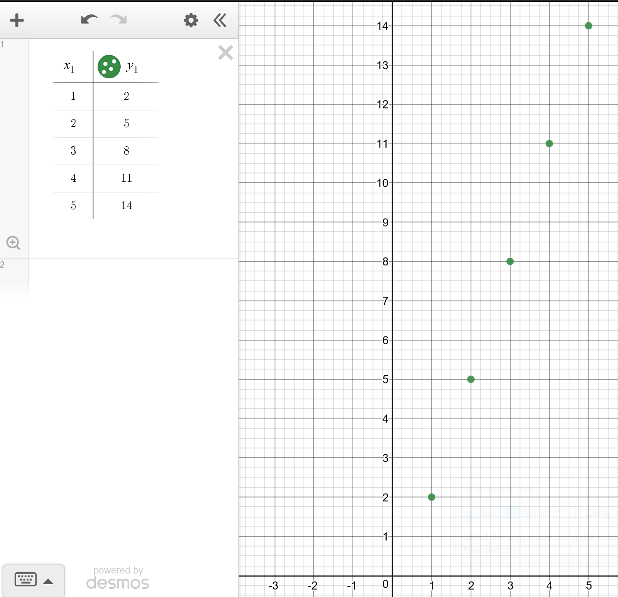
- Students to find the equation of the line through the points to express the relationship between $T_{n}$ and $n$.
Example: $y = 3x – 1$ -> $T_{n}=3n-1$
- Students to describe the relationship in terms of the shape of the graph.
- Students to work in pairs to write a rule for $T_{n}$ in terms of $n$, $a$ and $d$. Students will need to look at the relationship between $a$, $d$ and the $y$-intercept.
$$T_{n}=dn+a-d$$
$$T_{n}=a+dn-d$$
$$T_{n}=a+(n-1)d$$

Activity 2 – using a spreadsheet.
- Open the file: nth-term-arithmetic-sequence.XLSX
Students have two options,
- With formulas and graph (skip steps 3 and 4)
- Without formula and graph
- Students set a value for $a$ and $d$.
- Student use the definition of $Tn=Tn-1+d$ to complete the table of values for the first $10$ terms.
- Students are to graph the relationship between $Tn$ and $n$.
- Students to describe the relationship in terms of the shape of the graph.
- Students to come up with a new formula for $Tn$ using $a$, $d$ and $n$ and without referencing the previous term. Write a formula to check the values in column D.

