Using desmos to solve inequalities

Solve the inequality $x^{2}+5x+8≤2$
The inequality above is in the form $f\left(x\right)≤k$ where $f(x)$ is quadratic and $k$ is constant.
- Define $f(x)$ by entering f(x)=x^2+5x+8 into the input box on the left hand side. 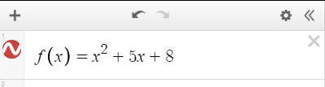

The curve for $y=f(x)$ will be displayed automatically.
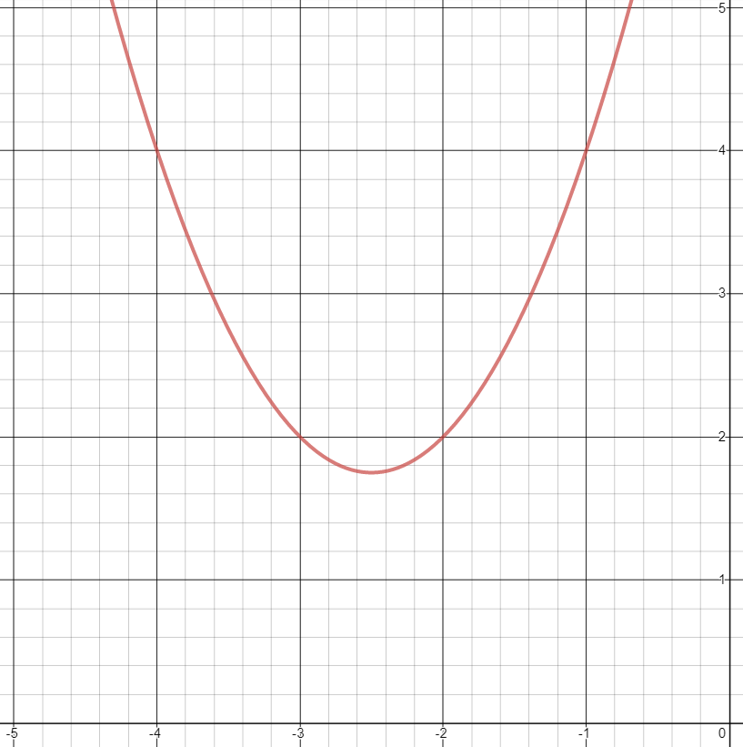

- Define $k$ by entering k=2 into an input box below $f(x)$.
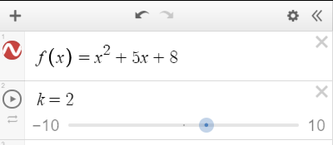

- Enter y=k into an input box below $k$ to display the line $y=k$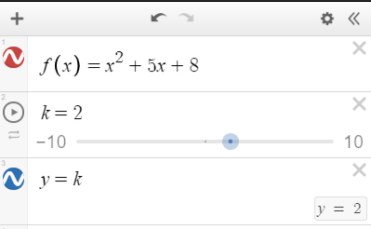
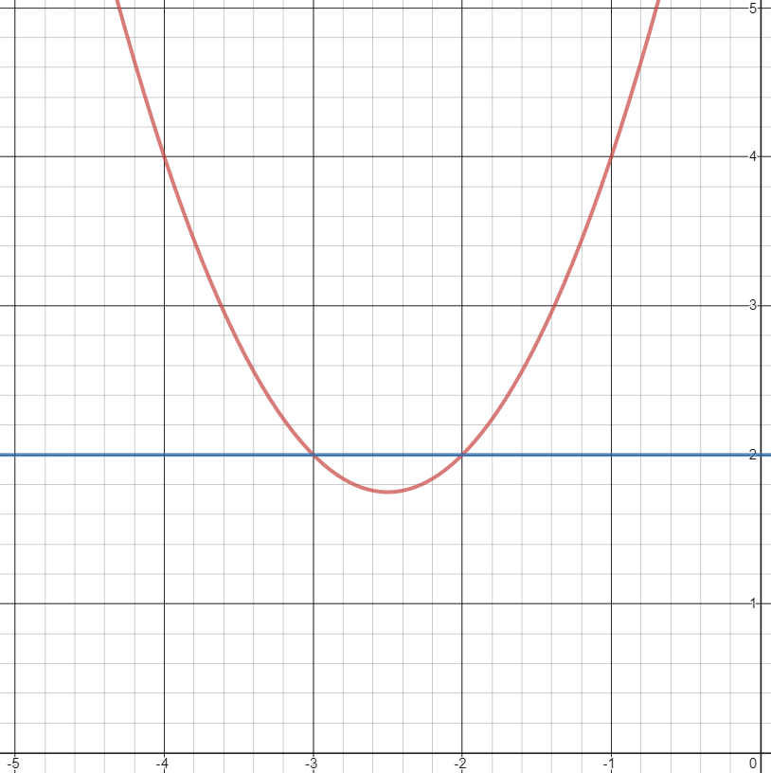

- Form the inequality statement $x^{2}+5x+8≤2$ by entering f(x)<=k as $f\left(x\right)$ and $k$ have already been defined.
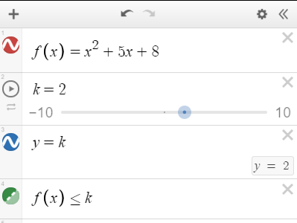

The regions for $x^{2}+5x+8≤2$ will automatically be displayed.
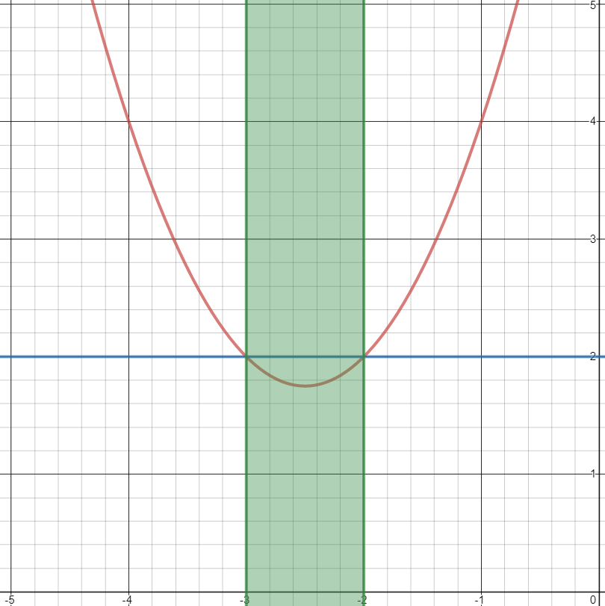
Reading the values for $x$ where the boundaries of the inequalities region cross the $x$-axis gives the solution $-3≤x≤-2$, which coincide with the $x$-ordinates of the intercepts between the curve and the line.

Source: Solving inequalities graphically desmos activity.

