Applications of integral calculus
Definite integrals
The study of calculus is important to many commercial fields including biomathematics, economics, engineering and the construction industry.

Application 1 – economics
Producer and consumer surplus
A producer surplus is achieved when a producer sells a product for more than the minimum price they were willing to accept. For example, if a producer is willing to sell an item for $\$6$ but achieve a sale of $\$9$, the producer surplus is $\$3$.
A consumer surplus is achieve when a consumer purchases a product for less than the maximum price they were willing to pay. For example, if the consumer was willing to purchase an item for $\$10$, but manages to purchase it for $\$9$, the consumer surplus is $\$1$.
The sum of the two surpluses is the overall economic surplus, in our scenario, $\$3 + \$1 = \$4$
Assuming that a product is sold for an equilibrium, where supply and demand are equal, this can be graphically represented as
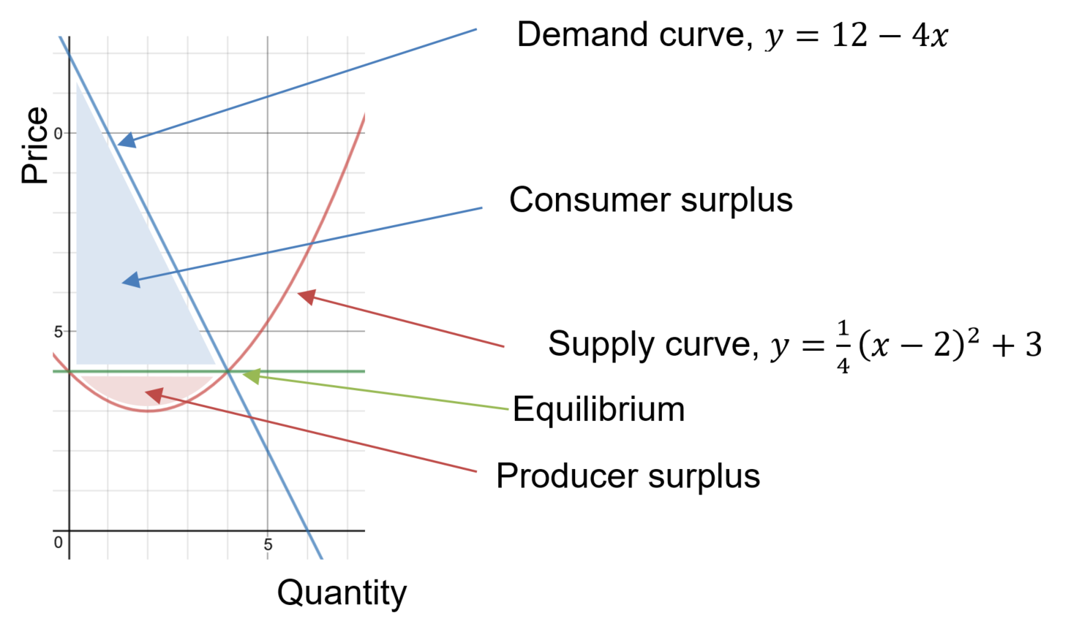
Activity: Calculate the size of the producer and consumer surpluses if the diagram shown.

Application 2 – average value of a function
The average value of a function can be calculated by:
$$y_{average}=\int_{a}^{b}{\frac{f(x)}{b-a}dx}$$
An application of the average value of a function is the head injury criterion.
Activity: Calculate the average temperature for an exponential cooling model or average population for an exponential growth model.

Application 3 – work
The work done when a constant force is applied over a distance is given by $W = F x d$
When the force required is not constant, such as when compressing a spring, integrals can be used to calculate the work done.
$$W=\int_{a}^{b}{F(x)}dx$$
Hooke’s law for springs: The force required to compress a spring is directly proportional to the length of compression, x, from its normal length.
Sample questions are presented on Interactive Mathematics.

Application 4 – braking distance of a car
An average passenger car brakes produce a deceleration force of $7m/s^{2}.$
The velocity (m/s) of a car, t seconds after the brakes are applied is given by $v = v_{0} – 7t$
Where $v_{0}$ is the initial velocity.

Activities
- Assuming it takes an average driver 1.5 seconds to react, calculate the stopping distances of a standard car for a range of speeds. Check your answers at the Queensland government, stopping distance webpage.
- A racing car produces a braking force of approximately $50m/s^{2}$. Calculate the stopping distances of a racing car for a range of speeds.
- Refer to wet stopping distance shown on the Queensland government, stopping distance webpage. Calculate the average braking force during wet weather.

