Investigating direct variation
The first part of the activity utilises a scaffold that can be modified for different scenarios. Two scenarios are provided.
It should allow students to examine the differences between scenarios involving linear relationships which are or are not examples of direct variation.
The second part of the activity allows students to refer to their scenarios and will enable students to:
- recognise that a direct variation relationship produces a straight-line graph passing through the origin
- determine a direct variation relationship from a written description, a straight-line graph or a linear function in the form $y=mx$
- recognise the gradient of a direct variation graph as the constant of variation

Part 1: Scenarios
Scenario 1
You are filling up your car with fuel. 1 Litre of unleaded petrol costs 152.9 cents. How much will it cost you to fill up your car if it needs 65 litres to be full?
Solve this three ways:
- Using a table of values
- Using a graph
- Using the equation
Table of values
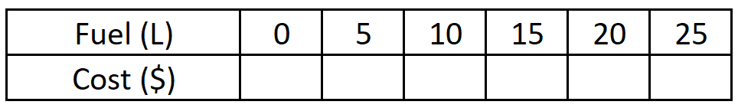
Graph:
Equation:

Scenario 2
You planning on hiring a venue for a party. It will cost $100 plus $20 per person. How much will it cost you if you have 70 people?
Solve this three ways:
- Using a table of values
- Using a graph
- Using the equation
Table of values
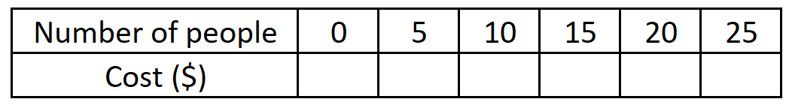
Graph:
Equation:

Part 2: Comparing scenarios
- For scenario 1, interpret the meaning of the:
  - gradient
  - y-intercept.
- For scenario 2, interpret the meaning of the:
  - gradient
- Which scenario represents direct variation?
- How can you tell if a linear relationship represents direct variation by considering:
  - The written description?
  - The features of the graph?
  - The table of values?
  - The equation?
- What is the relationship between the constant of variation and the gradient?

