Applying linear models
Within these activities, students will construct and analyse linear models, graphically or algebraically, to solve practical direct variation problems.
Students will also identify and evaluate the limitations of linear models which involve a practical context.
Some questions are based upon possible investigations or activities identified in NESA’s year 11 topic guide for algebra.

Practical questions

1. The weight of a person
The weight of an object on the moon varies directly with its weight on Earth. An astronaut who weighs 84 kg on Earth weighs only 14 kg on the moon. A lunar landing craft weighs 2449 kg when on the moon.
- What is the weight of this landing craft when on Earth?
  - Solve this problem algebraically.
  - Approximate the solution to this problem graphically to confirm your answer.
- For this scenario, what is the practical meaning of the gradient?

2. Converting currency
- Choose two currencies (one the Australian dollar) and record the rate of conversion. You may like to consider the currency used in a potential holiday destination.
- Complete an appropriate table of values to construct a currency conversion graph.
- Find the gradient and y-intercept of the graph and hence the equation used to convert between the currencies.
- Interpret the gradient. What does it mean?
- Interpret the y-intercept. What does it mean?
- What are the limitations of the model?
- Use the equation and graph to make a conversion both ways.
For example, if you did a US dollar (USD) and Australian dollar (AUD) conversion, convert:
  - 1000 USD to AUD
  - 1000 AUD to USD
- Cost out a one week holiday in the destination’s local currency and determine the approximate number of Australian dollars required.

3. The height of a person
The average height of males and females from age 2 through to 15 was collect and approximated using a linear model. (See graph on the following page)
- For the male model:
  - Find the gradient and interpret its meaning.
  - Find the y-intercept and interpret its meaning.
  - Find the equation (algebraic model) represented by the graph.
- For the female model:
  - Find the gradient and interpret its meaning.
  - Find the y-intercept and interpret its meaning.
  - Find the equation (algebraic model) represented by the graph.
- Predict the height (cm) of the following people using both the graph and the algebraic model.
Age and sex of person | Graph prediction | Algebraic model prediction
Male at birth
Female at birth
30 year old male
30 year old female
- Identify limitations of the model. Hint: Consider your previous answers).

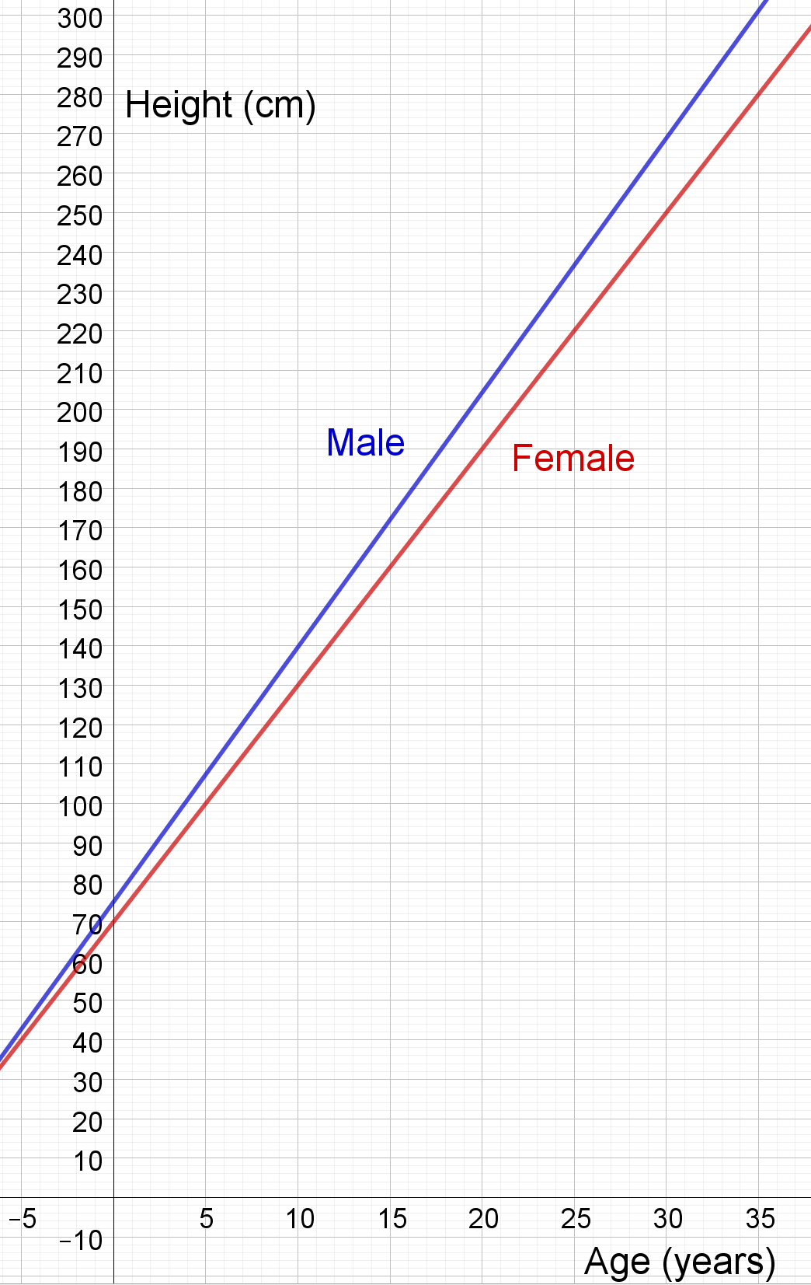

4. The life expectancy of a person
The following graph gives the life expectancy of an individual based upon their year of birth using data from 1880 through to 2015. It has been approximated using a linear model.
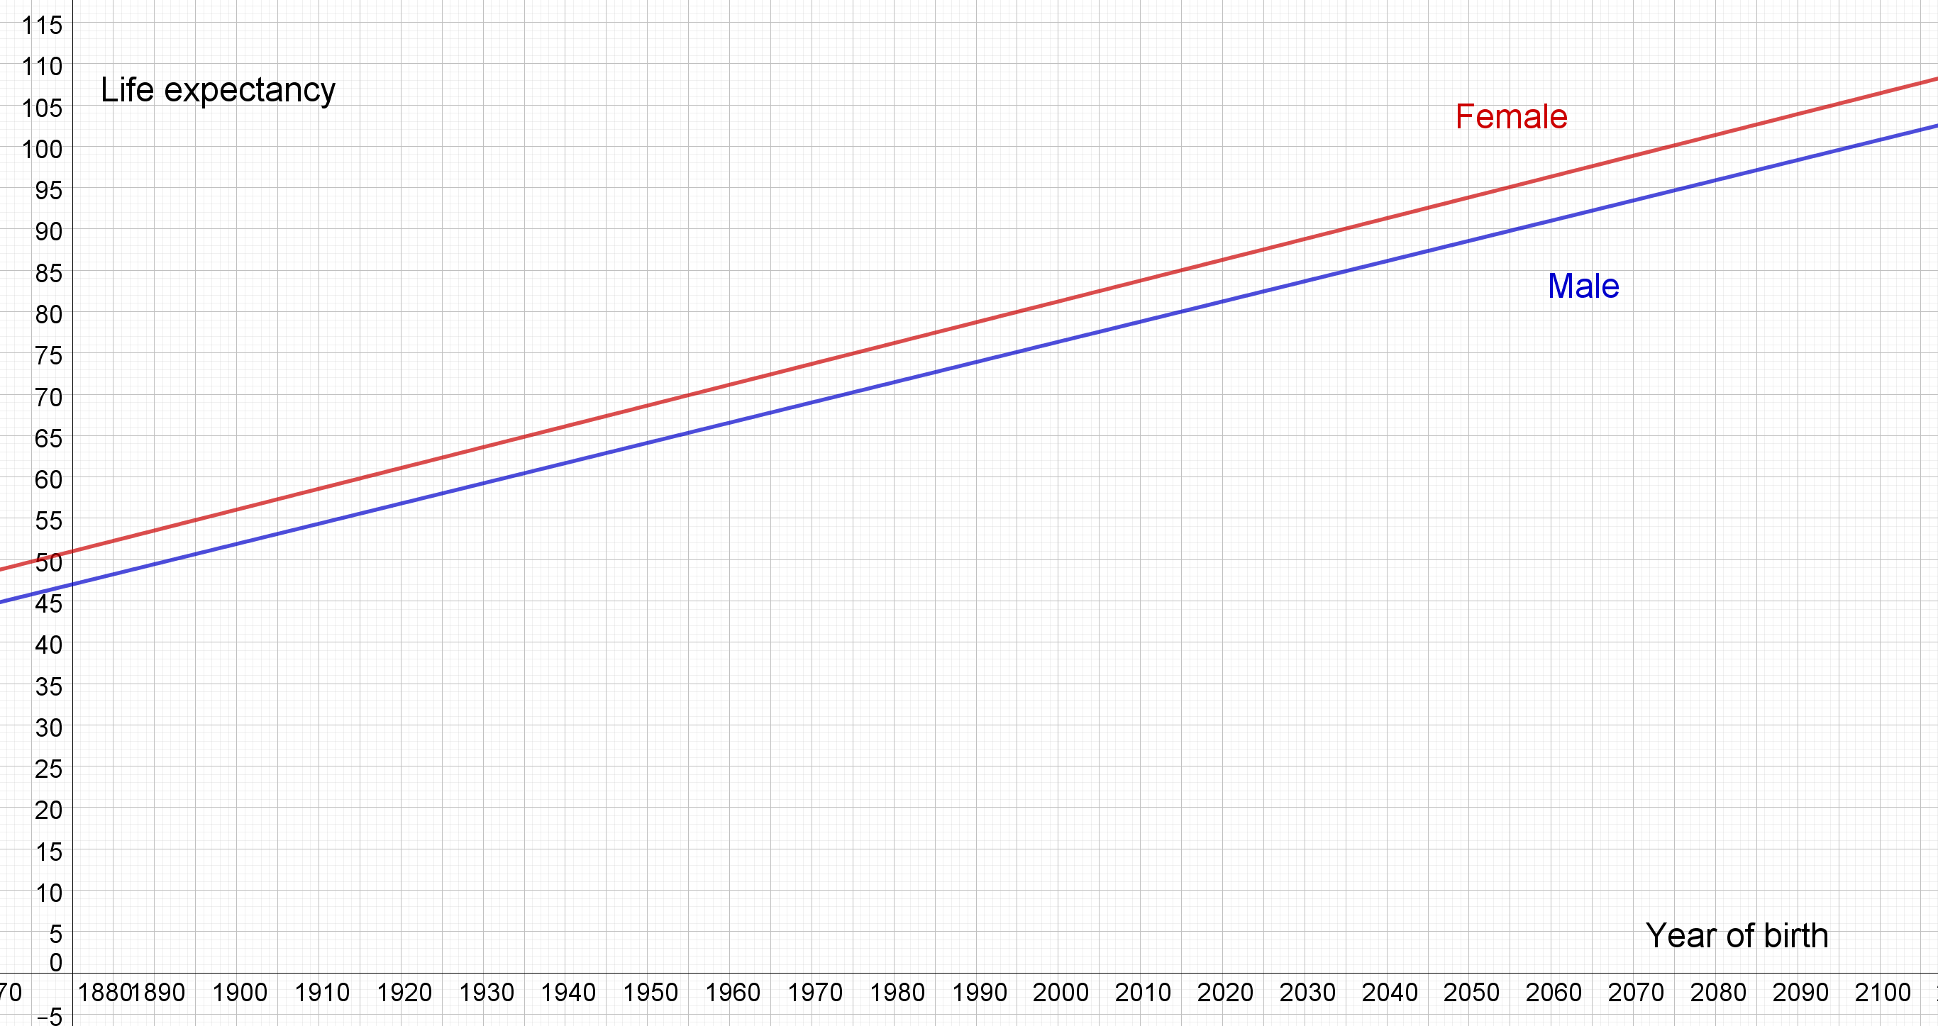
Source: Data approximated form the Australian institute of health and welfare.
- For the male model:
  - Find the gradient and interpret its meaning.
  - The y-intercept of the male model is approximately 1688. Interpret its meaning.
  - Find the equation (algebraic model) represented by the graph.
- For the female model:
  - Find the gradient and interpret its meaning.
  - The y-intercept of the male model is approximately 1678. Interpret its meaning.
  - Find the equation (algebraic model) represented by the graph.
- Predict the life expectancy (years) of the following people using both the graph and the algebraic model where possible
Sex and year of birth | Graph prediction | Algebraic model prediction
Male born 1500
Female born 1500
Male born 205
Female born 2050
- Identify limitations of the model. Hint: Consider your previous answers).

5. Celsius to degrees
In this activity students will examine the conversion of degrees Celsius to Fahrenheit including an approximate rule of thumb.
- The ‘rule of thumb’ for converting degrees Celsius to degrees Fahrenheit is “double and add 30”.
  - Use this rule to complete the table of values:
Celsius (C) | 0 | 10 | 20 | 30 | 40 | 50 | 60
Fahrenheit (F)

  - Use technology to graph the rule of thumb by plotting the points represented by the table of values.
  - Find the gradient of the line and hence the equation: $F=mC+c$
  - Graph the official equation used to convert degrees Celsius to degrees Fahrenheit.
$$F=\frac{9}{5}C+32$$
- Interpret the meaning of the y-intercept and gradient for each model.
- By making a range of conversions and by examining the graphs, answer the following questions:

Does the approximation method ‘Double and add 30°’ for converting from degrees Celsius to degrees Fahrenheit always give an answer close to the correct answer?

Note: Students can examine the limitations of the model to help answer this question.

