Year 11 Mathematics Standard

Assessment task
MS-M1 Applications of measurement

Driving question
Can I install enough solar panels to heat my pool?

Outcomes
- MS11-3 Solves problems involving quantity measurement, including accuracy and the choice of relevant units
- MS11-4 Performs calculations in relation to two-dimensional figures
- MS11-9 Uses technology to investigate, organise and interpret information in a range of contexts
- MS11-10 Justifies a response to a given problem using appropriate mathematical terminology and/or calculations.
All outcomes referred to in this unit come from Mathematics Standard Stage 6 Syllabus
© NSW Education Standards Authority (NESA) for and on behalf of the Crown in right of the State of New South Wales, 2017

Learning across the curriculum

Cross-curriculum priorities
  - Sustainability

General capabilities
  - Critical and creative thinking
  - Ethical understanding
  - Information and communication technology capability
  - Literacy
  - Numeracy
  - Personal and social capability

Other areas of learning
  - Work and enterprise

Task
Mathematics is an essential tool to analyse sustainability issues including predicted energy use and how we can reduce it using alternative energy sources such as solar cells. Through measurement and the reasoned use of data, we can predict and evaluate our impact on energy use, and develop a deeper appreciation of the use of Earth’s resources.
In this task, you will utilise your understanding of the various measurement applications, including your knowledge of surface area, volume and capacity, to design a swimming pool. You will also be required to research the efficiency of solar panels and calculate energy usage based on the size of panels and the output of energy.

Part 1
- When installing solar panels on the roof of a building, it is important that they face a specific direction and have a recommended tilt angle to maximise their energy output. Research the optimum aspect and tilt angle if a set of solar panels were installed in Sydney NSW. Write up to 5 sentences about your findings, making sure that you reference your source of information.
- Using Google Earth, locate the building that has the following coordinates 33 49’ 42.2”S, 151 05’ 04.3”E.
  - Measure the dimensions of the roof of the building, using the Ruler Tool correct to the nearest 0.5m.
  - Calculate the area of the roof you have just measured.
  - A single solar panel has the dimensions of 1.6m x 80cm. Calculate the area of one solar panel in m², and hence, how many panels could theoretically be placed on the roof?
  - In order to operate effectively, the solar panel installer has informed you that there must be a 5cm space between each row of panels, as shown below. Given this new information, draw a diagram of the layout of your panels, and determine how many full panels can actually fit on the roof.
  - List at least two reasons why your answer to part (c) and part (d) are not the same.
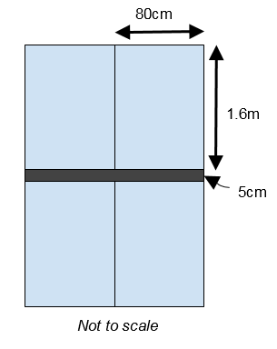
- The solar system installed in question 2 is a 0.72 Megawatt system.
  - Covert 0.72MW to kW.
  - Using the table below, predict how many kWh this system will produce each day for a building located in Sydney.
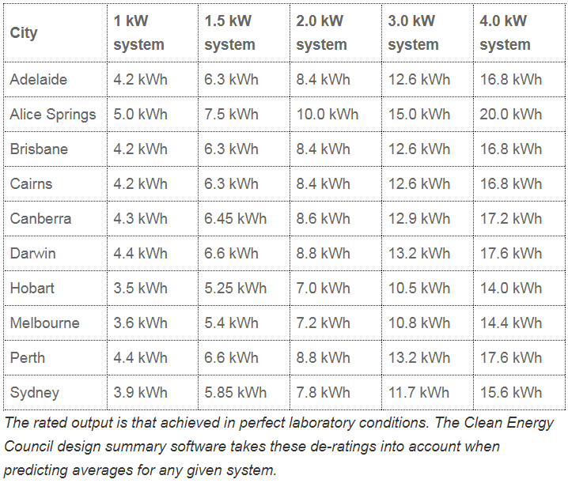
Average Daily Production table reproduced with permission from Clean Energy Council (http://www.solaraccreditation.com.au/consumers/purchasing-your-solar-pv-system/how-solar-pv-works.html)
- The building from question 2 and 3 uses three fifths of the energy produced by the solar panels and feeds the remaining energy back to the grid. An electricity provider is willing to buy back power at the rate of 6 cents/kWh. How much money, in dollars, will the building receive from the provider in the month of January?
- Johnson High School is about to install a pool. The shape of the pool is shown on the diagram below.
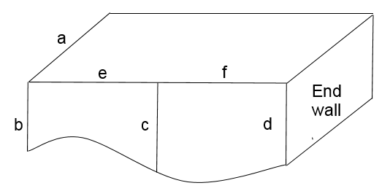
  - Select the dimensions of the pool for the following lengths (a, b, c, d, e, and f).
Your dimensions should reasonably reflect the measurements of real swimming pools.
  - Calculate the total surface area of the end walls.
  - Use the trapezoidal rule to calculate the surface area (with 2 applications) of the sides of the pool.
  - Calculate the cost of the four side walls if they are to be tiled at a cost of $50p/m2.
  - Calculate the capacity of the pool, when it is completely full, in kL, correct to one decimal place.
- Johnson High School is located in Cairns. It has been estimated that the pool will consume approximately 0.01 kWh/L each year. The school has already installed a 4kW solar system to supply the electricity demands of their new pool.
  - Using the table from question 3, will the solar system be able to supply enough energy to meet the requirements of the swimming pool? Justify your answer with suitable calculations.
  - Outline two advantages of using solar panels to supply some, or all, of the energy requirements of the pool.

Part 2
- Rich and famous magazine is holding a pool design competition. Design a pool of your choice to enter, and hopefully win, the competition. The requirements of the competition state your pool design must fit within a 6 metre by 10 metre flat block of land and contain between 55kL and 65kL of water.

- If you win the first prize, the Rich and Famous magazine will construct the pool on your property. You have two options for filling your pool with water.
Either you can
  - fill it directly from the water mains at a cost of $12 per kL of water
  - or have the water delivered in a tanker at a cost of $120 for delivery and $10 per kL of water
Choose the most appropriate method for filling the pool. Justify your answer with mathematical calculations.

Success criteria
Fluency, understanding and communication | Problem solving, reasoning and justification

Criteria | Working towards developing | Developing | Developed | Well developed | Highly developed
Part A
Question 1  MS11-9 | Student provides an answer.  An attempt is made to acknowledge sources. | Student provides clear, concise, accurate answer.  Sources are clearly acknowledged.
Question 2  MS11-4, MS11-9 | Students has shown some attempt to measure the dimensions and apply them to calculate the total number of panels needed. | Student attempts to measure both dimensions correctly, in metres, and with the correct accuracy of 0.5m.  Correctly calculates area, showing working out.  Correctly calculates area of 1 panel in m², showing working out.  Student attempts to calculate the total number of panels, showing working out. | Student measures both dimensions correctly, in metres, and with the correct accuracy of 0.5m.  Correctly calculates area, showing working out.  Correctly calculates the area of 1 panel in m², showing working out.  Correctly calculates the total number of panels, showing working out.
Questions 3 and 4  MS11-3, MS11-10 | Student converts MW to KW correctly | Student attempts to use the table to make an accurate prediction and use it to determine how much money is generated from the solar panels. | Student uses table to make a prediction with a reasonable level of accuracy.  Student determines how much money is generated from the solar panels.
Question 5  MS11-3, MS11-4, | Correct calculation of area of both ends with full working out. | Student attempts to use 2 applications of trapezoidal rule correctly and shows all working out.  Student attempts to calculate the total surface area of the 4 walls and the total cost of tiling, showing all working out.  Student attempts to calculate the capacity of the pool in kL, given to one decimal place. | Uses 2 applications of trapezoidal rule correctly and shows all working out.  Correctly calculates the total surface area of the 4 walls and the total cost of tiling, showing all working out.  Correctly calculates the capacity of the pool in kL, given to one decimal place.
Question 6  MS11-10 | Student attempts some calculations showing all working.  No attempt made to state advantages. | Student attempts all calculations showing all working.  Student attempts to state advantages. | Student carries out correctly all calculations showing all working with a relevant level of accuracy.  Student states the answer clearly using correct and clear language applying mathematical terminology.  Student states one accurate advantage which is stated in correct and clear language and using correct mathematical terminology and/or diagrams | Student carries out correctly all calculations showing all working with a relevant level of accuracy.  Student states the answer clearly using correct and clear language applying mathematical terminology.  Student gives two accurate advantages which are stated in correct and clear language and using correct mathematical terminology and/or diagrams
Part B
Question 1  MS11-3, MS11-10 | Student attempts to design a pool using regular shapes. | Student designs a pool using different regular shapes.  Student attempts to justify that the pool design meets the requirements of the competition. | Student designs a pool using different regular shapes.  Student clearly justifies that the pool design meets the requirements of the competition. | Student designs a pool using a wide range of different regular shapes.  Student clearly justifies that the pool design meets the requirements of the competition. | Student designs a pool incorporating a wide range of different regular and irregular shapes.  Student clearly justifies that the pool design meets the requirements of the competition.
Question 2  MS11-3, MS11-10 | Student makes some attempt to calculate the cost of one of the choices. | Student calculates the cost for one choice only and uses this to justify their decision. | Student provides an unconvincing argument to justify their choice for filling the pool, through either an inaccurate calculation for one of the choices or poor interpretation of the results.  Student attempts to calculate the cost for both choices. | Student clearly justifies the choice for filling the pool using clear and accurate mathematics related to their pool design.  Student determines and references the saving between the choices.
Notes
- Any non-attempt in a section will be deemed zero. Marks can only be attributed to attempted responses.
- Corresponding question numbers are shown in brackets.

Note to staff
The success criteria above has been designed for students and staff alike to use. Students should be presented the rubric as part of the assessment task package. Students and staff follow the process of the task downwards through the rubric and the depth of responses, for each element, across the rubric. Students should be encouraged to use the rubric to self-assess their progress as an assessment-as-learning strategy.
The aim of the assessment task is to develop students’ deep content knowledge. This is reflected in the descriptors, working towards developing through to highly developed. The level of skill and understanding required in each part of the task is different; some parts require highly developed or well-developed skills, other parts only capture a developing skill set.
None of the working mathematically elements are distinct and when demonstrating one element, you are invariably demonstrating another. As an example, communication runs concurrently through all the other working mathematically elements. Students cannot respond to this assessment without communicating in some form. However, it is envisaged that there is a general progression through the working mathematically elements, starting with fluency and leading to understanding, problem solving, reasoning and justification, with increasingly higher levels of communication accompanying each element. Careful consideration has been given to the position of the success criteria statements so they reflect the working mathematically elements demonstrated.
This assessment task has been designed to illuminate the style of questions and the types of responses needed to elicit deep content knowledge, however, staff are encouraged to use and adapt the assessment task and the success criteria to their school context. Staff may like to enhance or amend sections of the task. Staff may like to adapt the rubric to assign marks to the descriptors in order to differentiate between responses that address the same statement. All changes are the responsibility of the staff using the assessment.

