Paper scissors rock investigation
When playing paper scissors rock, who usually wins? What is your strategy when you play?

My Prediction:

Your Task:
- In pairs play a game of ‘Paper, Scissors, Rock’ 20 times and record the winner of each match in the tally boxes below

Tally

 | TALLY | TOTAL
Paper
Scissors
Rock

- Transfer the tally data into the graph worksheet.

Graph
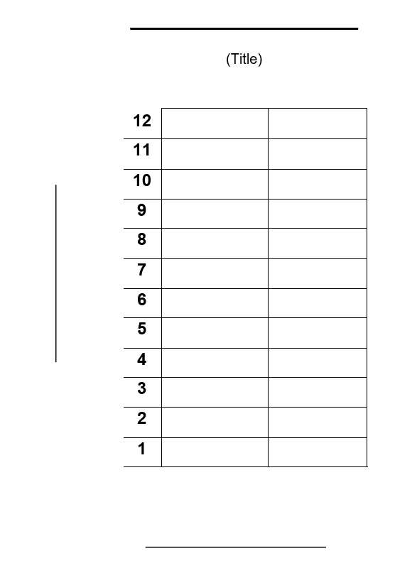

Results
- Compare your results with someone else. Are they the same? Why/Why not?
- Compare your results with the rest of the class. What was the average number of wins for paper, scissors and rock?
- Would you change your strategy? Why/Why not?

