M&M colour comparison

Step 1
Open your bag of M&M’s. DO NOT EAT THEM and DO NOT TIP THEM OUT. Select a random M&M and record its colour in the table below. Put it back in, shake it up and select another. Do this 25 times.

This will be our Experimental Probability.

Colour | Tally | Total
Red

Yellow

Orange

Blue

Green

Brown

Step 2
Calculate the experimental probability.

Colour | Experimental Probability | Convert to Decimal
Red | /25
Yellow | /25
Orange | /25
Blue | /25
Green | /25
Brown | /25
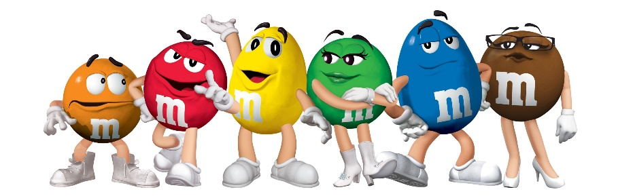
Step 3
What was the most likely colour to choose?

In a bag of 100 M&M’s how many of each colour would you expect?
Colour | Number | Colour | Number
Red |  | Blue
Yellow |  | Green
Orange |  | Brown
Step 4
Use your experimental probability to see how close you were.

Count how many M&M’s are in your bag: _________________ (this will be the bottom of your probability fraction)

Sort them by colour and count them.

Colour | Total | Probability (Fraction) | Probability (Decimal)
Red

Yellow

Orange

Blue

Green

Brown

Step 5
If each colour is equally likely to be made from the factory, what is the probability of choosing each colour at random?

Colour | Probability
Red

Yellow

Orange

Blue

Green

Brown

