Stage 6 Mathematics Life Skills

MLS – S1 Statistics

Overview
MLS-S1 Statistics | Unit Duration
A knowledge of statistics and probability helps students recognise and describe aspects of their world. With a working understanding of this topic, students develop their ability to predict and draw conclusions from what is happening around them.

Subtopic focus | Outcomes
In this subtopic students develop the skills related to all steps in the data process, gathering, organising, displaying, analysing and interpreting data. The knowledge, skills and understanding in this subtopic builds on Life Skills Years 7–10 outcomes and content for Statistics and Probability. | A student:  - explores mathematical concepts, reasoning and language to solve problems MALS6-1  - engages with mathematical symbols, diagrams, graphs and tables to represent information accurately MALS6-2  - uses data in a range of contexts MALS6-9  - engages with mathematical skills and techniques, including technology, to investigate, explain and organise information MALS6-13  - communicates mathematical ideas and relationships using a variety of strategies MALS6-14
Related Mathematics Standard outcomes | Related Numeracy CEC outcomes
MS11-1, MS11-2, MS11-7, MS11-9, MS11-10, MS1-12-1, MS1-12-2, MS1-12-7, MS1-12-9, MS1-12-10, MS2-12-1, MS2-12-2, MS2-12-7, MS2-12-9, MS2-12-10 | N6-1.1, N6-1.2, N6-1.3, N6-2.3, N6-3.1, N6-3.2
All outcomes referred to in this unit come from the Stage 6 Mathematics Life Skills Syllabus
© NSW Education Standards Authority (NESA) for and on behalf of the Crown in right of the State of New South Wales, 2017

Adjustments
Examples of adjustments can be found on the NESA website under Adjustments.
Student’s name | Adjustments
e.g. John Smith | Requires learning material to be printed on blue paper.

Unit of learning
Content  Students learn to: | Suggested teaching strategies and resources | Differentiation and modifications | Date and initial
S1.1: Gather data  Students:  - recognise information in a variety of tables and graphs  - recognise features of tables and graphs  - recognise examples of data observable in their everyday life | Interpreting graphs  - Students use a variety of resources (newspapers, magazines, Google images, online pages) to collect examples of graphs. Using these images students can:  - Group pictures according to graph types  - Classify graphs according to the product being surveyed  - Discuss the use of the graphs and who would use them  - Locate and name a range of features of their chosen graph (title, key, label, axis)  - Interpret information provided on the graphs (most/least popular, number of people surveyed)  - Redraw the information presented in the graph using a different type of graph  - Students watch a short video on Choosing the right graph  - Students could look through the many different graphs on the Data visualisation catalogue page, focussing on the more unusual styles of graphs

- identify the purpose of collecting a set of data, for example:  - identify why the owner of the local shop may want to know the most popular flavour of drink purchased  - pose a question that may be answered by a set of data | Collecting data  - Provide students with a variety of graphs without a title, key or labels. Get students to pose a question that may have been asked to receive the graphed results.
- identify a range of ways that data can be collected to answer a given question, for example:  - a verbal or written survey  - observations  - research on the internet  - use digital technology to conduct surveys, for example:  - online survey tools | Investigating methods for collecting data  - Students gather data using a range of surveying techniques.  - Verbal – students ask participants survey questions whilst recording their responses.  Resource: Collecting Data – Verbal. DOCX  - Written – students create a written survey to give to participants, collating results once completed.  Resource: Collecting Data – Written.DOCX  - Online – students create various surveys online via Survey Monkey, Google Forms or Microsoft Forms. Questioning could be based around common issues in society or within the school. This could be done after discussing the correct ways to ask survey style questions.  - Observation – students make observations on their survey topic, recording responses.  Resource: Collecting Data – Observation.DOCX
- select the best method to collect desired data  - design an appropriate data-collection tool for a given purpose | Designing surveys  - Students design a survey based on their interests. Examples include:  Yes/No answer survey  - Should I buy a new computer?  - Should I play football this year?  - Do you have a part time job?  - Do you read a newspaper?  Limited options survey  - Where should I go for tea tonight?  - What car should I purchase?  - Where do you work?  Open-ended survey  - What do I cook for tea tonight?  - What do I buy Mum for Christmas?  - What is your favourite TV show?
- explain the need to avoid bias when collecting data and suggest ways to do so | Avoiding bias data  - Students complete the Bias in data worksheet to look at how to avoid bias when collecting data.
- read a range of graphs and tables to gather information | Reading graphs  - Students practise interpreting picture graphs by looking at a Basketball Challenge  - Teacher to discuss data collected and displayed from the 2011 Australian Census  Reading tables  - Using a local bus or train timetable students discuss the following:  - How many trains/buses each hour?  - How many trains/buses per day?  - Is there a difference in the number of trains/buses running per day in different cities?
- investigate datasets related to a range of cross-curricular focus areas, for example:  - data on the environment  - data related to Australia’s neighbouring regions and cultures  - local, state and national census data from the Australian Bureau of Statistics | Investigating data  - Students play various Minute-to-win-it games to collect and analyse data.  Resource: Minute-to-win-it data analysis.DOCX  - As a class watch and discuss Does Hollywood ruin books? This could be used as a stimulus for students to undertake their own investigation.  - Students investigate dropping dummy firefighters out of mock buildings to determine the best size and location of net to catch them.  Resource: Is it safe to jump?
S1.2: Organise and display data  Students:  - record collected data using a variety of means, for example:  - tally marks  - concrete materials  - symbols  - digital technologies | Organising data  - Using a jar of jellybeans students create a “Guess how many jellybeans in the jar” competition.  - Students determine how much they will charge per guess as to cover the costs associated with running the competition and determine whether they would like to make a profit. (links with financial maths)  - Using the results from the competition, students calculate the mean, median, mode and range of the data.  - Students graph the results from the competition. This could include how many guesses were had each day, what time of day was the most popular, the number of guesses had by each person, etc.  - Students play The Jellybean Tree to organise data into a bar graph or pie chart
- order and sort numbers using terms, for example:  - ascending, descending  - ‘from 1 to 10 inclusive’  - order and sort data into groups, categories or ranges | Sorting data  - Students research prices of certain objects (electrical, food, clothing, rent, etc.). Students should then practise sorting their objects into different orders – alphabetical (name), weight, size, prices. Students will come back to this activity when they look at mean, median and mode.  Resource: Price Comparison.DOCX.  - Students complete the What's in a Name? Desmos activity where they sort data into dot plots.  - If working with a whole class, students could also complete:  - What’s my number?  - Strength in Numbers  - Human stopwatch
- construct frequency tables and make calculations related to these, for example:  - calculate total for the frequency column | Constructing frequency tables  - Students use the Frequency distribution calculator or Frequency table calculator to construct a frequency table using a given data set.  - Students participate in a footy tipping competition (AFL or NRL). After each round, students collate the results and determine the winning margin, range and average scores.  Resource: NRL footy tipping 2020.DOCX
- identify common features of graphs, including heading, scale, key, axes and labels, and locate these on graphs  - assess the accuracy and fairness of a graph, for example:  - check if it has all necessary key features  - check if it is free of bias or misleading information | Exploring the features of graphs  - As a class, watch How to spot a misleading graph or Identifying misleading graphs. Students could make a summary of the ways graphs can be misleading.  - Students collect graphs from newspapers etc and analyse headings, axes, scales etc for any incorrect or misleading features.  - Teacher to discuss Bruce gain and identify issues with the accuracy of the graph and identify misleading features
- choose the most appropriate display for a dataset, for example:  - picture graphs  - column graphs  - line graphs | Choosing appropriate data displays  - Using past national lottery results, students collate past lotto results. Using these result students can:  - identify the most and least common numbers  - choose the most appropriate graph to display the dataset  - select 6 numbers and calculate their results/winnings over a given time. Determining their winnings vs their cost to enter  - Students research and/or investigate the relationship between two measures and determine a suitable graph to display their results. For example:  - height versus weight,  - goals kicked versus Brownlow medal votes,  - position played versus best and fairest votes,  - income versus qualification.
- construct a line, picture or column graph  - construct a line, picture or column graph with increasing accuracy, for example:  - use correct graphing techniques, eg equal (measured) spacing, ruling of lines  - include all relevant, commonly accepted features of graphs  - plot points or measure columns accurately as required  - use graph paper to assist with creating graphs  - use digital technologies to create a range of graphs | Constructing graphs  - Students are given a packet of M&M’s to compare the colours in each pack and find averages and graph their data.  Resource: M&M Colour Comparison.DOCX  - Teacher to read A statistician got curious about M&M’s. as a class and discussion findings compared to the class findings in the previous activity.  - Students calculate the average weight of a given object (mini mars bars, apples, packet of chips, grape, etc.)  Resource: Average Weight.DOCX  - Students analyse the data on their own devices to determine how much time they spend using their phones and in which apps they spend the most time. An alternative could be for teachers to show screen shots from their own device or use the example provided on the stimulus. Topics for discussion include:  - Daily average  - Percentage up or down each week  - Weekly total screen time  - Total time spent each week Social networking/Productivity/Other  - Total time spent on different apps and/or devices  Resources:  - Screentime.PPTX  - Screentime on apple device  - Screentime on android device  - Using internet resources such as historical pump prices in Australia, students record fuel prices over a given time, graphing results using a line graph. Students could compare states, city vs country, or fuel type over the given time.  - Students are to survey teachers on what was their first job. Using head shots of teachers, students constructs a graph displaying this information in an area of the school that all students can see.
S1.3: Analyse and interpret data  Students:  - ask and answer questions about a set of data in general terms, for example:  - pose or answer questions based on the information displayed in a graph or table  - interpret graphs, tables and datasets from a variety of common sources, for example:  - newspapers  - television  - internet | Interpreting data  - Students complete the activities below where they interpret information given in different types of graphs.  - bar charts  - Pictograph game  - Interpret dot plots  - Students design a suitable title and axis labels for a mystery graph  Resource: Mystery data worksheet
- recognise that the terms ‘mean’ and ‘average’ describe the same concept in everyday use | Introducing the mean  - Teacher to introduce the terms mean and average by watching and discussing the Mean and Average song and 2.3 children advertisement. videos  Calculating Mean  - Students to roll a die 10 times and calculate the mean.  - Select 10 cards from a deck of cards, add them up (picture card equals 10) and calculate the mean.  - Measure the height of all members of the class and calculate the mean height.  - Count the letters in your first name and that of 10 family members and calculate the mean number of letters per name.
- calculate the range for a simple dataset and discuss its meaning  - calculate mean, median and mode for a simple dataset and discuss each concept | Introducing mean, median, mode and range  - As a class watch Mode, median, mean and range rap or The mean, median or mode toads and then discuss the differences between each  - Students play It's glow time to practise calculating the mean, median, mode and range  - Students draw cards from a pack and practise finding the mean, median, mode and range. Students could compete in small groups earning points for having the highest of each  Resources:  - Super Fun Mean, Median, Mode and Range activity(video)  - Written instructions and printable worksheets: Mashup Math  - Students return to their price comparison activity where they researched the prices of certain objects. They can now determine the mean, median, mode and range for their objects.  Resource: Price Comparison.DOCX.
- use statistical calculations to investigate data in work or other everyday situations, for example:  - calculate the mean pay for the workers at a business  - find the most popular day to go to the cinema (mode)  - calculate the age range in a family group | Investigating data in real life  - Students use realestate.com.au to research house prices in their area. They should keep variables the same eg 3 BR, 2 bathrooms. They can then find the mean and median prices.  Extension: Teacher could lead a discussion as to why the median price is most often quoted.  - Students can google local businesses and look at the busiest days and times  Resource: most popular time of the day.DOCX
- compare means and medians in a range of contexts, for example:  - compare and discuss why the mean house price in a suburb might be much higher than the median house price if there is an unusually expensive sale  - compare mean (or median) incomes for females and males | Comparing mean and median  - Students are given an NBA “team”, composed of a random sample of 15 NBA players. They graph the spread of salaries in their team and calculate the mean and median salaries. Students are provided with NBA teams’ salary data. They graph the spread of salaries in a single team and calculate the mean and median salaries. Students discuss how real NBA team data differs from their randomly sampled teams.  Resources: Sports Salaries  - Students may like to investigate AFL vs AFLW, or male vs female tennis players to determine the differences in mean and median crowd numbers and salaries. Discussion questions could include, whether crowd numbers and salaries are lower for all women’s vs men’s sports
- interpret information about a dataset and use it to draw conclusions, for example:  - given the average age of the workers at an organisation, discuss what this means and how it might affect the organisation | Drawing conclusions  - Using ABC splash students explore the way in which statistics are presented using a wide range of graph types for ten topics related to human rights. Students can customise and publish graphs and download data to a spreadsheet program such as Excel to enable further exploration.
- recognise and describe trends in data, for example:  - recognise that the average income in a profession is increasing over a number of years | Investigating data trends  - Students read and explains costs, data and graphical information on a bill or invoice from a utility organisation (phone, gas, electricity or water bill).  Resource: Household bill analysis.DOCX  - Students use Google trends to search for an item for interest eg Playstation 6 and look at the trends in that search term over a period of time. Questions to consider:  - Reasons for peaks and troughs  - Overall, are searches growing or declining?  - Is the pattern the same in other countries?
- use information to extrapolate or make predictions from data, for example:  - predict what will happen to the population of a certain native Australian species if current trends continue | Making predictions  - Students can use the place explorer website to look at trends in items such as life expectancy, population, fertility rates etc. Students can look at trends and make predictions as to what these numbers will look like in 2030, 2040, 2050 etc  - Students review the 100 most popular boys’ and girls’ baby names for 2017, using spreadsheets to analyse these names, and compare their findings to the names of students in the class or school.  Resource: What’s in a name?
- complete pre-constructed data tables either on paper or digitally, for example:  - a spreadsheet  - present findings of a statistical investigation using a range of formats and technologies | - Students should use a spreadsheet or CreateAGraph or Chartgizmo to create a variety of charts from data sourced online (Australian Bureau of Statistics) or collected from and/or by the students.  Resource: Graphing in excel.DOCX

Evaluation

Glossary
Term | Description
average | An average is a number expressing a central or typical value in a set of data. While it usually refers to the arithmetic mean, that is the sum of a set of numbers divided by the number of numbers in the set, it may also refer to other measures of central tendency, such as the mode or median.
bar graph | See column graph
bias | A systematic (built-in) error which makes all values wrong by a certain amount.
column graph | A column graph is a graph used in statistics for organising and displaying categorical data.  To construct a column graph, equal width rectangular bars are constructed for each category with height equal to the observed frequency of the category as shown in the example below, which displays the hair colours of 27 students.  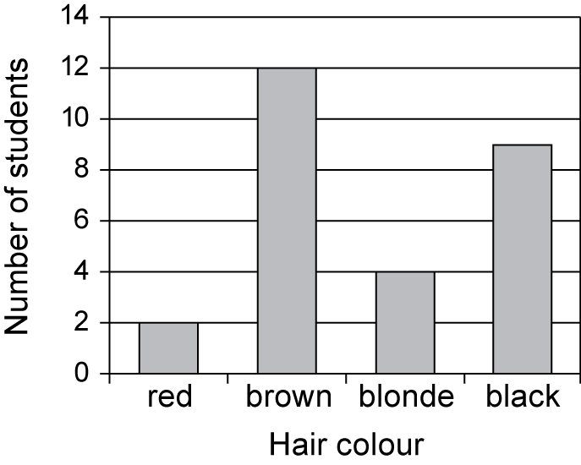  Column graphs are frequently called bar graphs or bar charts. In a bar graph or chart, the bars can be either vertical or horizontal.
data | Data is a general term for a set of observations and measurements collected during any type of systematic investigation.  Primary data is data collected by the user. Secondary data is data collected by others. Sources of secondary data include web-based data sets, the media, books, scientific papers, etc.
data display | A data display is a visual format for organising and summarising data.  Examples include column graphs, bar graphs and frequency tables.
data set data display | A collection of facts, such as numbers, words, measurements, observations or even just descriptions of things.
frequency table | A frequency table lists the frequency (number of occurrences) of observations in different ranges, called ‘class intervals’.
line graph | A line graph (also known as a line plot or line chart) is a graph which uses lines to connect individual data points that display quantitative values over a specified time interval. Line graphs use data point "markers" that are connected by straight lines to aid in visualization
mean | The arithmetic mean of a list of numbers is the sum of the data values divided by the number of numbers in the list.  In everyday language, the arithmetic mean is commonly called the ‘average’.
median | The median is the value in a set of ordered data that divides the data into two parts. It is frequently called the 'middle value'.  Where the number of observations is odd, the median is the middle value.  Where the number of observations is even, the median is calculated as the mean of the two central values.
misleading | Giving the wrong idea or impression.
mode | The mode is the most frequently occurring value in a set of data. There can be more than one mode. When there are two modes, the data set is said to be bi-modal.  The mode is sometimes used as a measure of location.
picture graph | A picture graph uses symbols and pictures to represent data.
side-by-side column graph | A side-by-side column graph can be used to organise and display the data that arises when a group of individuals or things is categorised according to two or more criteria.  For example, the side-by-side column graph below displays the data obtained when 27 children are categorised according to hair type (straight or curly) and hair colour (red, brown, blonde, black). The legend indicates that dark grey columns represent children with straight hair and light grey columns children with curly hair.  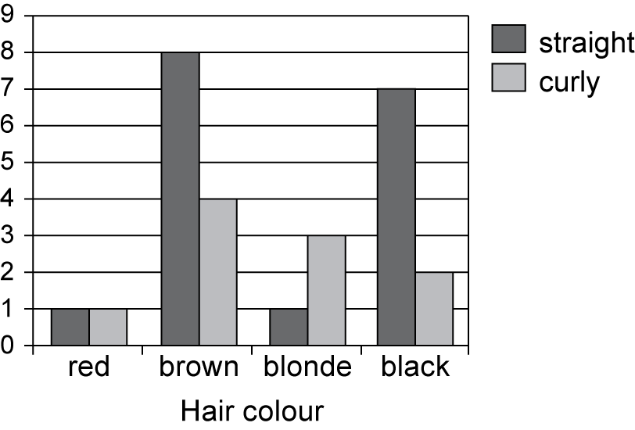  Side-by-side column graphs are frequently called side-by-side bar graphs or bar charts. In a bar graph or chart, the bars can be either vertical or horizontal.
two-way table | A two-way table is commonly used for displaying the two-way frequency distribution that arises when a group of individuals or things is categorised according to two criteria.  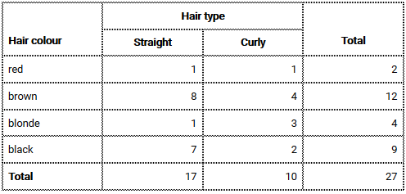  The information in a two-way table can also be displayed graphically using a side-by-side column graph.
venn diagram | A Venn diagram is a graphical representation of the extent to which two or more events, for example A and B, are mutually inclusive (overlap) or mutually exclusive (do not overlap).  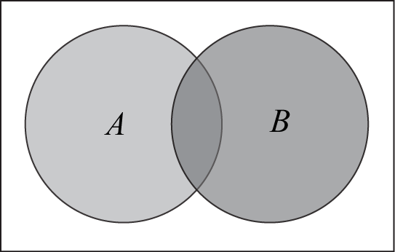

Supplementary resources

Cross curriculum project ideas

