Most popular time of the day
- Students using Google to search for a local business eg ‘harvey norman deniliquin’
- Amongst the search results, a panel will appear down the right side of the screen
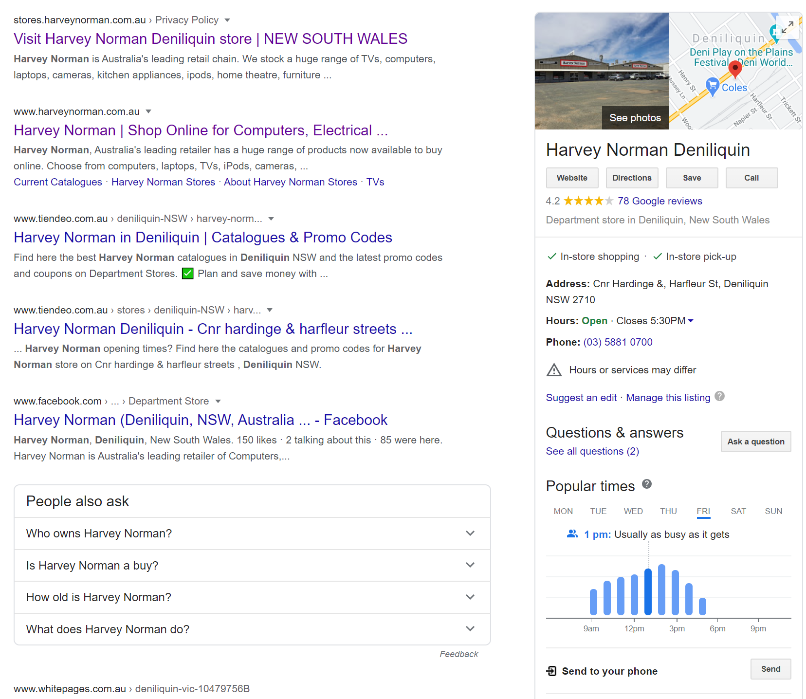

- Students can manipulate the graph to look at the most popular days and times.
- Questions to consider could be:
  - Is the store busy on a similar time each day?
  - Can you determine a reason why they might be busy on this day or time?
  - Research similar businesses, are there busiest times similar to your first business?

