Collecting Data – Observation
Flip a coin 30 times. Record your results.

Coin | Tally | Total
Heads

Tails

Roll a die 30 times. Tally the results

Dice | Tally | Total
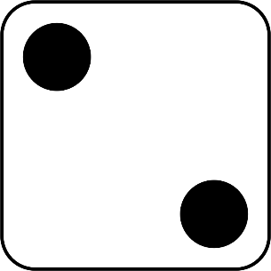
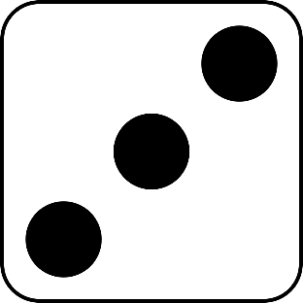
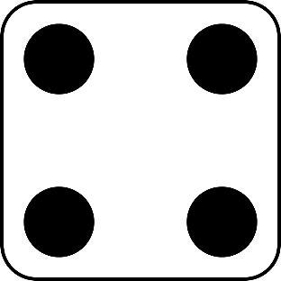

Survey the traffic which passes your school, for 20 minutes.

Vehicle | Tally | Total
Car

Truck

Bicycle

Bus

Walker

Other

Survey topic: Food purchased from the canteen.

Food | Tally | Total
Sausage Roll

Pie

Pizza

Toasted sandwich

Sandwich

Pasta

Other

Survey topic: Colour of cars which drive past the school.

Colour | Tally | Total
Red

White

Silver

Black

Blue

Grey

Other

Write your survey topic here:_________________________________________________

 | Tally | Total

