Planning a garbage collection route
This activity allows students to examine and consider the problem of planning a garbage collection route without retracing our steps.
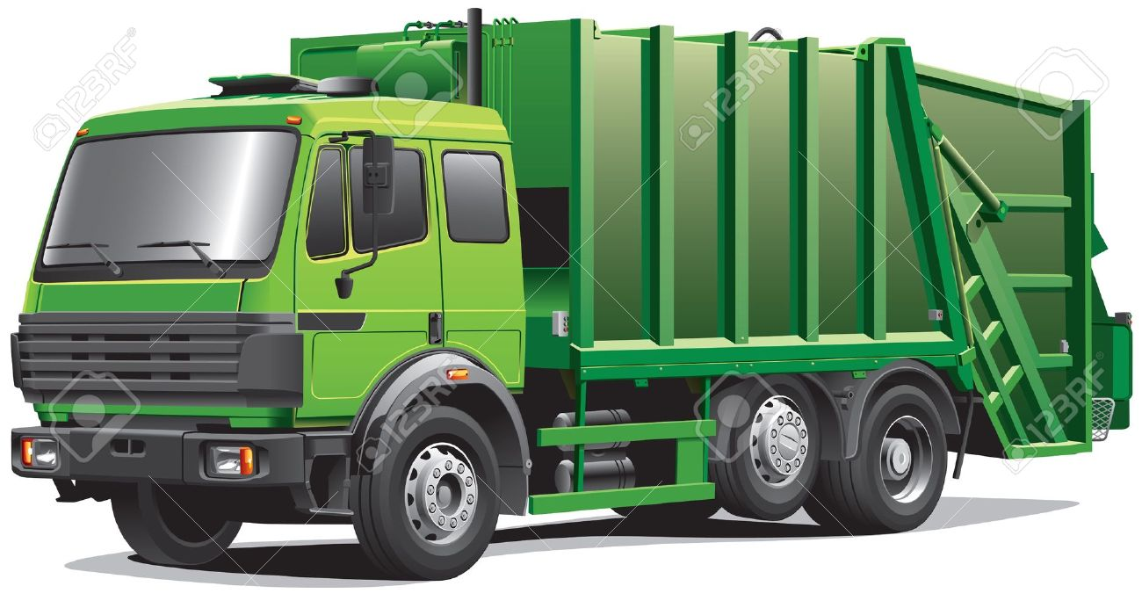

Activity
The map below shows a series of streets in Bateau Bay, NSW. On the next page, this is recreated as a network diagram.
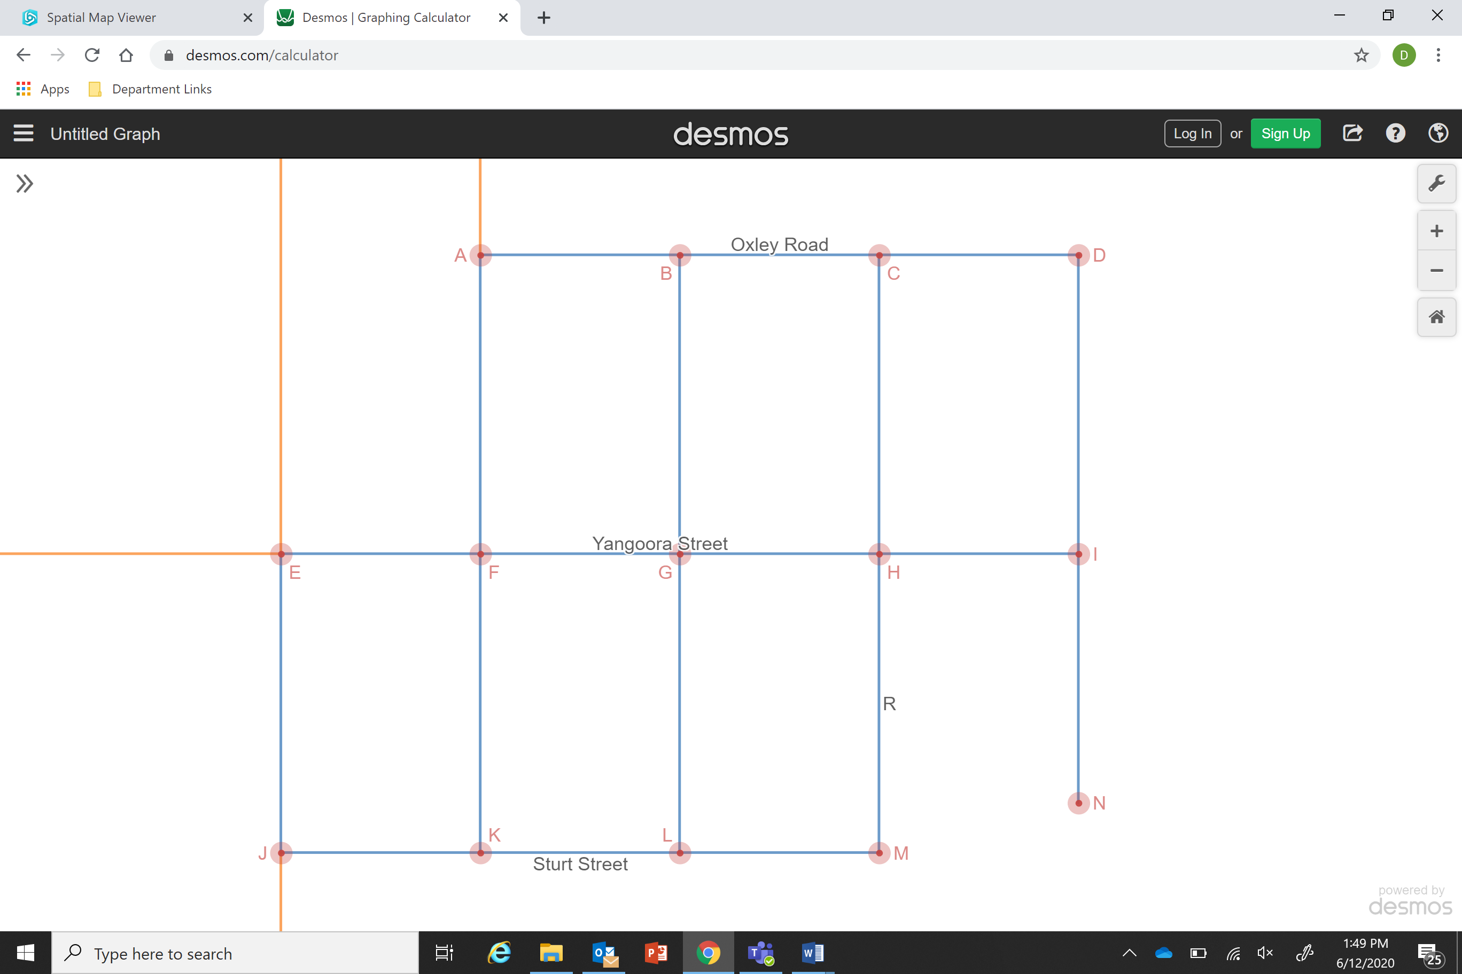
- How many edges are there in this diagram? What do the edges represent?

- How many vertices are there in this diagram? What do the vertices represent?

- What does the edge marked with an ‘R’ represent?

- Sturt Street goes from J-K-L-M. How would you describe Oxley Road?

- The garbage truck needs to collect the bins from all of the houses. If the garbage truck begins at point N, can you draw a path for the garbage truck so that it drives through every blue edge in the network diagram?
Describe this path using the letter notation from question 4.

- Compare your path with a classmate’s, or another path you can choose. Discuss which path is better and why.

Challenge
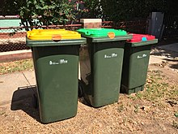
When a garbage truck collects bins, it needs to drive both directions up and down a street to collect the bins from both sides. In the network diagram below, the arrows show the truck travelling from point D to point N, and then back to point D.
Map out a path so the truck will travel so that:
- The truck travels every street at least twice, once in each direction
- The truck travels as few streets 3 times as possible.

