Following your school map

Method
Each student requires a copy of the school map.
- Locate your current position and use a highlighter to mark this spot.
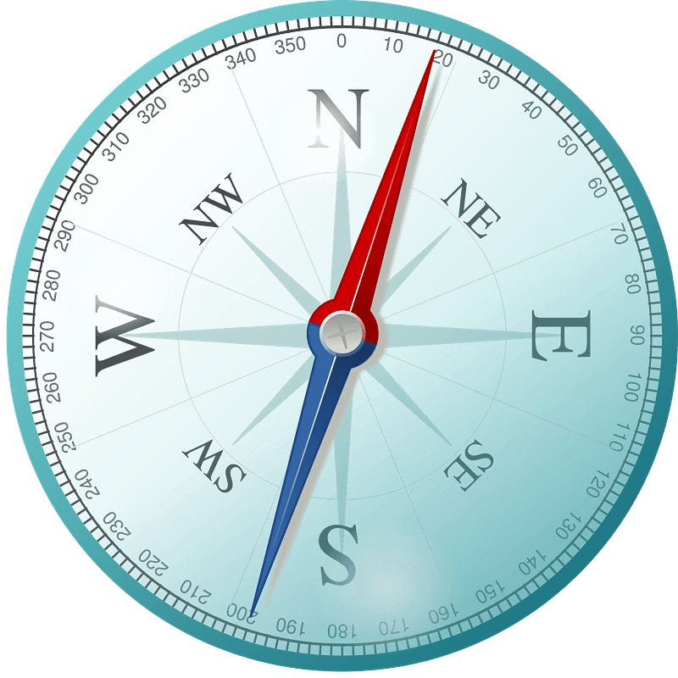
For tasks 2 – 5, you will need to use directions North, South, East and West.
If the direction is diagonal, you can use North-East, North-West, South-East or South-West.
- Mark the location of the school entrance (gates). What direction do you need to walk to get to the school entrance?

- Mark the location of the toilets. What direction do you need to walk to get to the toilets?

- Mark the location of the canteen. What direction do you need to walk to get to the canteen?

- Mark the location of the school library. What direction do you need to walk to get to the library?

Extension activities
- Using the map of your school, find all of the locations of first aid kits around the school.
- Select 5 rooms around the school that you are familiar with. Where is the closest first aid kit if you needed to find one in an emergency?

