Constructing a Model House
This activity tasks students with interpreting and investigating a floorplan for a house and constructing a model of a house using elevation plans.

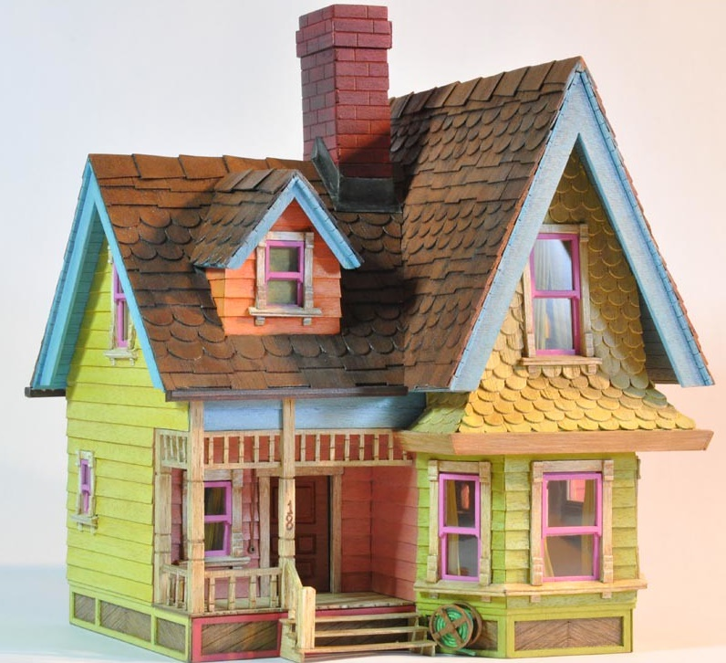

Situation
The floorplan below shows a four bedroom house.

Symbols
1. Match each of the following symbols with their meaning:

Window Sink Shower Stove Wardrobe Door Toilet

2. Highlight the front door on the original diagram.

Materials
Popsicle sticks
Glue
Cardboard for the base
Ruler

Method
Students can construct a three dimensional model of the floorplan above or another of their choosing. The teacher can introduce scale to the class depending on the experience and ability level of the students.
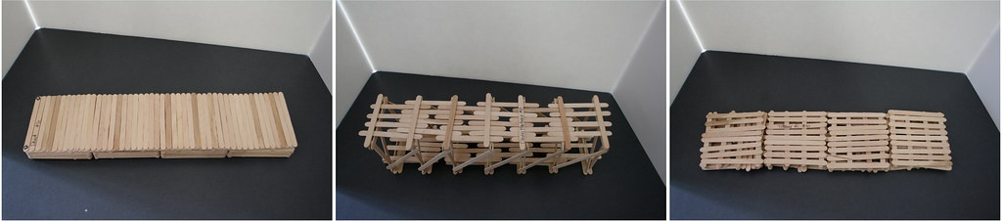

Application
- In the diagram, all four bedrooms are the same size. The two bathrooms are also the same size as one another. Are these features still the same size in your model? Is there anything else in your model that does not match the diagram? This would be an opportunity for peer review and feedback.
- If you used a scale, can you describe the scale that you used and how you applied it?

