A tour of Sydney
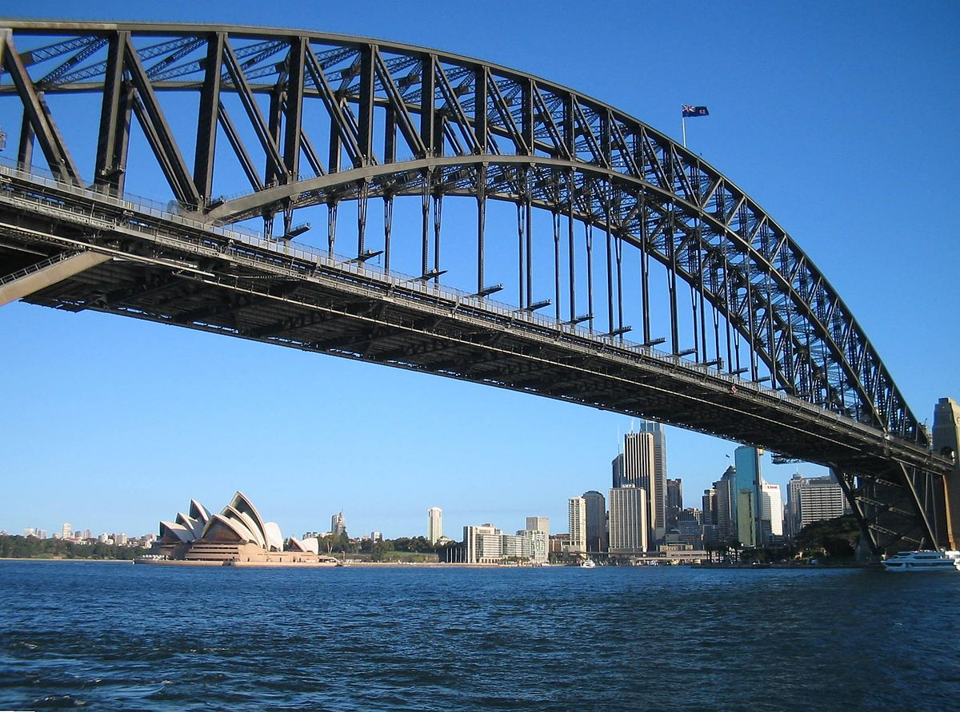
This activity allows students to investigate and plan a tour of the landmarks around Sydney, NSW.

Method
In this task teachers will find a map of key locations in Sydney, a map with these locations found using the NSW Government Spatial Map Viewer, and network diagrams with and without distances between locations.
Students can be challenged to investigate:
- The landmarks that interest them most
- The distances between locations, marking them on the network
- A path for a day that would get them to all (or many) landmarks without retracing their steps.

Resources
- The map below includes a key, and could be used with students to detail how they would get around Sydney through key landmarks they wish to visit.
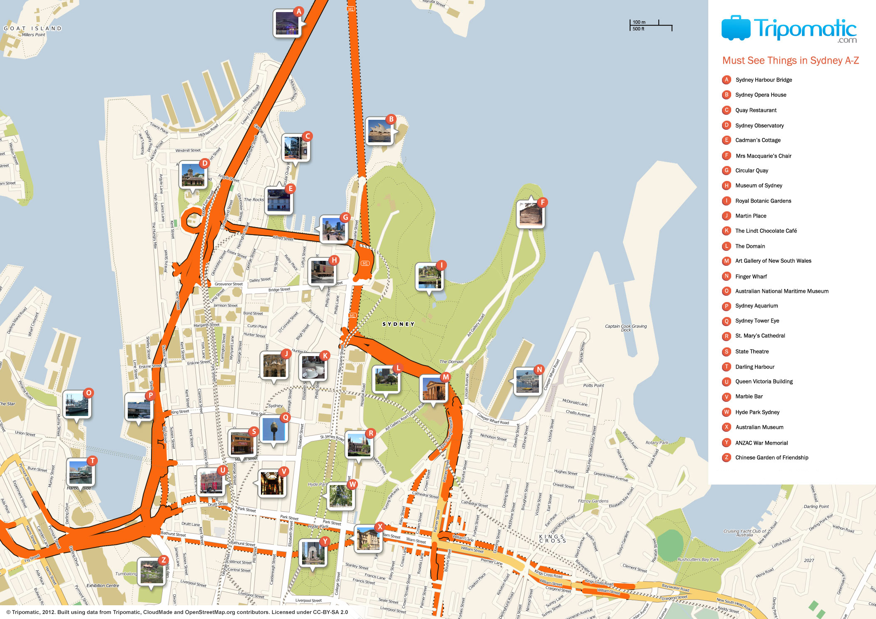

- The map below comes from the NSW Government Spatial Map Viewer. Students can create a similar map and use it to calculate distances between locations.

- The image below turns the previous two maps into a network diagram. The current image has no measurements on the edges to allow the teacher to decide to what level of accuracy they want the resource to be.
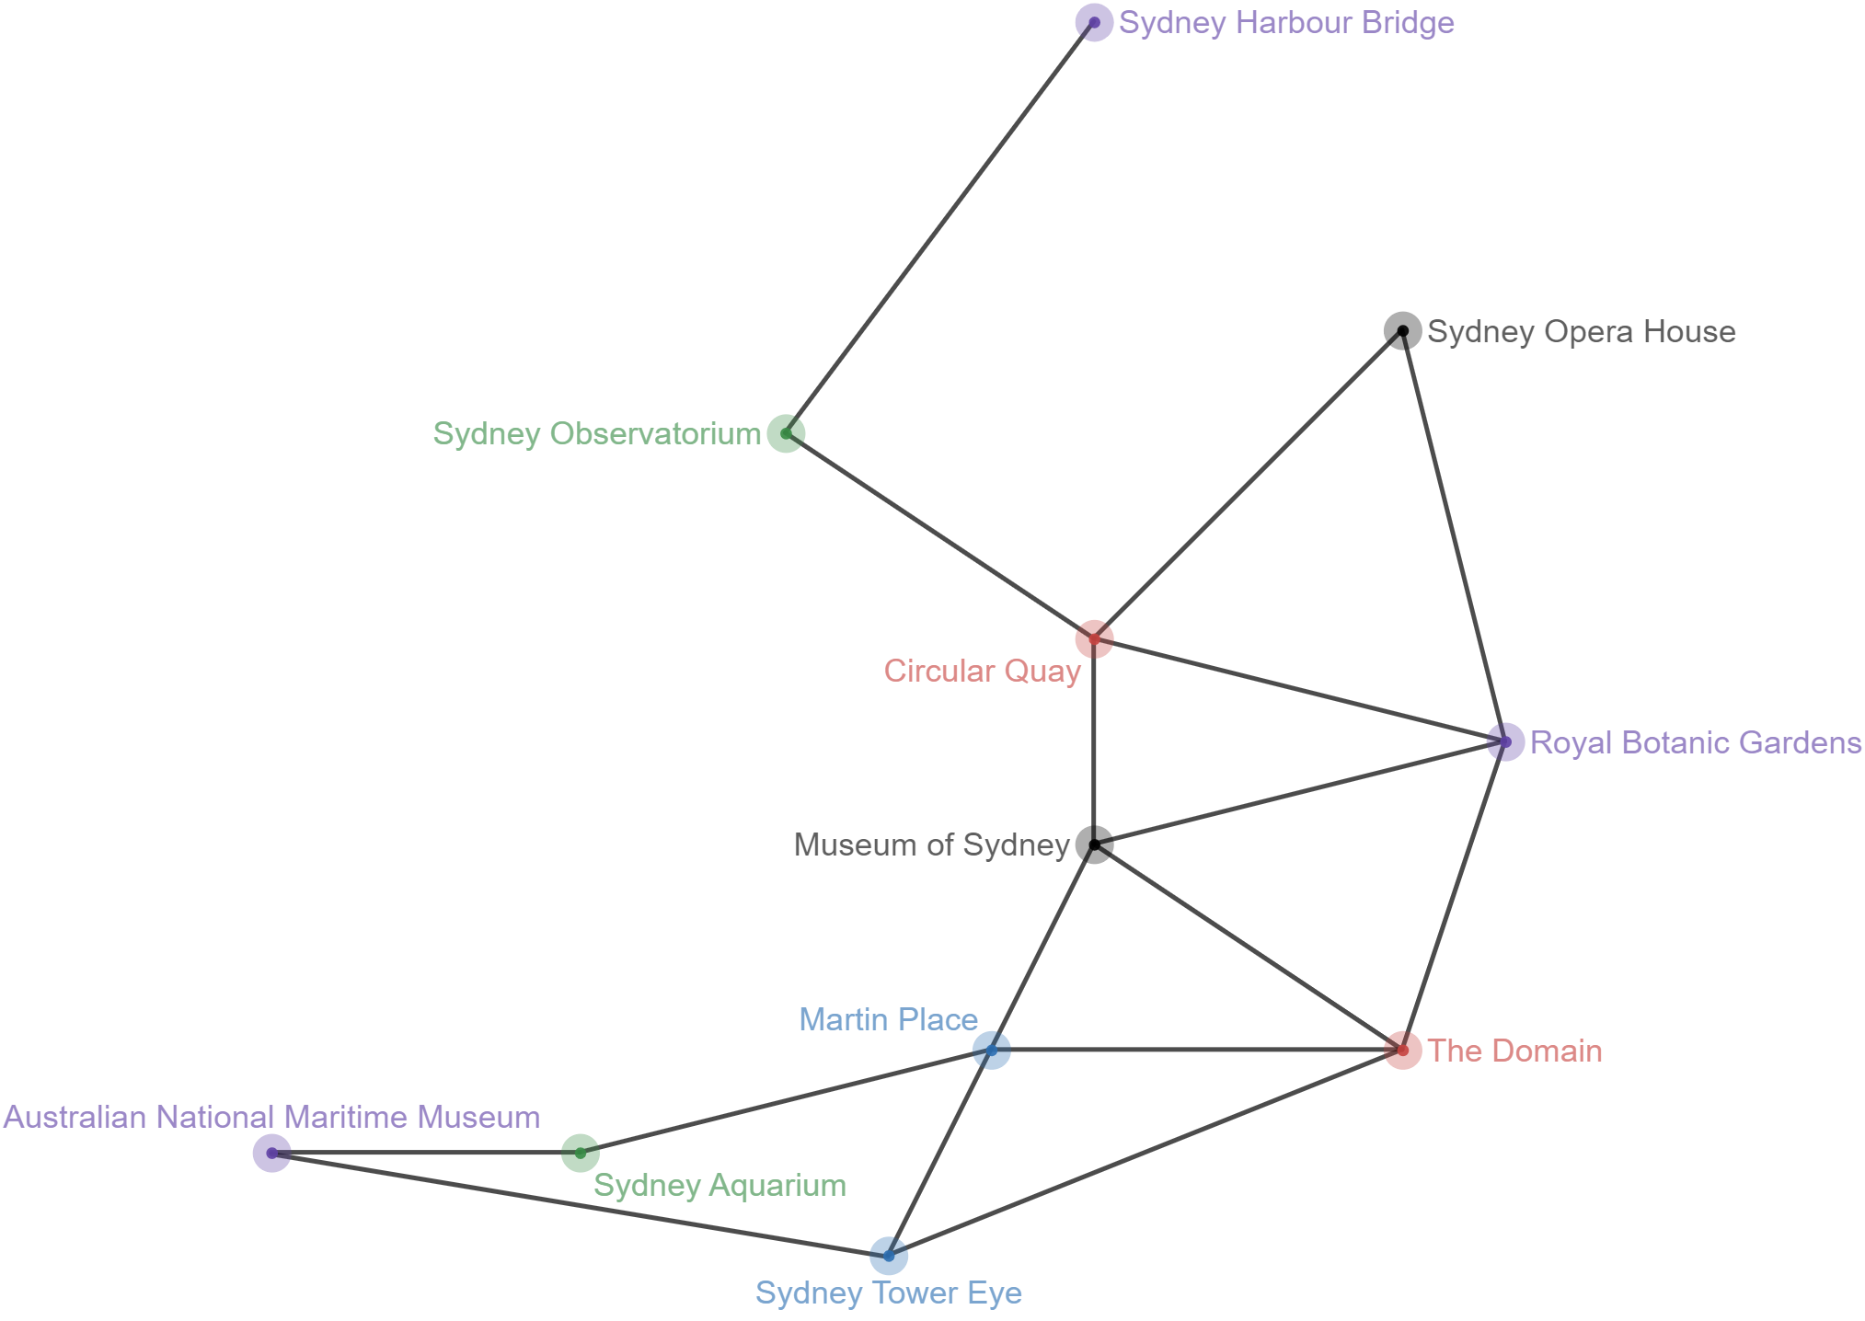

- The image below contains all of the distances between key landmarks, obtained from the NSW Government Spatial Map Viewer.
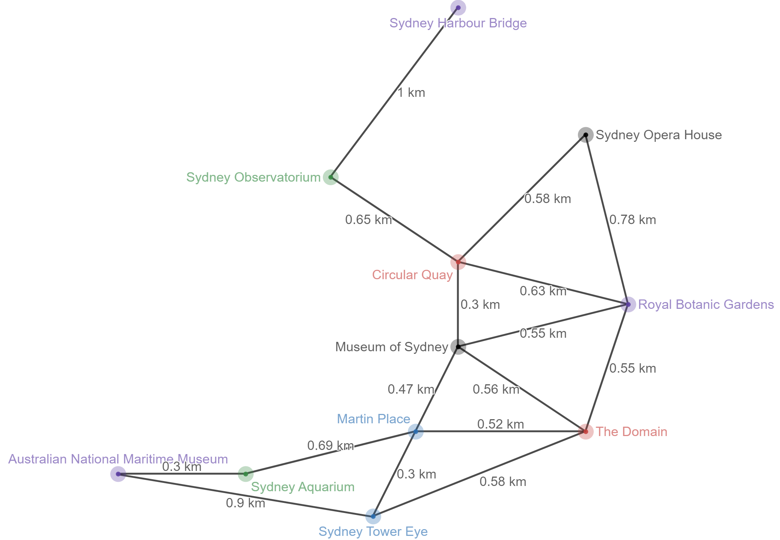

Problems
Students should be challenged to consider the meaning of the network diagram and explore via the following questions:
- Looking at the map and the network diagram, why is there no route between Sydney Harbour Bridge and Sydney Opera House?
- What is the shortest distance from Sydney Tower Eye to Circular Quay?
- If I want to visit all of these landmarks, what is the shortest path I can take around Sydney?

