Can you see a pattern?

Patterns in nature

Zebra
Look at the image below.
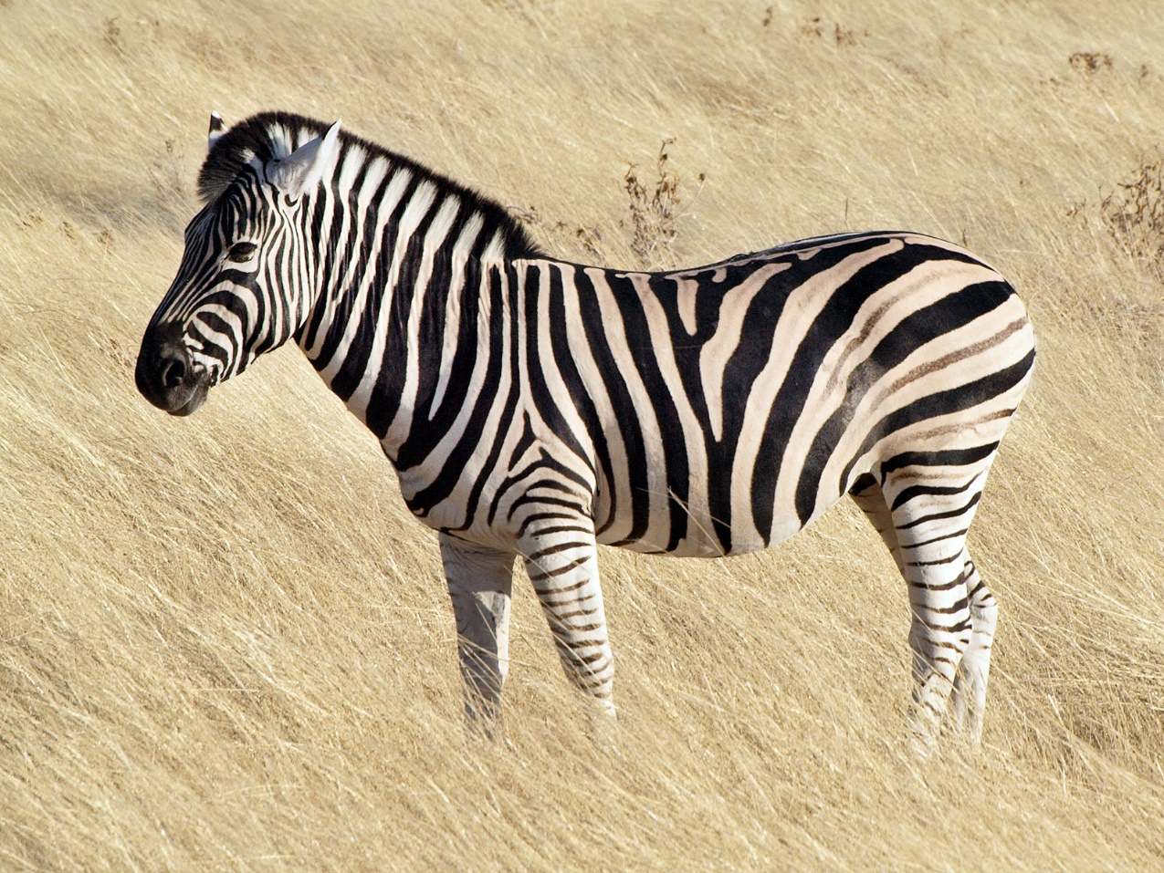
Source: https://commons.wikimedia.org/wiki/File:Common_zebra_1.jpg

Describe what is being repeated on this animal?
________________________________________________________________________

Did you know?
Every zebra has a different coat of stripes. They may look the same and their stripes may follow the same pattern, however no two zebras are exactly alike.
(Source: National Geographic – Plains Zebra)

Beehive
Look at the image below.
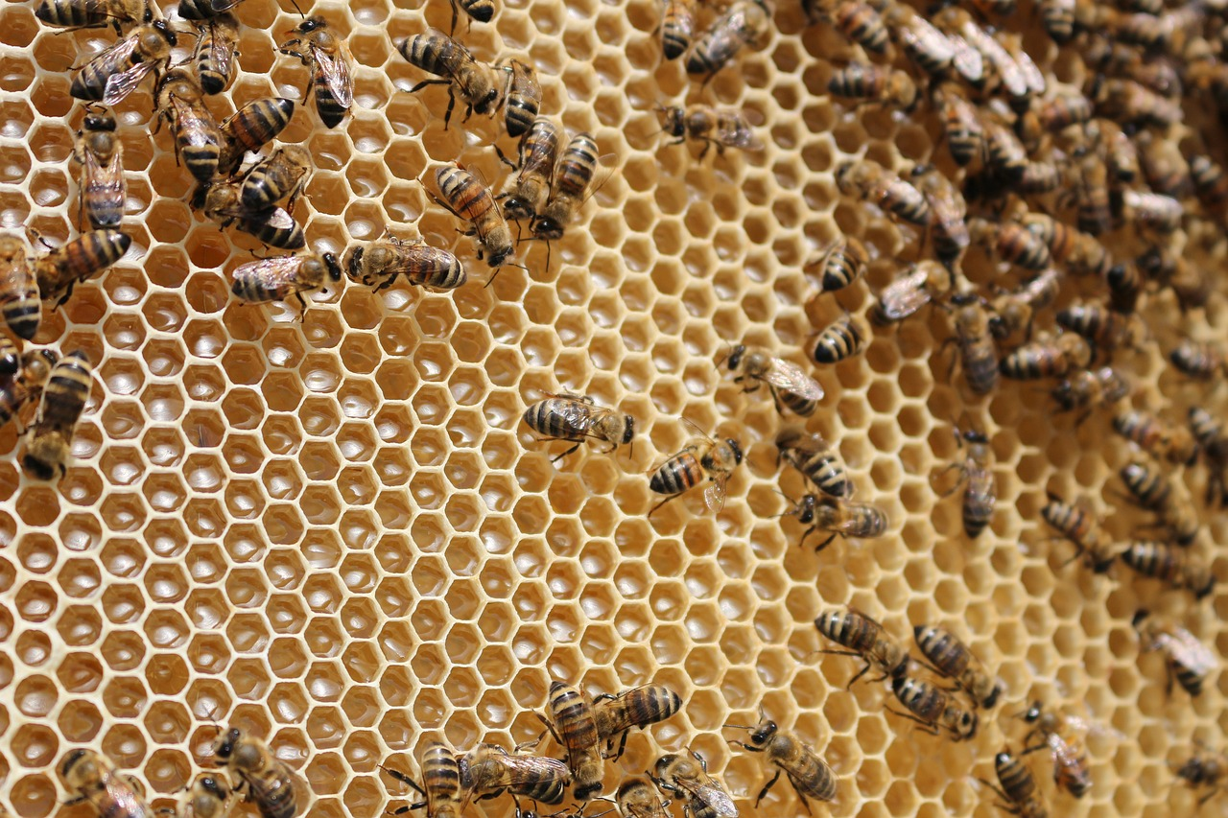
Source: https://www.needpix.com/photo/832748/beehive-bees-insects-collects-nectar

What shape can you see that has been repeated in the beehive?
________________________________________________________________________

Did you know?
A beehive can have a population of up to 80,000 honeybees.
(Source: National Geographic – Honey Bee)

Patterns in the home

Quilts
Look at the image below.
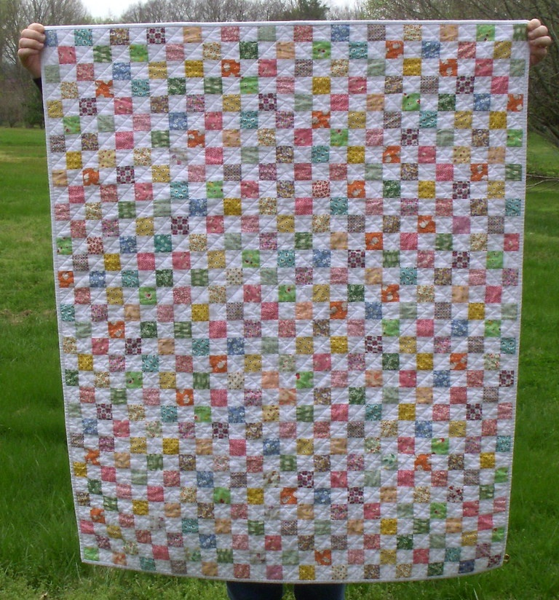
Source: https://www.flickr.com/photos/58593446@N07/5571072936/

Is there an easy way to work out how many little squares make up this quilt without having to count each square individually?
________________________________________________________________________

Did you know?
The world’s largest quilt measures 25100 square metres!
(Source: Guinness World Records – Largest patchwork quilt)

Board games
Look at the image below.
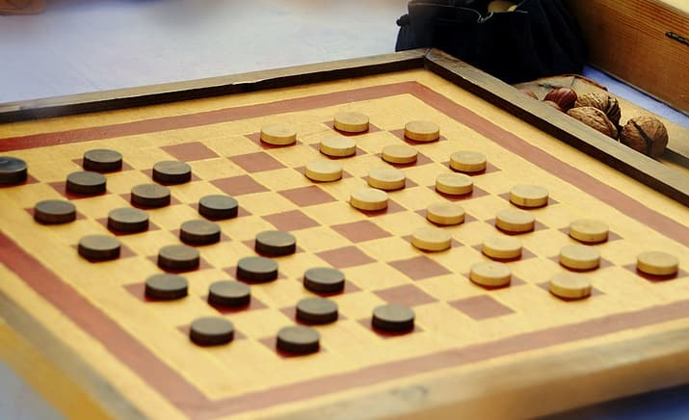
Source: https://www.pikrepo.com/nfuxt/brown-wooden-chess-board-game

What other games do you know of that uses a grid board to play on?
________________________________________________________________________

Did you know?
In some countries the game of checkers is also known as ‘draughts’.
(Source: Britannica)

Patterns in the classroom

Chairs and tables
Look at the image below.
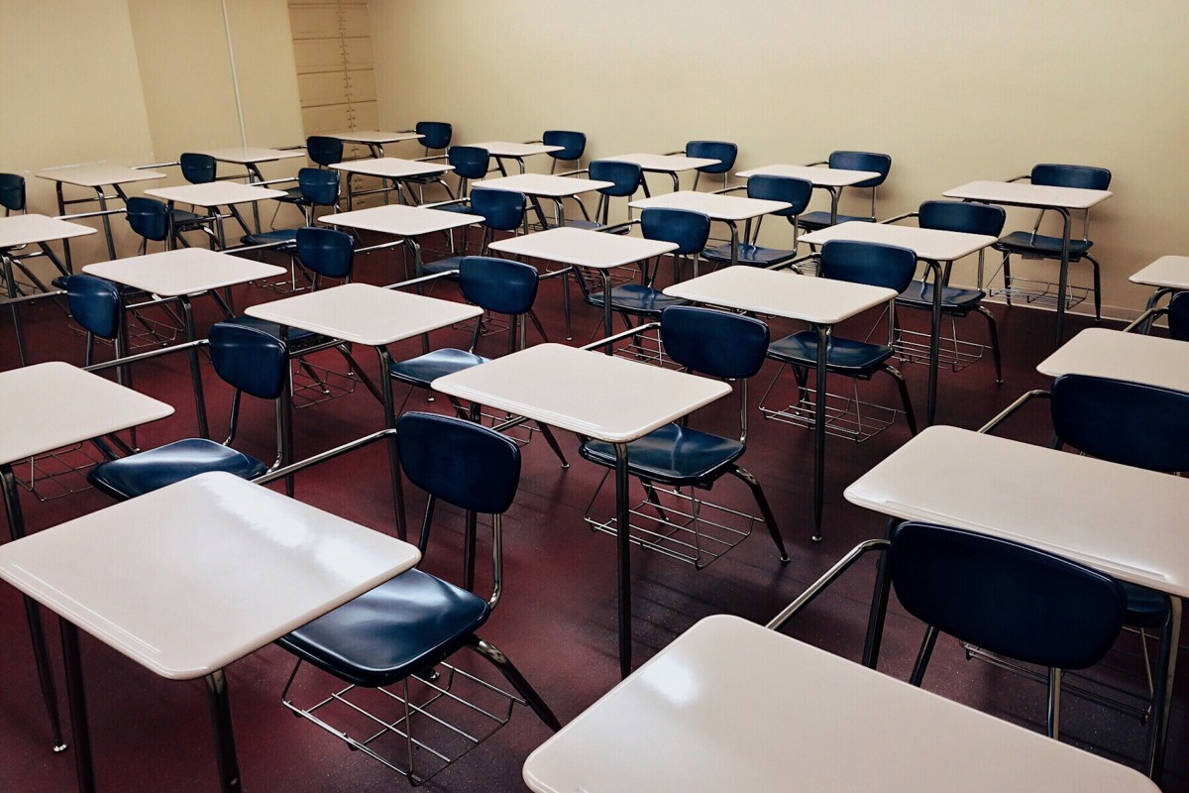
Source: https://pxhere.com/en/photo/1609072

What pattern are the chairs and tables arranged in within your classroom? Is it the same as the pattern in the picture above?
________________________________________________________________________

Did you know?
In 2020 there were 76 310 students who studied one or more HSC courses. Those students would need a lot of chairs!
(Source: NSW Education Standards Authority)

School timetable
Look at the table below.

Period or Break | Time
Period 1 | 9:00 – 9:40
Period 2 | 9:40 – 10:20
Morning recess | 10:20 – 10:40
Period 3 | 10:40 – 11:20
Period 4 | 11:20 – 12:00
Lunch | 12:00 – 12:30
Period 5 | 12:30 – 1:10
Period 6 | 1:10 – 1:50
Afternoon recess | 1:50 – 2:10
Period 7 | 2:10 – 2:50
Period 8 | 2:50 – 3:30
Source: https://albury-h.schools.nsw.gov.au/about-our-school/bell-times-and-timetables.html

Describe the pattern of the periods of learning and breaks? Does your school follow the same pattern? If not, what pattern does your school timetable follow?
________________________________________________________________________

Did you know?
The NSW Mathematics Life Skills course requires 120 hours of learning in Year 11 and 120 hours in Year 12. That is equivalent to 10 days straight with no sleep and no breaks!
(Source: NSW Education Standards Authority)

Patterns in the workplace

Food production line
Look at the image below.
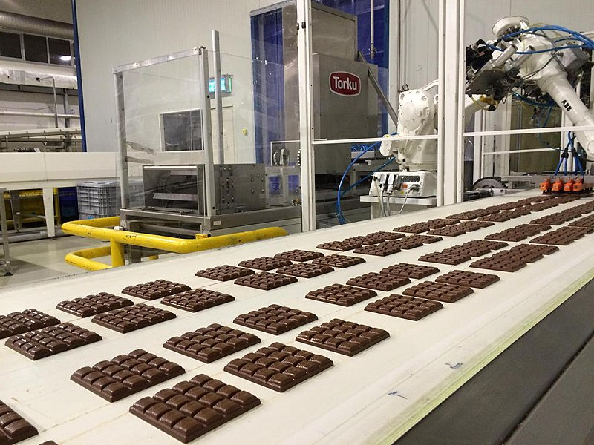
Source: https://commons.wikimedia.org/wiki/File:Chocolate_factory_in_Konya,_Turkey,_May_24,_2015.jpg

Why do you think it is important that when companies make chocolate that they use the same recipe and follow the same procedure every time?
________________________________________________________________________

Did you know?
The first Cadbury Freddo the Frog was produced in 1930 and now approximately 90 million Freddos are eaten in Australia every year.
(Source: Cadbury)

Tiling
Look at the image below.
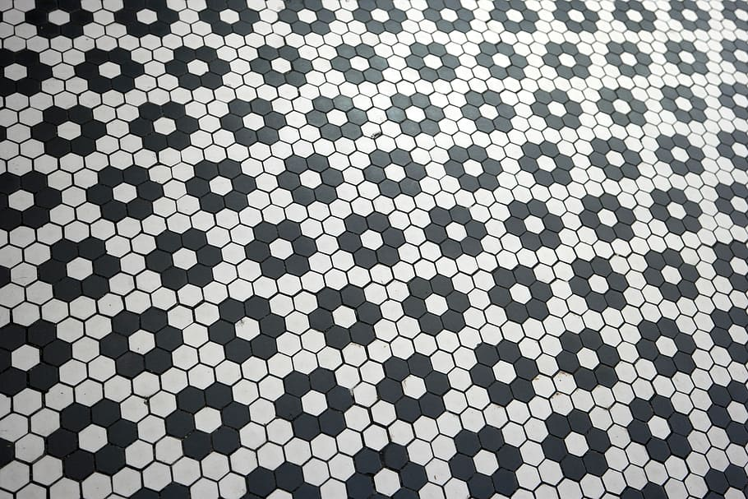
Source: https://www.pxfuel.com/en/free-photo-oxdjw

What shape is each tile?
How many tiles make up the pattern?
When the pattern repeats, how many tiles are common?
________________________________________________________________________

Did you know?
There are more than 1 million roof tiles used to cover the Sydney Opera House and it took 14 years to build.
(Source: Sydney Opera House)

Patterns in pictures

Tessellations
Look at the image below created by famous artist M C Escher.
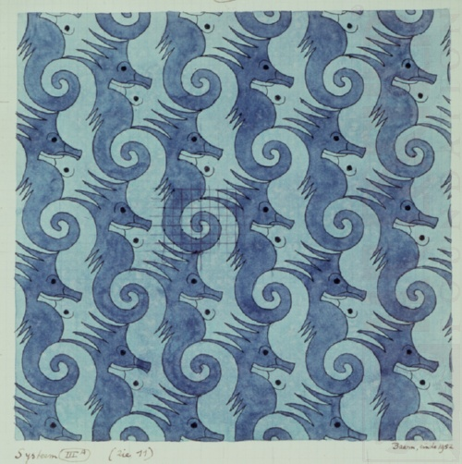
Source: https://mcescher.com/gallery/symmetry/

What do you notice about the seahorses? Can you see any gaps between them?
________________________________________________________________________

Did you know?
In 2011 there was an exhibition of Escher’s work in Rio that was visited by 780000 people in just 6 weeks. On average, how many people would have visited the exhibition each day?
(Source: M C Escher)

Optical illusions
Look at the image below.
Source: https://www.illusionsindex.org/i/hermann-grid

If you stare at the grid, how many dots do you see?
How many dots would you see in an 8 by 8 grid?
________________________________________________________________________

Did you know?
The above image is known as the Hermann Grid. It is named after the physiologist Ludimar Hermann in 1870 and is still used to trick the eye of thousands of people today.
(Source: How do optical illusions work?)

