# Clock faces

### Analogue

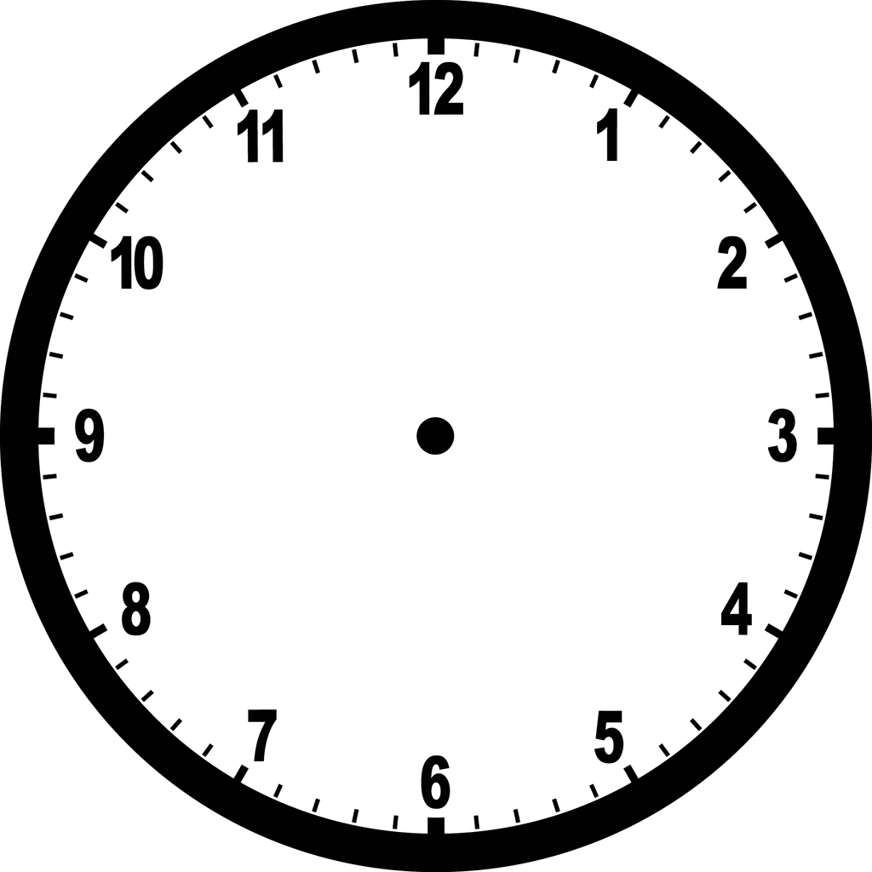

**Source:** <https://pixy.org/574889/>

### Digital

