Tiling patterns

Background
A tiling of square tiles can be made by placing the tiles next to each other. The rule is that at least one edge must be joining to an edge of another tile.

Each of these is a tiling of five tiles.

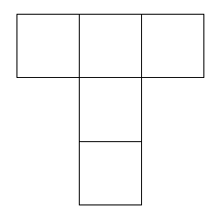

This is not a classified as a tiling because one of the tiles is only joined to the others by a corner as opposed to a whole edge.
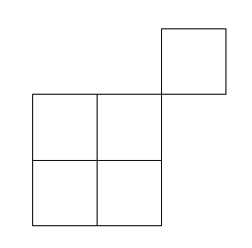

The perimeter of a tiling is the distance around the outside of it.

If the tiles have a side of 1 cm then the perimeter of this tiling, using 5 tiles, is 10cm.

The perimeter of this tiling, also using 5 tiles of the same size, is 12 cm.

The problem
In this investigation you are to calculate the largest and smallest possible perimeters of tilings with different numbers of square tiles. The tiles all have side lengths of 1 cm.

Task 1
Work out how many tiling patterns there are for different numbers of tiles by drawing each of the tiling patterns.

We have already shown you four different patterns for 5 tiles. Are there any others?

Make sure you rotate and reflect (flip) your tilings to ensure they are unique and are not congruent with a tiling pattern you have already discovered.

Task 2
Fill in the table below, showing the largest and smallest perimeters for different numbers of tiles.

Number of tiles | Largest perimeter in cm | Smallest perimeter in cm
1
2
3
4
5
6

Task 3
  - What do you notice about the tiling patterns that gave you the smallest perimeter? What about the largest perimeter?
  - Can you find a pattern in your table that would let you predict the smallest or largest perimeter for 10 tiles?
  - Can you predict the largest and/or smallest perimeter for 100 or 1000 tiles?

