Using Geogebra CAS
Geogebra’s Computer Algebra System (CAS) allows students to solve systems of equations and represent their solutions graphically. The CAS functionality can be found and accessed by changing the view menu option to include CAS, as shown below. While using CAS, students may find it useful to also use the Graphics view, which gives a graphical representation of the algebraic equations.
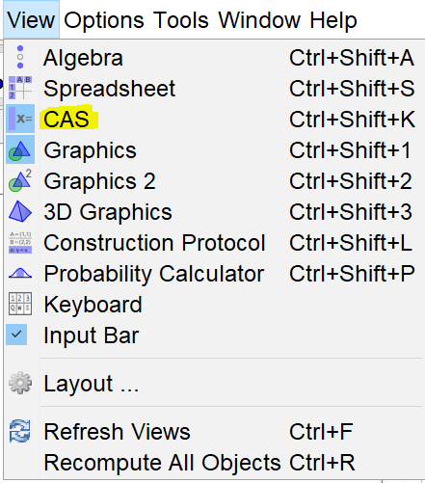

Solving simple linear equations
- Enter a simple linear equation into the first row of the CAS input table, eg. $5x-1=19$
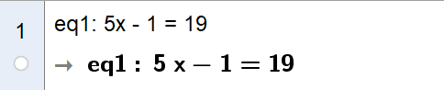
- Start deconstructing this equation by adding 1 to both sides by inputting $\$1+1$ into row 2, where $\$1$ references the equation in row 1.
- Divide both sides of the equation by 5 by inputting $\$2/5$, where $\$2$ references to equation in row 2.
- Check the solution by selecting the equation in row 1, by clicking on the row label, and clicking on the solve icon 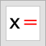 to generate the solution to the equation in a new row.

Solving simultaneous equations by substitution
- Enter two simultaneous equation, eg. $y=3x-1$ and $y=2x+1$, into rows 1 and 2, and plot both equations, in graphics view, by selecting the radial buttons on the row labels.
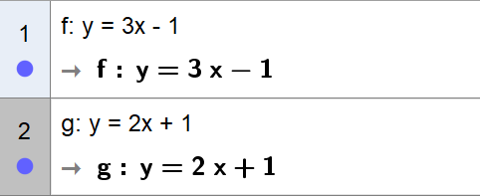
- Use the equation in row 2 and substitute in the equation from row 1 by inputting $Substitute(\$2,\$1)$
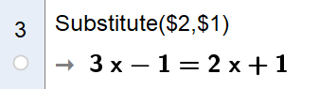
- Add 1 to both sides by inputting $\$3+1$
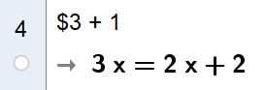
- Subtract $2x$ from both sides by inputting $\$4-2x$ to get a solution for $x$
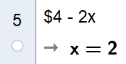
- Substitute the solution for $x$ into either of the equation in rows 1 or 2, for example input $Substitute\left(\$1, \$5\right)$
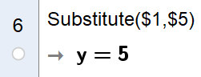
- Check the solution algebraically by selecting the equations in rows 1 and 2 and clicking on the solve icon .
- Check the solution graphically by reading the coordinates of the point of intersection of the two lines.

Solving simultaneous equations by elimination
- Enter two simultaneous equation, eg. $2x+3y=4$ and $5x-y=-7$, into rows 1 and 2, and plot both equations, in graphics view, by selecting the radial buttons on the row labels.
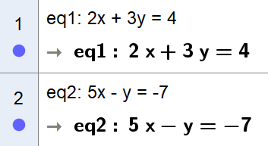
- Eliminate the $y$ variable by adding three lots of the equation in row 2 to the equation in row 1 by inputting $\$1+3*\$2$
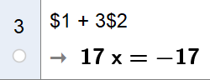
- Divide both sides of the equation by 17 to determine the solution for $x$ by inputting $\$3/17$
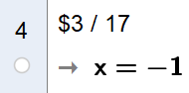
- Substitute the solution for $x$ into either of the equation in rows 1 or 2, for example input $Substitute\left(\$1, \$4\right)$
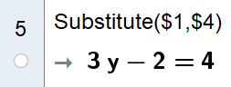
- Solve this equation to find the solution for $y$ by adding 2 to both sides and then dividing by 3. This can be done by inputting $(\$5+2)/3$
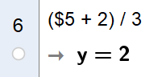
- Check the solution algebraically by selecting the equations in rows 1 and 2 and clicking on the solve icon .
- Check the solution graphically by reading the coordinates of the point of intersection of the two lines.

