Shortest path

Example question solutions
- In the 2x2cm grid, find the number of shortest paths that exist from A to B.
Solution: There are 6 shortest paths from A to B.
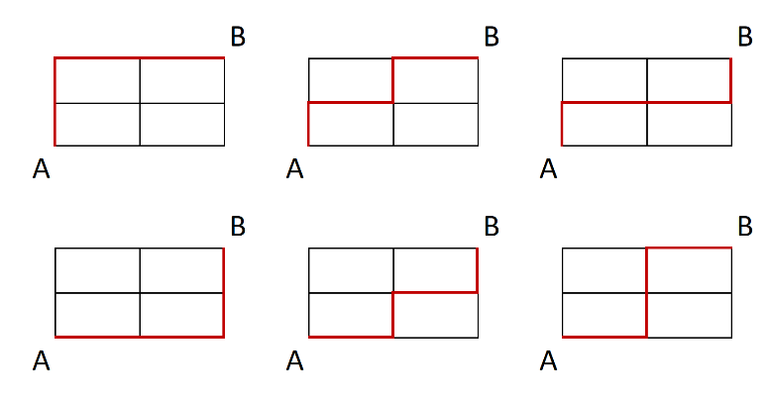
- Find the shortest path from the hall to the basketball court in the network diagram below:
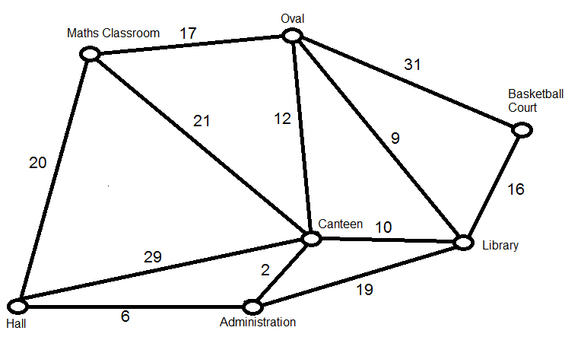
Solution: The shortest path is Hall-Administration-Canteen-Library-Basketball court.
$$Total weight=6+2+10+16=34$$
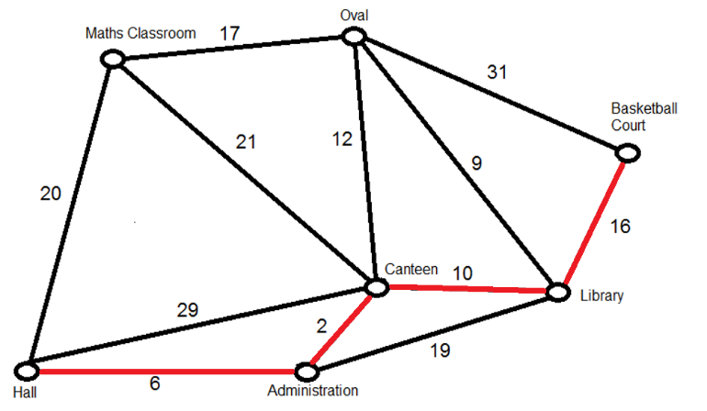

Dijkstra’s algorithm
- Colour a starting vertex.
- Find the vertex closest to the starting vertex. If there are several, just choose one. Colour this vertex and the shortest edge joining it to the starting vertex.
- Write the total distance (weight) to the starting vertex next to this newly coloured vertex.
- Consider the uncoloured vertices adjacent to a coloured vertex. Find the shortest distance from the start vertex to any of these uncoloured vertices. Colour this vertex and the shortest edge joining it to the coloured vertices. The path to this new vertex may be directly from the start or via any sequence of coloured vertices.
- Write the total distance (weight) to the starting vertex next to this newly coloured vertex.
- Repeat Steps 4 and 5 until the finishing vertex is reached.

Example: Find the shortest path from A to H.
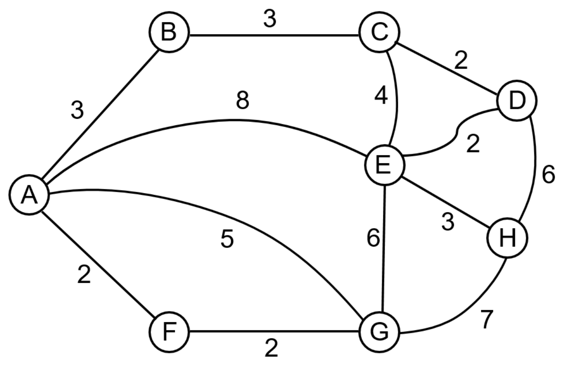
Solution: A-E-H or A-F-G-H. Note: Both have a distance of 11.

