Year 12 Mathematics Standard

Networks

Glossary of terms

Vertices
A vertex is represented by a circle or dot in a network diagram. It may also be called a node. Vertices are often given labels to indicate what is being represented.

Edge
An edge is the line segment that joins vertex to vertex. The line segments may be directed or undirected. If the line segment begins and ends at the same vertex, it is called a loop.
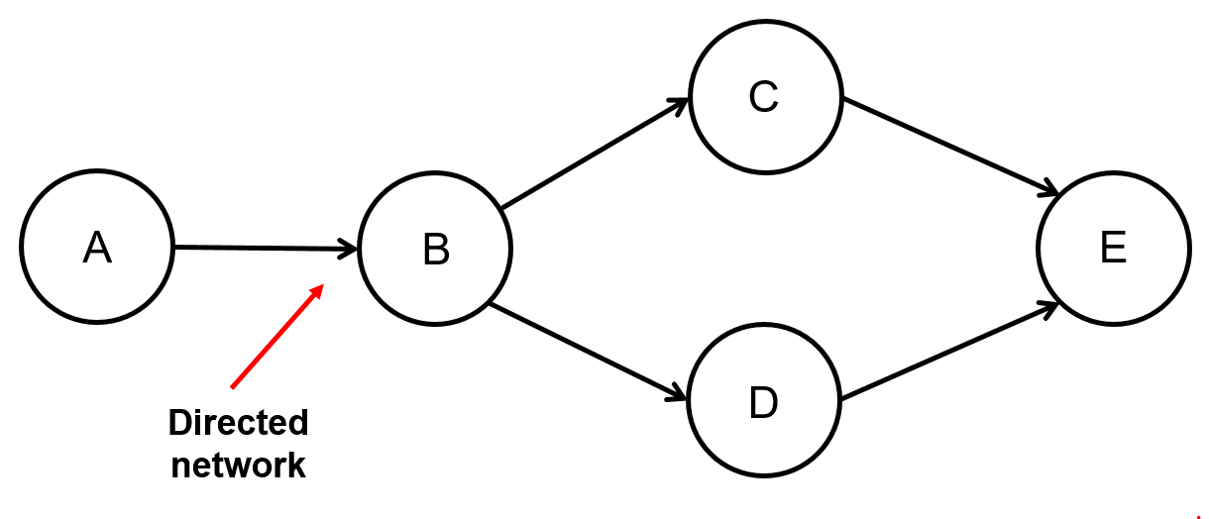
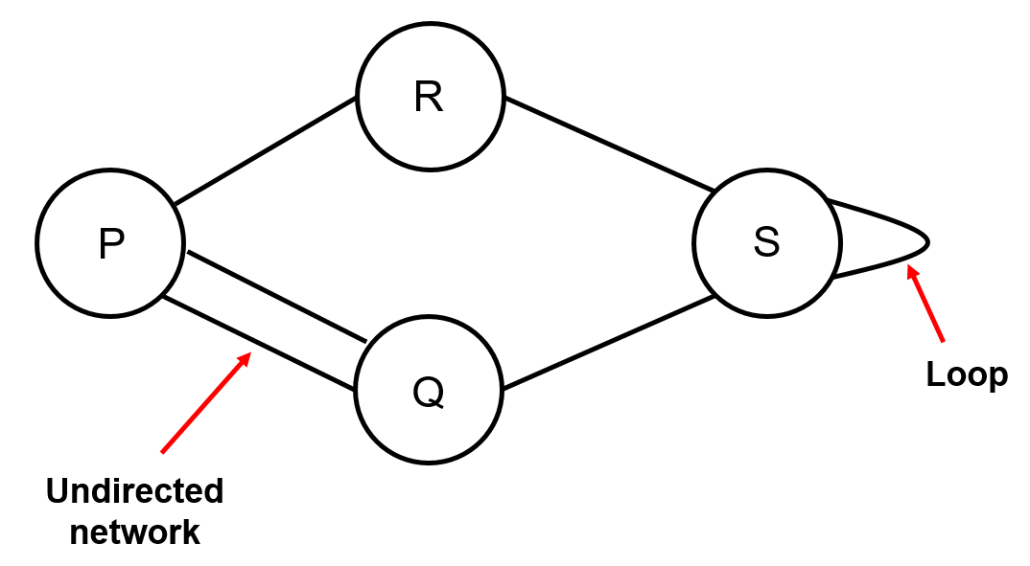

Network
A network is a collection of vertices and edges. If no two vertices are joined by more than one edge and there are no loops, the network is called simple.
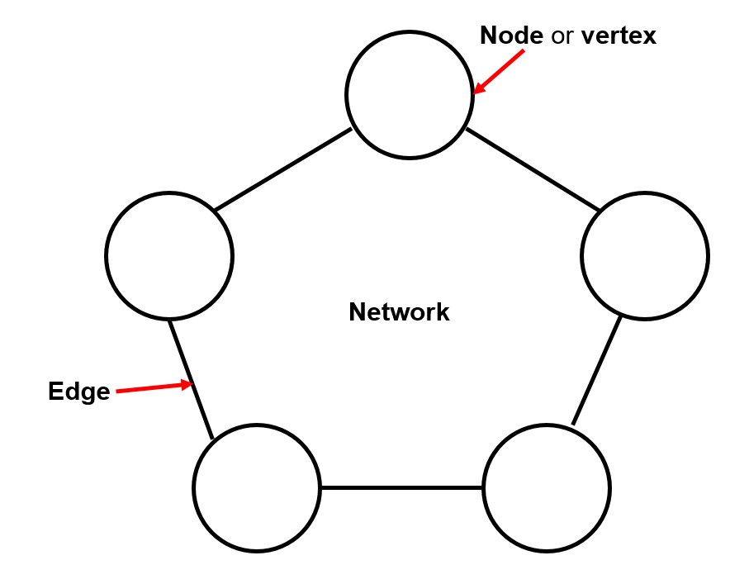

Degree
The degree of a vertex is the total number of edges that go into or out of it. Loops are counted twice.
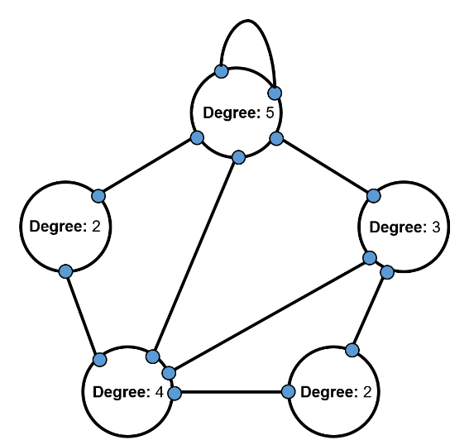

Weight
The weight of each edge is a numerical value which represents the relationship between two nodes. The weights may describe the distance, travel times or costs of connecting two nodes in the network.
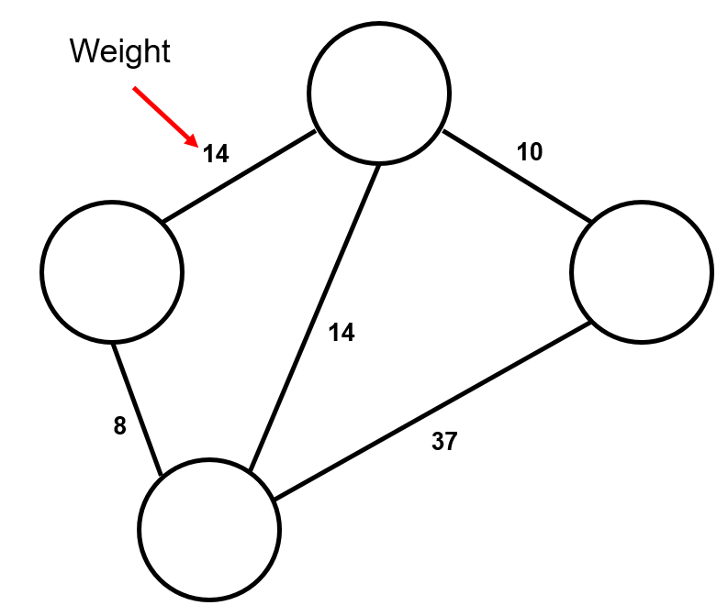

Walk
A walk is the sequence of moving from one vertex to another in a network.

Path
A path is a walk where no vertex is passed through twice, except for the beginning and end.
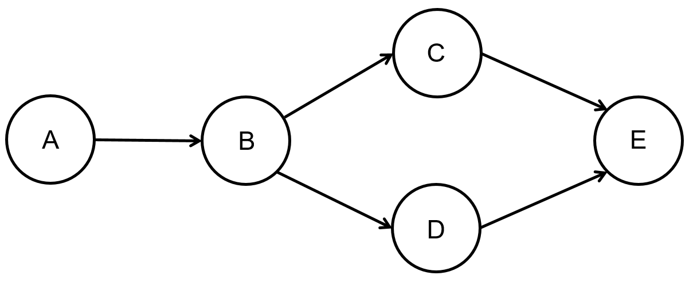
For example, B-C-E and B-D-E are walks, A-B-C-E is a path.
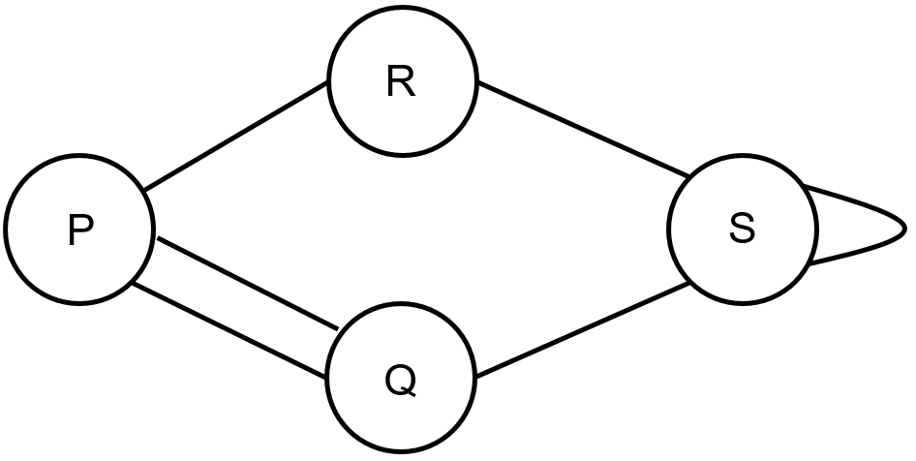
For example, P-Q-P-R-S-S is a walk, P-Q-S-R is a path.

