Year 12 Mathematics Standard 1
MS-N1 Networks and Paths – assessment task
All outcomes referred to in this unit come from Mathematics Standard Stage 6 Syllabus
© NSW Education Standards Authority (NESA) for and on behalf of the Crown in right of the State of New South Wales, 2017
Assessment type: Problem solving task
Stage: 6
Due Date:

Outcomes
A student:
- applies network techniques to solve network problems MS1-12-8
- uses mathematical argument and reasoning to evaluate conclusions, communicating a position clearly to others MS1-12-10

Learning across the curriculum
- Cross-curriculum priorities
  - Aboriginal and Torres Strait Islander histories and cultures
- General capabilities
  - Critical and creative thinking
  - Intercultural understanding
  - Literacy
  - Numeracy
- Other areas of learning
  - Civics and citizenship

Task
The Gooniyandi people are part of the world’s oldest continuous culture, located in central Western Australia. Students are to answer questions and solve problems relating to networks and the Gooniyandi people on their own paper. Neatly handwritten or electronic submission are both acceptable. All work is to be student’s own.
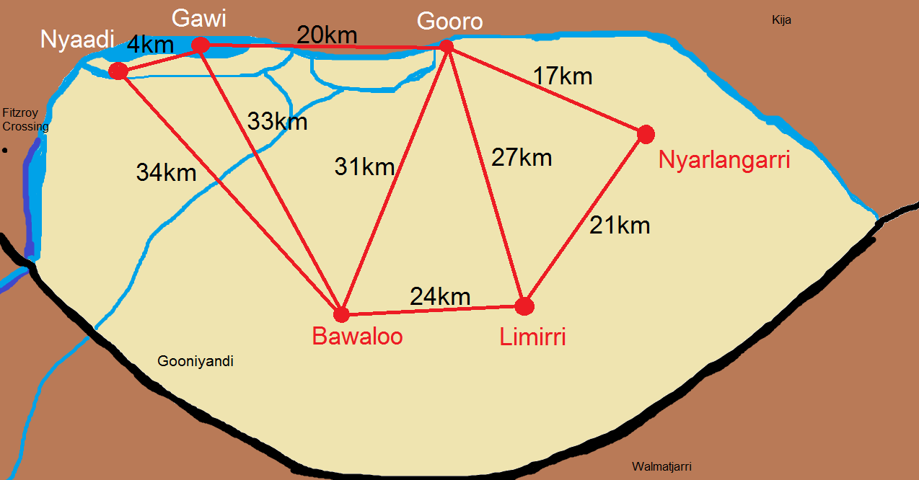
Map – Copyright mEsh Project, Laura Andrikidis
The Gooniyandi people recognise four seasons:
- Barranga (very hot weather time)
- Yidirla (wet season time when the river runs)
- Ngamari (female cold weather time)
- Girlinggoowa (male cold weather time)
Gooniyandi people closely follow the weather. The seasons can tell them when the best time is for hunting and collecting different plants and animals. The following list represents a small sample of the resources used by the Gooniyandi people:
- Bawaloo is the bush carrot, it is collected in the wet season, Yidirla.
- Nyaadi is a bulb like a big onion. During flooding the Nyaadi can be crushed and thrown into the river which feeds the fish to ensure they are a good size to eat all year round.
- Gawi (fish) are said to shut their mouths when the weather is cooler and the wind starts blowing from the east. This is not a good time to catch the Gawi.
- Gooro is the freshwater mangrove. The red bark put in the water and is used as a poison to stun fish which are then speared.
- Nyarlangarri (King Brown Snake) are all fat and ready for hunting during Ngamari.
- Limirri is a wax that comes from spinifex. It is ground up with water and used to connect spear and axe heads, it is also used to soften the mouth of didgeridoos.

Reference List
- Kunwinjku Seasons Calendar (CSIRO)
- Gooniyandi Seasons Calendar (CSIRO)
- Aboriginal Languages Map (Australian Geographic)

Questions
- List the number of edges.
- State the degree of each node.
- Which node(s) has the highest degree?
- Construct a table showing the distance between each node.
- Starting at Nyaadi and finishing at Nyarlangarri, which path would you follow to visit each node once to minimise walking distance?
- What is the shortest distance you could travel to complete the hunting of the Gawi starting at the Limirri?
- Problem solving – The best Gawi to catch are fat Gawi. Consider the information you have looked at about the Gooniyandi people and decide on a pathway you could take that would enable successful hunting of Gawi, starting at any point. Write a paragraph to explain your decisions and make reference to the information and map provided.
- Problem solving – During Yidirla, the Gawi to Gooro track would be flooded and cannot be used. The Bawaloo needs collecting as it is a food source and the Gawi needs to be fed with Nyaadi. Your starting point is Nyarlangarri and the end point is Gawi.
- Copy the given map of the Gooniyandi people.
- Considering you can only walk up to 20km per day, trace out the shortest pathway you would take and include additional nodes as campsites after each 20km. Use the node names ‘Camp 1’, ‘Camp 2’, and so on.
- How many days would your journey take?
- How many kilometres would you travel in total?

Extension
Refer to the Gooniyandi Seasons Calendar. (You can download a printable version from this site which is easier to read than the electronic version.)
Add in 3-4 more nodes to represent other resources that could be used by the Gooniyandi and where you think they could be found. Write an example plan, including direction for travel for hunting and gathering different items depending on the season, going over each node only once.

Marking guideline and rubric
Question | 4 marks | 3 marks | 2 marks | 1 mark
1. | N/A | N/A | N/A | Student correctly lists the number of edges.
2. | Student correctly states the degree of every node. | Student correctly states the degree of 4 nodes correctly. | Student correctly states the degree of 2 nodes correctly. | Student correctly states the degree of 1 node correctly.
3. | N/A | N/A | Student correctly states all answers. | Student correctly states one answer.
4. | Student constructs a neat table with nodes listed as column and row headings. All distances between each node are correct. | Student constructs a neat table with nodes listed as column and row headings. Most distances between each node are correct. | Student constructs a table with nodes listed as column and row headings. Some distances between each node are correct. | Student constructs a table with few distances between each node correct.
5. | Student lists shortest pathway with all six nodes included, total distance calculated. | Student selects nodes in correct order for the shortest path, however total distance is not correct. | Student calculated a route using all six nodes, however, not the shortest path. | Student has made some progress at calculating the shortest path.
6. | Student correctly identifies the shortest path while hunting the Gawi starting at Limirri. | Student incorrectly identifies the shortest path, however, have made significant progress towards the answer. | Student correctly identifies a shortest path, however, have not used the given start/end point. | Student incorrectly identifies the shortest path, however, have made some progress towards the answer.
7.  (Marks for information) | Paragraph describes thoughtful information and considers all constraints. | Paragraph describes thoughtful information and considers some constraints. | A sentence or two describes information and considers one constraint. | A sentence or less describes some information with little consideration.
7.  (Marks for spelling and grammar) | For the paragraph, all grammar and spelling correct. | For the paragraph, most grammar and spelling correct. | For the sentences, some grammar and spelling correct. | For the sentences, poor grammar and spelling.
8. a) | N/A | N/A | Student correctly and neatly product the network diagram without errors. | Student correctly reproduce the network diagram with some errors.
8. b) | Student correctly place additional nodes every 20km. Pathway is described correctly and is the shortest distance. All constraints are considered. | Student correctly place additional nodes every 20km. Pathway is not the shortest distance. All constraints are considered. | Student correctly place additional nodes every 20km. Pathway is not the shortest distance. Some constraints are considered. | Student correctly place additional nodes every 20km. Pathway is not the shortest distance. No constraints are considered.
8. c) | N/A | N/A | Student correctly identify the correct number of days for the journey for part b). | Student makes progress towards correct number of days.
8. d) | N/A | N/A | Student correctly identifies the correct distance of the journey in part b). | Student makes progress towards correct distance.

