Sample virtual program for Stage 5.2 Mathematics:
Guiding question
What are your students going to learn? (Learning intentions) | Students will learn how to construct and interpret linear graphs.
How are they going to learn it? (Resources and Strategies) | It is envisaged that all concepts will be introduced by the staff member via video conferencing and Microsoft Whiteboard; however, materials to supplement learning and independent learning activities have been provided for self-paced study.
Target date for completion | 4 lesson sequence
How are you going to know that they learned it? (Success criteria) | - Students identify linear and non-linear graphs  - Students interpret the coefficients of a linear equation as the gradient of the graph  - Students can find the linear equation for a linear graph  - Students can construct a linear graph from a linear equation
Collecting evidence of student learning (Verification) | Activities provide formative assessment opportunities as student responses are collected. Students are provided with assessment as learning opportunities during interactive activities.
Feedback (Evaluation) | Staff can use video conferencing and Microsoft Whiteboard to lead student discussion and pose assessing and advancing questions. Staff can use these platforms to respond to student misconceptions identified through the formative assessment activities.
Communication | Staff can facilitate discussion and collaboration though video conferencing, like Zoom and Microsoft Teams, and collaborative platforms, like Microsoft Whiteboard.

Model 2 – Sharing resources for students to view/read and reflect on.
It is envisaged that the following sequence of lessons would be facilitated by the peer discussion and conferencing, asynchronous discussion and mini-whiteboard activities from the Digital learning selector – Learning activities.
Resources for students could be shared through platforms such as Microsoft Teams, Google Classroom or via email.
Staff may like to access this Desmos tutorial in preparation for this lesson sequence, https://learn.desmos.com/graphing.

Constructing and interpreting Linear Graphs
Stage 5.2 Mathematics
During this sequence of lessons students will extend their understanding of the linear patterns in Stage 4, which use discrete data to develop deterministic linear models, and build skills to develop empirical models using continuous data.

Outcomes
A student:
- selects appropriate notations and conventions to communicate mathematical ideas and solutions MA5.2-1WM
- constructs arguments to prove and justify results MA5.2-3WM
- determines the midpoint, gradient and length of an interval, and graphs linear relationships MA5.1-6NA
- uses the gradient-intercept form to interpret and graph linear relationships MA5.2-9NA

Lesson sequence
1 | - Students are introduced to the concept of linear and non-linear graphs. Students complete the Investigating linear graphs activity. The staff member then leads discussion on the characteristics of linear and non-linear graphs and collates responses. The staff member leads students to the idea that linear graphs have a highest power of $x$ equal to one or zero (a constant); otherwise the graph is non-linear.  - Students are introduced to the idea that any equation in the form $y=mx+c$ is linear, as the highest power of $x$ is 1 when $m≠0$ and $x$ is 0 when $m=0$, hence satisfying the conditions from earlier. The staff member may like to facilitate the Demos classroom activity Linear and Non-Linear functions and collect and respond to students’ contributions. | Students use graphing software or a table of values to investigate the features of linear graphs  Investigating linear graphs  Students could use the Geogebra app to investigate the characteristics of linear and non-linear graphs  https://www.geogebra.org/m/ttkrmhxe  Students interact with this sequence of Desmos activities to identify linear and non-linear equations and graphs  https://bit.ly/2W3mqoS
2 | - Students complete the Desmos activity Linking linear graphs and rules to investigate the characteristics of a linear equation in gradient-intercept form.  - Discussion and collaboration can be facilitated using a collaborative tool, like Microsoft Whiteboard, and video conferencing, like Zoom. The staff member leads students to the conclusion that the coefficient of $x$ represents the gradient/slope or steepness of the linear graph; and the constant term represents the y-intercept which is the value of $y$ when the linear graphs cuts the $y$-axis.  - The staff member leads students to calculating the gradient by forming a right-angled triangle between two points on the linear graph. Introduce students to the idea of the run as the change in $x$ ordinates between the points, and the rise as the change in $y$ ordinates.  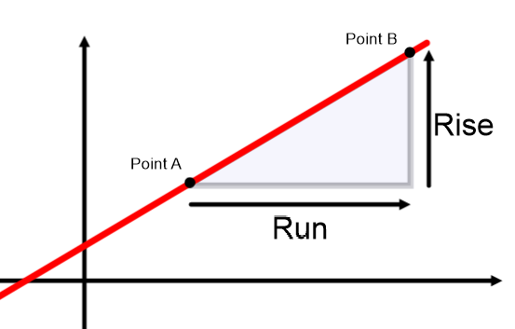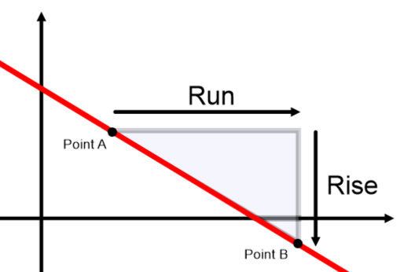  The staff member demonstrates the gradient calculation as $m=\frac{Rise}{Run}$.  The staff member should model examples of applying this calculation in a range of scenarios.  - Students can interact with the Geogebra app to gain fluency. Students should drag the points to form lines with different gradients, then attempt to calculate the rise and run before applying them to calculate the gradient. Students can click on the triangle check-box to check their calculations for the rise and run; and the gradient check-box to check their gradient calculation. | Students complete the Desmos activity Linking linear graphs and rules and investigate the linear equations for real life objects.  https://bit.ly/2WapZMd  Alternatively, students could interact with this Geogebra app to investigate the characteristics of linear graphs, including gradient and y-intercept  https://www.geogebra.org/m/tw4hmyax  Students interact with the Geogebra app to gain fluency with calculating gradients  https://www.geogebra.org/m/YJAJcq2M
3 | - Use the Geogebra app to establish that the gradient calculation is consistent regardless of the points used on a linear graph. Students can move points A and B to change the gradient of the line. The app demonstrates that the gradient is consistent across the linear graph by forming similar triangles, one red and one green. This shows the gradients are consistent as the ratio of rise over run is the same for both triangles (the property of similar triangles).  - The staff member should model examples for finding the linear equation given the graph. Students need to be directed to identify two easily identifiable points on the line and use them to calculate the gradient, $m$; and to locate the $y$-intercept by reading where the linear graph crosses the $y$-axis. Students should consolidate their understanding by attempting the questions on the worksheet provided. Students can submit their responses using Google Classroom or similar. | Student interact with the Geogebra app to determine the gradient is consistent across all intervals of the linear graph  https://www.geogebra.org/m/KnCMbVgJ  Students should print and attempt to answer all questions on this worksheet  https://bit.ly/33675oS
4 | - Students should be challenged to identify the gradient and y-intercept from a linear equation presented in a number of forms, for example $y=3x-2$; $y=4-x$; $y=\frac{3}{2}x+1$; $y=5x$. The staff member should lead student discussion via video conferencing, like Zoom, and a collaborative platform, like Microsoft Whiteboard.  - Students should be directed to construct linear graphs from a linear equation. Students should construct the $y$-intercept, $c$, first by drawing a point on the $y$-axis located $c$ units from the origin; then, identify the location of a second point by interpreting the rise and run from the gradient, in fractional form, and using them to construct the (shorter) sides of a right angled triangle. Complete the triangle by constructing the hypotenuse but continuing it beyond the triangle in both directions. | Students can interact with these Geogebra and Desmos apps to consolidate learning  - https://www.geogebra.org/m/SkTte9sj#material/WVGxwKKn  - https://www.geogebra.org/m/Dv3VKCSb#material/janxjF4N  - https://teacher.desmos.com/activitybuilder/custom/582b81f4bf3030840aacf265?collections=featured-collections,5d939bb5a577d244fa315ebd
Extension | Students may like to find examples in real life that follow a linear pattern. For example, converting from one currency to another, calculating total pay from hours work and wage per hour, Total cost from the number of objects and price per item

