Student workbook thinking mathematically 3 Stage 3
Name:
Class:

Overview
For the next 2 weeks, we hope you will be having some fun with mathematics – getting sweaty brains, thinking hard and feeling successful when you solve a problem, develop more confidence or understand something better. Many of these activities are games and investigations that you can play with your family, friends and classmates. Have fun and think deeply!
Most of these tasks have a video and some have downloadable resources to support your learning. You can find these using the digital student resource link on the Learning from home, K-6 support – mathematics page.

Day 1
Today we have 1 task. We will have an opportunity to deepen our understanding of patterns, by doing some investigating!
Resources – device to view videos, coloured pencils/ markers, collection of objects like blocks or unfix cubes

Staircase pattern 3
View video Staircase pattern 3
If we take any two consecutive triangular numbers, will it always make a square number? Over to you mathematicians to investigate!

Reflection
Talk about what you have discovered and learnt about today with someone.

Day 2
Today we are going to explore a really famous triangle that is full of patterns! The triangle is often named Pascal’s Triangle, after Blaise Pascal, a French mathematician from the 1600’s. Interestingly, the triangle was discovered and used much earlier in India, Iran, China, Germany, Greece and Italy!
Resources – device to view videos, coloured pencils/ markers

Pascal’s triangle
(From youcubed)
Find the missing numbers on the Pascal’s Triangle.
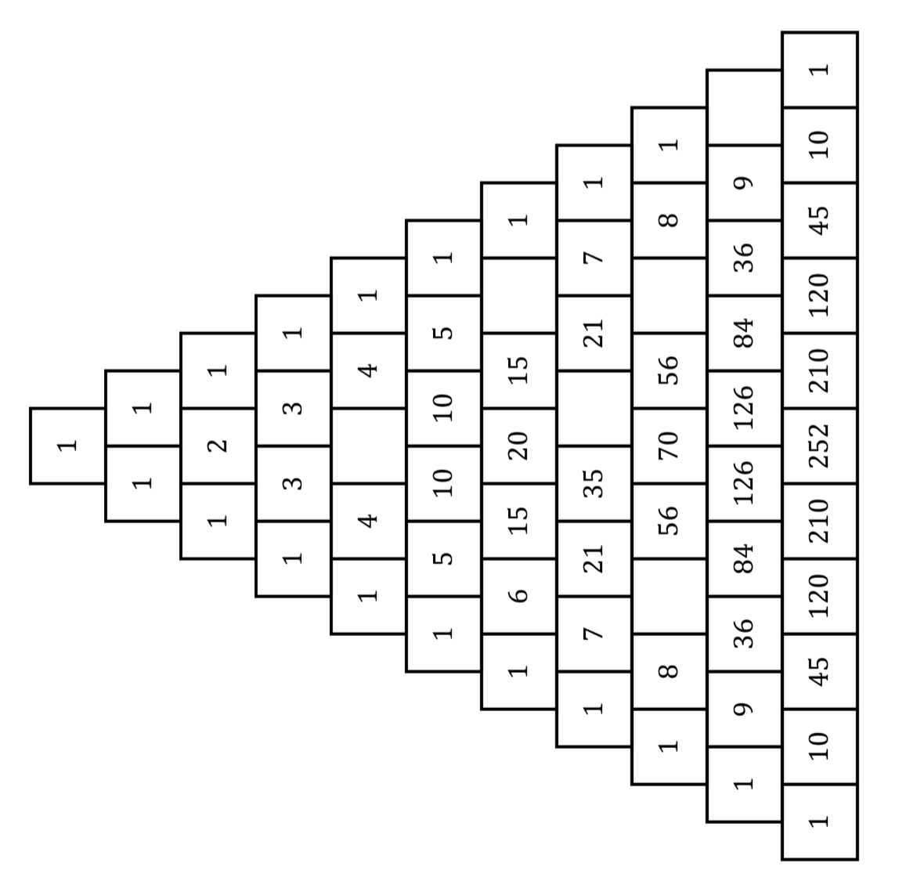
Find the sum of each row in Pascal’s Triangle. Is there a pattern?

Shade all of the odd numbers in Pascal’s Triangle. Is there a pattern?

Can you find triangular numbers in Pascal’s Triangle?

Find at least one more pattern in Pascal’s Triangle.

Reflection
Share the different patterns you created as a mathematician and talk about what they represent.

Day 3
Today we are going to explore a multiplicative problem brought to us by LEGO.
Resources – device to view videos, coloured pencils/markers

How many characters challenge
View video How many unique characters – part 1
How many unique mini figs can we make for our $25?

View video How many unique characters – part 2
See if the strategy shared in the video helps you think of all the different mini figs.
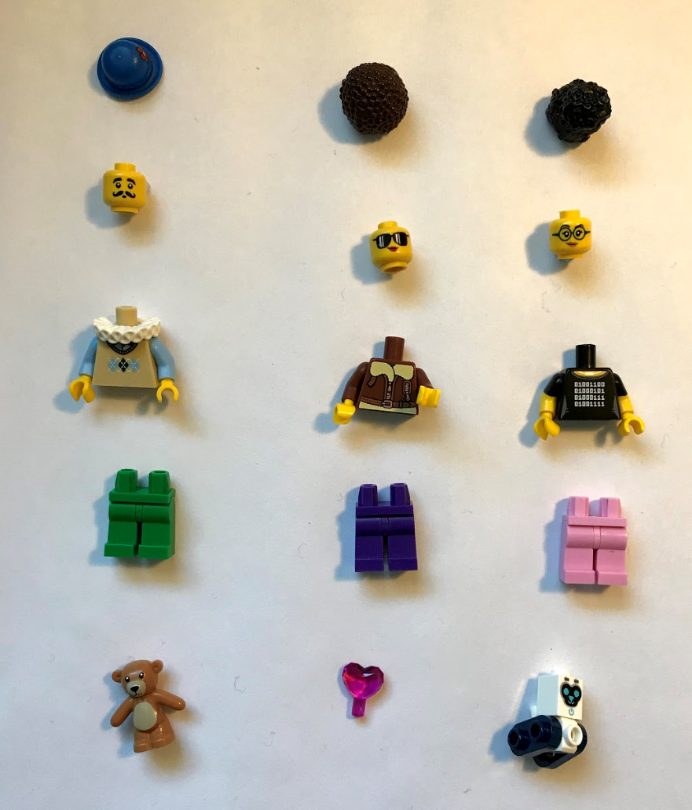

Reflection
What’s something you feel more confident with today? What’s something you found challenging today?

Day 4
Today we are going to make our own tangrams!
Resources –device to view videos, pair of scissors, 1 square sheet of paper

How to make a tangram
With an adult collect:
- pair of scissors
- 1 square sheet of paper (View video on how to make a square)
View video How to make a tangram with an adult and together make your own tangram.

Reflection
List 2 things about your learning that made you feel good today?

Day 5
Today we are going to use our tangram to find out more about shapes... and hopefully get sweaty brains as we wonder about trapeziums!
Resources – device to view videos, pencil

Tangrams: 3.1: exploring trapeziums
View video on Tangrams 1 –part 1
Use this adapted Frayer chart to define a trapezium.
Examples  (Draw, write or describe some examples) | Non-examples  (Draw write or describe some non- examples. Ask yourself “What isn’t it?”)

Definition and features
(Draw, write or describe a definition and some really important features.)
View video on Tangrams 1 –part 2
How many different trapeziums can you make using 2 tangram pieces?
- 2 tangram pieces
- 3 tangram pieces
- 4 tangram pieces
- 5 tangram pieces
- 6 tangram pieces
- 7 tangram pieces
Record your creations.

View video on Tangrams 1 –part 3

Reflection
Revisit your Frayer chart. Using a different colour pencil/marker add any more information or revise your thinking.

Day 6
Today we will continue exploring challenges using our tangrams.
Resources – device to view videos, coloured pencils/ markers, tangram you made earlier.

Tangrams 3.2: investigating fractions
View video Tangrams 2– part 1
What other rectangles can you make of exactly the same dimensions? Record your thinking.

View video Tangrams 3– part 1
If all the 7 tangram pieces formed into a square has a value of 1 whole, what’s the value of the individual pieces?
- The large triangle?
- The medium triangle
- The parallelogram?
- The square?
- The small triangle?

View video Tangrams 3– part 2
How can we prove that the medium triangle, the parallelogram and the square are all equal in area (they are all 1-eighth of the original square)?

View video Tangrams 3– part 3

Reflection
Draw a picture of 1 or 2 things that made your brain think hard today (that made your brain sweaty).

Day 7
Today we have 2 tasks. We are going to continue using our tangram to explore shapes and fractions, and then, we are going to learn a new game.
Resources – device to view videos, coloured pencils/ markers, post-it-notes or pieces of paper, tangram, 1-9 dice or spinner (see appendix)

Order! Order! 2
(From Mike Askew)
View video Order! Order! 2
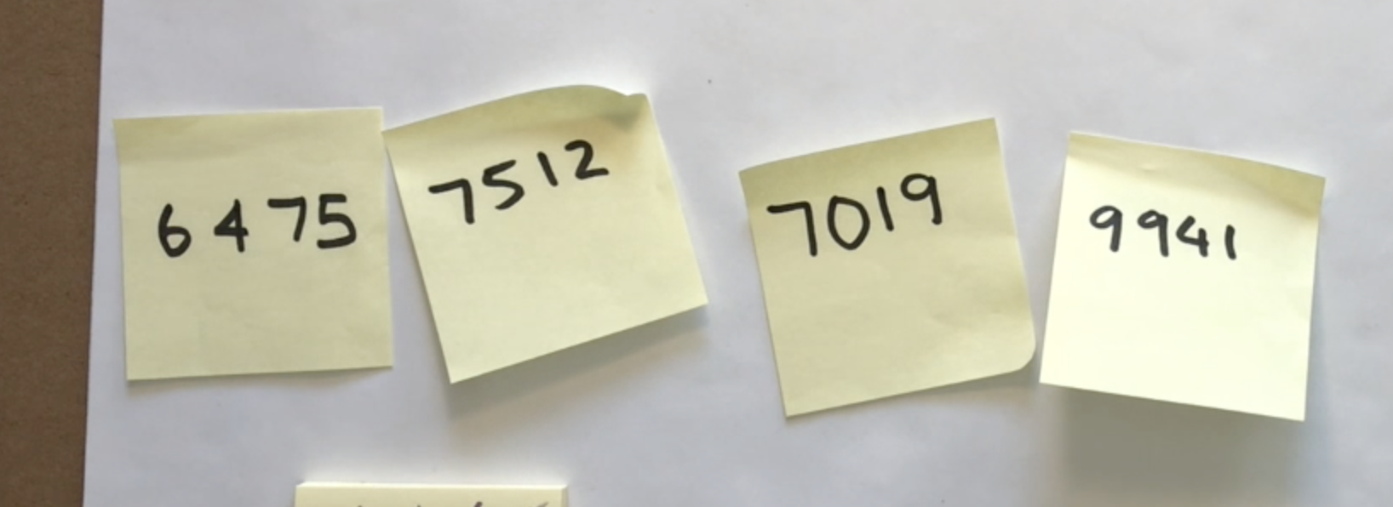
Can you help Michelle and Barbara? Is it possible to order these numbers from smallest to largest in less than 5 moves? Record how many moves it takes to order them.
Play Order! Order!
How to play
- Roll the dice and create and record a 4-digit number.
- Repeat until you have 4 numbers.
- Order them from smallest to largest, and largest to smallest in the fewest moves possible, moving adjacent cards only.

Tangrams 3.3: reimagining the whole
View video Tangrams 4– part 1
If the red square is now defined as 1 whole, what is the value of all the other tangram pieces?
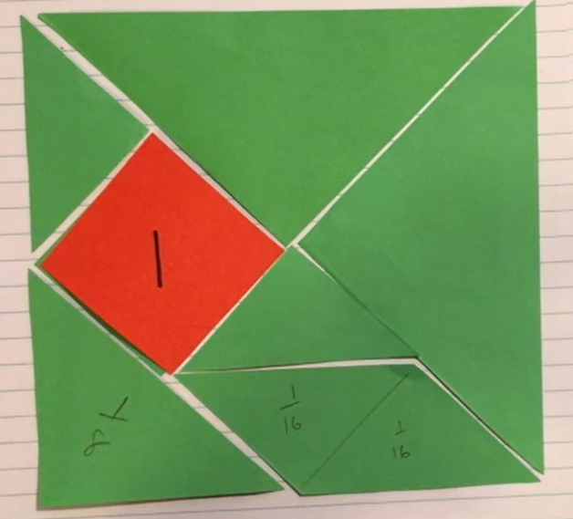
Over to you, mathematicians!

Reflection
Draw a picture of 1 or 2 things that made your brain think hard today (that made your brain get sweaty).

Day 8
Today we have 2 tasks. We will play two games that require strategic thinking whilst also focusing on place value and our skills in multiplicative thinking!
Resources – device to view videos, coloured pencils/markers, 8 counters (4 of one colour and 4 of a different colour), paperclip

Mastermind
View video Mastermind
Play mastermind!
How to play
- Each player writes down a 3-digit number (with no repeating digits)
- Each player draws up their game board (a table with 3 columns: 'guess', 'digits', 'places'
- Players take turns to guess a 3-digit number
  - Their opponent tells them how many digits are correct and how many are in the correct place
  - Players record their guess, the number of digits that are correct and the number of digits that are in the right place. Players then use this information to refine their guesses.
- The first player to correctly guess their opponents' number is the winner!
- Players can choose to play using 4-digit numbers, 5-digit numbers, and 2-digit numbers. etc.

Factors fun
View video Factors fun
Create your own factors fun spinner and play Factors fun.
How to play
- Get your game board, spinner, recording sheet, counters, and pencils ready
- Take it in turn to spin the spinner and divide the number by the chosen divisor (for example, 5)
- Players work out the solution and explain their thinking to their partner.
  - The partner records their thinking and if they agree, the player is able to place one of their counters on the number on the game board, claiming that place.
  - If the number is taken, students miss a turn.
  - If there are no new counters that can be added to the game board, players have to move an existing counter to a new place.
- Players win by getting four counters in a row (in any orientation, including a square).
- If preferred, students can use 5 or 6 counters, looking for 4 in a row.

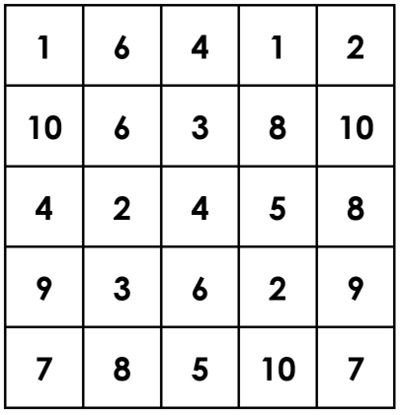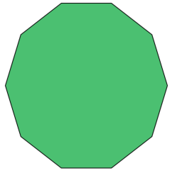
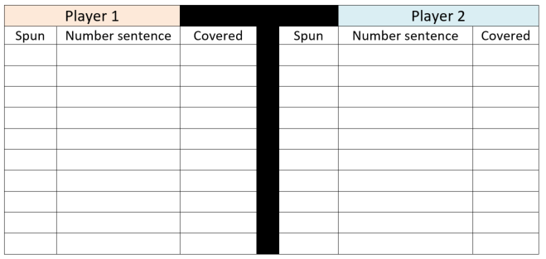

Reflection
Imagine yourself feeling good about mathematics. Draw a picture to show what you‘re doing when you feel good about mathematics.

Day 9
Today we are going to explore how different people might approach solving problems and then, we are going to play a game involving remainders.
Resources – device to view videos, coloured pencils/ markers

Which would you do in your head 2?
(Inspired by McIntosh Reys, Reys and Hope)
View video Which would you do in your head 2? Part 1
Which of these problems would you solve using a mental strategy?

Which would you solve using a written or digital strategy?

Survey your classmates, family or friends!
Is there a problem or problems that everyone would use mental strategies for?
Is there a problem or problems that everyone would use a written or digital strategy for?

View video Which would you do in your head 2? Part 2
Are there any problems that you would now rethink and solve mentally that you previously thought you use a written or digital strategy for?

Leftovers
(Adapted from Marilyn Burns)
View video Leftovers
Play the Leftovers game and record your game.
How to play
- Write the numbers 1-10 (or 1-20) along the top of your paper
- Record your starting number (we used 100 but you can change the starting number to any number you like)
- Player 1 chooses a divisor that will result in leftovers (remainders)
  - Player 1 works out the solution to their problem (in this case, Barbara worked out 100/7)
  - Player 1 collects the leftovers (remainders) as points
  - The chosen number (in this case, 7) is crossed off the list of options
  - A new starting number is determined by subtracting the leftovers from the previous starting number (e.g. 100 - 2 = 98)
- Play continues until there are no more moves that can be made
- The winner is the person with the most leftovers.

Reflection
What advice would you give someone who is joining you tomorrow for Leftovers
game?

Day 10
Today we are going to play a game from Mike Askew that helps us deepen our skills and understanding in estimating, rounding, using place value knowledge and reasoning. Have fun, mathematicians!
Resources – device to view videos, coloured pencils/ markers, 9-sided dice

Hit it!
(From Mike Askew)
View video Hit it!
Play Hit it! You can play this game using 2-, 3-, 4- or 5- digit numbers and beyond. You can even play with decimal fractions!
How to play
- Draw up your game board (in this game, we were working with 3-digit numbers but you can use larger or smaller numbers if you like)
- Select a multiple of hundred between 100 and 900 to be your target number
- The person with the most letters in their surname goes first
- Take it in turns to roll the dice and use the digit somewhere in your number
- Once the digits are full, players read their number and determine how far they are away from the target number. The player who is closest to the target number wins a point.
- The winner with the most points after 3 rounds is declared the winner.

Reflection
What would you do differently if you played Hit it! Again tomorrow? Please explain your reasoning.

Appendix
