Mathematics – learning sequence

Resource considerations
This lesson sequence allows for continuity of student learning and could be adapted to fit in with your existing teaching and learning program. Students will be supported to meet outcomes from a Key Learning Area. Each task has a duration of 30 minutes and could be used in conjunction with your framework, designed using the K-6 template. This lesson sequence uses a balance of synchronous and asynchronous learning strategies. The tasks provide options for students with and without technology. They can be used with any online platform. Suggestions about how your school will plan students’ learning from home and ways to communicate with students can be found through the Learning at home, school planning page. Assessment strategies are included to ensure evidence of learning is monitored and collected.

Stage 3 learning sequence
Outcomes
MA3-1WM describes and represents mathematical situations in a variety of ways using mathematical terminology and some conventions
MA3-2WM selects and applies appropriate problem-solving strategies, including the use of digital technologies, in undertaking investigations
MA3-3WM gives a valid reason for supporting one possible solution over another
MA3-4NA orders, reads and represents integers of any size and describes properties of whole numbers
MA3-5NA selects and applies appropriate strategies for addition and subtraction with counting numbers of any size
MA3-6NA selects and applies appropriate strategies for multiplication and division, and applies the order of operations to calculations involving more than one operation
MA3-7NA compares, orders and calculates with fractions, decimals and percentages
MA3-8NA analyses and creates geometric and number patterns, constructs and completes number sentences, and locates points on the Cartesian plane
MA3-10MG selects and uses the appropriate unit to calculate areas, including areas of squares, rectangles and triangles
MA3-13MG uses 24-hour time and am and pm notation in real-life situations, and constructs timelines
MA3-18SP uses appropriate methods to collect data and constructs, interprets and evaluates data displays, including dot plots, line graphs and two-way tables

Learning sequence overview – This sequence of lessons provides opportunities to practise additive and multiplicative thinking and explore equivalence in composite units and fractions through the contexts of games and investigations. Teachers will be able to leverage opportunities to connect learning between aspects of Number and Algebra with learning in Measurement and Geometry, and Statistics and Probability.

Aim of lesson sequence
Teachers should look for evidence of:
- Reasoning
  - What evidence do students use when making decisions?
  - Are students thinking logically to determine winning strategies and to solve problems?
  - Do students re-think ideas based on new evidence/new understanding?

- Communicating
  - Do students use appropriate mathematical language?
  - Do students use appropriate mathematical representations including diagrams, models and symbols when recording ideas?
  - Can students record and communicate ideas using various data representations and units of measurement?

- Additive strategies
  - Do students use a range of flexible strategies when solving problems using addition and subtraction?
  - Do students use the commutative and associative properties?

- Multiplicative strategies
  - Do students use a range of flexible strategies when solving problems using multiplication and division?
  - Do students use the commutative, associative and distributive principles?

- Number sense
  - Do students use and name numbers flexibly?
  - Do students use part-part-whole knowledge to solve problems?
  - Do students use operations flexibly?
  - Can students extend this thinking into their understanding of area and fractions?
  - Can students sequence decimal fractions on an empty number line?

Teacher Notes
- These tasks are easily adaptable and can be used co-operatively, competitively, in a digital or non-digital environment.
- To access the videos in the PowerPoint, open the PowerPoint online, teachers and students may need to sign in with their school email address if prompted.

Activities
- Closest to 100
This game involves a combination of luck and skill. It provides a rich context to enhance student reasoning as they think strategically in how they form numbers, and what number facts, operations and strategies they choose to use.
  - Digital: Class to collaborate online. Use Activity 1 on PowerPoint slides.
  - Non-digital: Students will need:
- Playing cards from Ace to 9 (where Ace = 1) or a 4 sets of 1-9 cards you’ve made at home.
Players shuffle the cards and put them in a central pile. One person takes 6 cards and places them face up for everyone to see.

The goal is to use addition and subtraction to get as close to a total of 100 as possible.

Each card can only be used once. It can be used to form a 1- or 2-digit number.
Imagine a 2, 4, 5, 1, 8 and 5 have been flipped over.

A team of players could:
- Use 8 and 5 and make 8 represent 8 tens to create the 2-digit number 85
- Use 1 and 5 and make 1 represent 1 ten to create the 2-digit number 15
- Add 85 and 15 together to make 100

If students had flipped over 6, 3, 9, 9, 1, 2, a student could:
- Make 91 and 9, adding them together to make 100
- Make 99 and 1, adding them together to make 100
- Make 63 and 29, adding them together to make 92.
- Then, add 9 more to make 101. Subtract 1 from 101 to make 100.

If students had flipped over 3, 3, 6, 8, 1, 2, a student could:
- Make 83 + 23 = 106. 106 - 6 = 100
- Make 86 + 13 + 3 = 102. 102 - 2 = 100

Players score 0 points if they are able to reach exactly 100. Otherwise, they work out their points based on the difference between their total and 100. For example, if a team created a total of 98, they would score 2 points.

Keep a cumulative total of their difference to 100. The winner is the team to have the lowest points score at the end.

Variations:
- The first 3 cards are ‘small numbers’ (single digits) and the next 3 cards are ‘multiples of 10’ (the face value multiplied by 10). E.g. I flip over cards showing 3, 6, 1, 9, 3 and 4 and have to use the numbers 3, 6, 1, 90, 30 and 40
- Change the target number, for example, to 50

- Multiplication toss This is a variation of a game from Professor Dianne Siemon and the Victorian Department of Education (https://www.education.vic.gov.au/Documents/school/teachers/teachingresources/discipline/maths/assessment/lafzone2intro.pdf) A version of this game can also be found here (https://www.youcubed.org/tasks/how-close-to-100/)
Multiplication Toss (or race to 100) is useful for representing multiplicative situations using arrays and regions, exploring the commutative and distributive properties, enhancing reasoning skills and supporting learning about number facts.
- Digital: Class to collaborate online. Use Activity 2 on PowerPoint slides.
- Non-digital: Students will need:
- 1cm square grid paper in student mathematics workbook
- different coloured pencils or markers
- two spinners (see mathematics workbook).
Players take turns to spin the spinners. If a 3 and 6 are spun, players can enclose either a block out of 3 rows of 6 (3 sixes) or 6 rows of 3 (6 threes).
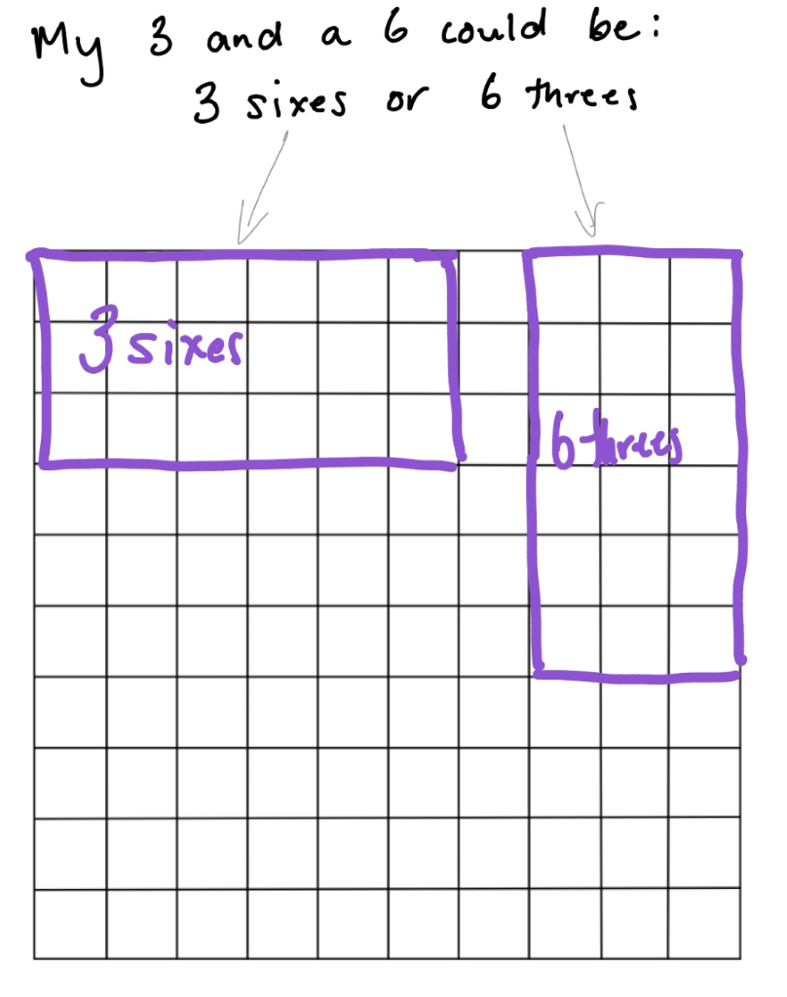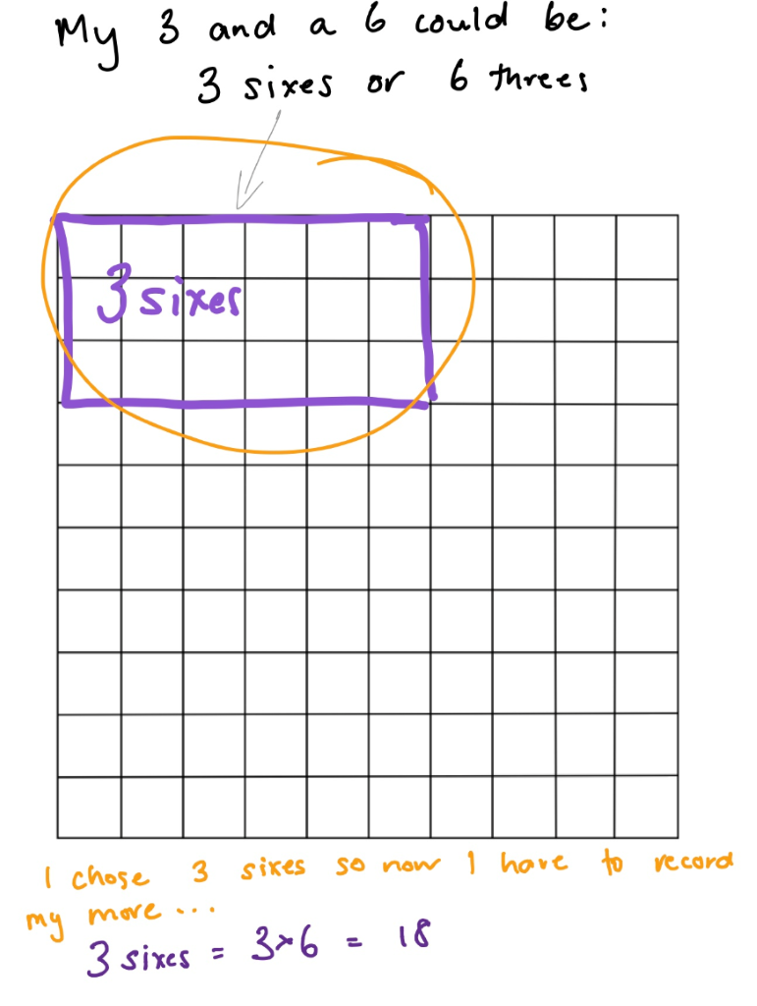
The game continues with no overlapping areas. The winner is the player with the largest area blocked out after 10 spins.
Eventually the space on the grid paper gets really small. Then, you have to think:
- What if my 3 sixes won’t fit as 3 sixes or as 6 threes? Players can partition to help them! So, for example, I can rename 3 sixes as 2 sixes and 1 six (if that helps me fit the block into my game board).
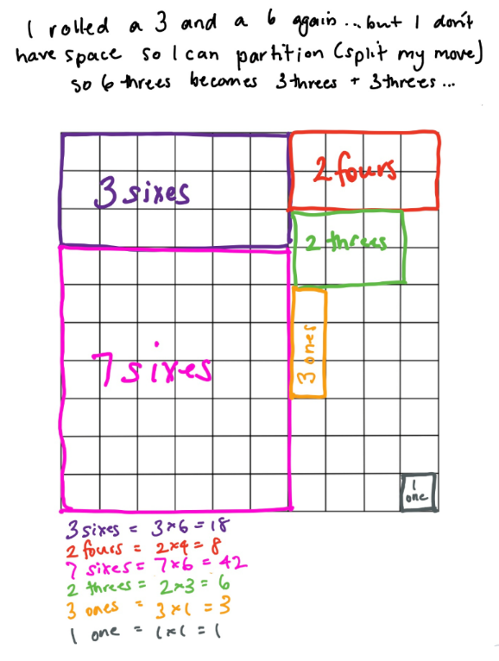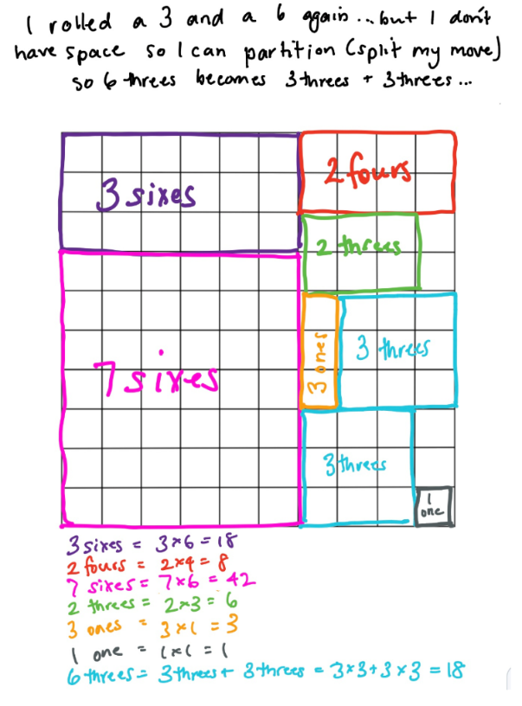

- Multiplication toss part 2
This is a variation of a game from Professor Dianne Siemon and the Victorian Department of Education (https://www.education.vic.gov.au/Documents/school/teachers/teachingresources/discipline/maths/assessment/lafzone2intro.pdf) A version of this game can also be found here (https://www.youcubed.org/tasks/how-close-to-100/)
Multiplication Toss (or race to 100) is useful for representing multiplicative situations using arrays and regions, exploring the commutative and distributive properties, enhancing reasoning skills and supporting learning about number facts.

Students play multiplication toss again. Later, they choose a selected area to investigate partitioning of composite units and explore equivalent areas.

  - Digital: Class to collaborate online. Use Activity 3 on PowerPoint slides. Watch follow-up video. Student selects an outlined area from their game board. Draw and label all of the different ways that area can be partitioned and renamed.
  - . Non-digital Student selects an outlined area from their game board, for example, here is a game board
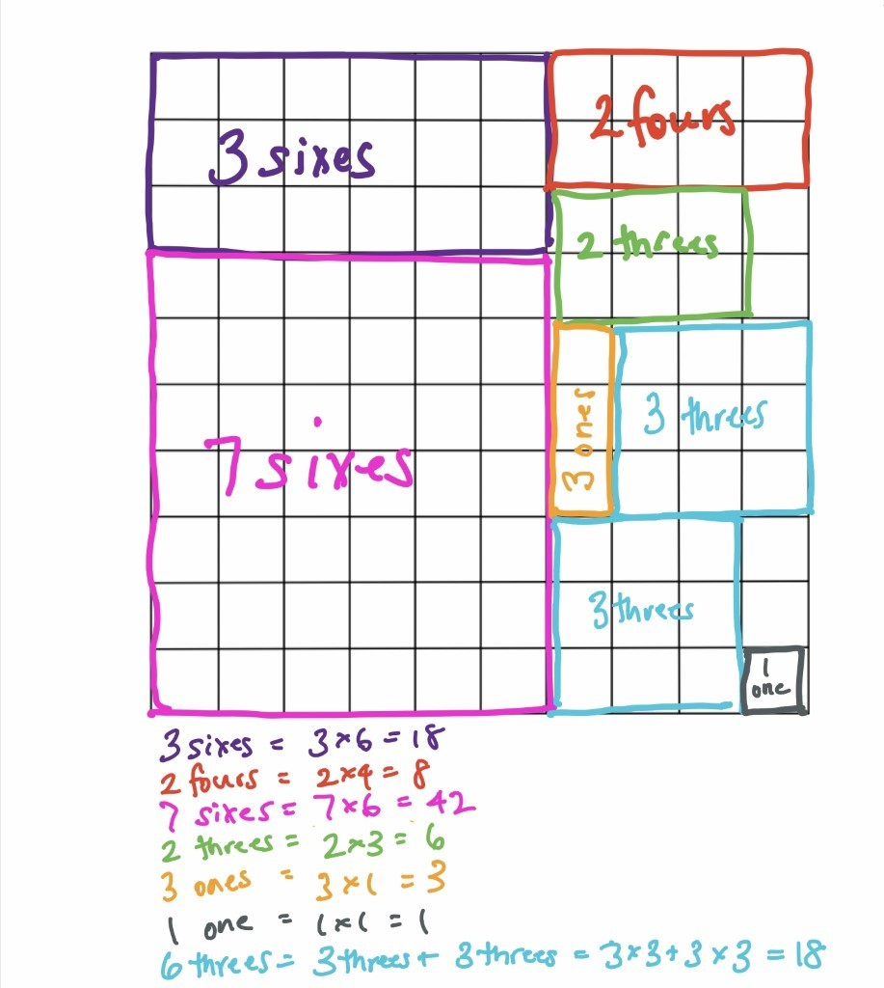

And you might choose this section:
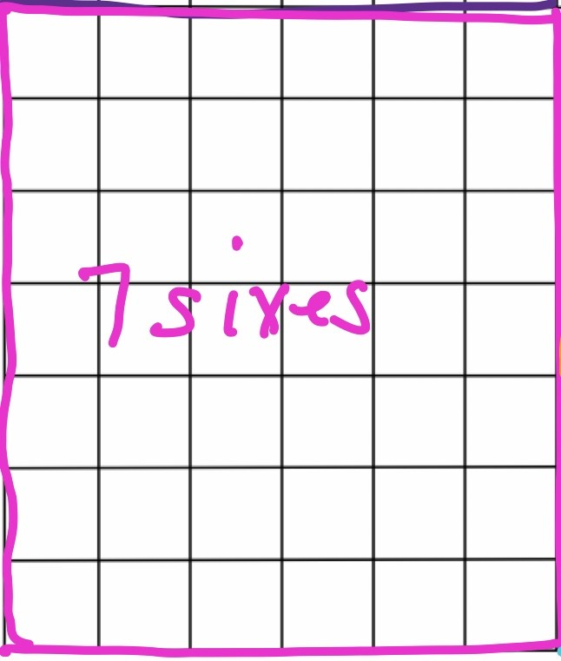
Draw and label all of the different ways that area can be partitioned and renamed.
For example (Here are 2 ideas)
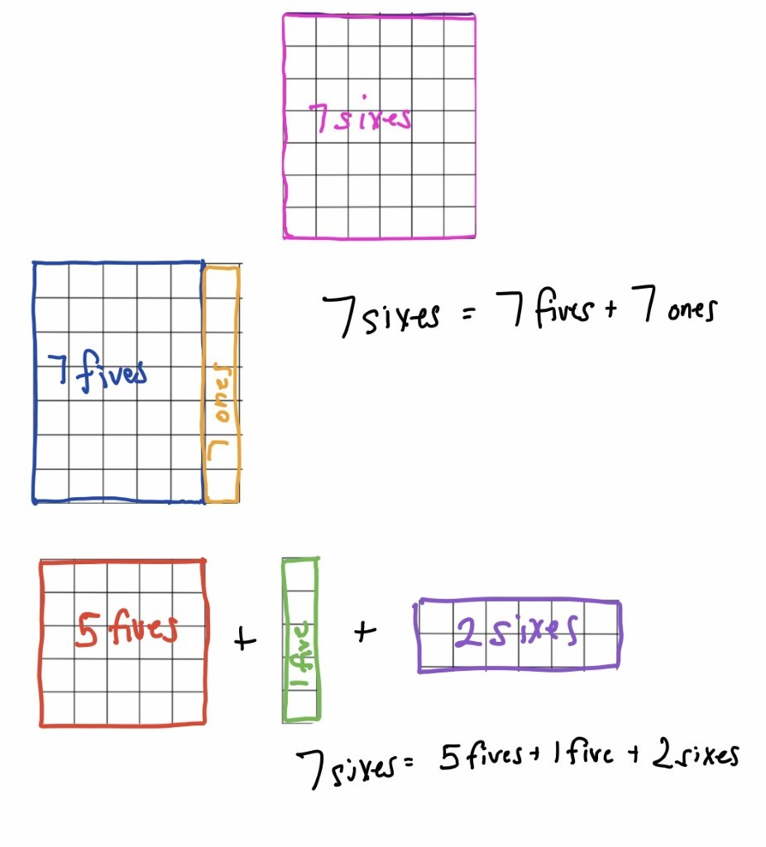
A student selects an outlined area from their game board. Draw and label all of the different ways that area can be partitioned and renamed.
- Colour in fractions (from: Clarke and Roche, Engaging Maths; 25 Favourite Maths Lessons, 2014)
a Digital: Class to collaborate online. Use Activity 4 on PowerPoint slides.
b.Non-digital: Students use dice or make cards that will create fractions up to twelfths, and a fraction wall. They colour in sections of the wall that correspond to the fractions that they roll with the dice or make with the cards.
Students will need:
- one die labelled 1, 2, 2, 3, 3, 4 in one colour or created on a spinner
- another die labelled *2 ,*3 ,*4 ,*6 ,*8 ,*12 in another colour or created on a spinner
- a fraction wall (game board) in the student mathematics workbook
- coloured pencils or markers

Players take turns to throw both dice or have a spin on their spinners. They make a fraction, the first die or spinner being the numerator. They then colour the equivalent of the fraction shown. For example, if a player rolls a 2 and *4 (or spins 2 and quarters) then they can colour in $\frac{2}{4}$of one line, or $\frac{4}{8}$ of one line, or $\frac{1}{4}$ of one line and $\frac{2}{8}$ of another, or any other combination that is the same as $\frac{2}{4}$.
For each roll or spin, the student should use a different colour pencil or marker.
If a player is unable to use their turn, they “pass.”
Students take it in turns to roll or spin and make fractions, marking them on their fraction wall. If the fraction rolled or its equivalence cannot be shaded, they miss a turn. This becomes more frequent later in the game.
Students are not allowed to break up a “brick.”
In finishing off the game, the student must have had 18 turns or have filled your wall. A larger fraction is not acceptable to finish.
The first player who colours in their whole wall is the winner, but the other player is encouraged to keep going (with the support of the first player) to fill their fraction wall, or the greatest number of wholes. If after 18 turns neither player colours in their whole wall, the player with the greatest number or wholes wins!

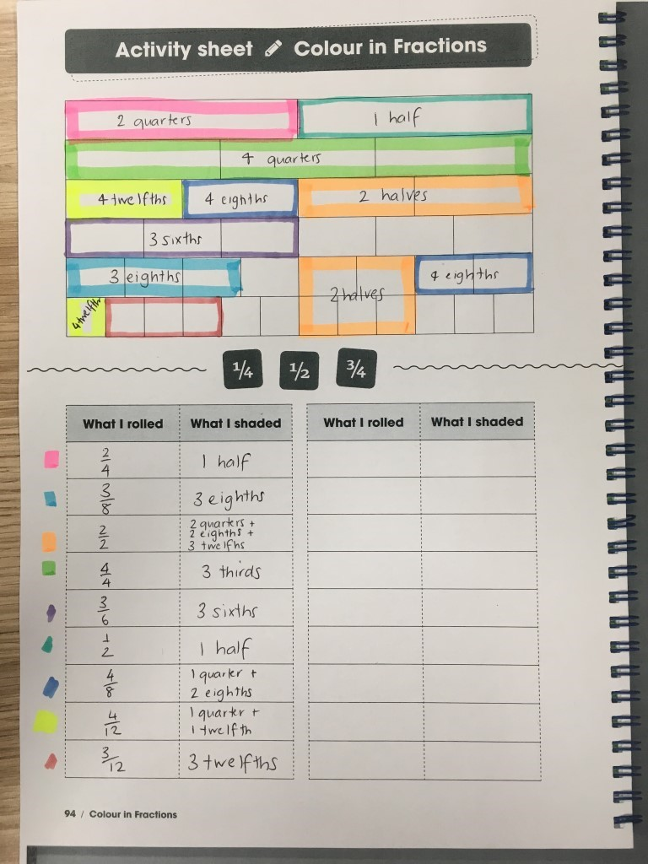
Students play colour in fractions in their student mathematics workbook.
Reflection questions:
1. If you played the game tomorrow, what would you do differently?
2. If you were giving some hints to a younger brother or sister who was about to play the game, what would you say to him or her to help them win?
- Colour in fractions (from: Clarke and Roche, Engaging Maths; 25 Favourite Maths Lessons, 2014)
Students will be guided into exploring equivalent fractions and renaming of fractions to support their skills in thinking flexibly and building number sense.
a. Digital Class to collaborate online. Use Activity 5 on PowerPoint slides.
b. Non-digital: Ask students to play the Colour in fractions game again.
Ask students to have a look at Michelle’s game board.
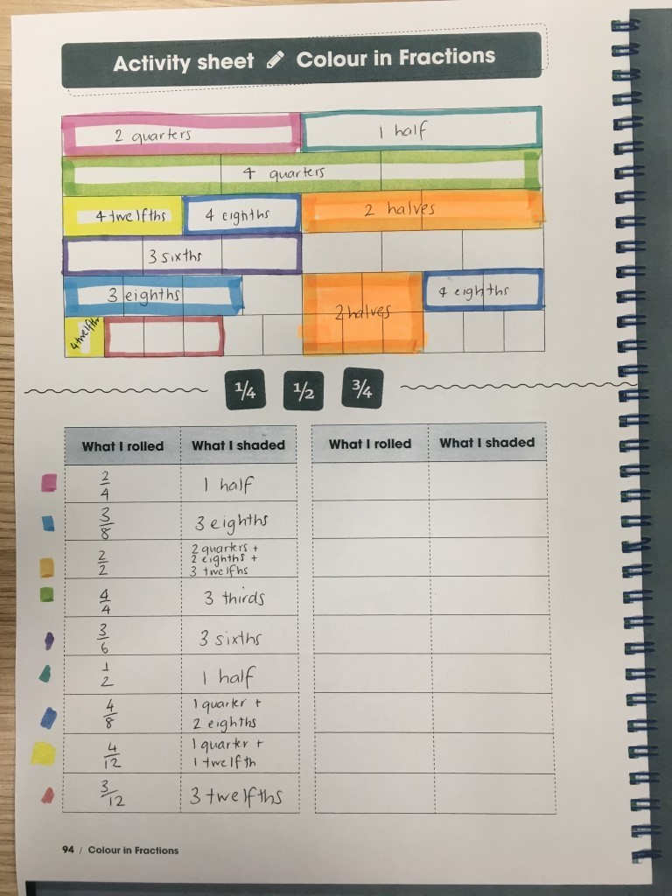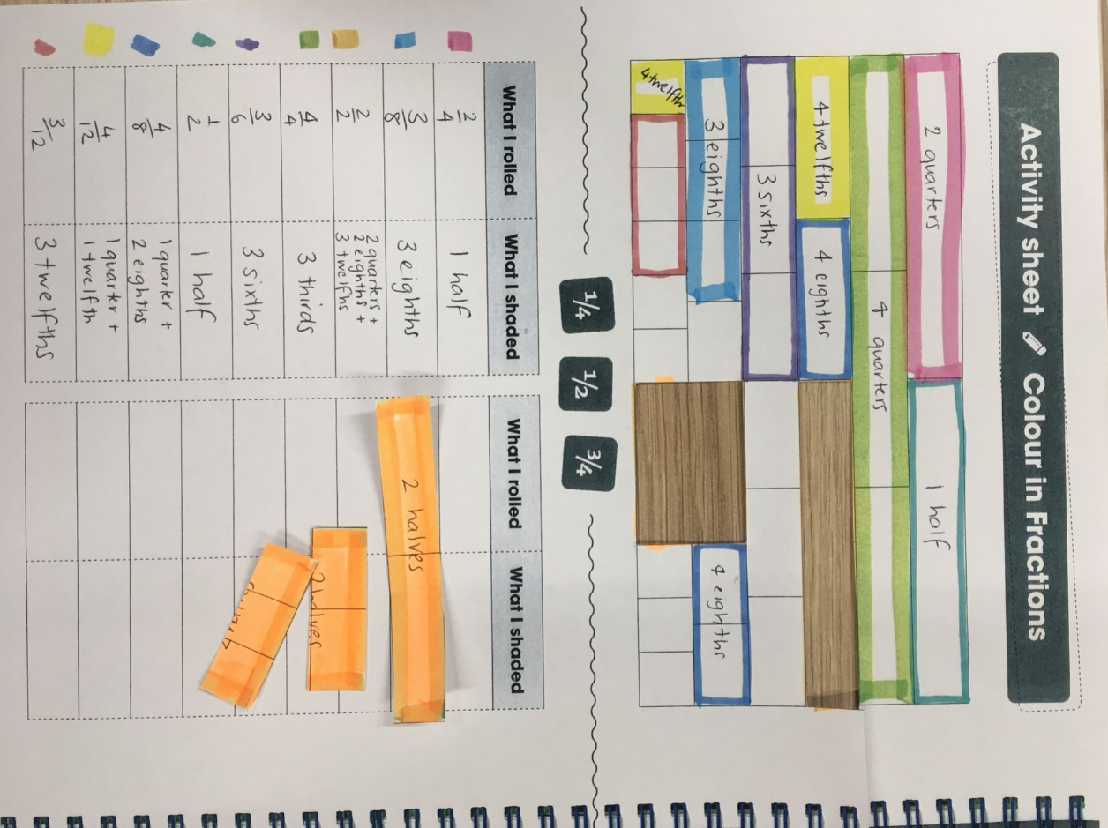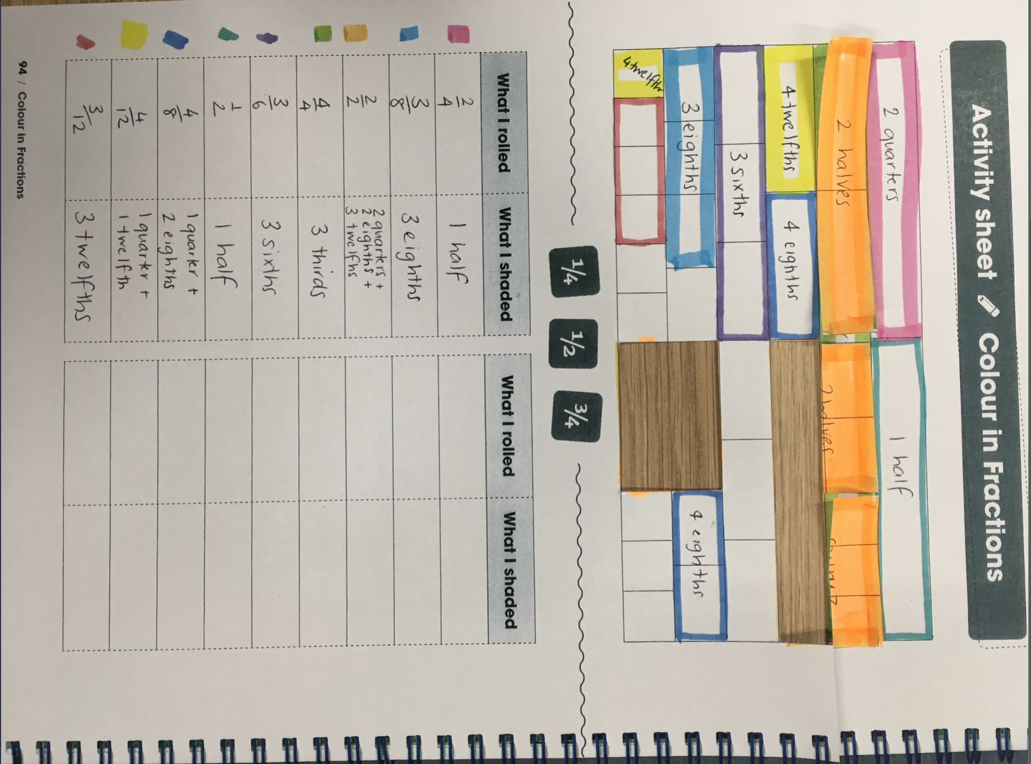
She recorded $\frac{2}{2}$ as 2 quarters + 2 eighths + 3 twelfths. She wondered... how many other ways can we rename $\frac{2}{2}$?$?$
Support students to use the game board to suggest ideas such as:
- 2 halves is...
- 2 quarters + 2 eighths + 3 twelfths
- 4 eighths + 1 half
- 4 eighths + 6 twelfths
- 3 sixths + 6 twelfths
- 3 thirds
Students can also explore their own game boards to investigate equivalent fractions.

- Basketball toss:
        - Digital: Class to collaborate online. Use Activity 6 on PowerPoint slides.
        - Non-digital: Students will need:
- pair of socks
- a clear space
- a bucket, basket or container
Your challenge: See how many times you can successfully shoot your rolled up socks into the basket.
Mark a clear ‘starting line’ for your Basketball toss
Take 3 big steps from your starting line and place a bucket, basket or container at the end.
Stand at your starting line and throw your socks. Throw your socks with your right hand.
Go back to your starting line and have your second throw. Repeat this until you have thrown your socks 10 times with your right hand.
Repeat the process with your left hand, with your eyes closed (using any hand you like) and trying backwards.

Keep a record of your baskets and graph your results.

What do you notice about your performance?
Do you think that these results will change with practice?

- Paul’s basketball challenge
              - Digital: Class to collaborate online. Use Activity 7 on PowerPoint slides.
              - Non-digital This graph shows the number of baskets Paul scored when he was playing basketball toss with his sister.
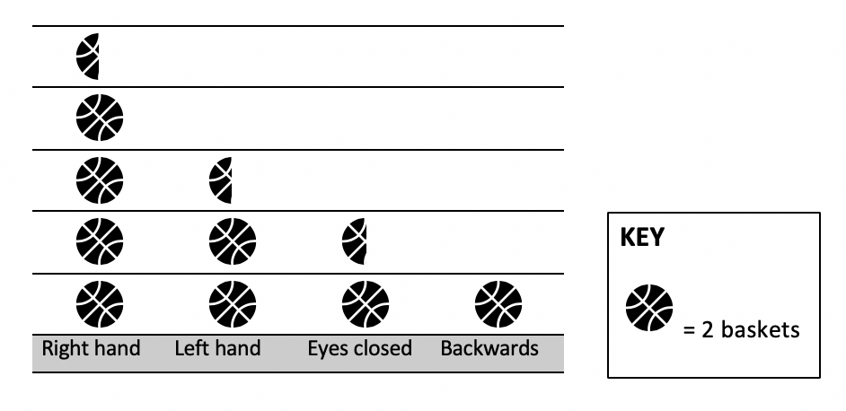
How many points did Paul score in total?
        - 9 and a half
        - 19
        - 16
        - 8
Paul decided that he wanted to improve his score and beat his sister the next time they played. He spent a lot of time practising using his left hand, playing backwards and with his eyes closed.
When he competed against his sister the next time, his efforts had worked! He had improved his score and he beat his sister! He scored 33 baskets. Paul had the same success with his right hand and improved by 1 with his eyes closed. How many baskets might he have scored with his left hand and backwards? What are all the possibilities?

- Let’s get magical! (A version this can be found on NRICH maths https://nrich.maths.org/11014/note)
It’s time to get magical! This magic trick provides a great context to practice additive strategies with 3-digit numbers and promotes reasoning and problem solving. Also, you get to read other people's minds using maths....no wonder it’s magic!
a. Digital: Class to collaborate online. Use Activity 8 on PowerPoint slides.
b. Non-digital: Students are invited to choose a 3-digit number where each digit is smaller than the previous one (but they don’t have to be in order. For example, 982 or 531.)
Then, reverse the digits and subtract the second number from the first one. So, if I had chosen 531 I would now work out 531 – 135. The answer is 396. (If you get 99, record your answer as 099.)
Next, reverse your new number. For example, from 396 I can make 639.
Finally, add these last two numbers together. For example, 396 + 639.
Here comes the magic...
The answer is 1089!
Invite students to try another starting number and test it out again...is the final answer still 1089?
Ask them to explore what happens if you use the same process, starting with a 2-digit number or a 4-digit number...what do you notice about the final answer? Why do you think this might be happening?

- Reaction time test (adapted from reSolve: Maths by Inquiry https://www.resolve.edu.au/authentic-problems-reaction-time)
During this activity, students will measure reaction times of themselves and others using the ruler drop test. This activity provides an opportunity to apply and refine their statistical and measurement skills as well as their understanding of time and decimal numbers.
a. Digital: Class to collaborate online. Use Activity 9 on PowerPoint slides.
b. Non-digital: Students will be investigating their reaction times using the ruler drop test.
To conduct the test, one person holds the ruler up reasonably high. The zero mark on the ruler is at the bottom.
The reacting person places finger and thumb at the bottom of the ruler, not touching but ready to grab.
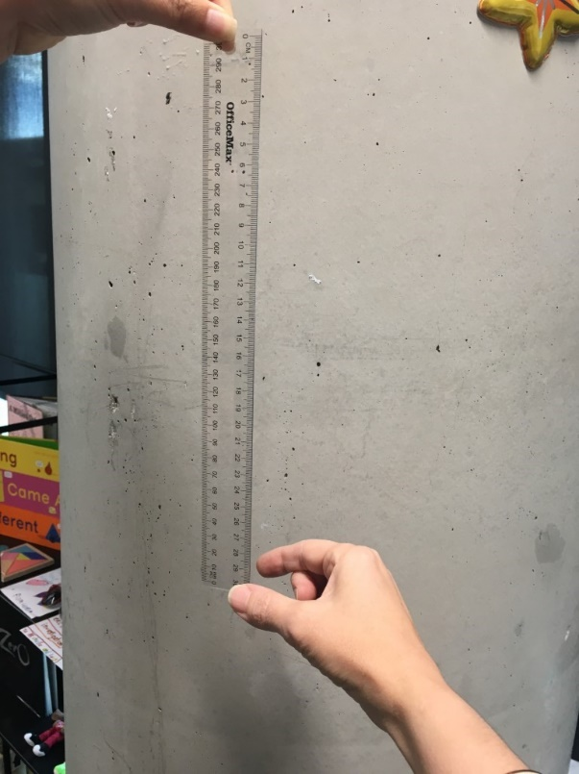
At an unpredictable time, the first person drops the ruler.
The reacting student catches it between their finger and thumb, and reads the distance below the thumb.
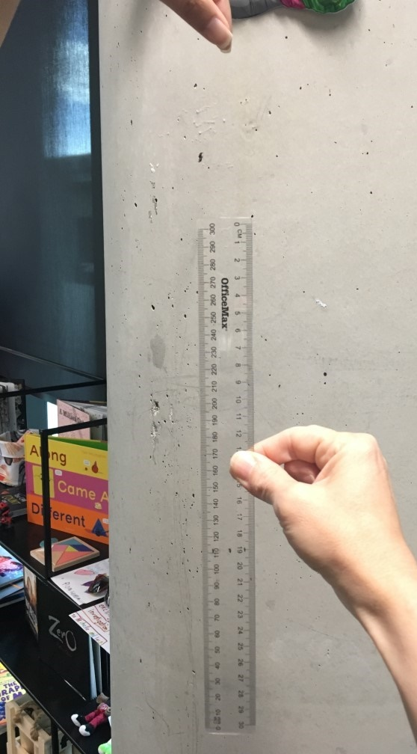
Conduct the test 5 times and record the results.
Convert the data into times using the ruler drop reaction time chart.
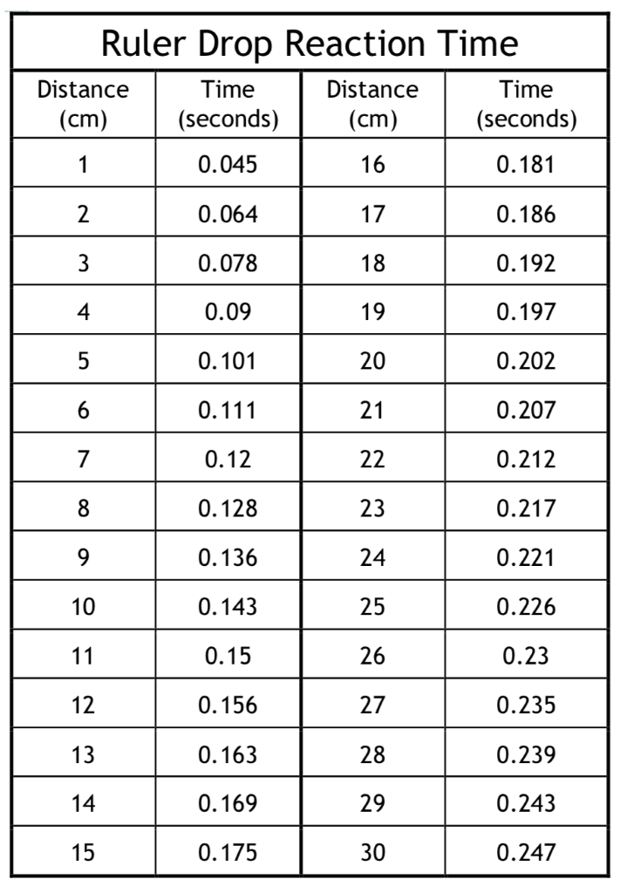
Ask students to draw a number line showing their reactions times.
Ask students to circle your fastest and slowest reaction times.
What is the difference between them?
Go explore: How does your reaction time compare with other people in your family?
- Raindrops (from YouCubed https://www.youcubed.org/wp-content/uploads/2018/09/Raindrop-Task-final-copy.pdf)
This activity involves students noticing and describing patterns using words and representations. Students use tables to help them notice the pattern, allowing them to generalise other cases.
  - Digital: Class to collaborate online. Use Activity 9 on PowerPoint slides.
  - Non-digital: Provide students with this image:
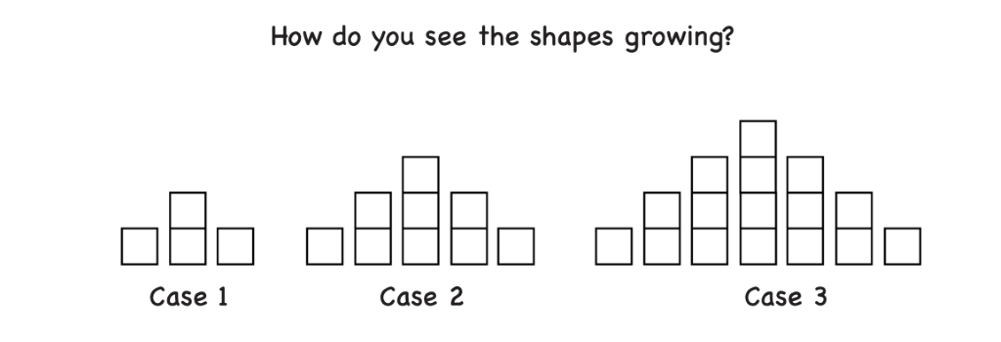
Explain that in case 2 there are more cubes than in case 1, and in case 3 there are more cubes again. Ask students to think about where they you see the extra cubes adding each time. Explain that there are many ways to answer this question as people see the cases in lots of different ways.
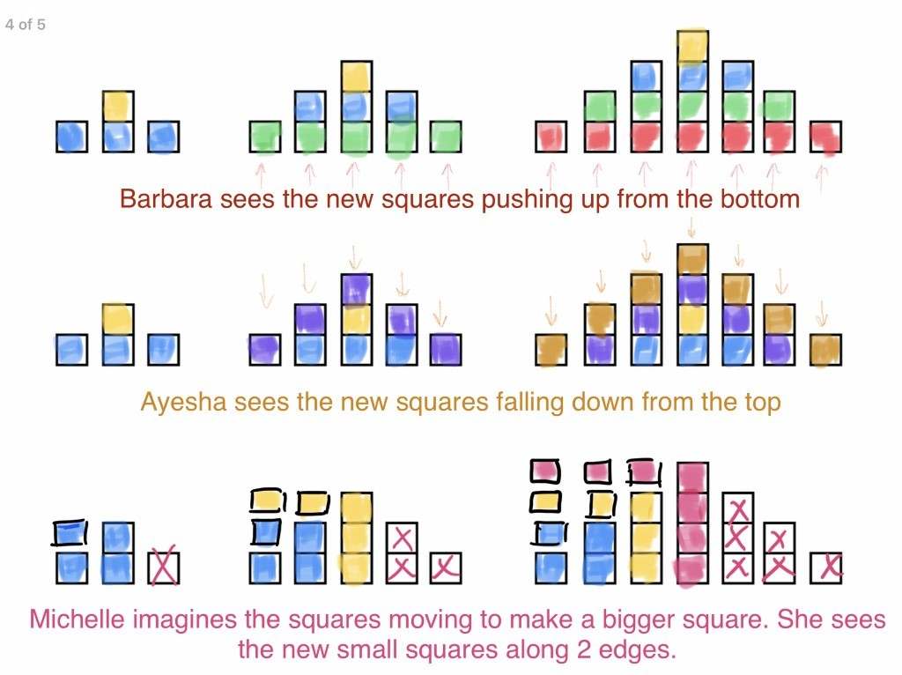
Ask:
- What will the fourth case look like?
- What will the tenth case look like?
- Mathematicians often like to draw diagrams and use tables to help them identify patterns. Can you use these strategies to help you?

Differentiation
Differentiation is a targeted process recognising that individuals learn at different rates and in different ways. Differentiation refers to deliberate adjustments to meet the specific learning needs of all students.
Here are some questions that you might consider when adapting the learning sequence to meet the needs of your students:
- What adjustments might you put in place for students who require additional support to access the task? For example, how will they get help when needed?
- Do you need to adjust the content to ensure it is adequately challenging and allows students to operate at their own level of thinking, skill and knowledge?
- Will you adapt the instructions so they are provided in a way that EAL/D students can easily interpret them? For example, through the use of visuals, checklists, diagrams or flow charts.
- Could you suggest ways that home language can be used as a tool to support learning? For example, bilingual dictionaries.
- Can you demonstrate that you value the Identity, culture, heritage and language of your Aboriginal students through your teaching practices?

Assessment

Using the aims of the lesson sequence as a guide, what do these tasks reveal about the knowledge, skills, understanding and interest of your students? You may like to take notes based on what you notice during conversations, student posts to digital platform and within student work samples.

Activity resources
- Online teaching resource (e.g. PowerPoint)
- Student mathematics workbooks
- Parent/carer advice: Parents may like to support their children by playing and talking to them about their experiences and their learning. It is strongly suggested they supervise their children when they are online. Teachers often find it beneficial to watch the videos like those included a few times to assist with developing confidence in noticing, wondering, talking, questioning, testing and playing like mathematicians. Feel free to play any of the games and activities more than once. These experiences are adaptable and so can be played with family and community members, who can join in on the fun!

