Mathematics workbook Stage 2
Name:
Class:

Overview
For the next 2 weeks, you will be having lots of fun with numbers. Most of these activities are games and investigations that you can play with your family and friends. Have fun and think deeply!
These activities do not require the use of a device. However, if you’re interested in seeing videos related to these activities, you can find the link on the Learning from home, Teaching and learning resources, K-6 resources page. https://education.nsw.gov.au/teaching-and-learning/curriculum/learning-from-home/teaching-and-learning-resources/k-6-resources

Activity 1
During this activity you will have to think hard to outwit your opponent. You will need to use your knowledge of strategies for addition and subtraction as well as number facts.
Resources – three colour pencils or markers

Strike it out! Let’s play!
(from NRICH Maths https://nrich.maths.org/8016
Draw a number line from 0 to 20 like this:
The first player chooses a number on the line and crosses it out.
The same player then chooses a second number and crosses that out too.
Finally, he or she circles the sum or difference of the two numbers and writes down the calculation.
For example, the first player's go could look like this:
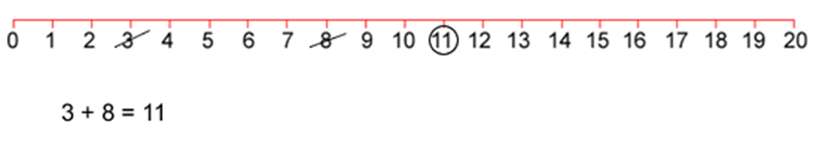
Player 2 must start by crossing off the number that player 1 has just circled. He or she then chooses another number to cross out and circles a third number which is the sum or difference of the two crossed-off numbers. Player 2 also writes down their calculation.
For example, once the second player has had a turn, the game could look like this:
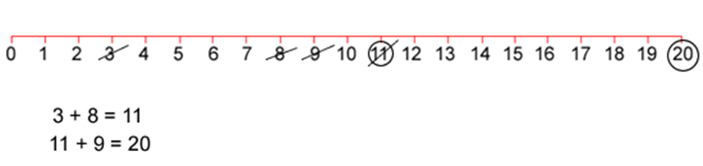
Play continues in this way with each player starting with the number that has just been circled.
For example, player 1 could then have a turn which left the game looking like this:
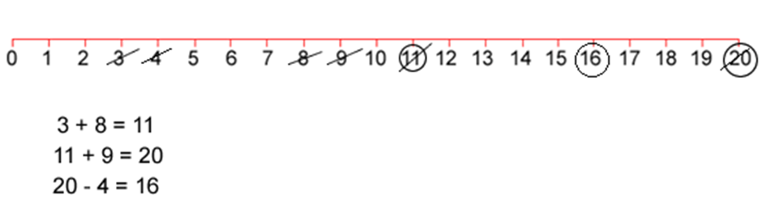
The winner of the game is the player who stops their opponent from being able to have a go.
Play this game with a partner.

Reflection
Think about what you have learnt in this activity. Use the two stars and a wish structure to guide your reflection.
Star  Something that went well! | Star  Something that went well! | Wish  A goal for next time…
 |  | (What is something you would do differently if you were to play the game again?)

Activity 2
During this activity you will have to think hard to outwit your opponent. You will need to use your knowledge of strategies for addition and subtraction as well as number facts.
Resources – three colour pencils or markers

Strike it out! Let’s investigate!
(from NRICH Maths https://nrich.maths.org/8016)
Now that you’ve had an opportunity to play a few games, were you able to cross out all of the numbers in one game?

You probably said; “no” to that question….and you might have realised it’s because there is a zero. Why do you think the zero means you can’t use every number from 0 -20?
Record your thinking.

If the number line went from 1-20, could all of the numbers be used? Play a game with someone and work together this time to answer this question. Record all of your ideas.

Play this game with a partner in your workbook or on paper.

Reflection
What did you discover about playing this game using different number lines?

Have you worked out a winning strategy? If so, what is it? How do you know it works?

Activity 3
During this activity you will need to use your knowledge and skills to work out how this magic trick works. As a mathematician, try looking for patterns between the numbers to help you crack the magicians code!
Resources – colour pencils, paper.

It’s time to get magical!
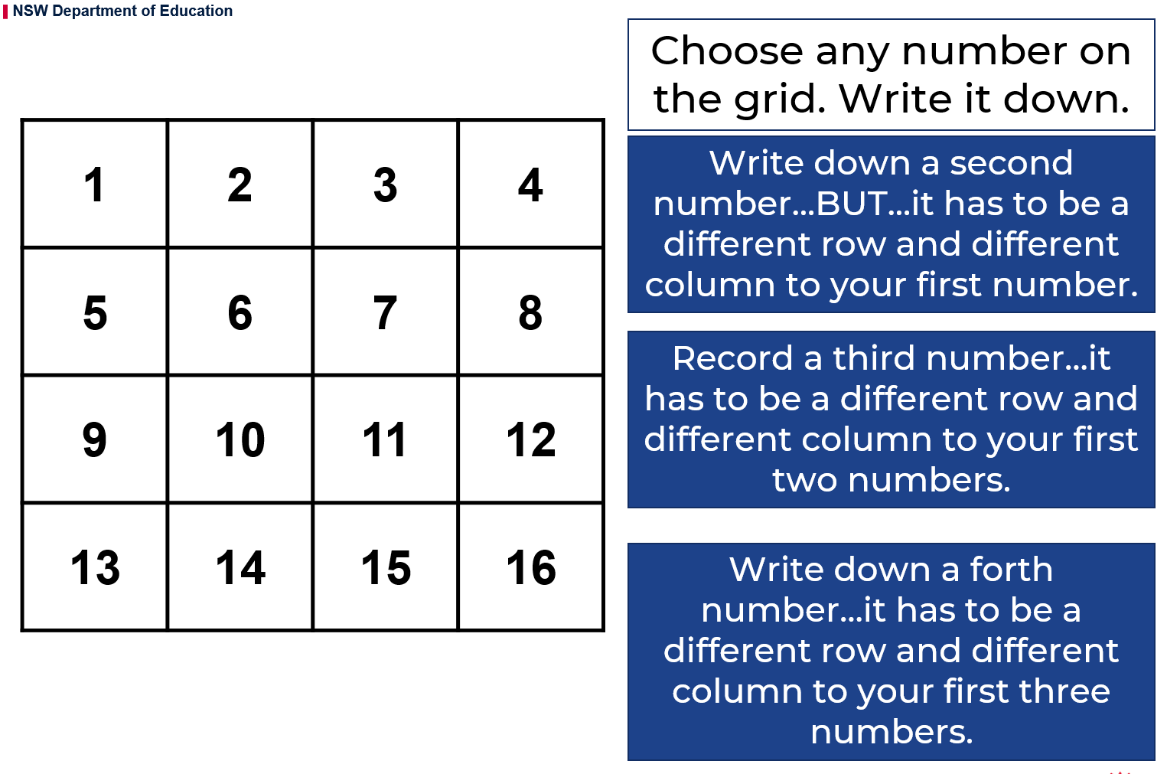
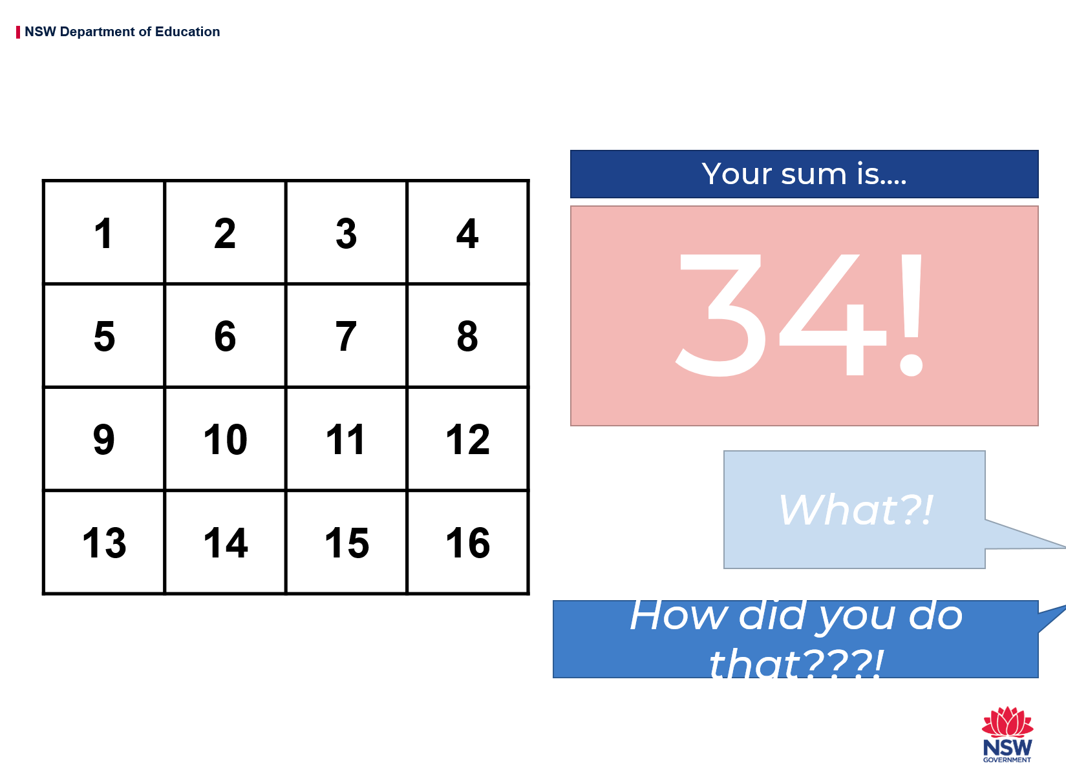
Explore and record your ideas.
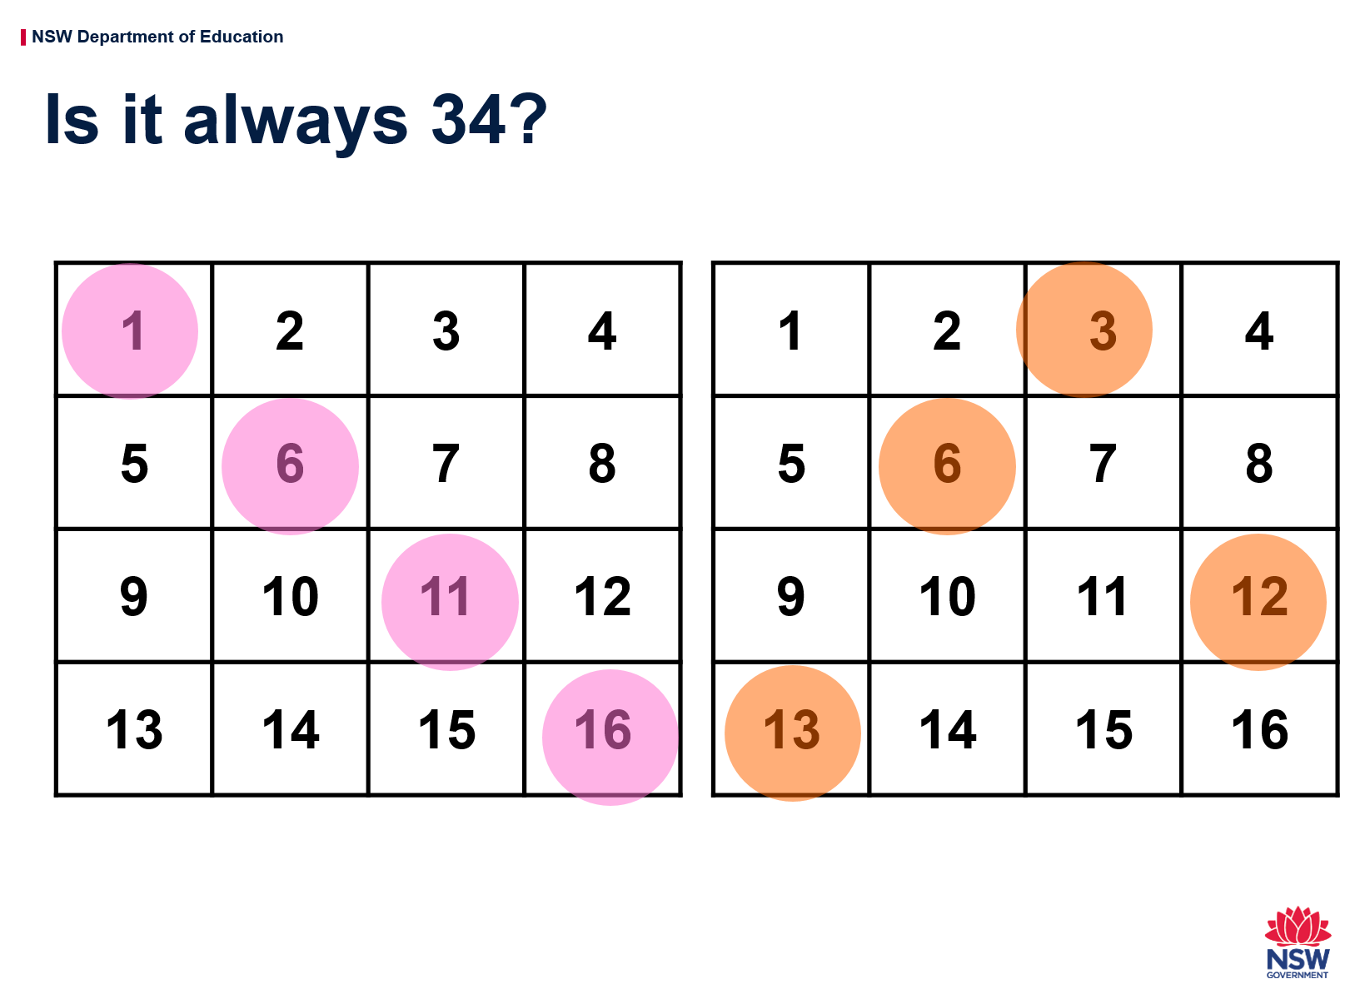
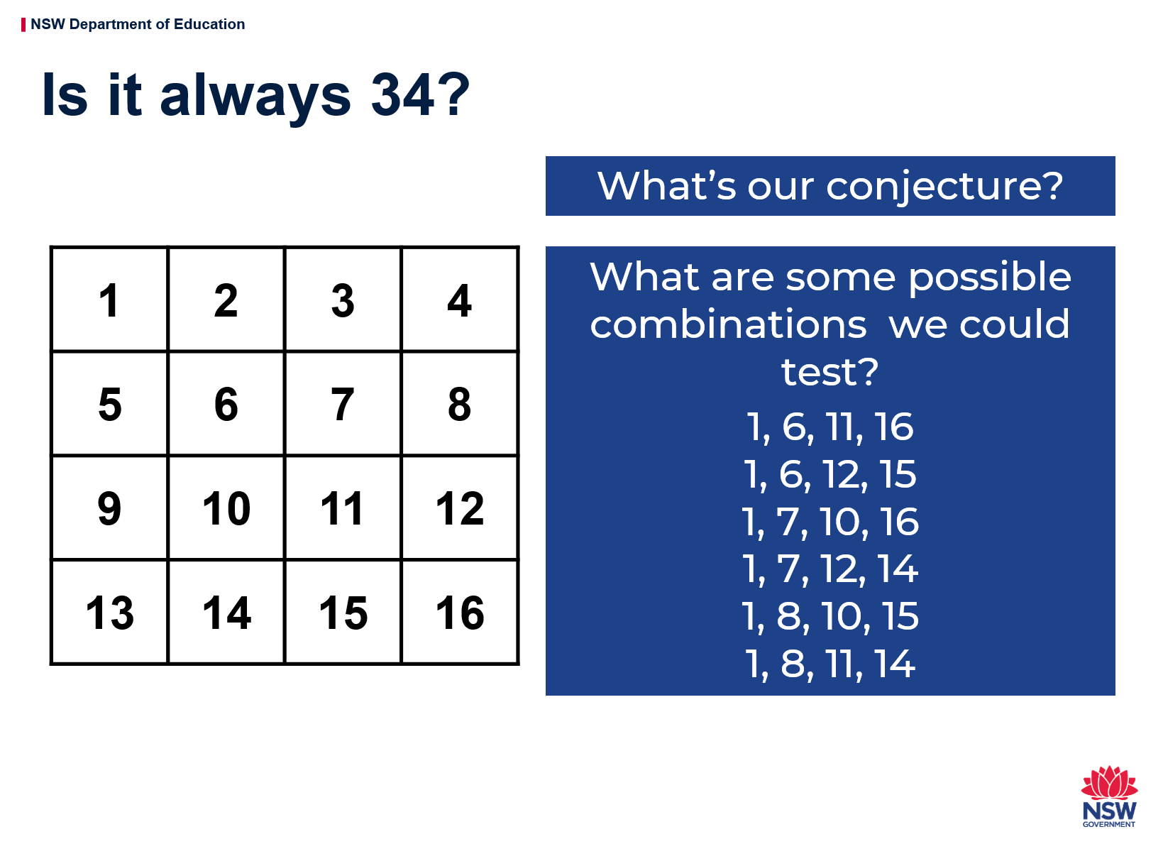
Explore these ideas and record your thoughts.

Reflection
If you follow the instructions, is the sum (total) always 34? Why do you think that works?

Activity 4
During this activity you will use your knowing of counting sequences and think strategically to beat your opponent! You should look for patterns to help you work out a winning strategy.
Resources – colour pencils or markers

The counting game: multiples
Select a target number, e.g. 85. Then, select a unit value, e.g. fives.
The goal is to be the player who says the target number. Players can count on by saying the next 1, 2 or 3 number words in the fives sequence. Players collect a counter (or a tally mark) if they say the target number. A new target number is chosen and players play again. For example:
Target number 85
Player A : 5, 10,
Player B: 15, 20, 25...
Player A: 30, 35, 40...
Player B: 45...
Player A: 50, 55
Player B: 60
Player A: 65,
Player B: 70, 80, 85!
Is there a way to play so that you never lose?

Could player A have changed their turn in any way to win? If so, how?

The counting game: multiples

Reflection
If you were to play this game again tomorrow, what would you do differently? Why?

Activity 5
During this activity you will use your knowing of counting sequences and think strategically to beat your opponent! You should look for patterns to help you work out a winning strategy.
Resources – colour pencils or markers

The counting game: multiples part 2
It’s time to test your strategies! This time staring from a given number and counting back, trying to be the person who says zero. For example
Target number 0 (starting at 110 and counting in tens)
Player A: 100...
Player B: 90, 80...
Player A: 70,...
Player B: 60...
Player A: 50, 40...
Player B: 30, 20, 10...
Player A: zero!!!!

Reflection
Think What did you notice about playing the game by counting backwards? Did it make your brain work harder or was it less difficult?

Did you work out a way to play this game so that you didn’t lose? What was your strategy? Did it work?

The counting game: multiples part 2

Activity 6
During this task, you will collect data about your success at sock basketball.
Resources: a basket or container, socks, pencils, a clear space
You can play this game alone or with a partner. Have fun!

Basketball toss
Your challenge: See how many times you can successfully shoot your rolled up socks into the basket, using your right hand and your left hand.

Mark a clear ‘starting line’ for your basketball toss.

Take 3 big steps from your starting line and place a basket or container at the end.

Stand at your starting line and throw your socks. Throw your socks with your right hand.

Go back to your starting line and have your second throw. Repeat this until you have thrown your socks 10 times with your right hand and 10 times with your left hand.
Keep a record on each shot using tally marks then graph your results.

Keep a record your success rate in your work book and then graph your results.

Reflection
What do you notice about your graph? What does it tell you about your success at playing sock basketball using your left hand compared to using your right hand?

Basketball toss

Activity 7
During this task, you will need to use your understanding of money, addition and subtraction, and problem solving skills to help you solve Sam’s Money Challenge.
Resources: pencil

Sam’s money challenge
Record how you would solve this problem.
Sam bought some lunch for his family which cost $13.65. He paid using this note:
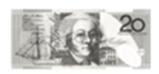
How much change will he receive?
a. $6.35 b. $6.45 c. $7.35 d.$7.45

As Sam put his change in his pocket, he realised he had been given 1 note and 4 coins. He wondered what other quantities could he make with one $5 note and 4 more coins?
- What’s the smallest amount I might have?
- What's the largest amount I might have?
- How many possibilities are there?

Reflection

Activity 8
During this task, you will answer the question ‘how many?’ by looking, thinking. You will need to organising your collection so that others can determine how many without needing to count everything.
Resources: pencil, pasta, counters, marbles, or dried broad beans

Two handfuls
Gather some equipment like pasta, counters, marbles, or dried broad beans. Take 2 handfuls and estimate how many you think you might have.
Determine how many items you have by looking and thinking.
Organise the collection so that someone can see how many there are without having to count everything by ones. Draw a picture of your work and use words and symbols to describe your thinking.
Is there another way you could arrange your object? Arrange them in a different way so you can see how many you have by looking and thinking. Draw a picture of your work and use words and symbols to describe your thinking.

Reflection
Compare the different ways you can arrange the collections:
  - Write down 3 things that are the same about the way you organised your collections
  - Write down 3 things that are different.

Two handfuls

Activity 9
During this task, you will answer the question ‘how many?’ by looking and thinking. You will need to organise your collection so that others can determine how many without needing to count everything.
You will also organise our collection into different arrays.
Resources: pencil, equipment e.g. dry pasta

Two handfuls part 2
Grab 2 handfuls of dried pasta (or another item). Use what you learnt yesterday to help you estimate how many pieces of pasta you might have in your handfuls today.
Determine how many you have by looking and thinking. Get 36 of pasta pieces, for example. Form them into a rectangular structure so that you have equal rows and columns. We call this an array. Draw and describe your array using words and symbols.
Re-organise your pasta pieces so it forms a different rectangle. Draw and describe your array using words and symbols. Keep re-organising your pasta pieces until there are no more arrays you can make. Draw and record all of your arrays.

Reflection
Pick your favourite array and describe it using both multiplication and division. Record your thinking in your notebook.

Star  Something that went well! | Star  Something that went well! | Wish  A goal for next time…

Two handfuls part 2

Activity 10
During this game, you will use your number sense and skills and knowledge in reasoning and multiplication and division! Have fun playing! During this task, you will determine quantities by looking and thinking and organise your collection so that others can easily determine how many without needing to count. You will also organise our collection into different arrays.
Resources: decagon shapes to make spinners, pencils or markers

Multiplication toss
You can play this by yourself or players take turns to spin the spinners. If a 3 and 6 are spun, players can enclose either block out 3 rows of 6 (3 sixes) or 6 rows of 3 (6 threes).
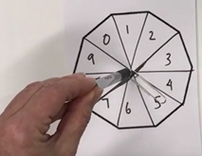
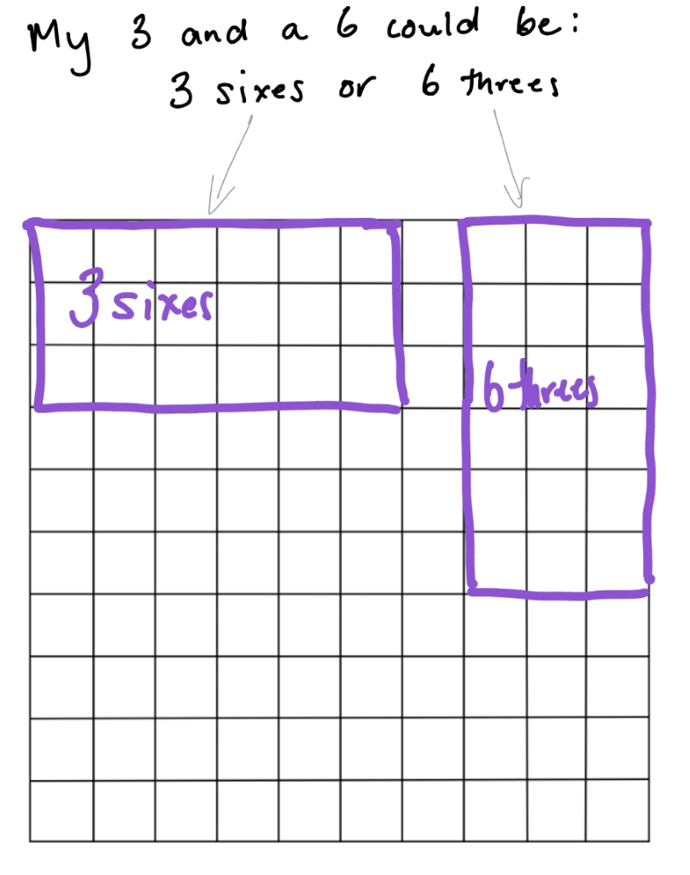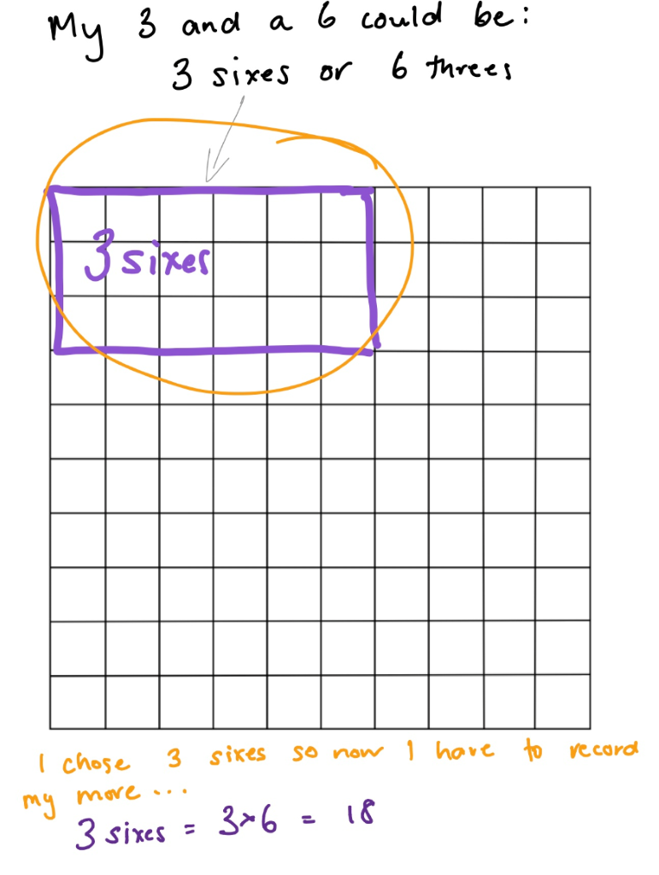
The game continues with no overlapping areas. If you are playing with a partner the winner is the player with the largest area blocked out.

Eventually the space on the grid paper gets really small. Then, you have to think:
  - What if my 3 sixes won’t fit as 3 sixes or as 6 threes? Players can partition to help them! So, for example, I can rename 3 sixes as 2 sixes and 1 six (if that helps me fit the block into my game board).
  - 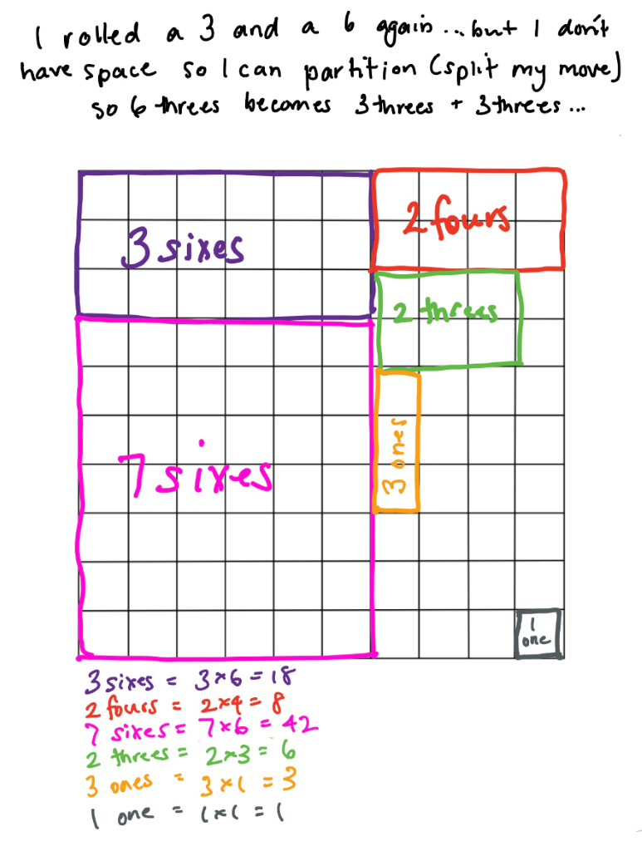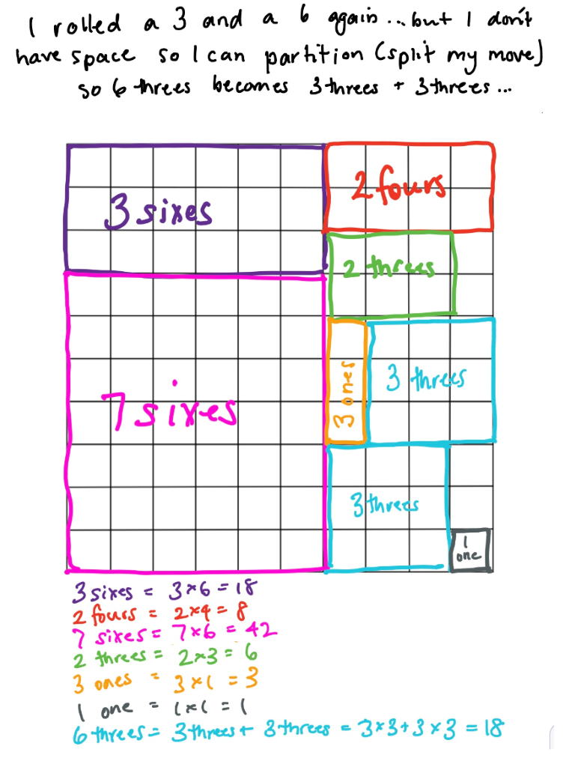

Play this game with a partner.

Reflection
Think about what you have learnt in this activity. Use the two stars and a wish structure to guide your reflection.
Star  Something that went well! | Star  Something that went well! | Wish  A goal for next time…

Resources
Grid for multiplication toss
