Mathematics – learning sequence

Resource considerations
This lesson sequence allows for continuity of student learning and could be adapted to fit in with your existing teaching and learning program. Students will be supported to meet outcomes from a Key Learning Area. Each task has a duration of 30 minutes and could be used in conjunction with your framework, designed using the K-6 template. This lesson sequence uses a balance of synchronous and asynchronous learning strategies. The tasks provide options for students with and without technology. They can be used with any online platform. Suggestions about how your school will plan students’ learning from home and ways to communicate with students can be found through the Learning at home, school planning page. Assessment strategies are included to ensure evidence of learning is monitored and collected.

Stage 2 learning sequence
Outcomes
MA2-1WM – uses appropriate terminology to describe, and symbols to represent, mathematical ideas
MA2-2WM – selects and uses appropriate mental or written strategies, or technology, to solve problems
MA2-3WM – checks the accuracy of a statement and explains the reasoning used
MA2-4NA – applies place value to order, read and represent numbers of up to five digits
MA2-5NA – uses mental and written strategies for addition and subtraction involving two-, three-, four- and five-digit numbers
MA2-6NA – uses mental and informal written strategies for multiplication and division
MA2-10MG – measures, records, compares and estimates areas using square centimetres and square metres
MA2-18SP – selects appropriate methods to collect data, and constructs, compares, interprets and evaluates data displays, including tables, picture graphs and column graphs
Learning sequence overview – This sequence of lessons provides opportunities to practise additive and multiplicative thinking and develop strategies in the contexts of games and investigations. Teachers will be able to leverage opportunities to connect learning between aspects of Number and Algebra with learning in Measurement and Geometry, and Statistics and Probability.

Aim of lesson sequence
Teachers should look for evidence of:
- Reasoning
  - What evidence do students use when making decisions?
  - Are students thinking logically to determine winning strategies and to solve problems?
  - Do students re-think ideas based on new evidence/new understanding?
- Communicating
  - Do students use appropriate mathematical language?
  - Do students use appropriate mathematical representations including diagrams, models and symbols when recording ideas?
  - Can students record and communicate ideas using data representations like graphs?
- Additive strategies
  - Do students use a range of flexible strategies when solving problems using addition and subtraction?
  - Do students use the commutative property?
- Multiplicative strategies
  - Do students use a range of flexible strategies when solving problems using multiplication and division?
  - Do students use the commutative and distributive principles?
- Number sense
  - Do students use numbers flexibly?
  - Do students use part-part-whole knowledge to solve problems?
  - Do students use operations flexibly?
  - Can students extend this thinking into their understanding of area?

Teacher notes
- These tasks are easily adaptable and can be used co-operatively, competitively, in a digital or non-digital environment.
- To access the videos in the PowerPoint, open the PowerPoint online, teachers and students may need to sign in with their school email address if prompted.

Activities
- Strike it out! Let’s play! (from NRICH Maths https://nrich.maths.org/8016)
Strike it out! is a great context to enhance skills in reasoning, working collaboratively, and applying knowledge of additive strategies. The game is easily adaptable for a broad range of learners, also allowing you to do some deep investigations around winning strategies and using all of the numbers along the number line.
Day 1 involves playing this game. Day 2 encourages some deeper investigatory work.
Digital: Class to collaborate online. Use Activity 1 PowerPoint slides.
Non-digital: Draw a number line from 0 to 20 like this:
The first player chooses a number on the line and crosses it out.
The same player then chooses a second number and crosses that out too.
Finally, he or she circles the sum or difference of the two numbers and writes down the calculation.
For example, the first player's go could look like this:
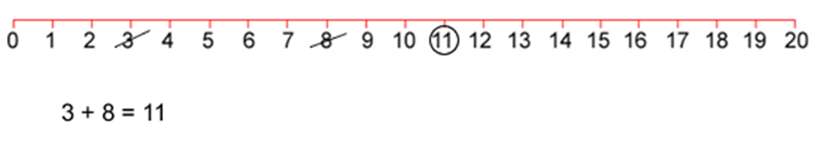
The second player must start by crossing off the number that player 1 has just circled.
He or she then chooses another number to cross out and then circles a third number which is the sum or difference of the two crossed-off numbers.
Player 2 also writes down their calculation.
For example, once the second player has had a turn, the game could look like this:
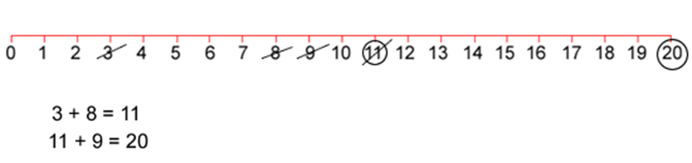
Play continues in this way with each player starting with the number that has just been circled.
For example, player one could then have a turn which left the game looking like this:
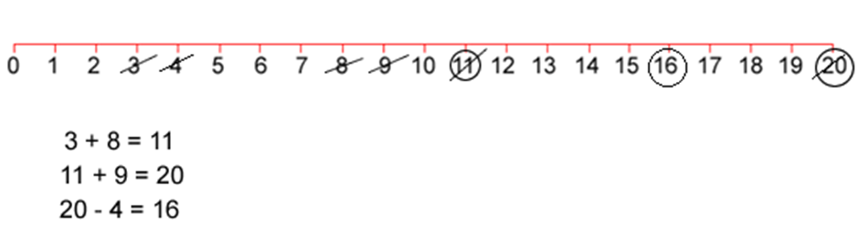
The winner of the game is the player who stops their opponent from being able to have a go.
- Strike it out! Let’s investigate! (from NRICH Maths https://nrich.maths.org/8016)
  - Digital: Class to collaborate online. Use Activity 2 PowerPoint slides for a strategy discussion about Strike it out!
Now that you’ve had an opportunity to play a few games, what are some of the strategies you used to try to help you win? Were you able to win every time you played?
Take some time to share different winning strategies before moving on to investigate whether all of the numbers along the number line can be used. Ask:
- Who had the fewest numbers crossed out on their number line? Did you win or did someone else? What different moves could have been done to have crossed out more numbers?
- Who played a game where all of the numbers were crossed out?
- Can you cross out all of the numbers in one game? How do you know?
- Give students time to work co-operatively or with the group before bringing them together again to see what they have found out. Some will have realised that it is impossible to cross off zero - encourage them to explain why this is the case. Then ask:
- What if the number line went from 0-19, or, from 1-20…could all the numbers be crossed out then? What could the game look like…what could the moves be?
- What if you could use multiplication and division…test it out and see how that changes the game.
  - Non-digital: Now that you’ve had an opportunity to play a few games, were you able to cross out all of the numbers in one game?
You probably said; “no” to that question….and you might have realised it’s because there is a zero. Why do you think the zero means you can’t use every number from 0 -20? Record your thinking in your notebook.
If the number line went from 1-20, could all of the numbers be used? Play a game with someone and work together this time to answer this question. Use your notebook to record all of your ideas.

- It’s time to get magical!
- Digital: Class to collaborate online. Use Activity 3 PowerPoint slides.
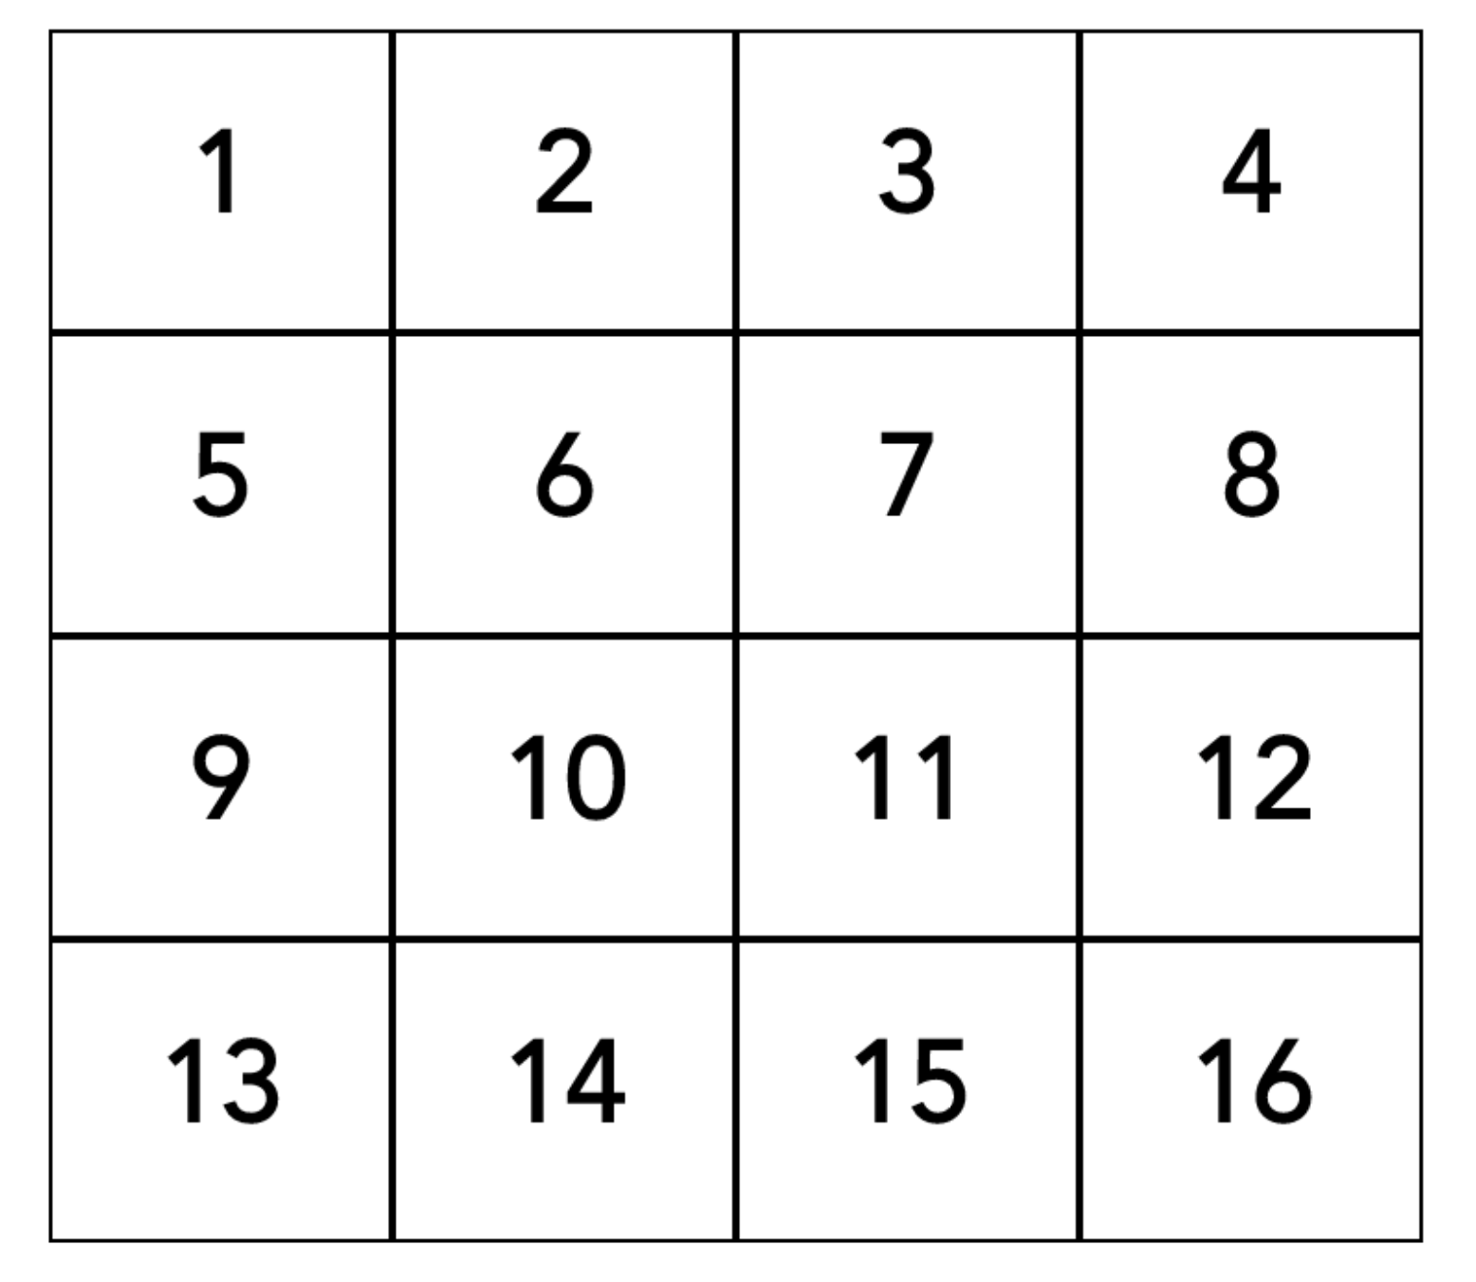
b. Non-digital: Choose any number from the grid. Write it down. Write down a second number…but…it has to be a different row and different column to your first number. Record a third number…it has to be a different row and different column to your first two numbers. Write down a fourth number…it has to be a different row and different column to your first three numbers. ...Your number is 34!
- Is it always 34?
- Devise a strategy to prove whether the sum of the 4 numbers will always be 34…no matter what numbers you use.
- Record thinking in notebook.

- The counting game: multiples
This is a great game that supports students in enhancing their reasoning skills whilst also practicing their knowledge of counting sequences. It is easily adaptable to suit a really broad range of learners.
- Digital: Class to collaborate online. Use Activity 4 PowerPoint slides.
- Non-digital: Students to select a target number, for example, 85. Then, select a unit value, for example, fives.
The goal is to be the player who says the target number. Players can count on by saying the next 1, 2 or 3 number words in the fives sequence. Players collect a counter (or a tally mark) if they say the target number. A new target number is chosen and players play again. For example:
Target number 85
Player A : 5, 10,
Player B: 15, 20, 25...
Player A: 30, 35, 40...
Player B: 45...
Player A: 50, 55
Player B: 60
Player A: 65,
Player B: 70, 80, 85!
Is there a way to play so that you never lose?
Could player A have changed their turn in any way to win? If so, how?
- The counting game: multiples part 2
a. Digital: Class to collaborate online. Use activity 5 PowerPoint slides.
Join your class online to play and put your winning strategies to the test! This time start from a given number and count back, trying to be the person who says zero.
b. Non-digital: It’s time to test out your strategies! This time starting from a given number and counting back, trying to be the person who says zero. For example,
Target number 0 (starting at 110 and counting in tens)
Player A: 100...
Player B: 90, 80...
Player A: 70...
Player B: 60...
Player A: 50, 40...
Player B: 30, 20, 10...
Player A: zero!

- Basketball toss
- Digital: Class to collaborate online. Use Activity 6 PowerPoint slides.
- Non-digital: You need:
- pair of socks
- a clear space.
- basket or container
Your challenge: See how many times you can successfully shoot your rolled up socks into the basket.
Mark a clear ‘starting line’ for your basketball toss
Take 3 big steps from your starting line and place a basket or container at the end.
Stand at your starting line and throw your socks. Throw your socks with your right hand.
Go back to your starting line and have your second throw. Repeat this until you have thrown your socks 10 times with your right hand and 10 times with your left hand.
Keep a record in your workbook.
Graph your results.
Do you think that these results will change with practice?

- Sam’s money challenge
- Digital: Class to collaborate online. Use activity 7 PowerPoint slides.
- Non-digital: Record how you would solve this problem.
Sam bought some lunch for his family which cost $13.65. He paid using this note:
$20
How much change will he receive?
a. $6.35 b. $6.45 c. $7.35 d. $7.45
As Sam put his change in his pocket, he realised he had been given 1 note and 4 coins. He wondered....what other quantities could I make with one $5 note and 4 more coins?
- What’s the smallest amount I might have?
- What's the largest amount I might have?
- How many possibilities are there?

- Two handfuls (developed by A Gervasoni, Monash University. Shared here https://www.resolve.edu.au/counting-handfuls
a. Digital: Class to collaborate online. Use Activity 8 PowerPoint slides.
b. Non-digital: Gather some equipment like pasta, counters, marbles, or dried broad beans. Take 2 handfuls and estimate how many you think you might have.
Invite students to determine how many items they have by ‘looking and thinking’.
Organise the collection so that someone can see how many there are without having to count everything by ones. Draw a picture of your work and use words and symbols to describe your thinking.
Is there another way you could arrange your objects? Arrange them in a different way so you can see how many you have by looking and thinking. Draw a picture of your work and use words and symbols to describe your thinking.
Compare the different ways you can arrange the collections:
- Write down 3 things that are the same about the way you organised your collections.
- Write down 3 things that are different.

- Two handfuls: part 2 (developed by A Gervasoni, Monash University. Shared here https://www.resolve.edu.au/counting-handfuls
- Digital: Class to collaborate online. Use Activity 9 PowerPoint slides.
- Non-digital: Grab 2 handfuls of dried pasta (or another item). Use what you learnt yesterday to help you estimate how many pieces of pasta you might have in your handfuls today.
Determine how many you have by looking and thinking. Get 36 pasta pieces, for example. Form them into a rectangular structure so that you have equal rows and columns. We call this an array. Draw and describe your array using words and symbols.
Re-organise your pasta pieces so it forms a different rectangle. Draw and describe your array using words and symbols.
Keep re-organising your pasta pieces until there are no more arrays you can make. Draw and record all of your arrays.
Pick your favourite array and describe it using both multiplication and division. Record your thinking in your notebook.

- Multiplication Toss
This is a variation of a game from Professor Dianne Siemon and the Victorian Department of Education (https://www.education.vic.gov.au/Documents/school/teachers/teachingresources/discipline/maths/assessment/lafzone2intro.pdf)
A version of this game can also be found on YouCubed (https://www.youcubed.org/tasks/how-close-to-100/)
Multiplication Toss (or race to 100) is useful for representing multiplicative situations using arrays and regions, exploring the commutative and distributive properties, enhancing reasoning skills and supporting learning about number facts.
  - Digital: Class to collaborate online. Use PowerPoint slides.
  - Non-digital: You need 1cm square grid paper, different coloured pencils or markers and two spinners (see mathematics workbook).
Players take turns to spin the spinners. If a 3 and 6 are spun, players can enclose either a block out of 3 rows of 6 (3 sixes) or 6 rows of 3 (6 threes).
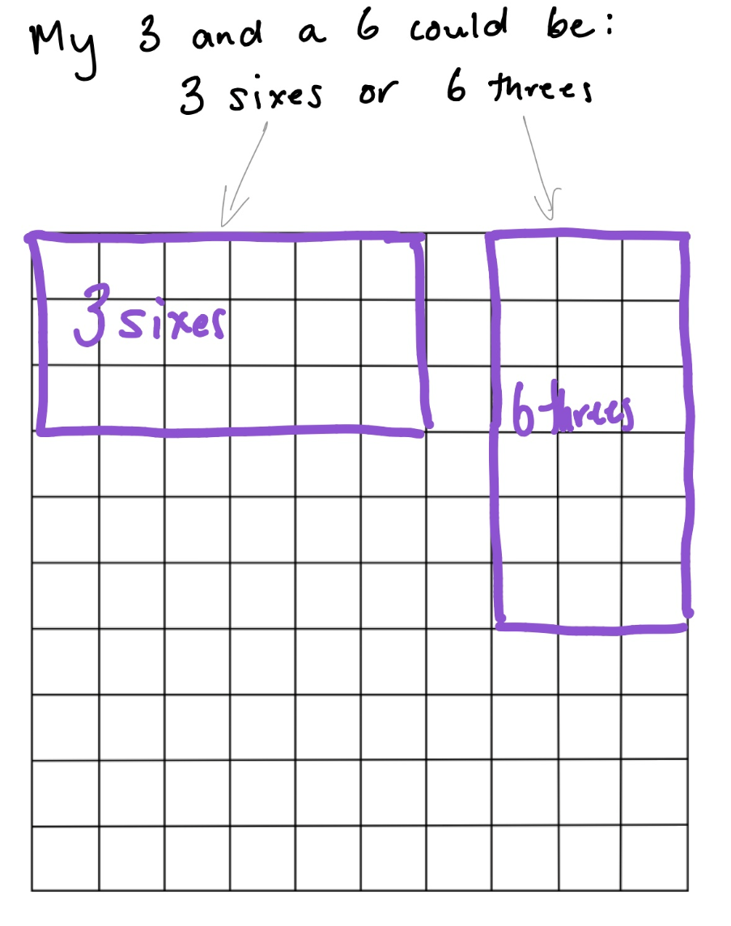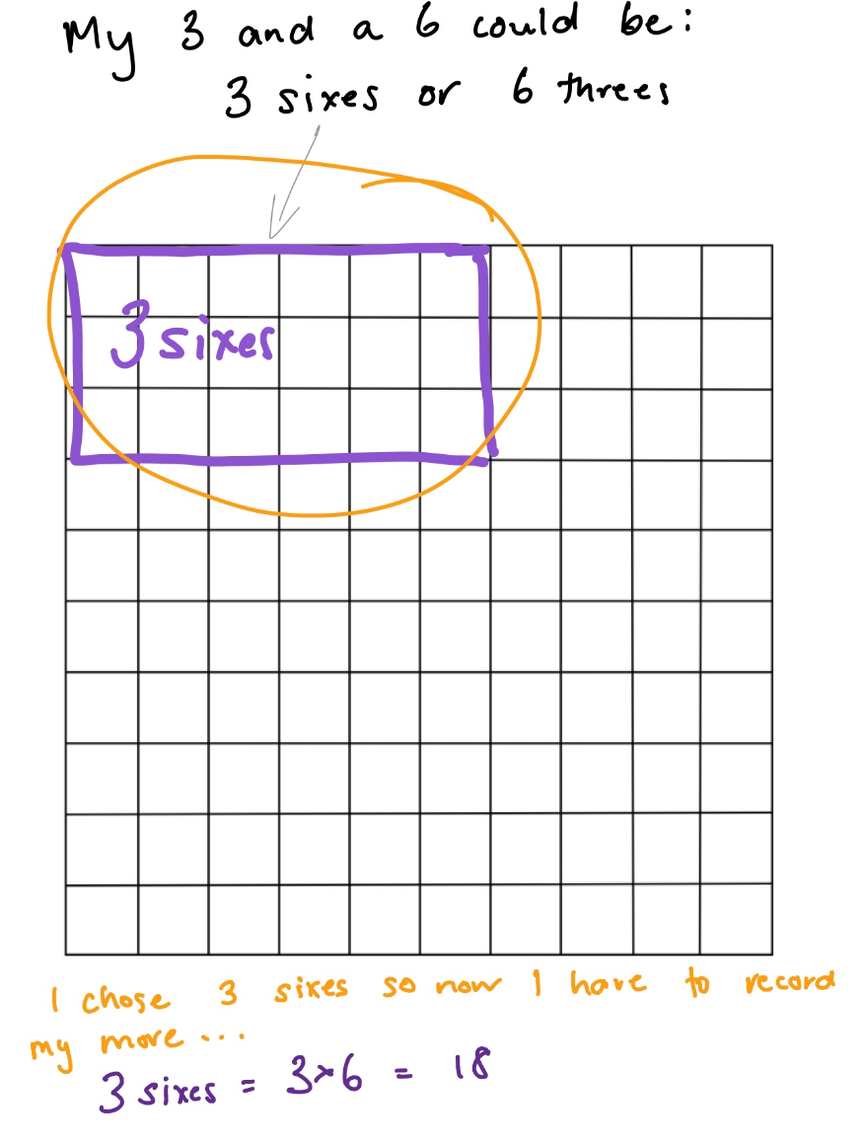
The game continues with no overlapping areas. The winner is the player with the largest area blocked out after 10 spins.
Eventually the space on the grid paper gets really small. Then, you have to think:
  - What if my 3 sixes won’t fit as 3 sixes or as 6 threes? Players can partition to help them! So, for example, I can rename 3 sixes as 2 sixes and 1 six (if that helps me fit the block into my game board).
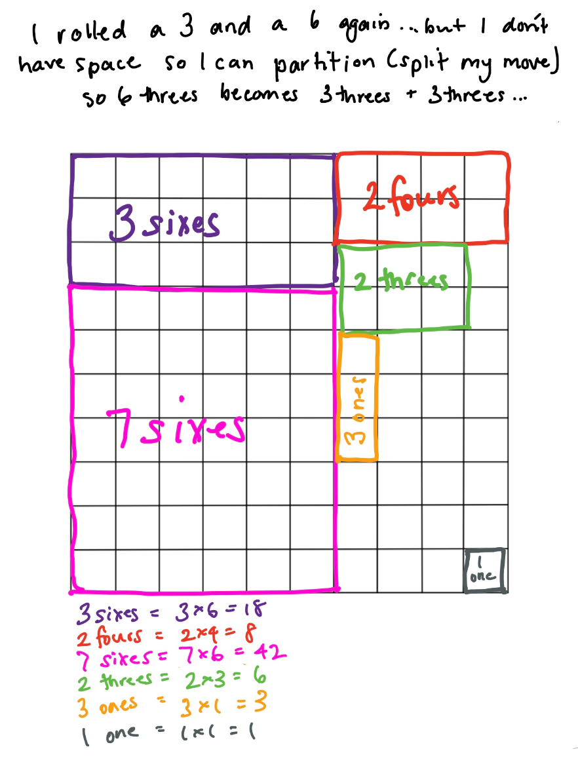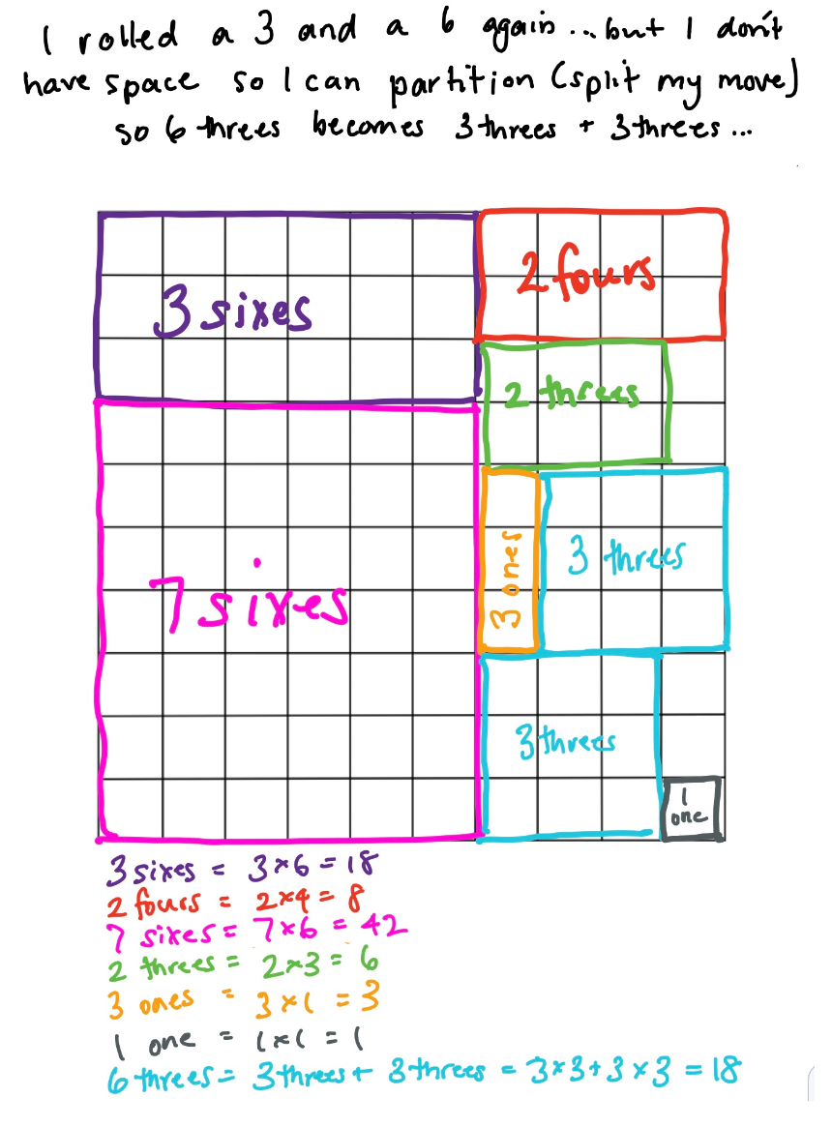

Differentiation
Differentiation is a targeted process recognising that individuals learn at different rates and in different ways. Differentiation refers to deliberate adjustments to meet the specific learning needs of all students.
Here are some questions that you might consider when adapting the learning sequence to meet the needs of your students:
- What adjustments might you put in place for students who require additional support to access the task? For example, how will they get help when needed?
- Do you need to adjust the content to ensure it is adequately challenging and allows students to operate at their own level of thinking, skill and knowledge?
- Will you adapt the instructions so they are provided in a way that EAL/D students can easily interpret them? For example, through the use of visuals, checklists, diagrams or flow charts.
- Could you suggest ways that home language can be used as a tool to support learning? For example, bilingual dictionaries.
- Can you demonstrate that you value the Identity, culture, heritage and language of your Aboriginal students through your teaching practices?

Assessment
Using the aims of the lesson sequence as a guide, what do these tasks reveal about the knowledge, skills, understanding and interest of your students? You may like to take notes based on what you notice during conversations, student posts to digital platform and within student work samples.

Activity resources
- Online teaching resource (for example, PowerPoint)
- Student mathematics workbooks
- Parent/carer advice: Parents may like to support their children by playing and talking to them about their experiences and their learning. It is strongly suggested they supervise their children when they are online. Teachers often find it beneficial to watch the videos like those included a few times to assist with developing confidence in noticing, wondering, talking, questioning, testing and playing like mathematicians. Feel free to play any of the games and activities more than once. These experiences are adaptable and so can be played with family and community members, who can join in on the fun!

