Mathematics workbook Stage 1
Name:
Class:

Overview
For the next 2 weeks, we hope you will be having some fun with mathematics – getting sweaty brains, thinking hard and feeling successful when you solve a problem, develop more confidence or understand something better. Many of these activities are games and investigations that you can play with your family, friends and classmates. Have fun and think deeply!
Most of these tasks have a video and some have downloadable resources to support your learning. You can find these using the digital student resource link on the Learning from home, Teaching and learning resources, K-6 resources page.

Day 1
Today we have 4 tasks. We will have opportunities to deepen your understanding of some important mathematical relationships.
Resources – colour pencils/ markers, device to view videos, 2 counters, 2 paperclips, 0-119 bottoms up hundreds chart (game board), 2 spinners (in appendix) , 5 pieces of A4 or A5 paper, playing cards

Dot card talk
View video on Dot card talk-1 page
How do you see the representation?

How do people in your family see the representation?

Race to zero
View video on Race to zero page
How to play?
Players place their counters at the end of 119. The person whose birthday is closest to February 29 goes first. Players take turns to spin both spinners and decide which to use, subtracting the amount from their current position. For example, a player rolled 60 and 4. He or she can choose to subtract 60 or 4. Players explain where they need to move their counter to and explain their thinking. If their partner agrees, they move the counter to the corresponding position. Players take turns until someone has been able to land exactly on zero. Students miss a turn if they cannot move. If a roll means they would move into negative numbers, they have to move their counter back to 25.
Another way to play:
- Use a 0-119-chart cut into a number strip as a game board

Play Race to zero
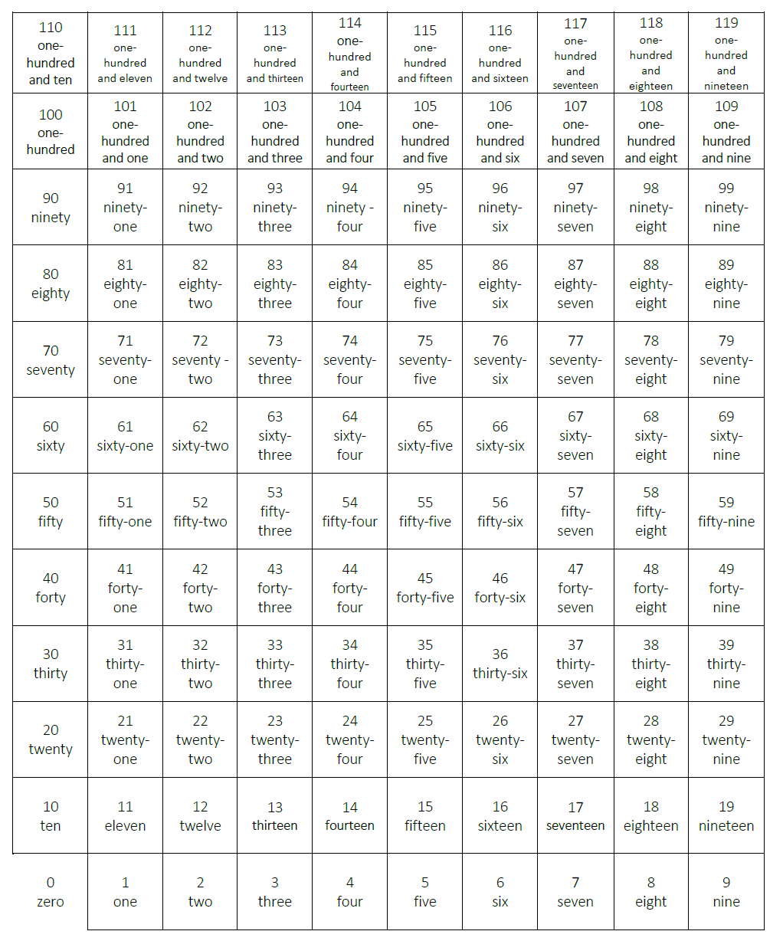

How to make a square
View video on How to make a square page
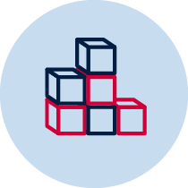Follow the steps in the video to make 5 squares and keep them for Day 2.

Go fish: relationships
Video on Go fish: relationships page to learn how to play the game.
Play +1/ -1 or 2 go fish with someone at home. Have fun trying some of the other game versions suggested in the video.

Reflection
- What’s something you feel more confident with today?

Talk about what you have discovered and learnt about today with someone at home.

Day 2
Today we have 4 tasks. We are going to explore different ways of thinking about numbers which helps us discover and understand different ideas, strategies and things about numbers and operations. We will also have fun with some puzzling squares!
Resources – device to view videos, dried pasta, blocks or counters, coloured pencils/ markers, 5 paper squares, grid paper

Subitising – match my collection
View video on Subitising – match my collection page and have your collection of 10 things, like dried pasta or blocks, ready to complete the tasks within the video.

Let’s talk 1 – Stage 1
View video on Let’s talk 1- Stage 1 page
What is different strategy you can use to solve 23-19? Record your thinking.

What is another different strategy you can use to solve 23-19? Record your thinking.

Pentominoes 1
View video on Pentominoes – 1 page
Find all the unique shapes you can make using all 5 squares. Remember, the edges of each square must join other squares perfectly and of the shapes you make must be different. That means that two shapes are considered the same if one can be fitted exactly on top of the other, even if you have to turn it around or turn it over.
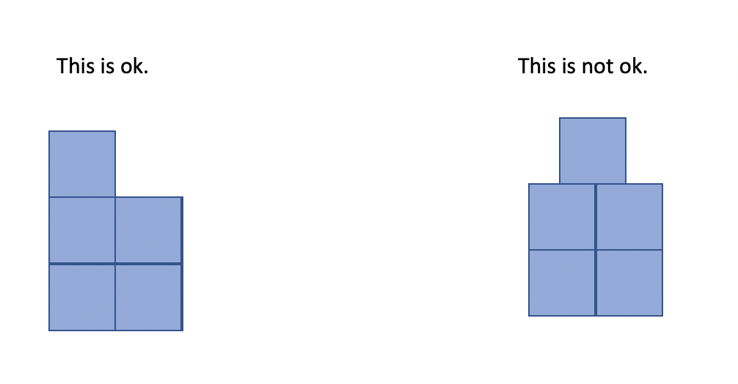
Record your thinking on the grid paper.

Go fish: relationships
View video on Go fish: relationships page
Play Go fish: relationships again. The video also shows you how you can adapt Go fish: relationships into a game of concentration.

Reflection
- Which strategy for solving 23 – 19 would you like to know more about?

Day 3
Today we have 3 tasks. We are going to use counting to explore important things about our number system and we are probably going to get sweaty brains as we investigate some strategies we can use to solve problems. Oh! And our puzzling squares are back!
Resources – device to view videos, pentominoes made on Day 2, scissors,

Quantifying collections – paddle pop sticks 1
View video on Quantifying collections – paddlepop sticks 1 page

Let’s investigate 1 – Stage 1 and Stage 2
View video on Let’s investigate 1 – Stage 1 and Stage 2 page
How could you use this strategy to help you solve 13 – 9? Record your thinking.

Pentominoes – 2
View video on Pentonimoes –2 page and complete the activities.
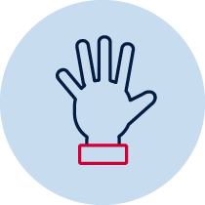What other shapes can you make by joining your pentominoes together?
- Can you make a rectangle?
- Can you make more than one rectangle?
- Try making some of these from Abaroth’s World. After making them, you may like to colour them in to match your pentominoes.
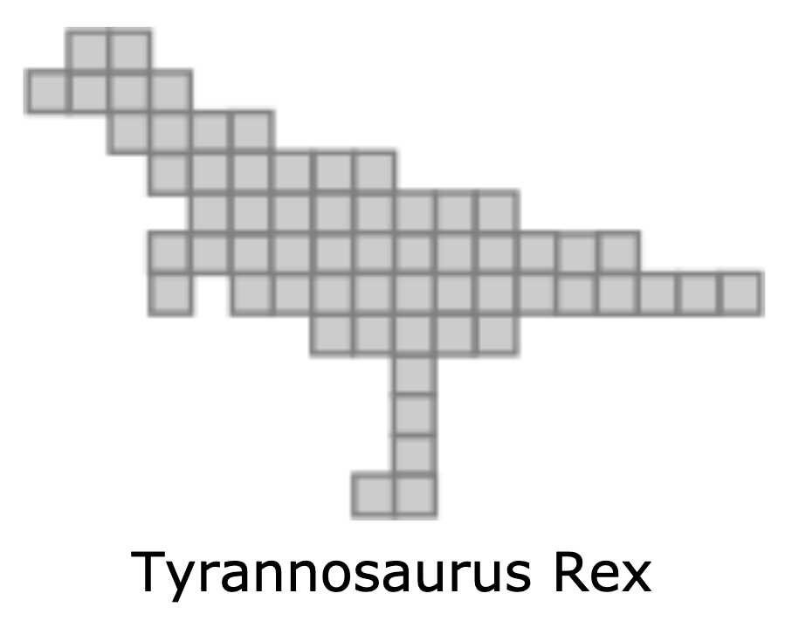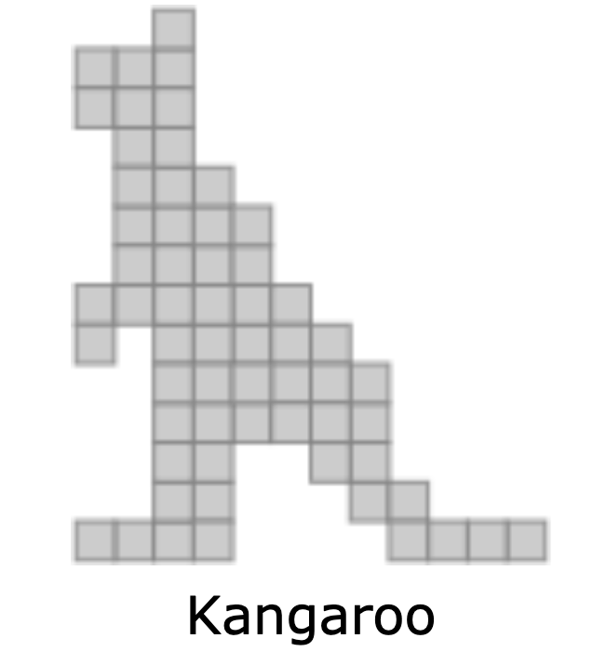
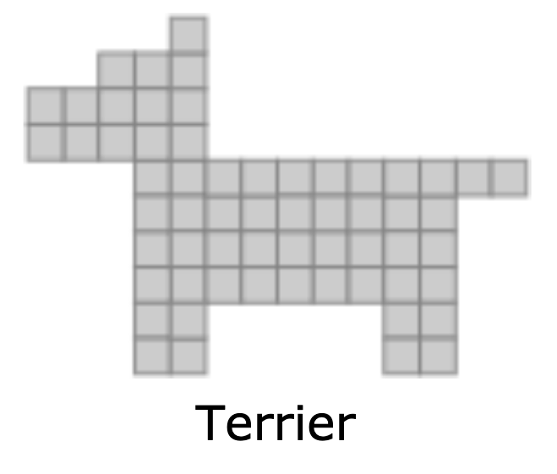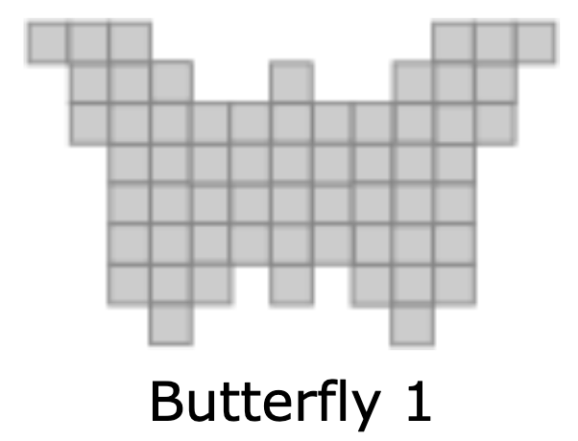
- If you need some clues take a peep in the appendix.
- What else can you create?

Reflection
You might have had a sweaty brain today looking at a strategy we could use to solve 23 – 19. Your brain might also have felt excited! Draw a picture to show what your brain was thinking as we investigated a strategy for solving 23 – 19.

Draw a picture to show what your brain was thinking as we puzzled with pentominoes.

Day 4
Today we have 3 tasks. We are going to explore ‘efficiency’ today. It’s really important that we remember efficiency can be a personal thing as it depends on our knowledge, confidence and the problem we are solving. Mathematicians know it takes a long time to become confident users of efficient strategies so remember – it’s ok if you’re still learning! As mathematicians, we all have opportunities to grow our brains.
Resources – pencils, device to view videos, paper scissors, Concentration – constant difference cards

Which one doesn’t belong? 1
View video on Which one doesn’t belong? 1 page and complete the tasks within the video.
Which one doesn’t belong?

Can you make a case for why each domino doesn’t belong?

Record other reasons why each domino doesn’t belong?

Collaborate with your family, friends or classmates to discuss and record, which one doesn’t belong?
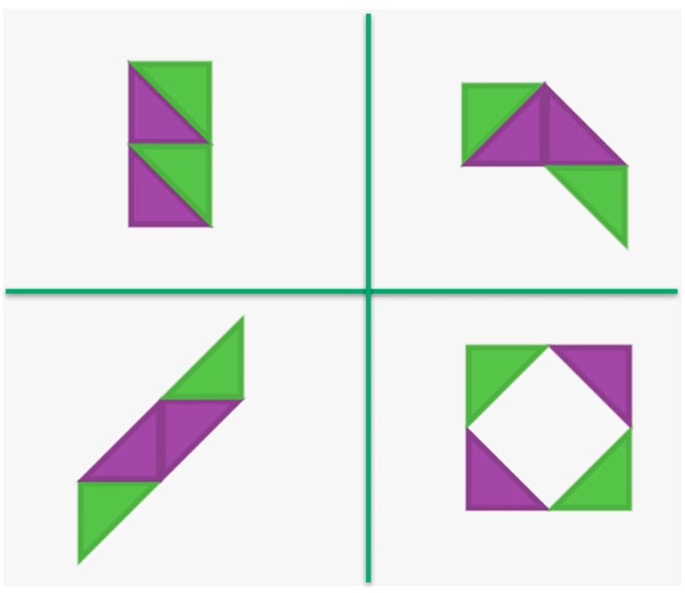

Can you make a case for why each one doesn’t belong?

Let’s explore 1 – Stage 1
View video on Let’s explore 1-Stage 1 page and complete the activities
Reflect on the strategies you used to solve 23 – 19 and identify the most efficient strategy you used.

How many steps did it take?

Do you think you could use the same strategy with other problems? Record your thinking. Write 1 or 2 problems you could use this strategy with.

Concentration – constant difference
View video on Concentration – constant difference page to download the constant difference cards and cut them out.
How to play?
To set up a game of concentration (also known as memory or pairs), first shuffle the cards well and then place each card face down. Each player takes a turn by turning two cards over. If the cards match, then the player picks up the cards and keeps them. If they don't match, the player turns the cards back over. You can also play by yourself. 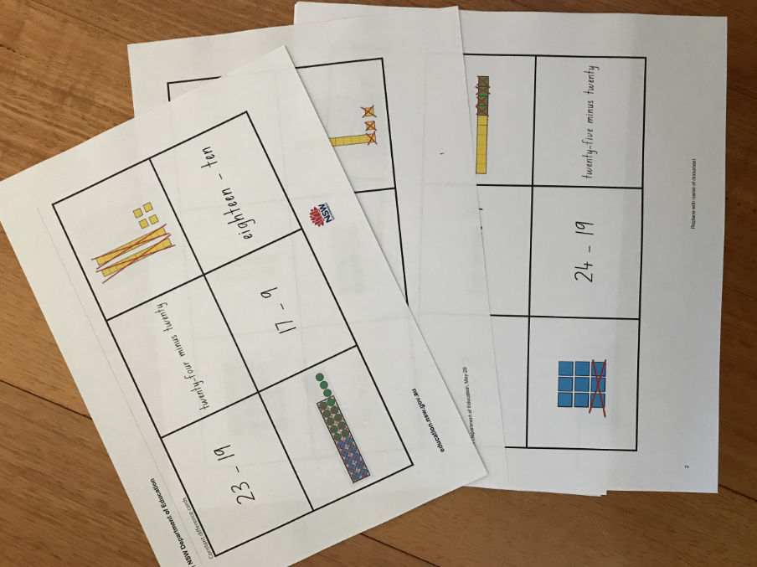
Play Concentration – constant difference with someone at home.

Reflection
Talk about what you have discovered and learnt about today with someone at home.

Day 5
Today we have 3 tasks. We are going to explore different ways of thinking about numbers which helps us discover and understand different ideas, strategies and things about numbers and operations. It's likely we might have sweaty brains as we explore how a strategy works in different contexts. It might be important to remember that learning takes time and often, it also takes lots and lots of opportunities to explore ideas.
Resources – pencils, device to view videos,

6 vs 6 dot talk comparison
View the video on 6 vs 6 dot talk comparison page and complete the activities

What do you notice that’s different between the two collections of 6?

What is the same about the two collections of 6?

Draw a representation of 6 that shows 6 is one less than 7.

Let’s generalise 1
View video on Let’s generalise 1 – Stage 1 page and complete the activities
What happens with addition?
Use any numbers you feel comfortable working with to investigate this idea. For example, look at these numbers and see if you can work out a strategy that you could use:
7 + 14 = 21
8 + 13 = 21
9 + 12 = 21
10 + 11 = 21

5 + 16 = 21
7 + 14 = 21
9 + 12 = 21
11 + 13 = 21
Record your thinking using pictures, as well as words and symbols.

Capture ten
(From Cathy Fostnot and Antonia Cameron)
View video on Capture a ten page
Play Capture ten with someone at home.
How to play:
Shuffle your cards (using Ace - 10).
Turn over 2 cards.
Work out: Can you capture a ten? If you can, record your cards in the appropriate column before you put them at the bottom of the pile. Then, have another turn.
If you can't capture a ten, put your cards at the bottom of the pile and take 2 more cards.
10 +1  ten +1 | 10 +2  ten +2 | 10 +3  ten +3 | 10 +4  ten +4 | 10 +5  ten +5 | 10 +6  ten +6 | 10 +7  ten +7 | 10 +8  ten +8 | 10 +9  ten +9

Day 6
Today we have 3 tasks. These tasks will help us see that as mathematicians, we get to be in charge of the numbers. We will see some different ways to think about strategies and numbers.
Resources – device to view videos, colour pencils, doubles cards,

reSolve double decker bus part 1
View video on reSolve double decker bus part 1 page.
How many children altogether? Explain how you worked out the total number of children.

Are there other ways you can solve this problem?

youcubed number visuals
(From https://www.youcubed.org/wp-content/uploads/2019/08/WIM-Number-Visuals-Grades-1-2.pdf)
View video on youcubed number visuals page
Explore the number visuals and record the different ways you see each number visual made up of other numbers.
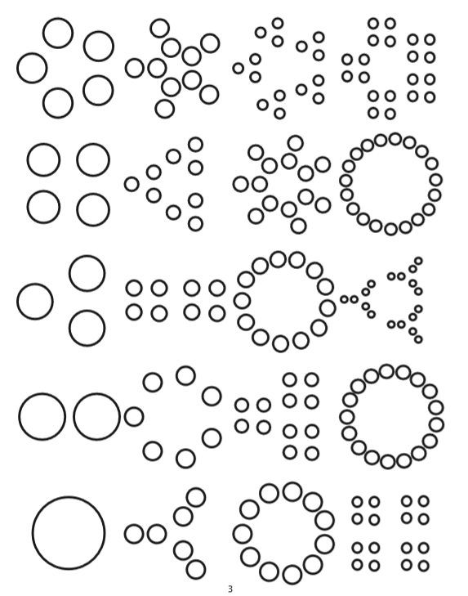
https://www.youcubed.org/wp-content/uploads/2019/08/WIM-Number-Visuals-Grades-1-2.pdf)

Double facts concentration
Visit Doubles facts concentration page to download the doubles cards and cut them out.
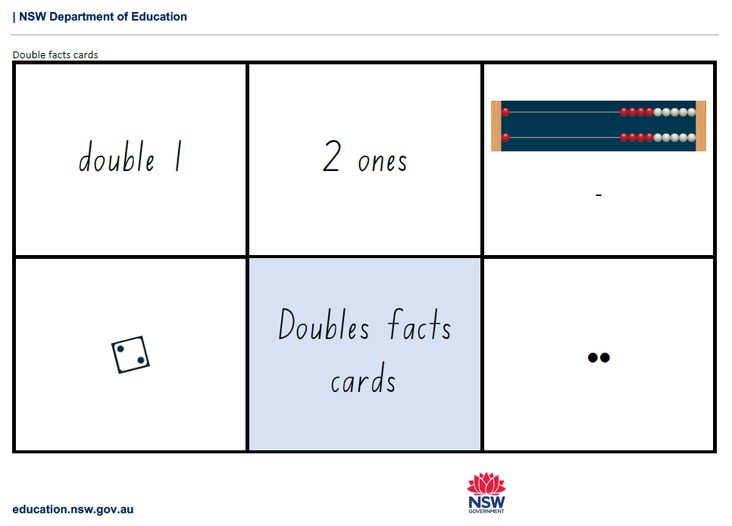
How to play?
To set up a game of concentration (also known as memory or pairs), first shuffle the cards well and then place each card face down. Each player takes a turn by turning two cards over. If the cards match, then the player picks up the cards and keeps them. If they don't match, the player turns the cards back over. You can also play by yourself.
Play Double facts concentration with someone at home.

Reflection
- Draw a picture of 1 or 2 things that made your brain think hard today (that made your brain get sweaty).

Day 7
Today we have 4 tasks. We are going to spend some more time investigating different strategies for solving problems and you’ll get some time to practise too! And, then, it’s time for a maths investigation! We are going to spend some more time investigating different strategies for solving problems and you’ll get some time to practise too! And, then, it’s time for a maths investigation!
Resources – device to view videos, colour pencils or markers, paper, 9 sided dice or spinner, Doubles fill spinner, 1 or 2 paperclips, Doubles fill grid,

Dot card talk 4
View video on Dot card talk 4 page.

reSolve double decker bus part 2
View video on reSolve double decker bus part 2 page
Choose 3 of your favourite scenarios. Draw a picture to show what strategy you would use to solve the 3 problems you choose. 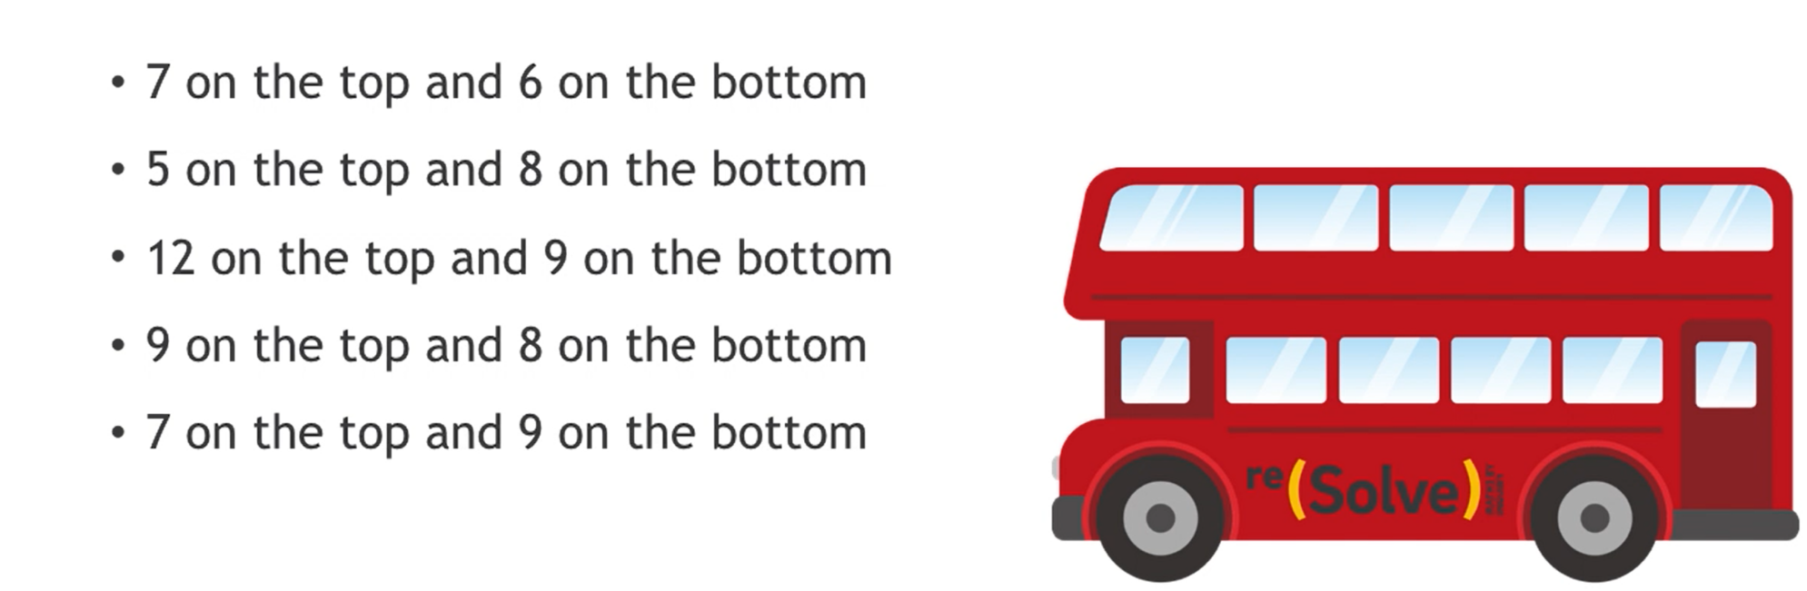

Some strategies are more efficient than others.
Remember how Zoe’s strategy took 15 steps and Ahmed’s strategy 3 steps. You might like to use what we learnt to help you here.
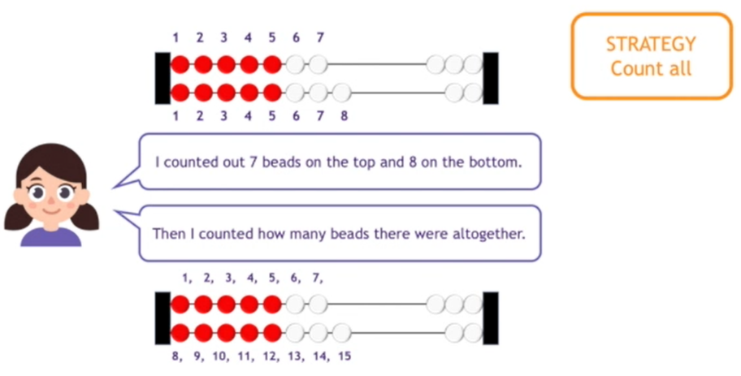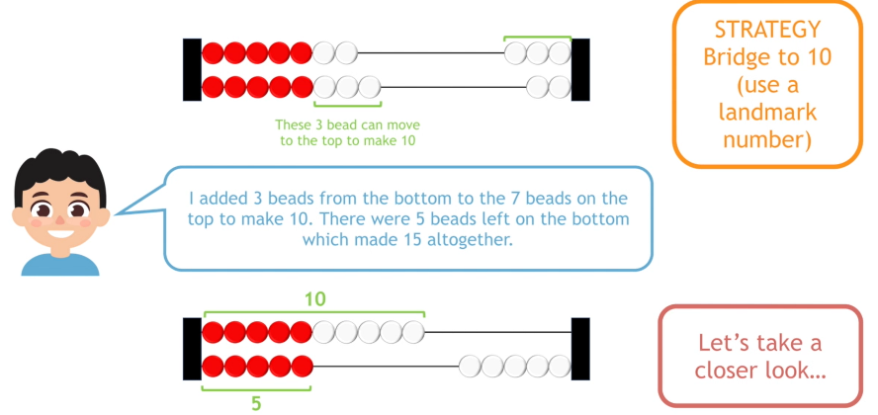

Doubles fill
View video on Doubles fill page.
How to play?
Players take turns to spin the 9 spinner (or roll dice) and spin the doubles fill spinner. If a player spins a 6 and spins ‘double’, he or she doubles 6 to make 12, explaining their thinking to their partner who records the number sentence. The player then colours in a corresponding array. Players swap roles. If there is no space on the grid, players miss a turn and play continues until no one is able to add another array. Players then calculate the number of squares they covered and the person with the largest area is the winner.
Other ways to play:
- use materials to work out double facts
- make up ‘codes’ to show the order in which they made the arrays (see video)
- students can rotate and rename the array to use the commutative property, e.g. change 5 twos into 2 fives and colour the corresponding array
- change the spinner to include repeated doubling.
Play Doubles fill with someone at home.

Doubles fill

Player 1 |  |  |  |  |  | Player 2
Rolled | Spun | Product | Code |  | Rolled | Spun | Product | Code

MathXplosion – Most people are seven feet tall
Watch the episode of MathXplosion – Most people are seven feet tall
View video on MathXplosion 7 feet follow up page and have a go at making your own foot as a unit of measurement.
Are you 7 feet tall?
Can you find some things that are more than your 7 feet tall? Write and draw your findings in the space provided.

Can you find somethings less than your 7 feet tall? Write and draw your findings in the space provided.

Reflection
What advice would you give someone who wants to accurately measure the length of something? When would using your feet not be a good unit of measurement?

Day 8
Today we have 4 tasks. We will investigate how using a familiar structure can help us answer the question “how many?”. We will also explore similarities and differences before we investigate numbers and shapes.
Resources – device to view videos, colour pencils or markers, cup or container, collection of small items for example dried pasta

Counting with understanding up to 100
View video on Counting with understanding up to 100 page.
Find a cup or container and find some collections you can quantify.
Can you find 2 different collections of objects that your cup or container holds the same amount of?

6 is…
View video on 6 is… page.
Have some blocks (of the same size e.g. LEGO) so you can join in making your own combinations of 6.

What are all the different ways we can make 6? Investigate by using blocks or by drawing the blocks using coloured pencils. How many ways can you make 6…?
- with just 1 colour pencil?
- with 2 different colours?
- with 3 different colours?
Use the space provided to record your ideas.

Numberblocks – Stampoline follow up
You may like to view the episode of ’Numberblocks – Stampolines’. ​
View video on Numberblocks – Stampoline follow up page.
What are all the different shapes Six could make playing Stampolines?
Can you come up with at least 5 different ways?

Go fish: teen/-ty numbers
Play Go Fish using the teen/-ty number cards with someone at home.
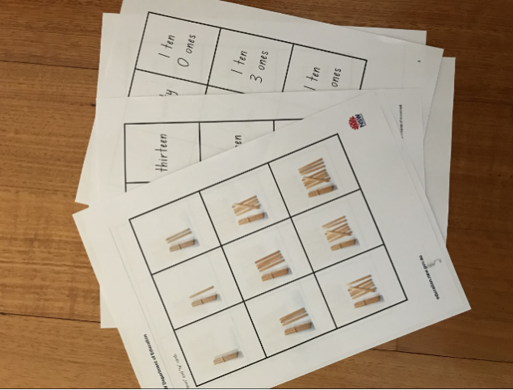
How to play?
Shuffle the cards. If you have 2 players, deal 7 cards to each player. If you have 3 or more players, deal 5 cards to each player. Put all of the left-over cards in a central pile. Choose a player to go first. Then, take turns to look for matching pairs. Once you have a pair, you can put the pair down and keep it. Take it is in turn to ask a player for a specific card. For example, “Amy, do you have ‘thirteen’ in words?” If the player has the card you asked for, she or he must give you that card. If she or he doesn’t have the card, they say “go fish” and the person picks up a card from the central pile. If you happen to draw a card you need, a pair can be made. Otherwise, it is the next player's turn.
Go Fish continues until either someone has no cards left in their hand or the draw pile runs out. The winner is the player who then has the most matches (sets of pairs).

Reflection
Imagine yourself feeling good about mathematics. Draw a picture to show what you‘re doing when you feel good about mathematics.

Day 9
Today we have 3 tasks. We are going to use our mathematical imaginations to measure items and explore what happens to how many cookies you get to eat when people come to visit! We will also teach you a new game today that helps us build our knowledge of important mathematical relationships.
Resources – device to view videos, colour pencils

About how many paperclips? 1
View video – ‘About how many paper clips? 1’.
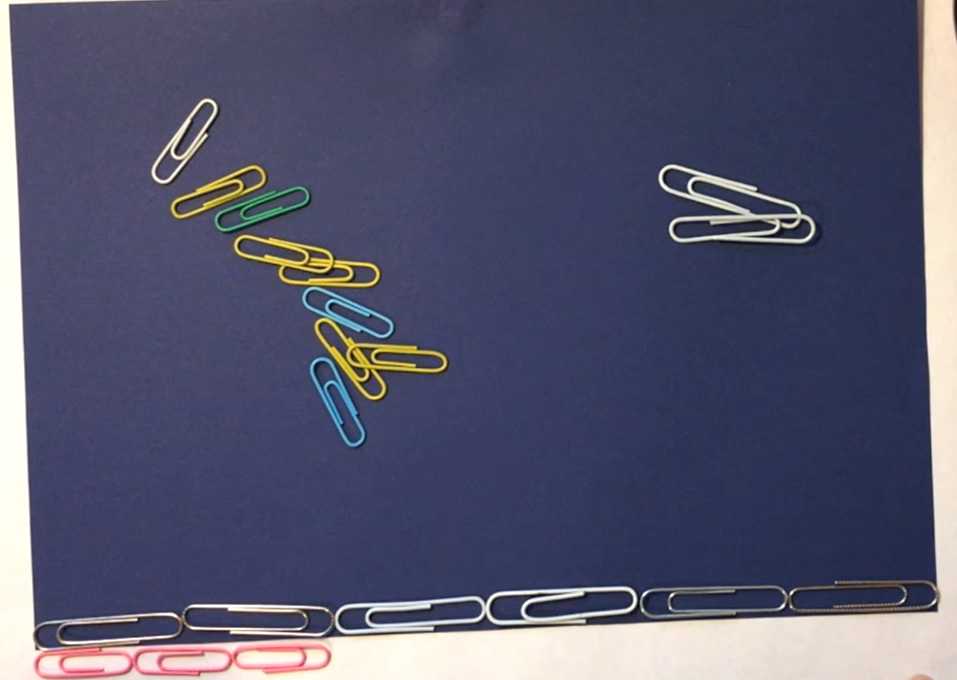
Use the space provided to draw your estimation of how many small paper clips it will take to measure the length of the paper.

About how many paperclips? 2
View video ‘About how many paper clips? – 2’. Have your drawing ready.
What did you notice? Did you notice the same things?

The doorbell rang
(The Doorbell rang by Pat Hutchins ISBN: 9780688092344)
View video on ’The doorbell rang’ page.

How many more cookies did Grandma need to bring to make sure…
- - everyone who was there got 2 cookies each?
- - everyone who was there got 6 cookies each?

Turn over 3
View video on Turn over 3 page.
How to play?
Using playing cards Ace-10 (representing 1-10) and the jokers (representing 0), shuffle the cards into a pile. Place the pile face down between two players. Take turns to turn over the top three cards. Players look for doubles, near doubles, combinations to 10 and 20. Players keep the cards of any known facts they identify and know, justifying their thinking to their partner who records it on the recording sheet. Any unused cards are placed into a discard pile. Players continue taking turns until the cards run out. When then happens, is a reshuffle all of the unused cards. Re-distribute them into 3 piles and continue playing. The winner is the player with the highest cumulative total at the end of 5 rounds.
Other ways to play:
- For subtraction, choose which cards to combine using known facts and then subtract the third card. Players are able to keep all three cards if they are able to identify a known fact and then subtract the third value, explaining your mental computation to the other player.
- Play until the whole deck of cards is used.
Play Turn over 3 with someone at home.

Turn over 3
Player 1
Flipped | Knew | Used | Cumulative total

Player 2
Flipped | Knew | Used | Cumulative total

Reflection
Draw a picture to represent your favourite part of The Doorbell rang.

Day 10
Today we have 3 tasks. We are going to practise our subitising skills and read one of our favourite books! These tasks will help us in thinking about important mathematical relationships like 1 less than, 1 more than, the number before, and the number after.
Resources – device to view videos, colour pencils, dried pasta,

Subitising 6 – one less than
View video on Subitising 6 – one less than page.

None the number
View video on None the number page.
(The Hueys in None the Number A Counting Adventure, Oliver Jeffers ISBN: 9780007567119)
Is there another way you could have worked out
1 + 2 + 3 + 4 + 5 + 6 + 7 + 8 + 9 + 10?

How might you solve 2 +3+ 4 + 5? Draw a picture to show your strategy.

Watch episode of Numberblocks – step patterns

Capture ten
(From Cathy Fostnot and Antonia Cameron)
View video on Capture a ten page
Play Capture ten again with someone at home.

Capture ten
10 +1  ten +1 | 10 +2  ten +2 | 10 +3  ten +3 | 10 +4  ten +4 | 10 +5  ten +5 | 10 +6  ten +6 | 10 +7  ten +7 | 10 +8  ten +8 | 10 +9  ten +9

Reflection
Use the ThinkBoard to represent a problem that leaves you with none.
Story

Drawing

Concrete materials

Symbols

Appendix

Spinners for Day 1 Race to zero
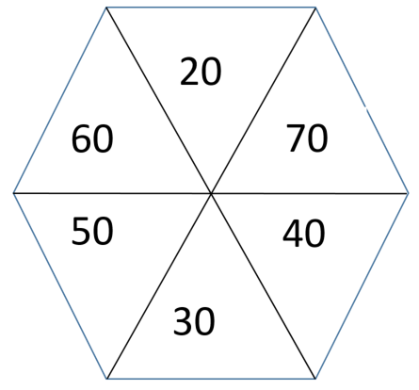
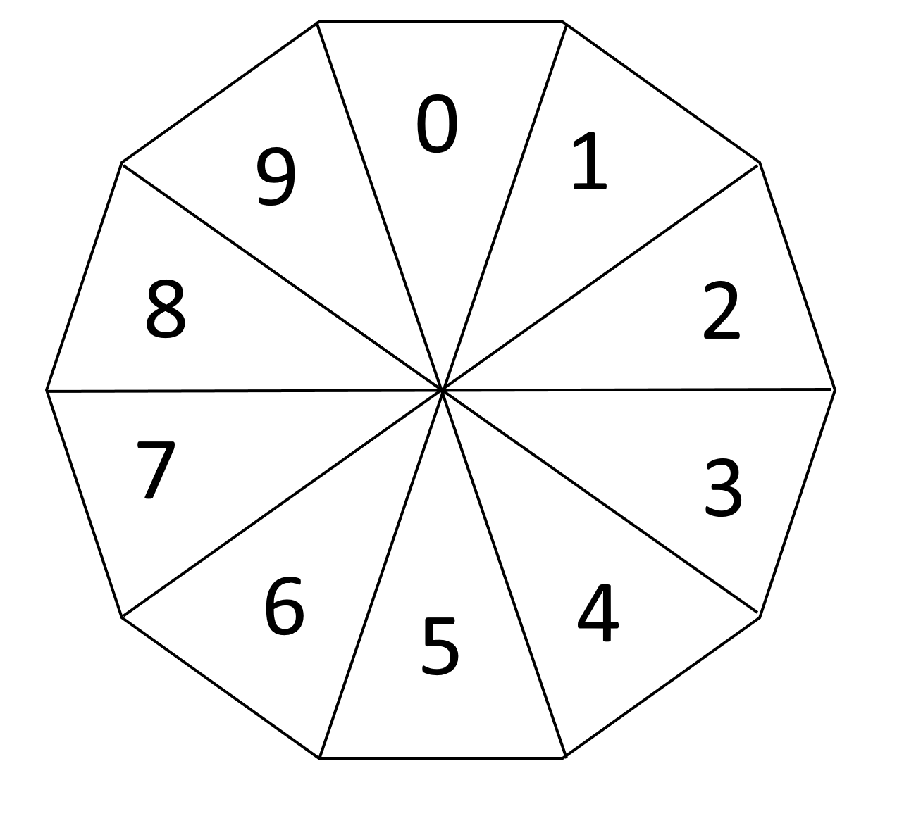

Day 3 Pentominoes 2
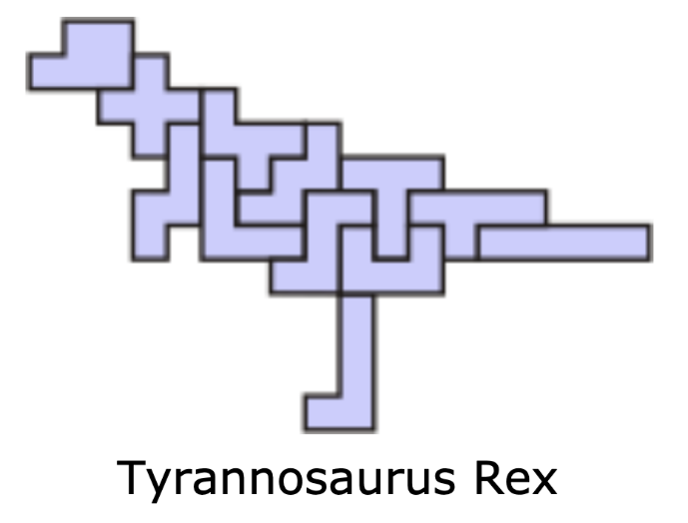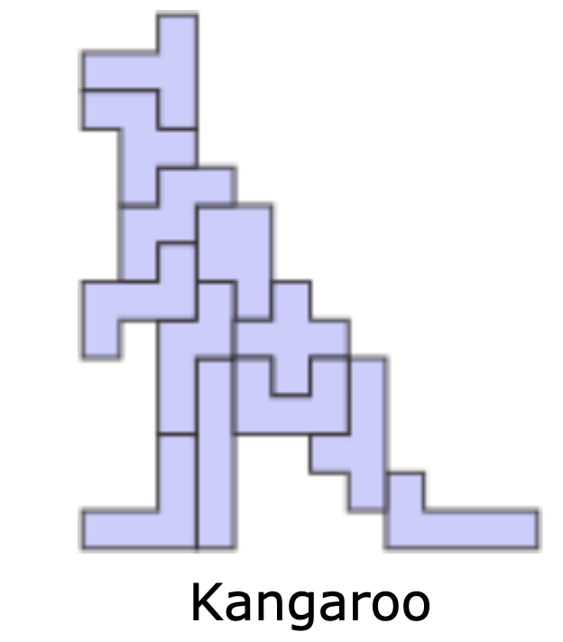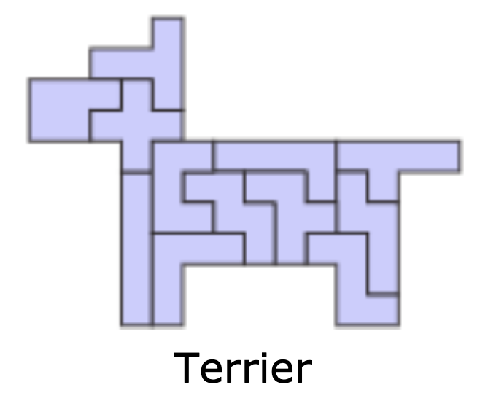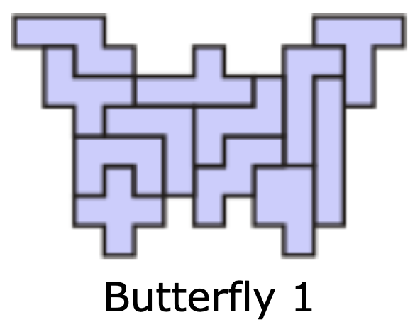

Spinners for Day 7 Doubles fill
