Year 12 Mathematics Standard 1
MS-A3 Types of Relationships | Unit duration
Algebra involves the use of symbols to represent numbers or quantities and to express relationships, using mathematical models and applications.  Knowledge of algebra enables the modelling of a problem conceptually so that it is simpler to solve, before returning the solution to its more complex practical form.  Study of algebra is important in developing students’ reasoning skills and logical thought processes, as well as their ability to represent and solve problems. | 2 weeks

Subtopic focus | Outcomes
The principal focus of this subtopic is the graphing and interpretation of relationships, and the use of simultaneous linear equations in solving practical problems.  Students develop their ability to communicate concisely, use equations to describe and solve practical problems, and use algebraic or graphical representations of relationships to predict future outcomes.  Within this subtopic, schools have the opportunity to identify areas of Stage 5 content which may need to be reviewed to meet the needs of students. | A student:  - uses algebraic and graphical techniques to evaluate and construct arguments in a range of familiar and unfamiliar contexts MS1-12-1  - represents the relationships between changing quantities in algebraic and graphical forms MS1-12-6  - chooses and uses appropriate technology effectively and recognises appropriate times for such use MS1-12-9  - uses mathematical argument and reasoning to evaluate conclusions, communicating a position clearly to others MS1-12-10  Related Life Skills outcomes: MALS6-1, MALS6-7, MALS6-8, MALS6-13, MALS6-14

Prerequisite knowledge | Assessment strategies
Students need to be familiar with the skills and concepts from MS-A2 Linear Relationships and Stage 5.1 Linear Relationships and be able to plot points from a table of values; graph straight lines; and understand the terms slope, intercept and point of intersection. | - Pre-test – A pre-test on creating tables of values by substituting into a rule, and then plotting points and graphing linear equations would be useful to determine students’ skills before starting this topic.  - Investigative Project

All outcomes referred to in this unit come from Mathematics Standard Stage 6 Syllabus
© NSW Education Standards Authority (NESA) for and on behalf of the Crown in right of the State of New South Wales, 2017

Glossary of terms
Term | Description
break-even point | The break-even point is the point at which income and cost of production are equal.
exponential model | An exponential function is a function in which the independent variable occurs as an exponent (or power/index) with a positive base. For example, $y=2^{x}$is an exponential function where $x$ is the independent variable.
point of intersection | 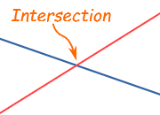  Where lines cross over (where they have a common point). The red and blue lines have an intersection.
simultaneous linear equations | Two or more equations that share variables.  For example: the following two equations both share the variables $x$ and $y$:  $x+y=6$ and $-3x+y=2$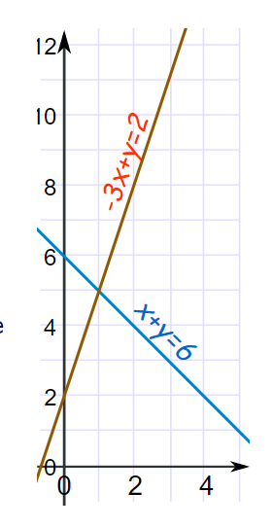  Solving these equations simultaneously involves finding where the two equations intersect. In this example the simultaneous solution is $\left(1,5\right).$

Sequence | Content | Suggested teaching strategies and resources | Date and initial | Comments, feedback, additional resources used
Solve simultaneous equations graphically  (2 lessons) | A3.1 Simultaneous linear equations  - solve a pair of simultaneous linear equations graphically, by finding the point of intersection between two straight-line graphs, with or without technology | Reviewing graphs of linear equations  - Teachers should revise the features of a straight line graph ie gradient and y-intercept  - Once students feel comfortable being able to identify the y-intercept and gradient of a line given $y=mx+c$ they can revise how changing these values affects the equation and graph of the line using technology such as Desmos or Geogebra.  - Student activity: Students could investigate the gradient and y-intercept of straight lines using the online resources below. Each of the above resources provide students with the opportunity to solve problems requiring knowledge of how to graph linear functions.  - Land the Plane  - Graph a Line from an Equation  - Match my line  Solving simultaneous equations graphically  - Students need to understand that the point where the two graphs meet has to satisfy both equations.  - Desmos or Geogebra may be used to enter equations for straight lines and draw the graphs so that students can simply read off the point of intersection.  Resource: using-geogebra-CAS.DOCX  - Student activity: Racing Dots Students predict where a pair of moving dots will meet by using tables, graphs, and/or equations. While students can use any of those representations to solve the challenge, the activity was designed with an eye toward solving systems of linear equations via substitution.  - Students are asked to predict where two dots will meet and how confident they are of their answer.  - They are then allowed to see their classmates’ estimates and teacher leads a discussion as to what data we need to make our estimates more accurate (for example, speed of the dots).  - Students are then given the position of the dots after 4 seconds and asked to revise their original estimate. Teacher could at this point remind students how to find the speed of an object.  - The program then shows students three methods to find the answer; table of values, graphically and algebraically. (Although algebraic methods are not a part of this course, it doesn’t hurt to remind students of other methods).  - Student activity: Systems of equations A good follow up activity to the previous one is to look at different mobile phone contracts. It provides an opportunity to revise linear equations and substitution.  - Students write an equation for two different phone plans, graph each equation and then discuss which plan would be better over different periods of time. It is important to point out why the graphs start at zero and that the lines don’t extend to the left of the y-axis.  - The website then demonstrates how the point of intersection satisfies both equations and goes on to give numerous examples of graphing two equations and finding the point of intersection.  - The activity finishes with a quiz that returns to the phone plan question at the start of the lesson.
Solve practical problems involving simultaneous equations  (2 lessons) | - develop a pair of simultaneous linear equations to model a practical situation AAM  - solve practical problems that involve determining and interpreting the point of intersection of two straight-line graphs, including the break-even point of a simple business problem where cost and revenue are represented by linear equations AAM | Solving practical simultaneous equation problems  - This topic lends itself well to using linear models to solve problems or to aid decision- making. Applications include choosing an energy-efficient appliance or car; distance/time problems; mixing proportions of ingredients to make a blend; organising an event; setting ticket prices; problems of supply and demand.  - Students should be able to solve ‘break-even problems’ graphically in questions emphasising the break-even point, the profit zone and the loss zone, and interpretation of the $y$-intercept.  - In modelling physical phenomena, functions and graphs should involve only positive values of the independent variable and zero.  - Student activity: Supply and demand or profit and loss scenarios are commonly solved using simultaneous equations. Using the scenario of a cake-shop owner selling muffins for $2.50 each with costs of $1 to make each muffin and $300 for the equipment needed to make the muffins, the teacher should help the students to develop equations for income and expenditure before graphing the equations and determining the break-even point.  - As per the previous examples, students should discuss what is happening in different parts of the graph and why it is not realistic to extend the graph to the left of the y axis.  - Student activity: Students watch the Stacking Cups video and then guess how many cups are required for the stacks to be equal.  - The teacher should then discuss with students what information we require to be able to solve the problem. For example, the height of the cups and the width of the lips. The pictures underneath the video in Act 2 show the height of each type of cup and the width of the lip.  - At this point the teacher should help the students to develop an equation for the height of each type of cup based on the number of cups.  - Students should then graph each equation to determine the answer. The video in Act 3, shows the correct answer of 7.  - Teacher and students could then brainstorm other questions that can be asked about the cups. For example, how many of each cup is required to reach a certain height? A number of different questions are given at the bottom of the video.  - Student activity: Teacher sets the scene of the Tortoise and the Hare race. The tortoise takes off at 0.5km per hour. The hare, being cocky, leaves 4 hours later at 2km/h. Who will win the race?  - Students should be given the opportunity to try and solve the problem themselves. Some discussion of the different methods used should follow.  - The teacher could then help the students to develop equations or tables of values so they can graph the equations and find a solution. This is a good opportunity to practice converting decimal time to hours and minutes or minutes and seconds.  - Students can then find the point where they catch up, but who actually wins? Need to discuss how long the race was and who would win for different race lengths.  - The video link shows how the equations are developed and how to read and interpret the solution. It would be best to show this after the students have tried to find the solution for themselves.  NESA exemplar questions  - The following scenario is depicted in the graph below:  A cake-shop owner sells muffins for $2.50 each. It costs $1 to make each muffin and $300 for the equipment needed to make the muffins.  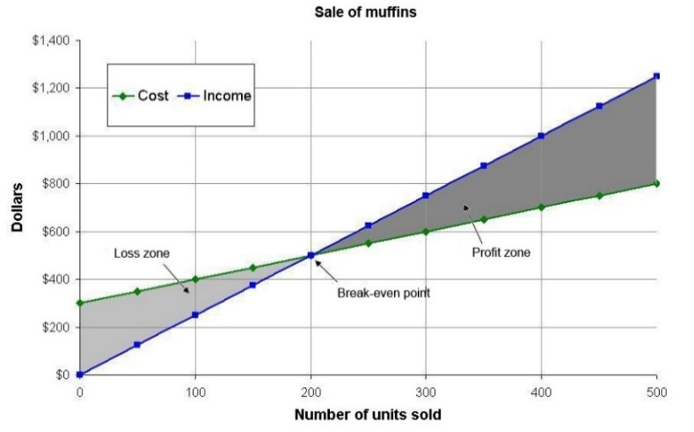  - Typical questions based on the graph could include:  - How many muffins need to be sold to ‘break even’?  - How much profit is made if 400 muffins are sold?  - The graph shows the supply (S) and consumer demand (D) curves for a farm product.  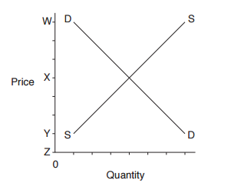  Which letter corresponds to the price at which both the producer and consumer would be satisfied (equilibrium market price)?  (A) W (B) X (C) Y (D) Z  Resource: ms-a3-nesa-exemplar-question-solutions.DOCX
Introduction to non-linear graphs  (3 lessons) | A3.2 Graphs of practical situations  - sketch the shape of a graph from a description of a situation, for example the time passed and the depth of water in different shaped containers, or the speed of a race car as it moves around different shaped tracks | Introducing non-linear graphs  - Students should recognise the limitations of linear models in practical contexts, for example a person’s height as a function of age may be approximated by a straight line for a limited number of years. Students should be aware that models may apply only over a particular domain.  - Students distinguish between linear and non-linear relationships and recognise relationships that can be described as exponential from the shape of the graph.  - Mathematics Standard 1 students are not expected to find the algebraic equation of an exponential function from the graph of the function.  - Students use graphing software to graph exponential functions or develop a table of values and plot the associated points to produce a sketch of the graph.  - The ‘Graphing Stories’ website provides a number of different real life scenarios for students to practise graphing. There are a variety of different graph types. The website has a handout that teachers can print which has axes already drawn and an appropriate time scale.  - Students initially watch the event and then the video replays it at half speed so students get a better idea of what is happening.  - At this point, students could make a first attempt at drawing a graph to represent the action.  - The teacher should then replay the video and point out any important events such as change of direction or change of speed or height.  - Students should then amend their graph if necessary.  - The video then shows the correct graph.  - The teacher should discuss any differences between student graphs and the correct graph.  - ‘Bum height off ground’ produces a decreasing graph that has linear elements with stationary points  - ‘Distance from bench’ produces a periodic graph  - ‘Height of tennis ball’ produces a parabolic graph that decreases  - ‘Height of waist off ground’ also produces a periodic graph  - Student activity: On board F1 GP Australia 2013 (camera car) shows the speedometer of a race car as it goes around a track. As above, students could graph the speed of the car over the first minute.  - Student activity: The Filling Glasses and Container Filling activities are a good follow up to the previous activity and reinforce the idea that not all graphs are linear.  - Students need to notice that the fluid level rises more quickly in a narrow glass than in a wide glass and they need to identify the other variables which determine the shape of each line graph.  - Both activities involve students matching different shaped containers to their appropriate graphs. It shows many different types of graphs without introducing terms such as exponential.  - After the students have played with the interactives for a while, it would be timely to stop the class and discuss with students why different shaped containers give different graphs and what is causing a graph to become steeper or flatter.  - Students can then use this shared knowledge to aid them in completing the rest of the activities.  - If teachers do not have access to technology they could bring in a range of different shaped containers and have students fill them with water, taking notice of how quickly the water level rises in different parts of the container.
Introduction to exponential graphs  (3 lessons) | - construct a graph from a table of values both with and without technology  - use values of physical phenomena, eg the growth of algae in a pond over time, or the rise and fall of the tide against a harbour wall over time to plot graphs and make predictions | More examples of non-linear graphs  - Student activity: Using historic tide times from Tide Times (Bureau of Meteorology) students can graph tide times versus tide heights over a number of days.  - They could then compare their graphs with those on the Australia Tide Times (Willy Weather)site. Discussion points are around the cyclic nature of the graph. How often does the graph repeat? What is the highest point? What is the lowest?  - Student activity: In the Lake Algae activity, students study a species of algae that is doubling in area every day.  - Have students discuss questions such as how long it would take to completely cover the lake, or, if 99% of the algae was removed, how long would it take before the lake would again have to be cleared?  Introducing Exponential graphs  - Students are introduced to exponential graphs and the change in gradient from the start of the graph to the end.  - Student activity: Pose the question to students – ‘Can folding a piece of paper 45 times get you to the moon?’ How folding paper can get you to the moon Ask for their opinions.  - Create a table of values and start with 0 folds giving 1 thickness, 1 fold giving a thickness of 2, and so forth.  - Have students draw the graph either by hand or by using a graphing program to see how quickly the thicknesses increase.  - Have students predict how thick the paper would be after 45 folds.  - Assuming the paper is 0.001mm thick initially, how thick will it be after 45 folds? How close is this to the moon?  - Is this model practical in real life? How many times can students fold a piece of paper? Have students fold a piece of A4 Reflex paper. Can they fold this more or less times than a sheet of tissue paper of the same size?  - Students could then watch the Ted Ed lesson on the power of exponential growth.  - Student activity: Tell students the story of The rice and chessboard.  - Students could then discuss how much rice they think the inventor would have once the king had finished completing the chessboard.  - Have students draw up a table of values showing the number of grains of rice on each square and a further column showing the total number of grains.  - Discuss how quickly the numbers grow.  - The students could then count how many grains of rice it takes to fill a small container in order to determine how much room would be required to store the inventor’s rice.
Determining the best model  (2 lessons) | - determine the best model (linear or exponential) to approximate a graph by considering its shape, using technology where appropriate AAM  - identify the strengths and limitations of linear and non-linear models in given practical contexts AAM | Determining the best model  - This is a good opportunity to revisit simple interest (linear) and compound interest (exponential) as well as straight line depreciation (linear) and declining balance depreciation (exponential).  - Student activity: Avi and Benita’s repair shop In this twist on a classic activity, students compare linear and exponential growth in the context of daily payments. One plan increases by $100 each day, while another starts at $0.10 and grows by doubling the previous day’s payment.  - This activity can be done by hand if there is no access to technology. Students draw up a table of values in their book and then graph the two models on the same graph.  - Students are asked to consider which method of payment is better and to then extend their thoughts to consider which payment is better over different lengths of time.  - The connection between table of values and graphs is reinforced.  - This activity is appropriate for students who have studied linear functions but may not have any experience with exponential growth. With that in mind, it makes a great first activity in an exponential functions unit.  - Student activity: Students could use Google Trends to search for a term of their interest and then graph the results in a spreadsheet program.  - Students to debate whether the graph is linear or exponential  Resource: using-google-trends.DOCX  - Student activity: Will it hit the hoop? Although quadratics are not part of the syllabus, this activity is useful as it reinforces the idea that linear graphs are not appropriate in all situations. It does not assume any knowledge about quadratics, but demonstrates why a linear model is not appropriate.  - Activity starts by asking students to fit a straight line through some points that indicate the position of a basketball moments after being thrown.  - It then demonstrates the limitations of this model as it assumes the ball will keep rising.  - Students are introduced to parabolas and are asked to drag points to make the parabola model the path of the basketball.  - Students use these parabolas to predict whether or not the ball will pass through the hoop.  - The last few extension questions introduce students to the idea of the vertex representing the maximum height of the ball. (This would be extension only, and is not necessary for this course)

Reflection and evaluation
Please include feedback about the engagement of the students and the difficulty of the content included in this section. You may also refer to the sequencing of the lessons and the placement of the topic within the scope and sequence. All ICT, literacy, numeracy and group activities should be recorded in the ‘Comments, feedback, additional resources used’ section.

