Setting up an ESSI Money Account
This guide is designed to support a teacher to implement the ESSI Money game effectively with their class.

Set up guide
- Begin by registering for an ESSI Money account at the Financial Basics website.
- Once logged in, click on the Manage ESSI Money.
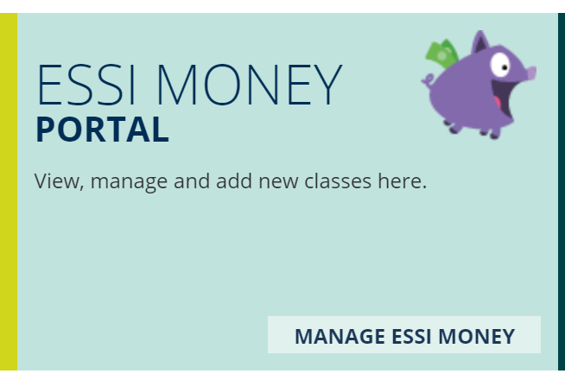
- On the right of screen, you can add a new ESSI Money class.
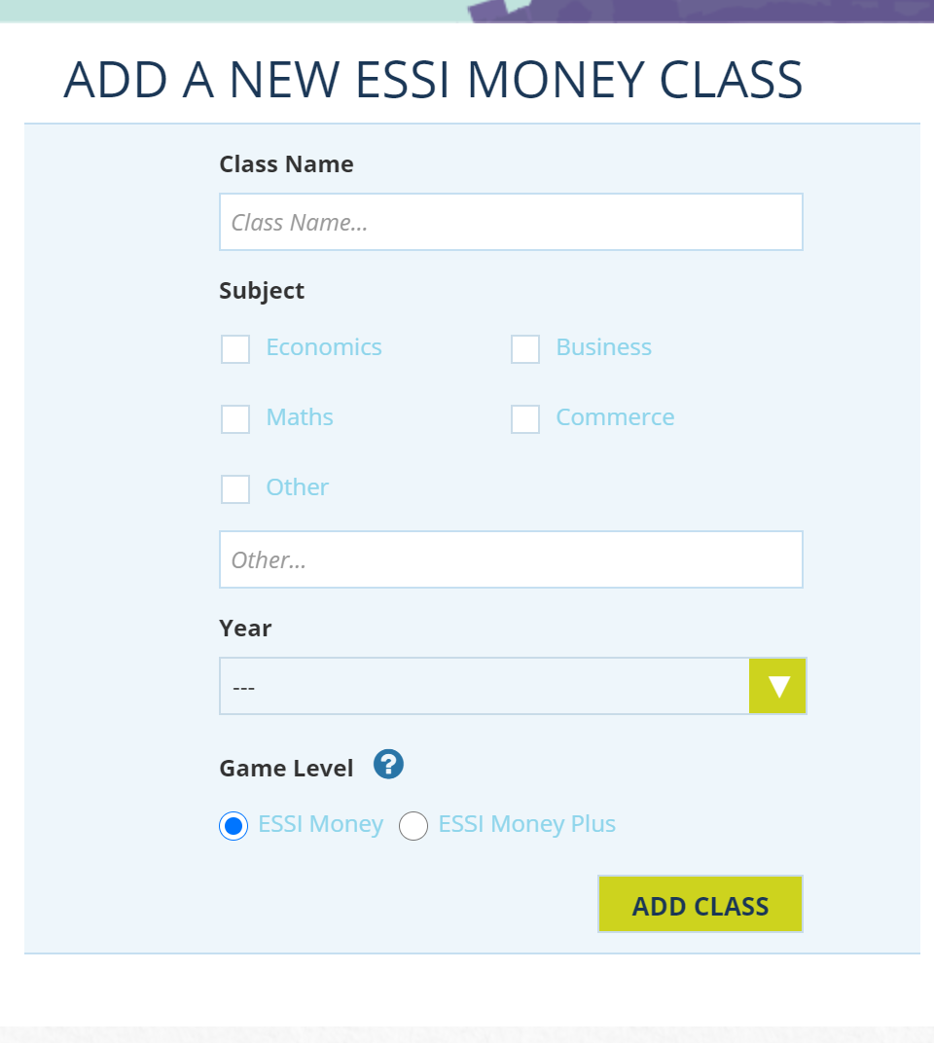

- Once your class is registered, you will see the class details on the left of your screen. You can get the link to share with students so they can create their own accounts and engage with the program by clicking on “game link”.
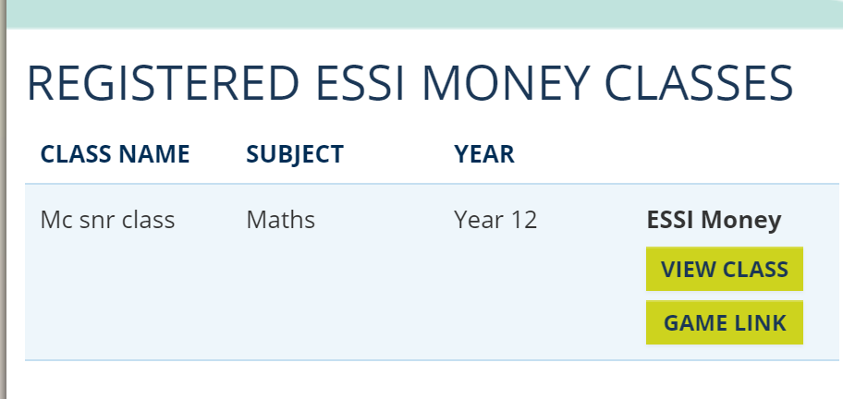

- Once each student is registered, they will have their own portfolios. Students look into their assets and review what money they currently have.
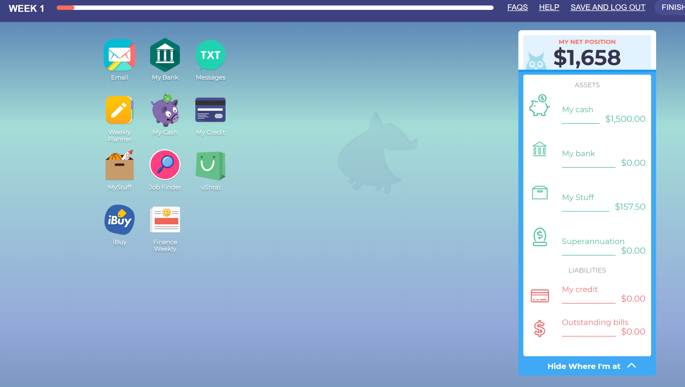

- Students can go to “My Stuff” section to review their current items.
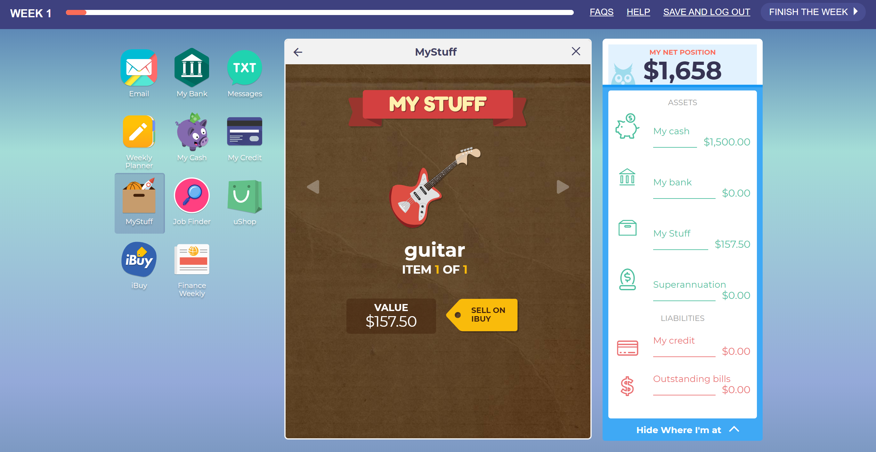
- They can review the money they have in their wallet by going to “My Cash”.
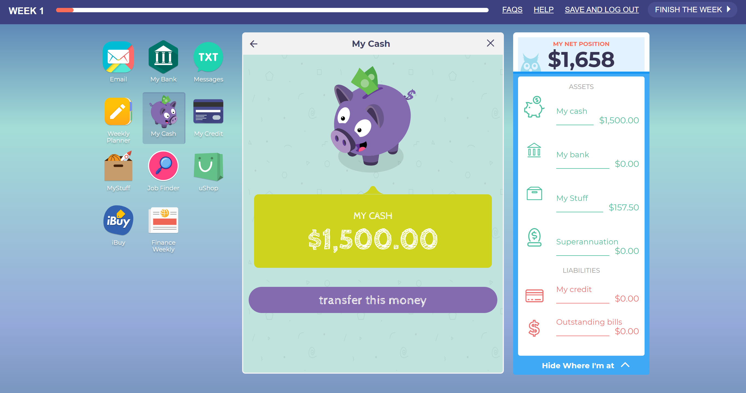

- To become familiar with the site, students can look at the iBuy page (Ebay) and the ushop page (online shop).
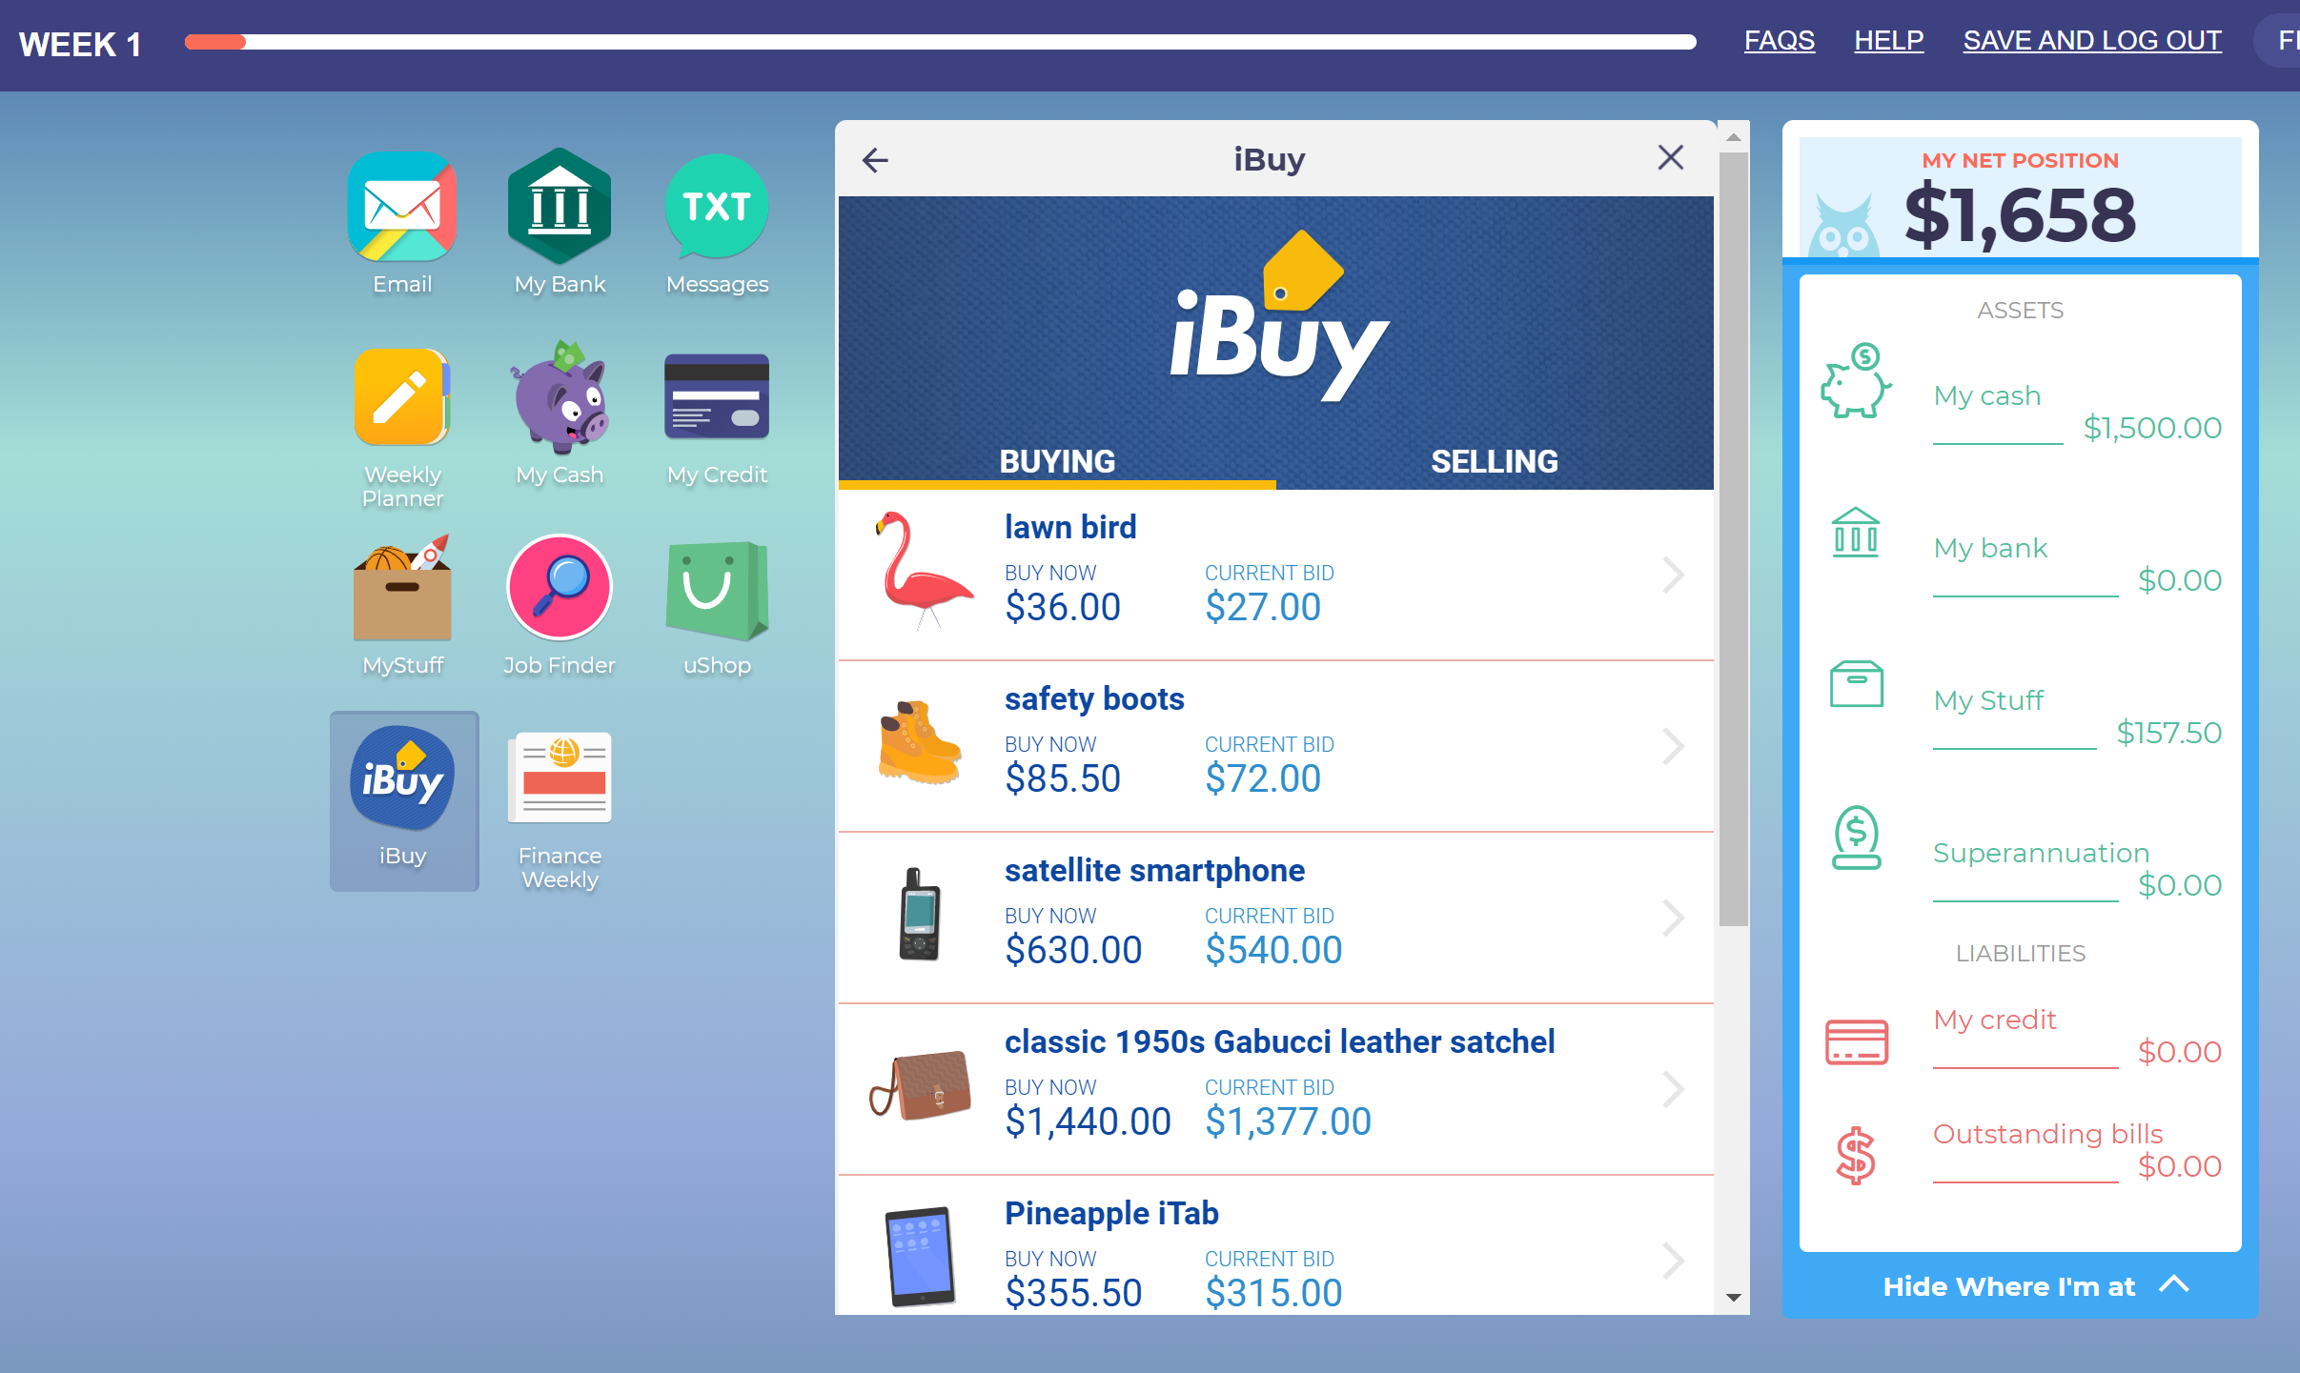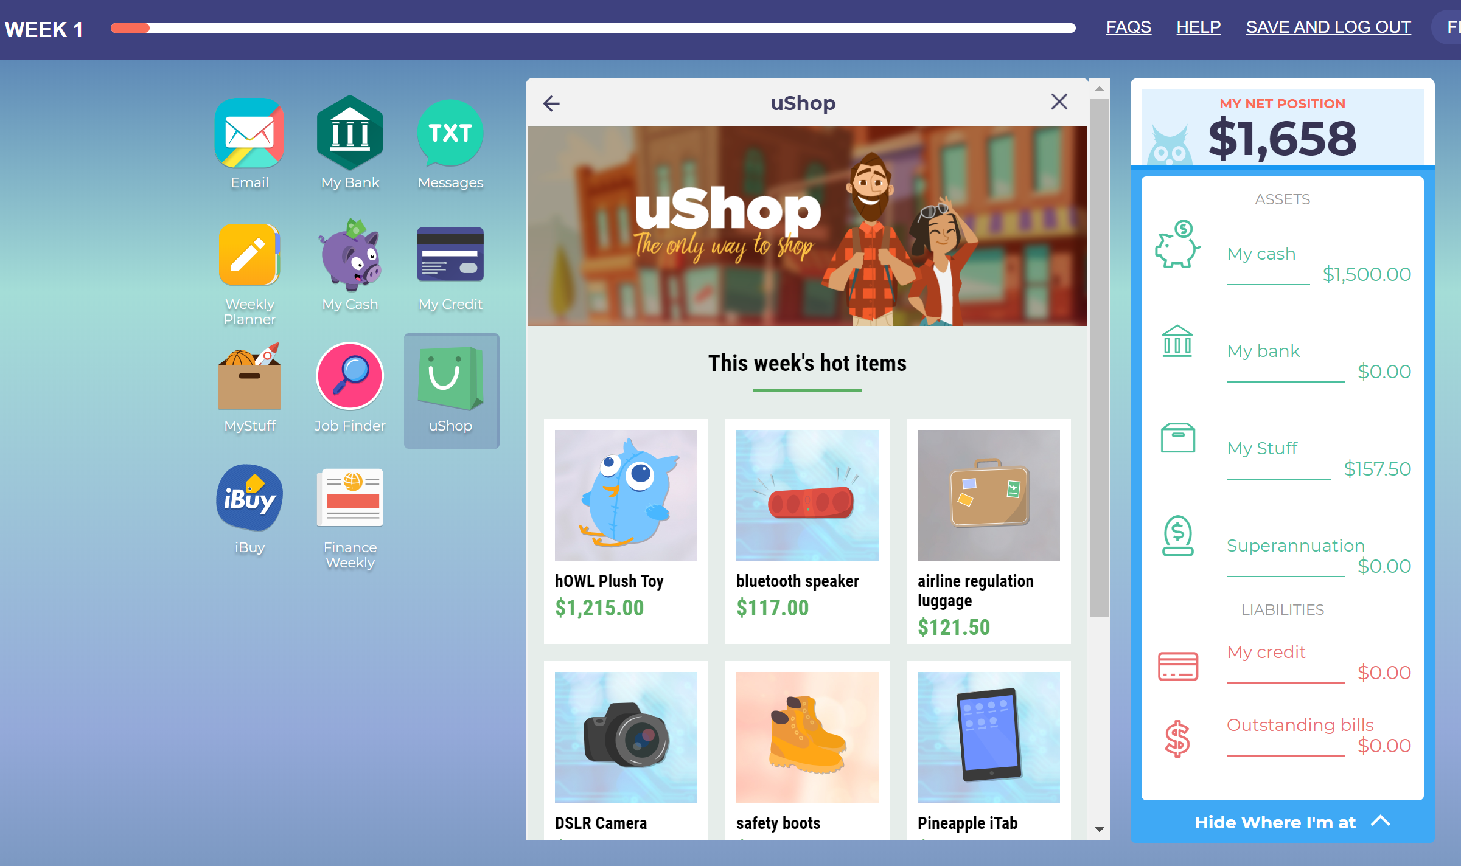

- Students then open a bank account. Sound advice could be to select the first account, and advise students to put $1000 into the account from their wallet. You can have some discussion about types of accounts benefits/negatives of each type.
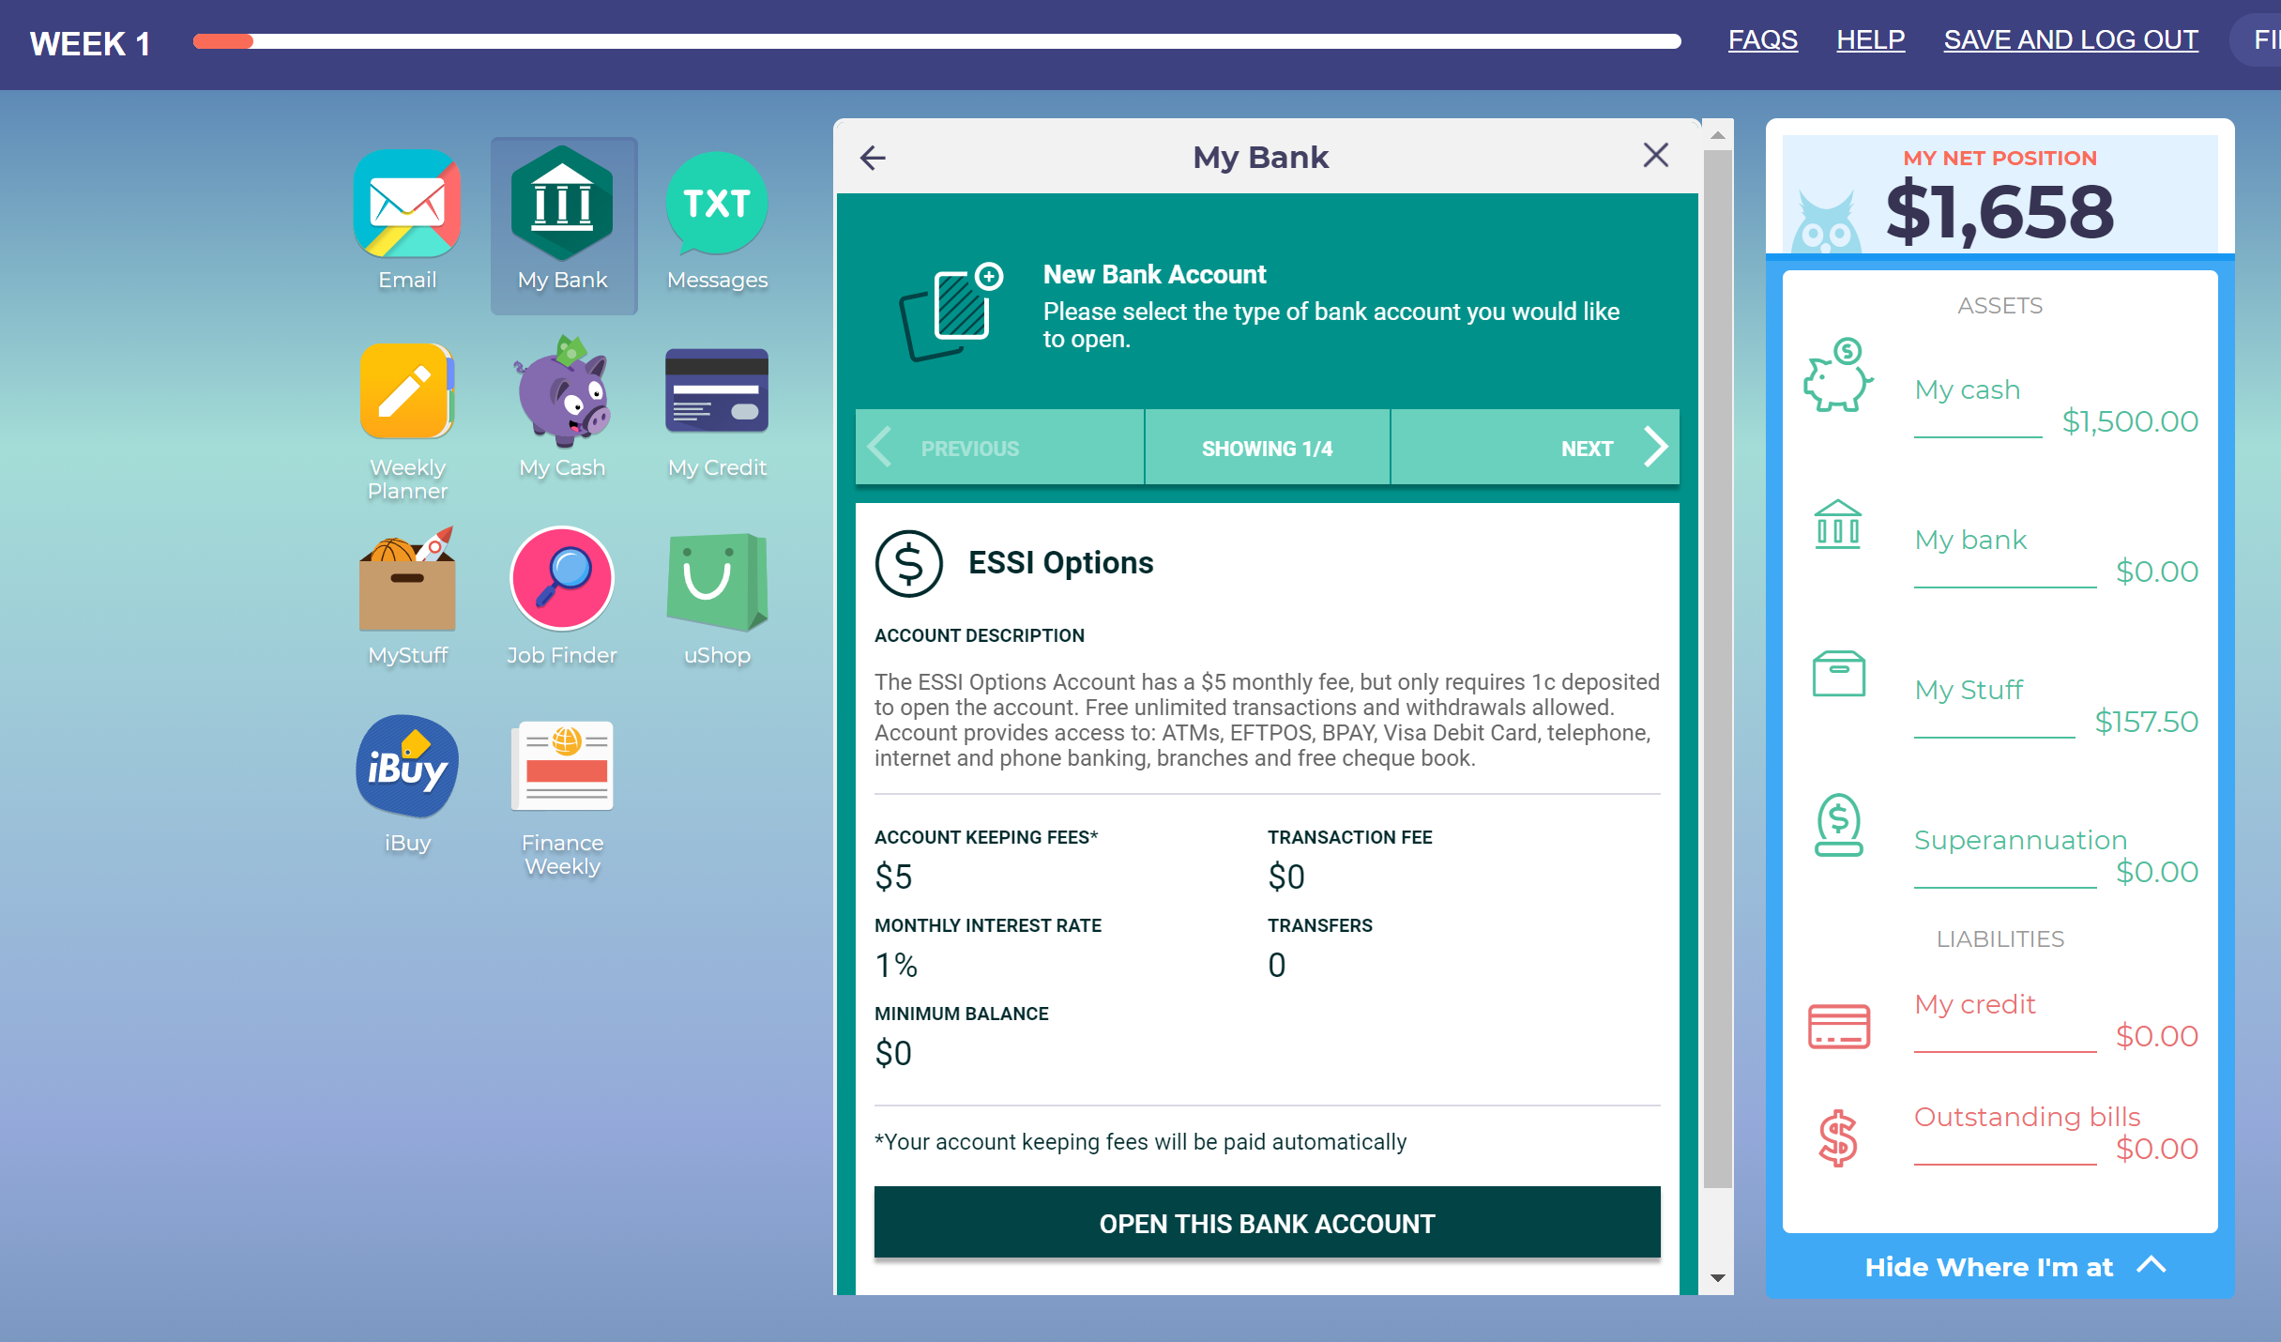
- Students should then select a job in the “Job Finder” section.
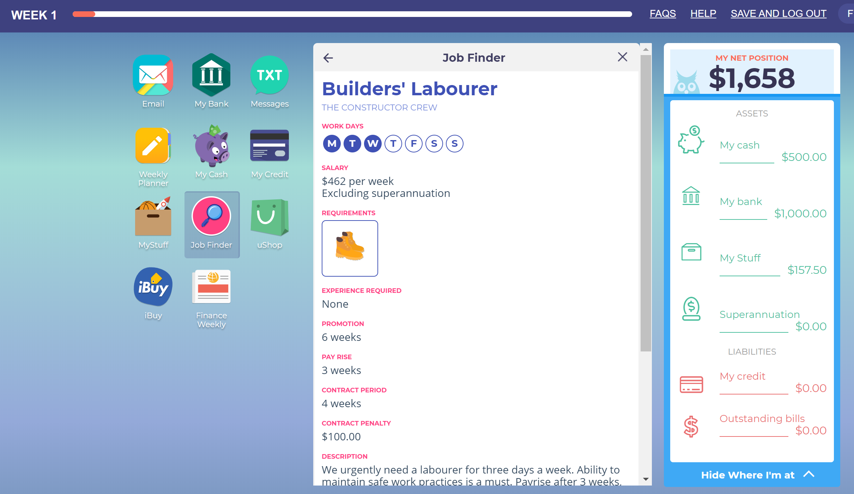

As we can see with this job, students will be required to purchase an asset before they can apply for the job. They can go to ushop or iBuy to purchase these. There is an opportunity to discuss which option is cheaper and why.

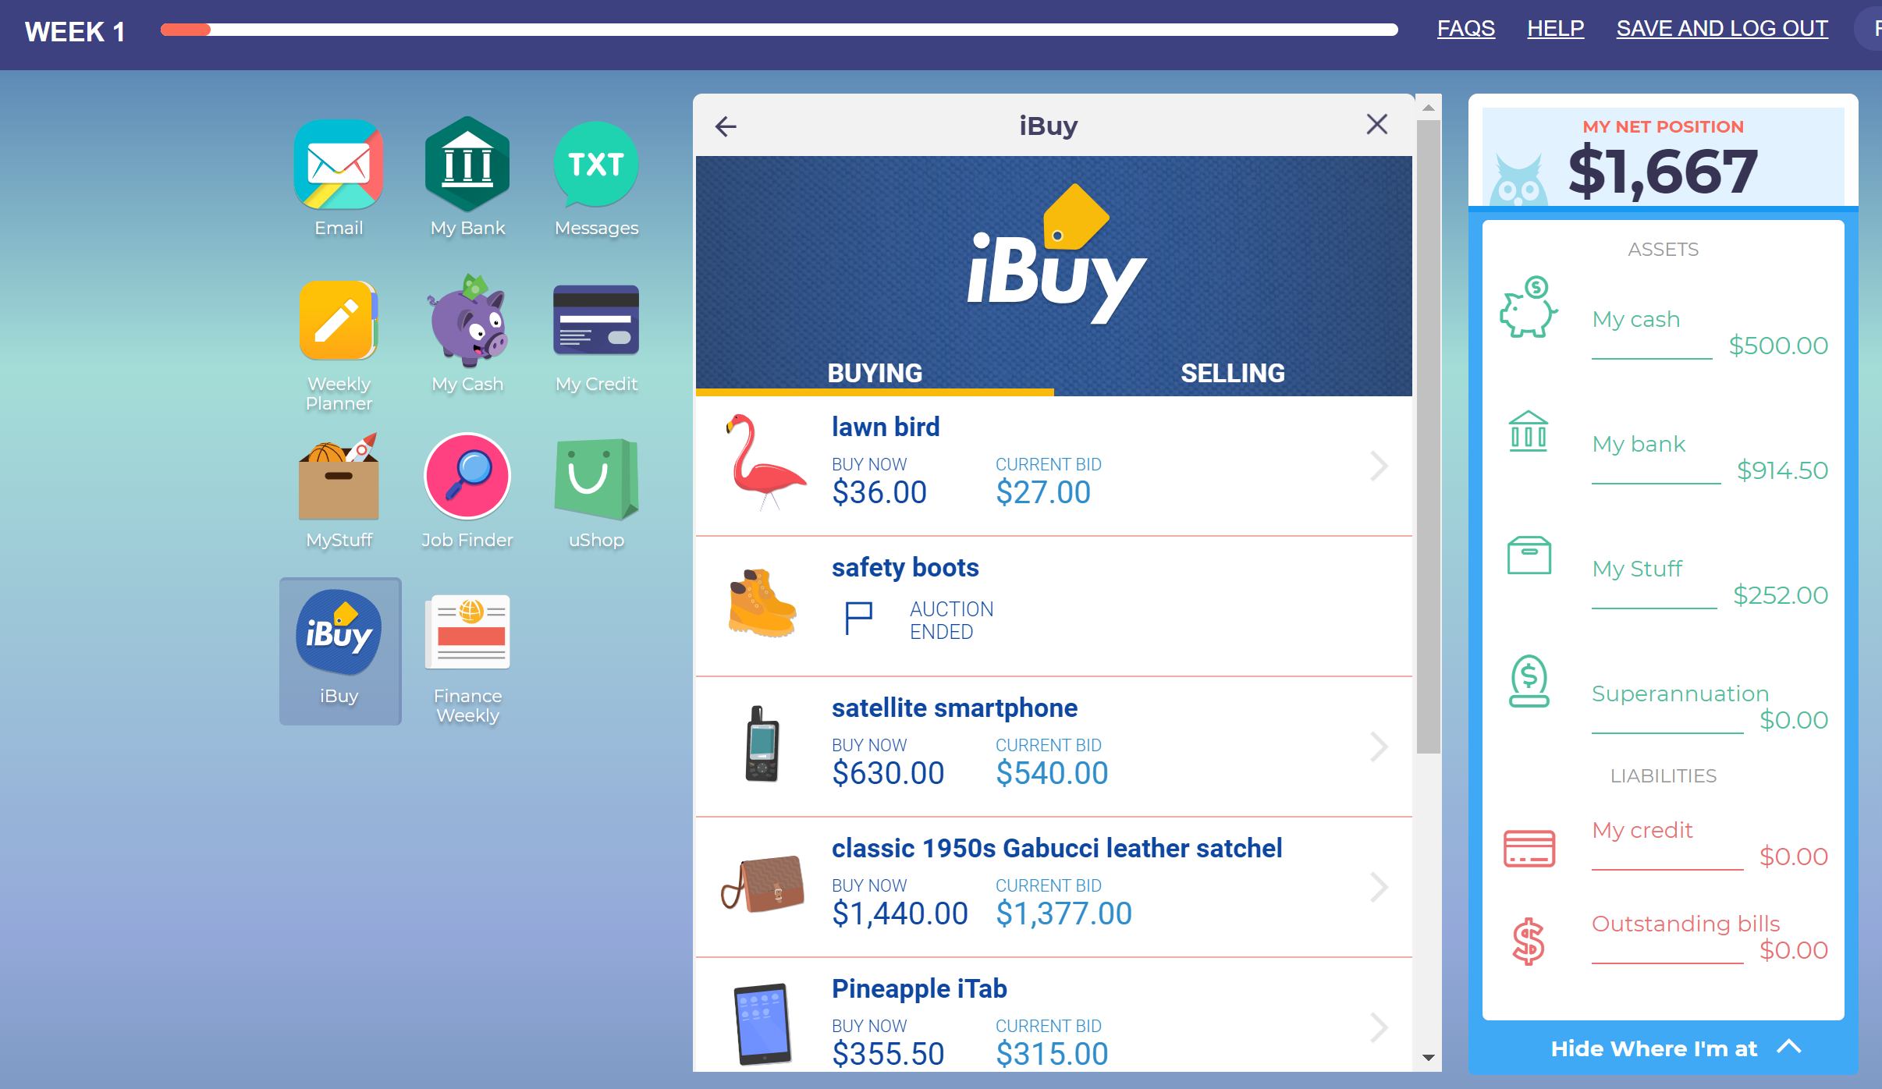

Remember to go back into “Job Finder” and apply for a job.
Go to “Finish the Week”. There is a bonus question for some extra cash.

- The next time you open the game for the following week, they should’ve received an email offering them the job. Students should click to accept the job.
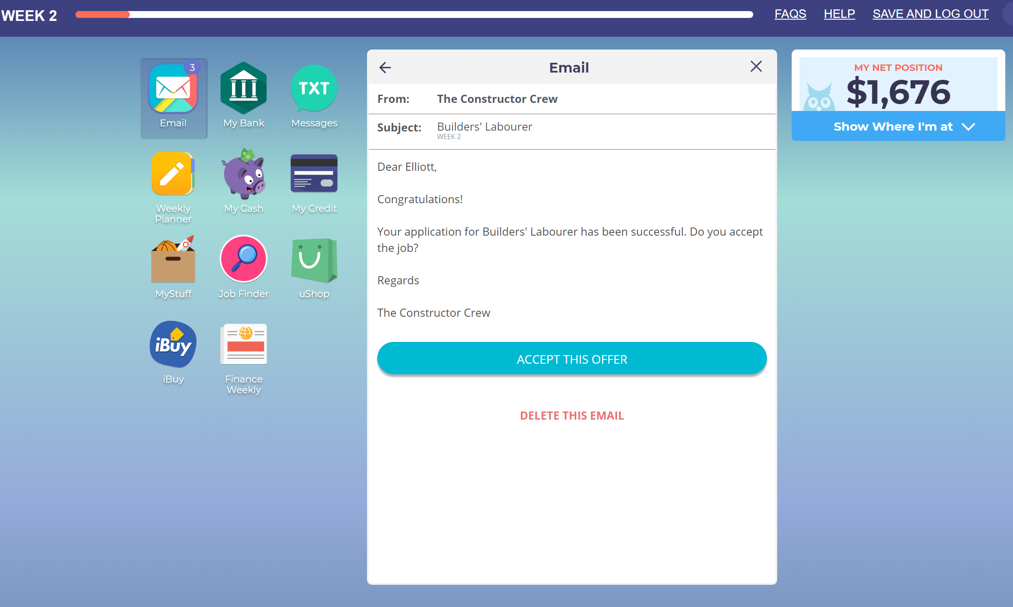

Additional Features

Ways of earning money
Students receive frequent text messages offering money for small tasks, such as taking over a person’s paper round or tutoring a friend’s child.
Students also have investment opportunities in your emails.

Budgeting
Going into the weekly planner, there are sliders where you can plan your budget. This could lead to discussions around “do we need to earn more money? What jobs could we get, what other tasks should we take on to earn more money?”
Students can set goals for what they want to buy, how much will they need to save each week to achieve this.

Tax
If you don’t delete the emails of your payslips, you can review these after 6-10 weeks to discuss what tax you are being charged. Over the space of 6-10 weeks, you are likely to get a pay rise and a promotion, or else get a new job. Either way, your tax will change and the concept of “the more we earn, the more tax we are charged can arise”.

Shopping for needs and wants
Students can look through both uShop and iBuy and make purchases as well as setting goals for what they want to save up for.
Make choices about what to buy and from where. Most items are available in both iBuy (second hand in eBay) and uShop (new in an online shop). Students can consider which items they want brand new and which they will settle for second hand, as well as the need to buy something in order to get a job.

