Decimal and Percentage Word Search
Find all the hidden words form the list in the word search.
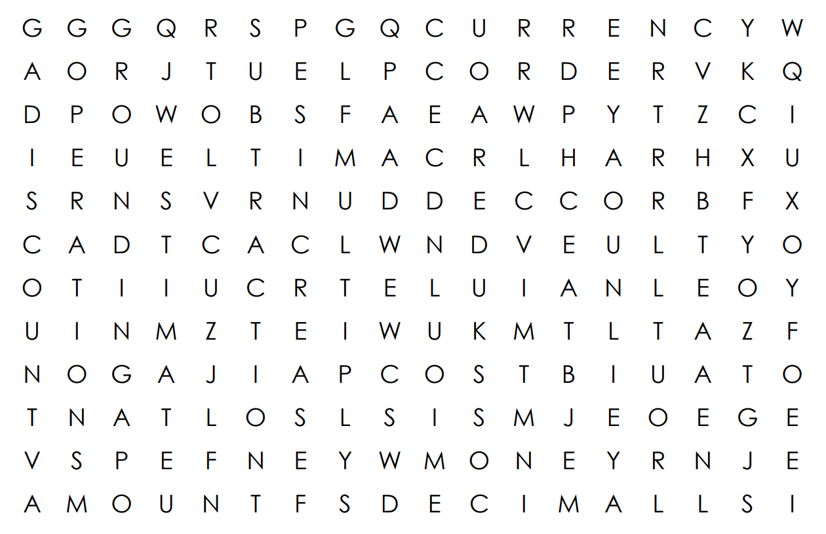

ADDITION
AMOUNT
CALCULATE
CURRENCY
DECIMAL
DISCOUNT
ESTIMATE
INCREASE
MONEY
MULTIPLY
NUMBER
OPERATIONS
ORDER
PART OF
PERCENTAGE
PLACE VALUE
ROUNDING
SUBTRACTION
WHOLE
Note: this word search was created using: Super Teacher Worksheets

