What can I buy for lunch?

I have been given money to spend at the school canteen for lunch.
Using the school canteen menu, I need work out what can I buy to eat for lunch?
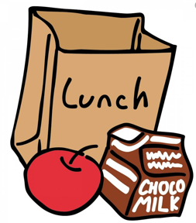

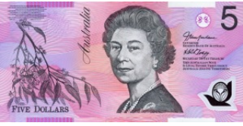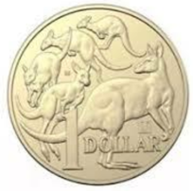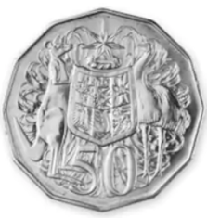

- How much money do I have? _______________________

Food / Drink Item | Price ($)
Total Cost $

- Do I have any change left over? If so, how much? _______________________

Extension Activity

Reorganise the table of your food items from the most expensive to the least expensive
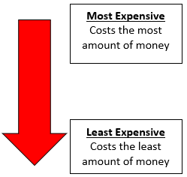

Food / Drink Item | Price ($)

