What is the value of $1 around the world?
Using the online currency convertor tool provided by Google complete the following table to find out the value of $1 Australian dollar in comparison to places around the world.
 | Country | Value of $1 AU
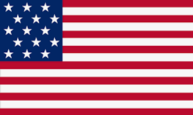 | United States of American  US Dollar
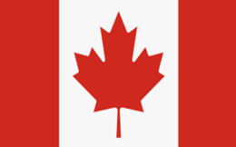 | Canada  Canadian Dollar
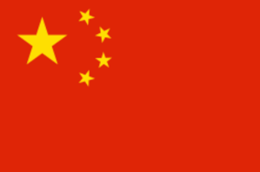 | China  Chinese Yuan
France
Euro
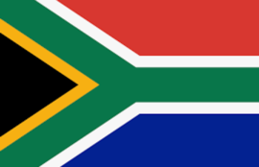 | Africa  South African Rand
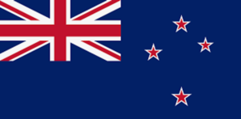 | New Zealand  New Zealand Dollar
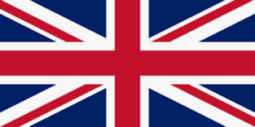 | United Kingson  Pound Sterling

