

Everyday Maths Hub: Years 5 and 6 Resources
Looking for ideas to spark positive conversations about mathematics in the everyday?
Take a look at these themed resources to engage, inform and inspire your child/ student:
- Building positive maths mindsets
- People who used maths to help them change the world
- Puzzling and wondering through maths
- Maths in surprising places
- Having fun when using maths
- Books to build understanding

Building positive maths mindsets
Keep your child’s curiosity in maths flourishing with these resources, videos and tips. Packed with profound lessons and real-life stories about resilience, problem solving and perspective, these resources can help you continue to support your child build a positive mindset towards learning.
What Do You Do With A Problem? Written by Kobi Yamada – This picture book is about a persistent problem that follows a child around. The longer the problem is avoided, the larger it seems to get – isn’t that always the way? When the child finally musters up the courage to face the problem, it turns out to be something quite different all together. This profound story might just help your child uncover how brave they can be and how important it is to embrace challenges, no matter what format they come in.
Salt In His Shoes: Michael Jordan In Pursuit Of A Dream, written by Deloris Jordan and Roslyn M. Jordan and illustrated by Kadir Nelson – When Michael Jordan was a child, he almost gave up on being a basketball player because he feared he would never be tall enough. Then his parents taught him about patience, determination and hard work. This inspirational illustrated story is about how a family can work together to help a child achieve their dreams - true for almost all things when you want to feel more confident.
Confidence-Boosting Maths Messages (8:36) Speaker: Professor Jo Boaler (developed By Youcubed at Stanford). In this insightful video, Professor Jo Boaler from Stanford University and her students explain why everyone can master maths. They use the latest brain research as well as examples and stories of the mathematicians in history who’ve encountered setbacks and spent years working on problems. This video can help us realise that maths isn’t about speed – it’s about growing our brains, creativity, and finding and solving problems.
Mistakes That Worked: The World’s Familiar Inventions And How They Came To Be, written by Charlotte Jones and illustrated by John O'Brien – Did you know many of the things we use in daily life were invented completely by accident? How’s that for an upside to making a mistake? This book shares 40 tales of the unlikely origins of foods, clothing, toys and devices we use in our daily lives. Perfect for any upcoming entrepreneurs in your family!
The Boy Who Dreamed Of Infinity: A Tale Of The Genius Ramanujan, written by Amy Alznauer and illustrated by Daniel Miyares – This a real-life story of Ramanujan, who managed to change modern mathematics and science forever. The beautifully illustrated book will make your child think twice about numbers, and inspire them to dare to dream as big as Ramanujan did.

People who used maths to help them change the world
Spark your child’s imagination with these incredible stories of trailblazers in architecture, space, and design… all of whom needed to use maths to help them change the world. In these five books you’ll also find positive lessons about determination, collaboration, and the importance of working hard when going after your dreams.
Women in Science: 50 Fearless Pioneers Who Changed The World, written and illustrated by Rachel Ignotofsky – A great collection of stories about 50 famous scientists from ancient to modern times. Profiles include renowned biologist Rachel Carson and primatologist Jane Goodall, as well as less famous pioneers, such as Dr. Patricia Bath and Barbara McClintock, a Nobel Prize-winning cytogeneticist. Fuel your child’s passion for maths by telling them the stories of the remarkable figures that have gone before and show them how maths has been used to change our world.
The World Is Not A Rectangle: A Portrait Of Architect Zaha Hadid, written and illustrated by Jeanette Winter – Imagine having a hand in creating buildings all over the world? This triumphant story of famed architect Zaha Hadid, details her childhood where she dreamt of one day designing her own cities, using her mathematical skills and knowledge to overcome obstacles to help her achieve her goals.
Blockhead: The Life Of Fibonacci, written by Joseph D'Agnese and illustrated by John O'Brien – This book tells the story of Leonardo Fibonacci - a man whose attention to detail, passion for numbers and endless wonder helped him notice the recurring patterns in nature, and led to his discovery of what has come to be known as the Fibonacci sequence. Next time you’re walking outdoors, this book might inspire you to notice and wonder about the world around you.
The Girl With A Mind For Math: The Story Of Raye Montague, written by Julia Finley Mosca and illustrated by Daniel Rieley – As a child, Raye Montague toured a submarine and this event ignited her passion for engineering. But while she loved maths, she still had many obstacles to overcome to reach her goals. This acclaimed naval engineer changed the course of ship design, as the first person to create a computer-generated draft. Talk about a legacy!
Astronaut With A Song For The Stars: The Story Of Dr. Ellen Ochoa, written by Julia Finley Mosca and illustrated by Daniel Rieley – If your child loves looking up at the night sky and pondering the universe, they may enjoy this story about NASA astronaut, Dr. Ellen Ochoa. Growing up, Ochoa dreamt of becoming a professional flautist but all of that changed when she discovered engineering in college. Ochoa's story shows us how it’s never too late or too early to realise your dream and reach new heights with hard work, perseverance and, of course, maths!

Puzzling and wondering through maths
Puzzling, wondering and playing with ideas are key qualities in the pursuit of mathematical thinking and problem solving. In these five interactive resources, you can help your child enrich their mathematical skills with everything from codebreaking to programming.
Over 50 Secret Codes, written by Emily Bone and illustrated by Sam Meredith – Did you know that language, codes and communication are underpinned by mathematics? If your child is interested in coming up with their own secret language, they’ll want to read this book! In it, they’ll find some of the world’s most famous codes including Semaphore, Morse Code, “Grid Code” and even Egyptian hieroglyphics. After exploring this book with your child, lunchbox notes might take on a whole new adventure.
Frank Einstein And The Antimatter Motor, written by Jon Scieszka and illustrated by Brian Biggs – Science inventions, funny jokes, robot adventures and maths facts make this an entertaining and memorable story for your child. Frank Einstein loves building and experimenting in his garage lab. When the robot he builds gets stolen, fun and puzzling times unfold!
The ‘I Hate Mathematics!’ Book, written by Marilyn Burns and illustrated by Martha Hairston – If you or your child are almost convinced that some maths is nearly impossible, just for “smart people” or simply no fun at all - this book shows that maths can be a very different experience. Its combination of hilarious illustrations and creative suggestions will help expand your child’s understanding of what maths can be and what we can use maths to do.
Red Dragonfly Mathematics Challenge, Adapted from Yasuhiro Hosomizu and illustrated by Stephen Axelsen – offers a range of problems to challenge and stimulate your child's curiosity. The various puzzles and problems will build your child’s grit and patient problem solving as they use their skills in how numbers work, the operations, patterning, area, length and more.
Girl Geeks 1: The Hackathon, written by Alex Miles – In this novel, the first in the ‘Girl Geeks’ series, Hamsa’s teacher announces that the class will be running a hackathon. Out of her element, Hamsa has no idea what a hackathon nor coding is, and to make matters worse, she’s not partnered with her best friends. Can Hamsa and her team work together to pull off this challenge? Will things fall apart? This is a relatable read for any student who has to collaborate, persevere through challenging experiences or learn about something for the first time.

Unexpected places where you’ll find maths
From the oceans, to football, to magic tricks, maths plays a vital role in many unexpected places. Use these resources to explore the unexpected places where mathematics can be found and how it helps us make sense of the world.
Reaching The Stars with Maths (2:14) – Speaker: Karlie Noon (developed by Australian Mathematical Sciences Institute (AMSI). This is the inspiring story of Karlie Noon, the first Indigenous Australian in New South Wales to complete a double degree in maths and physics. She is currently researching for a Master’s in the field of Astrophysics. Her story reveals how as a mathematician, perseverance and curiosity are everything.
Football School Season 1: Where Football Explains the World, written by Alex Bellos and Ben Lyttleton and illustrated by Spike Gerrell – Do you live with a budding soccer superstar? Or are they just a massive fan of the sport? Then this series will be right up their alley! It’ll also help support mathematical skills and understanding at the same time. These true stories explore maths, science and history, accompanied by funny drawings and jokes that are bound to get your child thinking differently.
The Golden Ratio Coloring Book: And Other Mathematical Patterns Inspired by Nature and Art, written and illustrated by Steve Richards – Help your child relax and investigate mathematical ideas at the same time. This colouring-in book explores the ‘The Golden Ratio’ and other mathematical patterns that can be found in nature, art and architecture. The intersection of maths and art is also depicted through fractals, mandalas and tiles, all while colouring in.
How Big Is The Ocean? (5:25) – Speaker: Scott Gass (developed by TED-Ed). How do we measure the size of the ocean? Watching this video will help your child grapple with this very big question by investigating what “the ocean” is, looking at how much area it covers on the Earth’s surface (hint: a LOT), and talking about how much of the planet’s life it contains. For any flourishing marine biologists, environmental scientists, statisticians, nature-lovers or curious minds, this video shows how we use maths to help us explore and make sense of the world around us.
Magical Mathematics: The Mathematical Ideas That Animate Great Magic Tricks, written by Persi Diaconis and Ron Graham, and foreword by Martin Gardner Magic powered by maths? – Of course! Your child can learn a collection of card tricks from this book - and the mathematical ideas behind them. It has step-by-step instructions and ideas around enhancing their performance skills. There’s also an explanation of shuffling, the “Three-card-Monte” trick, and information about some magicians in history who have who used maths. A magician might never reveal the secrets behind his or her tricks, but here’s a hint: there’s often maths involved!

Games to have fun with maths
These games will help enrich your child's reasoning and problem-solving skills as they enhance their knowledge of how numbers work, quantifying collections, patterning, algebra and probability. Help your child expand their mathematical skills using these five fun games.
Prime Climb – A colourful board game for ages 10 and up, Prime Climb combines strategy and luck as players battle to be the first to land both pawns in the 101 circle at the centre of the game board. By rolling dice and choosing which operation you’d like to use, players can bump their opponent’s pawns off the board in this exciting race to 101!
Mabble – Described as “crosswords with numbers”, Mabble is a mathematical version of Scrabble. Players use tiles to create equations, aiming to be the player with the highest score. Mabble enriches reasoning skills as your child draws on their knowledge of algebra and operations to make, or add-on to, mathematical equations. Like most games, the whole family can enjoy this one at your next celebration or games night!
Yahtzee – Yahtzee is a great way for your child to enhance their skills in quantifying collections, understanding how numbers work and using operations. Combining both skills and luck, there’s a chance that probability might enter the conversation too! The object of the game is to get the highest score. Players take turns rolling dice and meeting specific criteria to grow their score. Good luck rolling a Yahtzee!
Qwirkle – This is a game of spatial reasoning and strategising that you can enjoy with mathematicians young and old! This award-winning game involves matching colours and shapes on a set of tiles and using them to form rows and columns, similar to Sudoku. Your child will need to use their knowledge of patterning, the operations and position as they carefully work out what and where to play!
Battleships – Battleships is another classic board game that can be enjoyed by players young and old. The goal is simple: Find the hidden battleships on your opponent's board by taking turns to eliminate coordinates using skills in reasoning and position. As the game progresses, figuring out which squares are more likely to hold a ship can become easier… but the risk of getting struck down also increases!

Books to build understanding
Your child can use these five books to expand their knowledge about probability, numbers and the Fibonacci sequence. While they may not all be cover-to-cover reads, you can choose your own adventure by selecting chapters your child finds interesting. Some of these books you can return to again and again!
The Number Devil: A Mathematical Adventure, written by Hans Magnus Enzensberger, translated by Michael Henry Heim, and illustrated by Rotraut Susanne Berner – Have you ever dreamt about mathematics? This book follows Robert as he adventures with different mathematical principles through 12 different dreams. Both Robert and your child will learn about things like prime numbers and the Fibonacci sequence, exploring how numbers work and other mathematical concepts.
If: A Mind-bending Way Of Looking At Big Ideas And Numbers, written by David J. Smith and illustrated by Steve Adams – Numbers help us describe the world around us. To do that, sometimes we need really big numbers, which may be challenging for young minds to understand. But what if your child could think about those numbers in relation to things we can readily see, feel and touch? If your child has ever wondered 'how big is that?' this incredible book is for them.
Mind-boggling Numbers, written by Michael J. Rosen and illustrated by Julia Patton – “If everyone on Earth owned exactly the same amount of land, how big would your yard be?” This book poses some curious questions and uses maths to help us answer them. This is a fun read that encourages noticing and wondering whilst also exploring aspects of measurement and numbers.
G Is For Googol: A Math Alphabet Book, written by David M. Schwartz and illustrated by Marissa Moss – Featuring maths trivia and fun facts to entertain your child, this book explains maths with humour and quirky illustrations. It contains an A-Z list of some cool mathematical ideas from a googol to the little-known rhombicosidodecahedron. This maths companion guide is a fun read from front to back, back to front, and any combination in between.
That's A Possibility! written and illustrated by Bruce Goldstone – What makes something possible, impossible, or probable? This book dives into different situations, exploring likely outcomes. You can read this book to explore concepts of probability with your child.

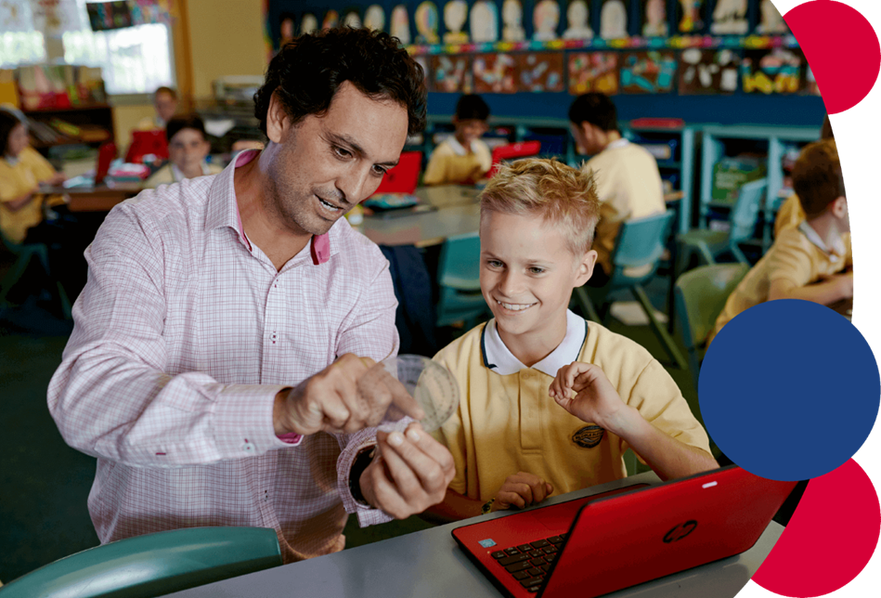
For more information contact: nswms@det.nsw.edu.au

