Everyday Maths Hub: Years 1 and 2 Resources
Looking for ideas to spark positive conversations about mathematics in the everyday?
Take a look at these themed resources to engage, inform and inspire your child/ student:
- Building positive maths mindsets
- People who used maths to help them change the world
- Puzzling and wondering through maths
- Unexpected places where you’ll find maths
- Having fun when using maths
- Books to build understanding

Building positive maths mindsets
As your child gets older, you can continue to fuel their curiosity and help build a positive mindset towards learning using these 5 books, packed with inspiring lessons about persistence, perspective and individuality.
Your Fantastic Elastic Brain: Stretch It, Shape It, written by JoAnn Deak PhD and illustrated by Sarah Ackerley – Another excellent picture book for teaching your child that making mistakes can, in fact, be a great thing! Mistakes not only help your child grow their brain, they can be helpful for overcoming fears and helping to build courage – essential ingredients for working like a mathematician.
Count On Me, written by Miguel Tanco – Follow the story of a young girl as she celebrates maths in everyday life. She sees maths in the concentric circles a skipping stone makes in a lake, the curve of a slide and the geometric shapes and objects in a playground. It’s everywhere and it’s thrilling! This book can help your child realise that there are many different ways to see the world – and the joys of seeing it through a mathematical lens.
The Most Magnificent Thing, written and illustrated by Ashley Spires – An important story about perseverance and how one little girl made the “most magnificent thing” by keeping at it. This thought-provoking picture book will give your child perspective, and is a relevant read for them as young learners who need to develop the skills and confidence to keep trying even in the face of multiple set-backs.
All The Ways To Be Smart, written by Davina Bell and illustrated by Allison Colpoys – This heartfelt picture book can help to boost your child's self-esteem by showing them how all children are special in their own way. Being smart takes many forms – whether you’re good at persevering with problems, dancing or being brave. It’s healthy and wonderful to think differently, and this book can help you embrace the importance of having different skills, especially as a mathematician.
Rosie Revere, Engineer, written by Andrea Beaty and illustrated by David Roberts – Let Rosie’s story and mission help your child see failure as an important stepping stone towards success. This triumphant book shares an important lesson: You only really fail when you quit. Like some of the most famous mathematicians of all time, you’re in great company when you need to keep persisting to achieve your goals!

People who used maths to help them change the world
The stories of inventors, innovators and trailblazers can inspire us to try new things or offer a new perspective. Introduce your young child to the wide and wonderful possibilities of maths and empower them to learn more through the stories of these five mavericks.
Grace Hopper: Queen Of Computer Code, written by Laurie Wallmark and illustrated by Katy Wu – As far as revolutionary people go, Grace Hopper is definitely an inspiring one. Digital illustrations and an easy-to-read story bring this picture book biography to life. Grace was an inventor, software tester, avid reader, naval leader, mentor, rule breaker and chance taker - and served an almost 50-year career in the navy where she used mathematics to shape computer science as we know it today.
Counting The Stars: The Story Of Katherine Johnson, NASA Mathematician, written by Lesa Cline-Ransome and illustrated by Raúl Colón – At NASA, Katherine Johnson was one of the incredible mathematicians known as the “human computers”. This inspiring picture book follows her journey to become a mathematician who helped astronauts make it to the moon when she worked out the maths behind launching a rocket into space. Her story, and how she used maths to change the world, is one for the ages.
Nothing Stopped Sophie: The Story Of Unshakable Mathematician Sophie Germain, written by Cheryl Bardoe and illustrated by Barbara McClintock – Introduce your child to 18th century mathematician Sophie Germain, a trailblazer who defied the odds to study mathematics (in secret) and dedicated six years of her life to a theorem to work out patterns of vibrations. This equation laid the groundwork for modern architecture and construction - so there’s a lot to thank Sophie for! This is a tale of resilience, breaking boundaries and passion.
Stephen Hawking: My First Stephen Hawking, written by Maria Isabel Sanchez Vegara and illustrated by Matt Hunt – In this sweet picture book from the Little People, Big Dreams series, your child will be introduced to famed theoretical physicist and author Stephen Hawking. While he was never considered the “top” of his class, his passion, dedication and ideas opened up doors to the top universities in England. This book is suitable for young children and offers awe-inspiring messages from the life and career of one of the world’s most influential figures in maths and physics.
On A Beam Of Light: A Story Of Albert Einstein, written by Jennifer Berne and illustrated by Vladimir Radunsky – Einstein reportedly said, “Imagination is more important than knowledge”. This sweet and inspiring picture book tells his story: A young boy with an endless fascination for the world around him, who overcomes challenges and refuses to give up on problems. The story of Einstein reminds us that sometimes, when you persevere with maths, you can use it to help change the world.

Puzzling and wondering through maths
Puzzling, wondering and playing with ideas are key qualities in the pursuit of mathematical thinking and problem solving. In these five interactive and entertaining books, you can help your child enrich their imagination and critical-thinking skills.
The Rabbit Problem, written and illustrated by Emily Gravett – How does one lonely rabbit end up with an overflowing field of rabbits? This beautiful, pop-up and interactive picture book gives us lots to puzzle over as it explores mathematical ideas like patterning, time and quantifying collections. Hidden within the pages is a baby book for bunnies and a recipe book dedicated to carrots.
Which One Doesn't Belong? - Playing With Shapes, written and illustrated by Christopher Danielson – This picture book will encourage your child to notice features about 2D shapes and develop a convincing argument to decide, ‘Which one doesn’t belong?’ With plenty of opportunities to notice and wonder, it can help show your child there is often more than one solution to a mathematical problem.
Rainy Day Pocket Puzzle Book, written by Simon Tudhope – Featuring mazes, spot-the-difference, brain teasers, jumbled sequences and other mind-bending puzzles, this collection is sure to give your child’s critical-thinking muscles a workout. Perfect for after school, during the holidays, or on a rainy weekend, you can play through the pages with your child, building your skills in communicating, reasoning and problem solving!
1001 Animals To Spot, written by Ruth Brocklehurst and illustrated by Terri Gower – If your child loves animals, hide-and-seek or has an adventurous streak, they’ll relish the challenges in this book. From elephants in the Serengeti to sloths in the Amazon Rainforest, they’ll learn about wild animals and their habitats as they enhance their noticing and reasoning skills. This book will also help your child enhance their skill in quantifying collections, position and patterning.
Math Appeal: Mind-Stretching Math Riddles, written by Greg Tang and illustrated by Harry Briggs – In this book of riddles, artworks, puzzles and fables, you'll find insightful tips for effective problem solving. Your child will be encouraged to keep an open mind, look for unusual number combinations, use multiple skills and look for patterns.

Unexpected places where you’ll find maths
From the animal kingdom to outer space, maths underpins it all! These five awe-inspiring books will give your child a glimpse of some of the unexpected places where maths can be found - often without us even realising until we look closer.
The LEGO Ideas Book: You Can Build Anything! Written by Daniel Lipkowitz – Aside from being a lot of fun to play with, LEGO is a versatile tool that can support spatial reasoning, an understanding of 3D objects, position, quantifying collections and how numbers work. This book is full of ideas for LEGO projects you and your child can build together like cars, buildings, and things from outer space. It encourages invention and ingenuity - valuable qualities in all young mathematicians.
Maps, written and illustrated by Aleksandra Mizielinska and Daniel Mizielinski – This detailed and entertaining book has 52 illustrated maps exploring countries around the world and shares information about their flags, populations and landmarks. Whether you’re creating secret treasure maps in the yard or sending someone on a special mission around the home, we need a range of mathematical skills. Creating maps helps build understanding of position, length, area, quantifying collections, 2D shapes and operations.
Lifetime: The Amazing Numbers In Animal Lives, written by Lola M. Schaefer and illustrated by Christopher Silas Neal – Many children love animals, and this book connects them and their homes in nature with numbers using colourful illustrations. Your child can explore the number of holes drilled in a tree by a woodpecker, the number of spots on a giraffe, or try to count 1000 baby seahorses. They will see that mathematical ideas really are everywhere… and they can be used to help us explore almost everything!
If Pluto Was A Pea, written by Gabrielle Prendergast and illustrated by Rebecca Gerlings – If Pluto was the size of a pea, how big would the earth be? It can be challenging for children to imagine very big, abstract objects and how they compare to other things, objects and spaces. This book explores the size of the planets by using everyday objects showing us how, once again, maths can be used to help us make sense of the world. Use this book to stimulate your child’s imagination and get them thinking about the universe.
Iggy Peck, Architect, written by Andrea Beaty and illustrated by David Roberts – Iggy is a boy with a passion for building great things – a passion that requires hard work and commitment to a goal – and maths! Like all users of mathematics, Iggy faces some challenges as he follows his dream in unconventional ways, inspiring children and adults alike to persevere.

Games to have fun with maths
These five games are a great way to have fun and help your child develop their ability to think mathematically.
Blokus – This award-winning game of strategy is an enjoyable way for your child to enhance their spatial reasoning skills and explore area and position. How do they win? They need to be the player with the most pieces on the board at the end of the game. The players take turns placing coloured tiles on the board. The tiles must have a corner touching another corner of a tile of the same colour, but they cannot be placed edge-to-edge. Good luck reasoning your way into a winning position!
Checkers – This two-player board game is a classic and helps enhance your child’s problem-solving and spatial reasoning skills. As they move across the board, players have to make careful decisions to help them outwit their opponent! By moving game pieces diagonally and always forward on a checkerboard, your child’s goal is to remove all of the other player’s pieces from the board or put them in a position where they cannot move. They remove the other player's pieces by “jumping” over them. To win, they’ll need to be able to think and plan a few steps ahead!
SET – SET is a card game that uses a specially designed deck with 81 unique cards. The standard game involves laying down no more than 12 cards on a table, with the players finding sets of cards with certain features. It’s a great way to develop skills in patterning and probability, with the odds of finding a set increasing as the game continues.
Mancala – This ancient game is a great way to help your child work on their problem-solving and reasoning skills as they quantify collections and try to outwit you! While there are many variations of this game, it usually involves two players and the game ends when one player has captured all of their opponent’s pieces.
Jenga – A game of Jenga will involve you and your child carefully removing blocks out of the tower, and then placing them carefully on top. The person that collapses the tower loses and the game is over. Jenga by itself is fun enough, but it also supports ideas about 3D objects, mass, equivalence and also basic engineering concepts like balance, load and position. Now that your child is developing their mathematical skills at school, it’s a good time to help them expand their understanding of what they’re learning. These books will help broaden their minds to the possibilities!

Books to build understanding
Now that your child is developing their mathematical skills at school, it’s a good time to help them expand their understanding of what they’re learning. These books will help broaden their minds to the possibilities!
How Big Is A Million? Written by Anna Milbourne and illustrated by Serena Riglietti – Your child may know that a million is big - but how big, exactly? This book can help them explore very big numbers. Pipkin the penguin’s quest to learn what this number means also introduces other large numbers, before finally reaching a million.
12 Ways To Get To 11, written by Eve Mirriam – Quantifying collections and learning how numbers work are important areas of learning in the early years. Read this book with your child to practice counting and play with numbers in enjoyable ways.
Great Estimations, written and illustrated by Bruce Goldstone – Estimation is an important mathematical skill, but looking at a collection of objects and estimating how many there are can be a tricky skill to develop. This book examines ways to enhance estimating skills and explores what big collections look like so your child can notice and think about what they see.
Sheep Won’t Sleep: Counting By 2s, 5s And 10s, written by Judy Cox and illustrated by Nina Cuneo – This intriguing book deals with quantifying collections by counting not just sheep, but colourful yaks and llamas too. Clarissa can’t get to sleep, and when the familiar strategy of counting sheep doesn’t work, she takes a creative approach to the problem.
How Tall, How Short, How Far Away? Written by David A. Adler and illustrated by Nancy Tobin – Build on your child’s knowledge of measurement with this book, which includes fun and interesting facts about its history. It also explains the development of standard units of measurement, including the metric and imperial systems.

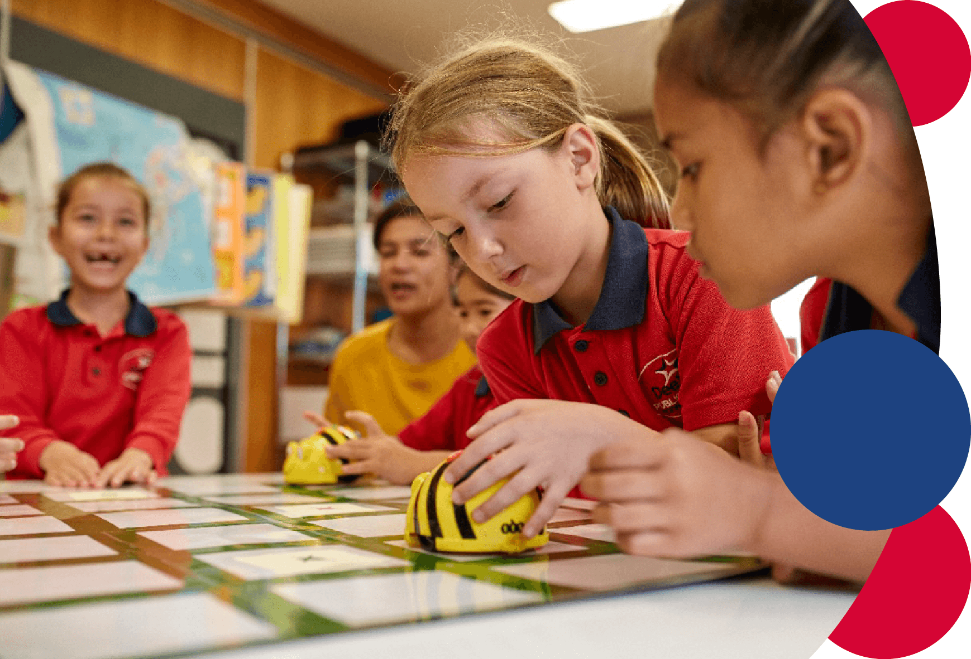
For more information contact: nswms@det.nsw.edu.au

