Everyday Maths Hub: Kindy Resources
Looking for ideas to spark positive conversations about mathematics in the everyday?
Take a look at these themed resources to engage, inform and inspire your child/ student:
- Building positive maths mindsets
- People who used maths to help them change the world
- Puzzling and wondering through maths
- Unexpected places where you’ll find maths
- Having fun when using maths
- Books to build understanding

Building positive maths mindsets
Stoke the flame of your child’s growing curiosity in maths with these 5 brilliant picture books that encourage exploration, experimentation and learning from mistakes.
Beautiful Oops! Written and illustrated by Barney Saltzberg – As children get older, they may begin to feel like they have to get everything right the first time they try. Beautiful Oops! is a charming interactive picture book that’ll help your young child learn that making a mistake can be an opportunity for adventures in creativity. The ideas in this book can help build a positive mindset towards learning in all subjects, including mathematics.
Your Fantastic Elastic Brain: Stretch It, Shape It, written by JoAnn Deak PhD and illustrated by Sarah Ackerley – Another excellent picture book for teaching your child that making mistakes can, in fact, be a great thing! Mistakes not only help your child grow their brain, they can be helpful for overcoming fears and helping to build courage – essential ingredients for working like a mathematician.
The Most Magnificent Thing, written and illustrated by Ashley Spires – An important story about perseverance and how one little girl made the “most magnificent thing” by keeping at it. This thought-provoking picture book will give your child perspective, and is a relevant read for them as young learners who need to develop the skills and confidence to keep trying even in the face of multiple set-backs.
Rosie Revere, Engineer, written by Andrea Beaty and illustrated by David Roberts – Let Rosie’s story and mission help your child see failure as an important stepping stone towards success. This triumphant book shares an important lesson: You only really fail when you quit. Like some of the most famous mathematicians of all time, you’re in great company when you need to keep persisting to achieve your goals!
How To Catch a Star, written and illustrated by Oliver Jeffers – This charming picture book tells the story of a boy who loves stars so much, he wants to catch one for himself! The eye-opening story will challenge the way your child sees the world, offering them a new perspective – which they can apply to the many different problems they find and solve.

People who used maths to help them change the world
The visionaries at the centre of these stories tested boundaries and changed the world! Enjoy these five inspirational books with your child, sharing stories with them about maths that can be used to make a difference.
On A Beam of Light: A Story of Albert Einstein, written by Jennifer Berne and illustrated by Vladimir Radunsky – Einstein reportedly said, “Imagination is more important than knowledge”. This sweet and inspiring picture book tells his story: A young boy with an endless fascination for the world around him, who overcomes challenges and refuses to give up on problems. The story of Einstein reminds us that sometimes, when you persevere with maths, you can use it to help change the world.
Ada Lovelace, written by Isabel Sanchez Vegara and illustrated by Zafouko Yamamoto – Ada Lovelace was a mathematician, daughter of poet Lord Byron and ‘the princess of parallelograms’. At the age of 12, Ada wrote a book about planes and as she grew up, she married her love of logic and poetry to develop the world's first computer program. This book series shares stories about inspiring and interesting historical figures to help the next generation think about how they might change the world.
Kid Innovators, written by Robin Stevenson and illustrated by Allison Steinfeld – This collection of stories shows how many well-known innovators started out as kid innovators. There’ll be no shortage of inspiration with this diverse group of inventors and trailblazers from fields of technology, education, business, science, art, and entertainment…all of whom needed maths to help them innovate!
This Little Explorer: A Pioneer Primer, written by Joan Holub and illustrated by Daniel Roode – Introduce your pioneer-in-training to ten of the most influential explorers that ever lived with this bright and colourful picture book. From Neil Armstrong and Christopher Columbus to Marco Polo and Amelia Earhart, these tales will help inspire your child to explore, and show them how mathematics underpins all of these amazing feats of human adventure.
Alan Turing, written by Maria Isabel Sanchez Vegara and illustrated by Ashling Lindsay – The ultimate problem solver, Alan Turing is often called the father of theoretical computer science and artificial intelligence! Not a bad title, eh? With beautiful hand-drawn illustrations that bring Alan’s story to life. This book from the Little People, Big Dreams series tells the story of a shy boy with a keen interest for numbers who eventually went on to crack the code of the Enigma Machine. A must-read for any child who fancies curious problems, mysteries and or a little code-cracking!

Puzzling and wondering through maths
Puzzling, wondering and playing are key qualities in the pursuit of mathematical thinking and problem solving. In these five interactive and entertaining books, your child will get to put their imagination and critical-thinking skills into practice.
Press Here Written and illustrated by Herve Tullet – Help your child identify patterns and learn about cause and effect with this instructive and interactive picture book. They’ll be instructed to ‘press here’ and then see the consequences of their actions on the next page as they play and explore like mathematicians.
Which One Doesn't Belong? - Playing With Shapes Written and illustrated by Christopher Danielson – This picture book will encourage your child to notice features about 2D shapes and develop a convincing argument to decide, ‘Which one doesn’t belong?’. With plenty of opportunities to notice and wonder, it can help show your child there is often more than one solution to a mathematical problem.
Adi Sorts with Variables Written by Caroline Karanja and illustrated by Ben William Whitehouse – A sweet book about a girl named Adi who needs to clean her room. If only a computer could do it for her! With that mission in mind, she partners up with her best friend Gabi and they put on their computer coding caps, making tidying up more efficient and fun with maths. Tip: After reading the story, ask your child what things they’d like to invent and how they can use maths to bring their inventions to life!
We're Going on a Bear Hunt Written by Michael Rosen and illustrated by Helen Oxenbury – What surprise will your child find in the cave on the other side of the dark forest? Take your child on an adventure with this classic picture book. As they wade through grass, splash through the river and squelch through the mud in search of a bear, they’ll encounter mathematical ideas like position, temperature, length and patterning.
Hello Ruby: Adventures In Coding Written and illustrated by Linda Liukas – This activity book tells the story of Ruby, a small child with a huge imagination and no limitations! By following Ruby’s adventures, your child will be introduced to coding through imaginative storytelling and illustrations.

Unexpected places where you’ll find maths
Maths happens all around us – at school, at home, indoors and outdoors too! You can use these five ideas to explore maths in different and often unexpected places.
The LEGO Ideas Book: You Can Build Anything! Written by Daniel Lipkowitz – Aside from being a lot of fun to play with, LEGO is a versatile tool that can support spatial reasoning, an understanding of 3D objects, position, quantifying collections and how numbers work. This book is full of ideas for LEGO projects you and your child can build together like cars, buildings, and things from outer space. It encourages invention and ingenuity - valuable qualities in all young mathematicians.
Round Trip, written and illustrated by Ann Jonas – You can use this fun picture book to explore the mathematical ideas related to 2D shapes with your child. With a story told through text and reverse illustrations, together you can follow the adventure of a family that is taking a trip into the city and back again.
The Usborne Outdoor Book, written by Jerome Martin and Emily Bone, and illustrated by Briony May Smith – Why not take your child and their exploration of mathematical ideas out of the home? Use this book as a source of inspiration for all sorts of outside adventures - with some maths-related ideas popping up along the way. Whether it be quantifying collections by counting seashells, using understanding about position to draw maps, or investigating time by observing the sun and the seasons – there are plenty of ways to support your child’s mathematical understanding.
Little Leonardo's Fascinating World of Engineering, written by Bob Cooper and illustrated by Greg Paprocki – Without mathematics, little Leonardo would not have been able to create amazing structures or share them with other people. This book explains nine different kinds of engineering and how engineers build everything from giant bridges to mobile phones, using maths to help them.
Walking with the Seasons in Kakadu, written by Diane Lucas and illustrated by Ken Searle – Have you ever thought about how maths is used to help us explore changing seasons and weather patterns? This book depicts the passage of time and the change in weather in Kakadu, in northern Australia. Your child can explore the seasonal calendar of the local Gundjeihmi-speaking community and investigate a way of measuring time.

Games to have fun with maths
Games are a fun way to get your child thinking, communicating and reasoning like a mathematician. Here are five games for you to play together.
Snakes And Ladders – This classic board game can help your child build confidence with quantifying collections, learning how numbers work and developing spatial skills. Players take turns to roll the dice to determine how many spaces they need to move. Landing on a snake will send you plunging down the board, whereas landing on a ladder will get you closer to the winning square. If you don’t have a commercial copy of the game at home, you can make your own.
Tiny Polka Dot – You and your child can play different games with this versatile set of colourful cards, aimed at children aged from 3 to 8 years. Playing Tiny Polka Dot can help build your child’s understanding of how numbers work, help them quantify collections, and develop reasoning and communicating skills.
Go Fish – This card game can be played with a standard deck of playing cards. Go Fish helps your child explore how numbers work as well as developing their skills in quantifying collections and patterning. There's also some strategic thinking required so they can outwit their opponents! You can shake things up by tweaking the rules to explore other mathematical ideas.
Connect 4 – This game is similar to Tic-Tac-Toe or Noughts and Crosses and will help your child practice their skills in quantifying collections, strategic thinking and position. In Connect 4, two players compete to be the first to make a line of four coloured discs - either vertically, horizontally or diagonally. If you don’t have access to the game itself, you and your child can still play a version of it on paper.
UNO – is a card game that develops your child's knowledge of quantifying collections, how numbers work and strategic thinking. It's played with a coloured deck of cards numbered one to ten, with additional special action cards. The goal of the game is to run out of cards first, yelling UNO before anyone else when you have one card left in your hand. Coming in classic, junior and specialised formats, UNO is a game the whole family can enjoy!

Books to build understanding
The LEGO Ideas Book: You Can Build Anything! Written by Daniel Lipkowitz – Aside from being a lot of fun to play with, LEGO is a versatile tool that can support spatial reasoning, an understanding of 3D objects, position, quantifying collections and how numbers work. This book is full of ideas for LEGO projects you and your child can build together like cars, buildings, and things from outer space. It encourages invention and ingenuity - valuable qualities in all young mathematicians.
Round Trip, written and illustrated by Ann Jonas –You can use this fun picture book to explore the mathematical ideas related to 2D shapes with your child. With a story told through text and reverse illustrations, together you can follow the adventure of a family that is taking a trip into the city and back again.
The Usborne Outdoor Book, written by Jerome Martin and Emily Bone, and illustrated by Briony May Smith – Why not take your child and their exploration of mathematical ideas out of the home? Use this book as a source of inspiration for all sorts of outside adventures - with some maths-related ideas popping up along the way. Whether it be quantifying collections by counting seashells, using understanding about position to draw maps, or investigating time by observing the sun and the seasons – there are plenty of ways to support your child’s mathematical understanding.
Little Leonardo's Fascinating World of Engineering, written by Bob Cooper and illustrated by Greg Paprocki – Without mathematics, little Leonardo would not have been able to create amazing structures or share them with other people. This book explains nine different kinds of engineering and how engineers build everything from giant bridges to mobile phones, using maths to help them.
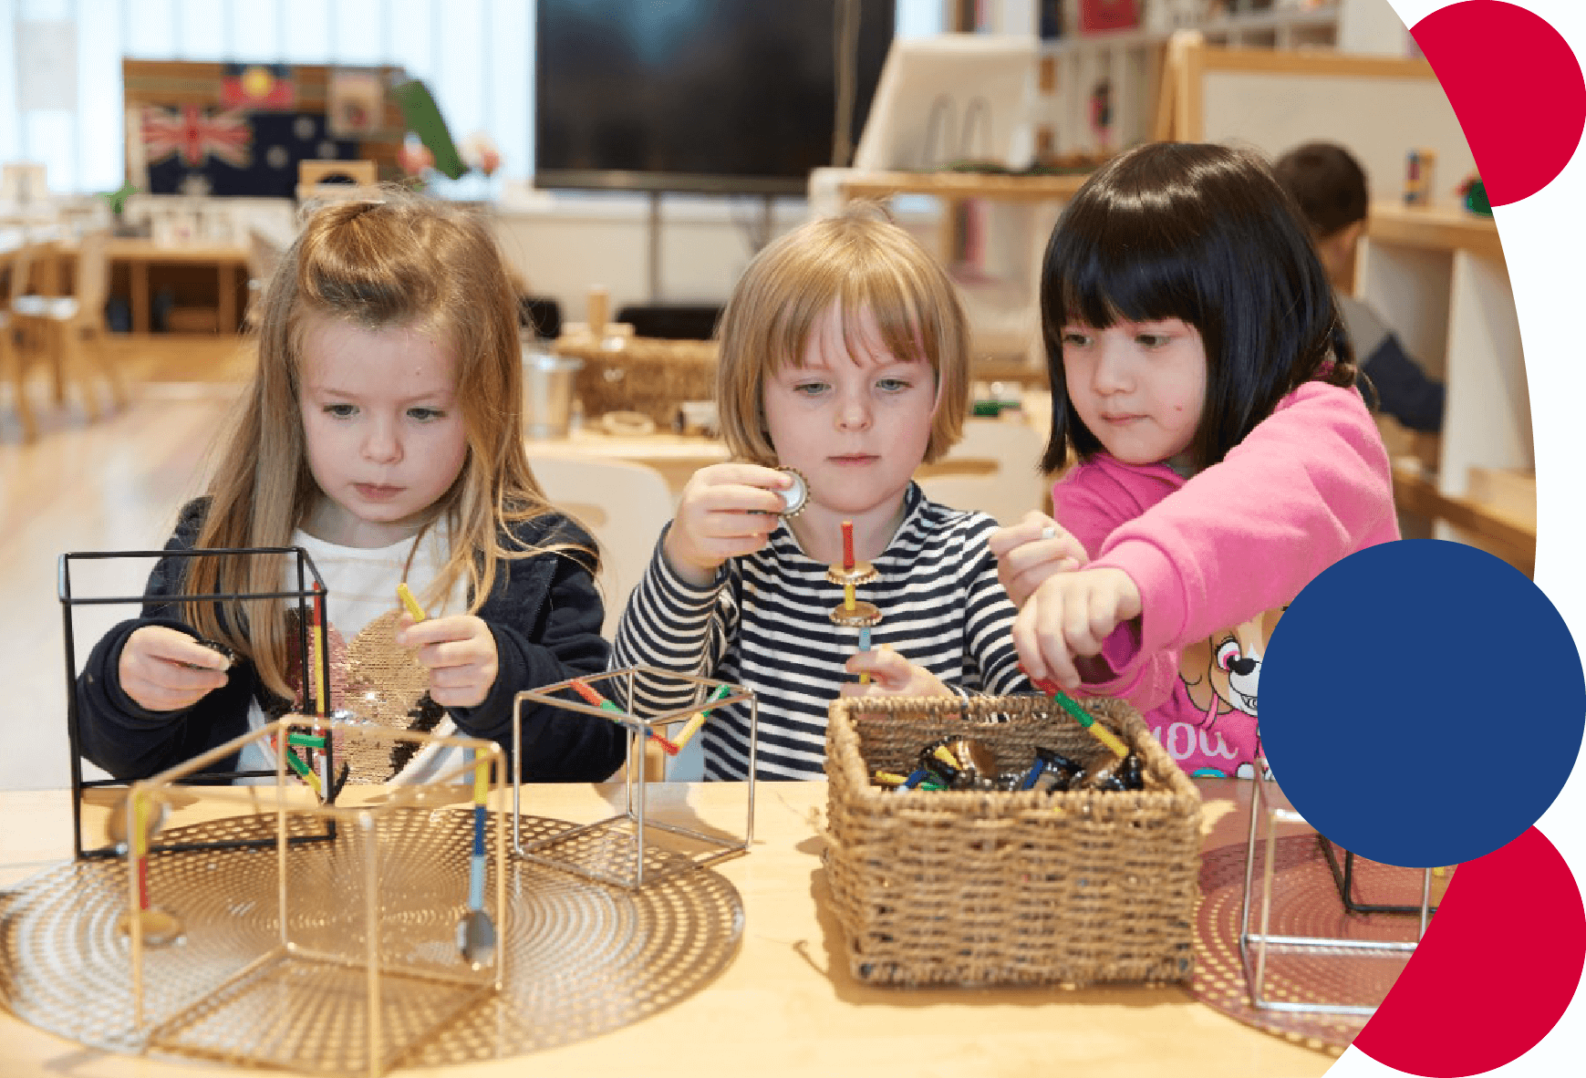
For more information contact: nswms@det.nsw.edu.au

