Calendars
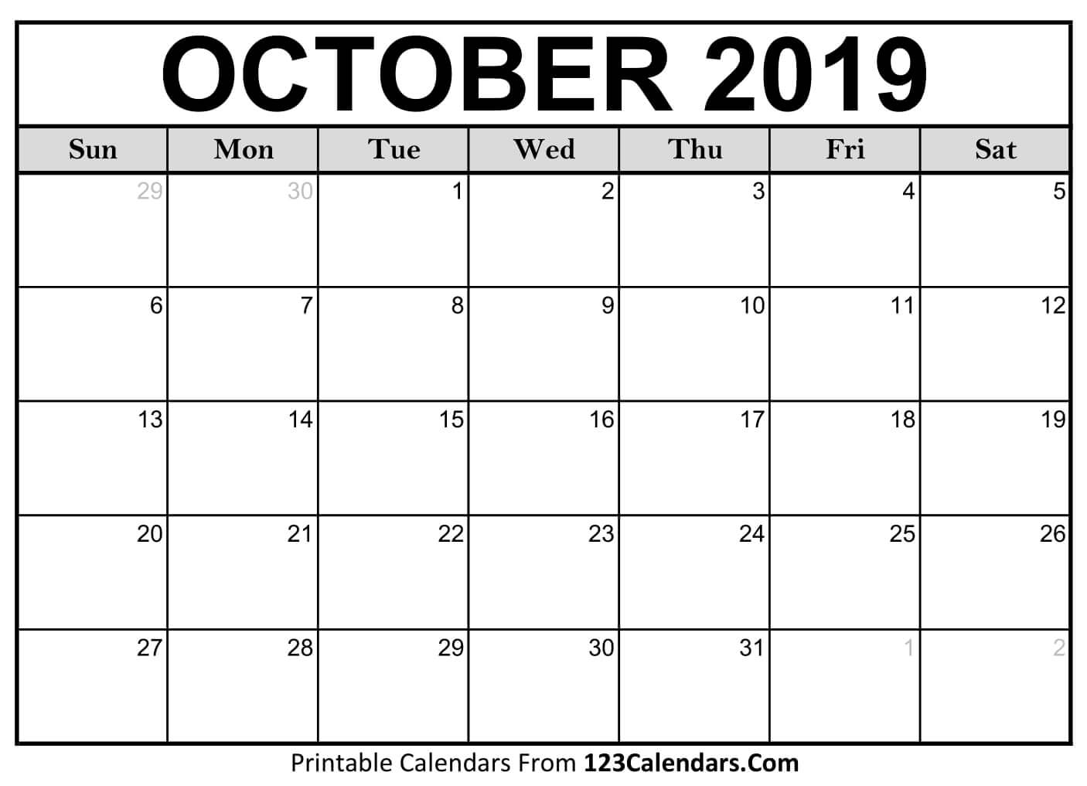
- Sally has a doctor’s appointment on 17 October. Write this on her calendar.
- What day of the week is 12 October?
- Sally plays badminton on 9 October. Write this on her calendar. What is the date of her next match two weeks later?
- How many days in October?
- What day of the week is 30 September?
- What day of the week is 2 November?
- How many Tuesdays in October?
- How many Mondays in October?
- How many public holidays are there in October 2019?
- Sally meets friends in the coffee shop on the second Thursday of every month. What date is this in October?
- Sally goes to TAFE on Monday afternoons. How many times does Sally go to TAFE in October?
- Sally promised to look after her friend’s cat for five days, starting on 20 October. What is the last day she has to look after the cat?

