Samples of great assessment tasks – and why we love them!
At our syllabus implementation workshops in 2018-2019, your feedback indicated you wanted more information on assessment tasks, specifically samples of tasks which:
- focus on authentic communication
- assess the new outcomes, especially the ones which can be a bit trickier to assess
- combine 2 or more macros skills.
Authentic communication has a purpose, and context and audience, and you will notice all of these tasks have these 3 elements.
The assessment tasks which follow were developed by teachers – they were submitted as post-tasks at our programming workshops, and we think they shine! We hope you recognise one of yours. Whilst we have matched these tasks to Stage 5 outcomes, you could adapt many of these tasks to make them suitable for Stage 4.

Task 1 – exchange to [target country]
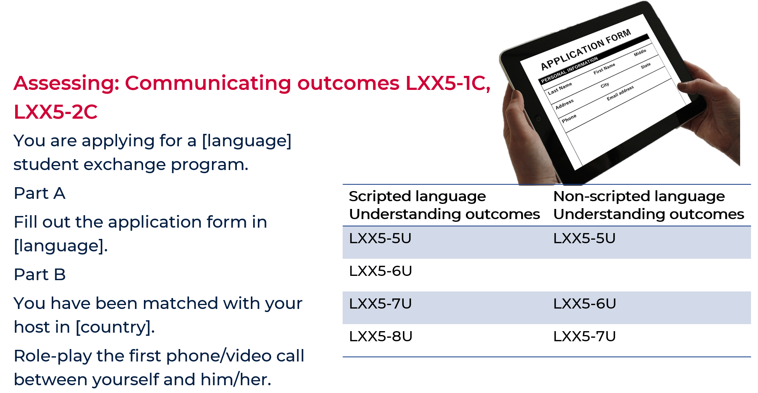

Why we love this task
These are highly authentic products for the context. Part B allows students to explore what they would want to be able to say and ask, with support from you in learning suitable phrases for that context. A range of outcomes is being assessed and students are writing and speaking.

Task 2 – planning your festival itinerary

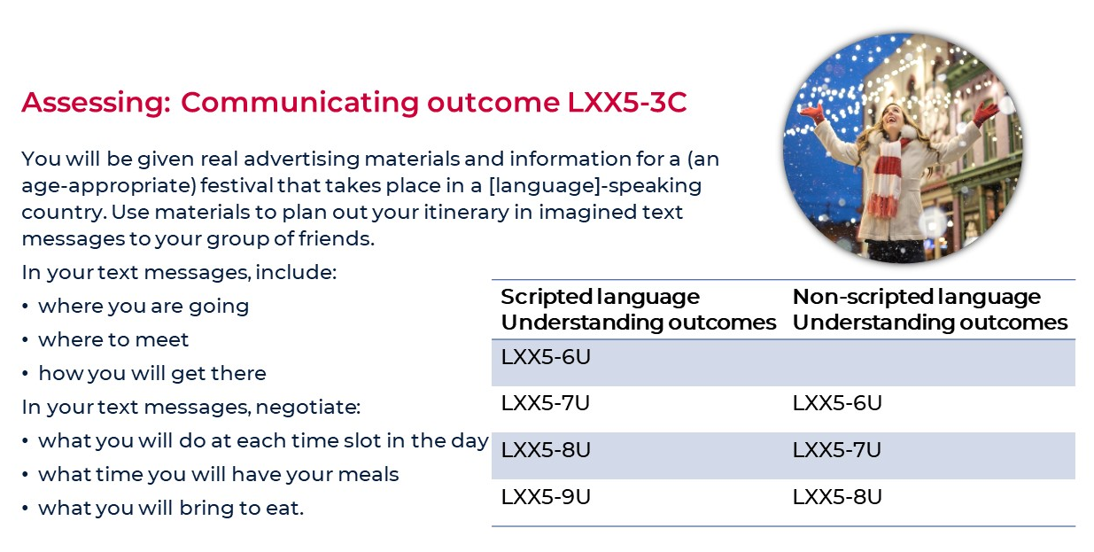

Why we love this task
We think students will be really motivated by this one because you are using a real event and authentic support material instead of a made-up one. If it is an annual event, you should be able to find real social media snippets of people enjoying the festival in previous years. This is a much more interesting take on the topic of daily routine. How often do we realistically talk about our everyday routine? We do, however, talk about what time to do things when we are planning a social event like this. This task assesses 3C, as students are taking the information they have read and are using it to create a text message conversation with friends. Please note, the fact that we are the ones providing students with the stimulus material, allows us to accurately check that they have used/interpreted the information correctly.

Task 3 – film festival

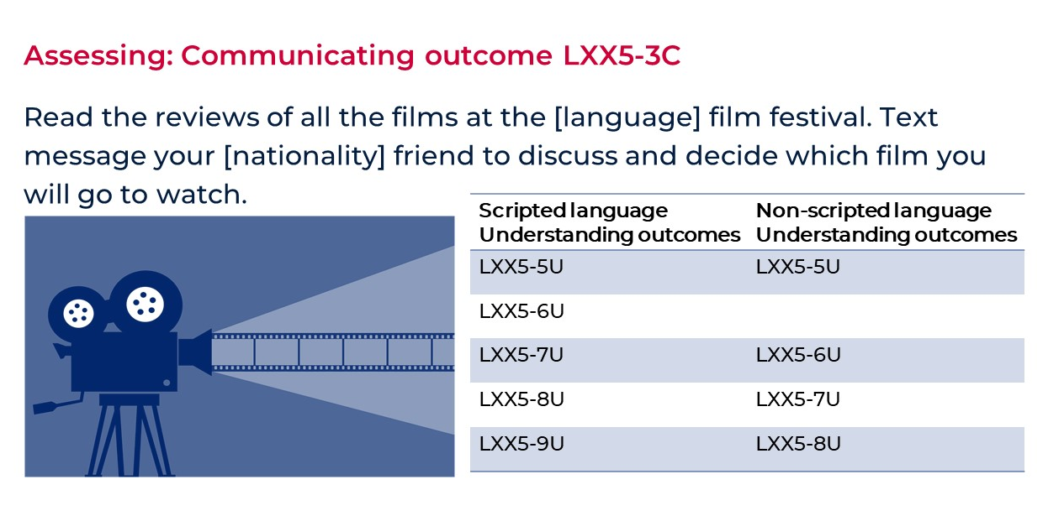

Why we love this task
What’s not to love about film? You can actually include watching a film in the language – what better way is there to hear such sustained communication in the target language (other than flying the class to the country!). This is a topic students are sure to love, and the product is highly authentic. This is how they communicate nowadays. It’s also an opportunity to research the language of text messages in the target country. We can find many authentic resources online for this one!

Task 4 – food vlogger

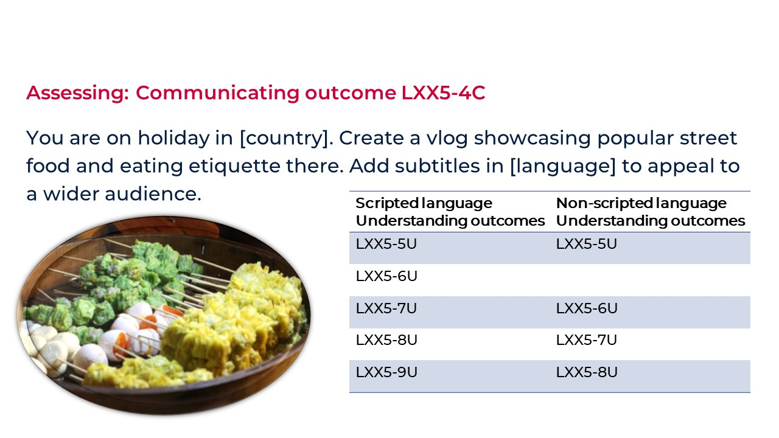

Why we love this task
Two words – food, travel! That’s all that needs to be said. YouTube is a way to make income nowadays and street food is experiencing a surge in popularity all around the globe. You will find a wealth of authentic videos on YouTube of people talking about and eating food, from which you can extract real language to teach students how people speak today. This unit presents a good opportunity to embed learning across the curriculum content of ‘work and enterprise’. You can switch languages around with this one too. If you want this to be all about speaking, students can present in the target language and subtitle in English, and you can assess 5U. If you want to focus on writing skills, they can present in English and subtitle in the target language, and you can assess 6U in non-scripted languages. As you can see, it’s a very versatile task.

Task 5 – travel agent

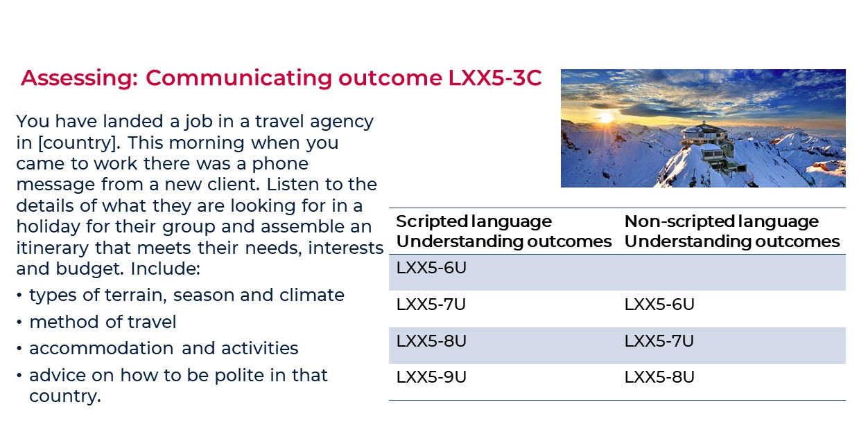

Why we love this task
This task presents the perfect opportunity for differentiation. Teachers can easily provide different stimulus texts that will appropriately challenge the different levels of learners. To target those with prior learning and background speakers, the ‘client’ could provide more detailed requests using increasingly sophisticated language, such as special interest holidays such as eco-tourism or traveling with a cause. Because the context pitches the task to be created in the language, it gives students the freedom of choosing anywhere in the world to research and present to their clients.

Task 6 – welcome to our home

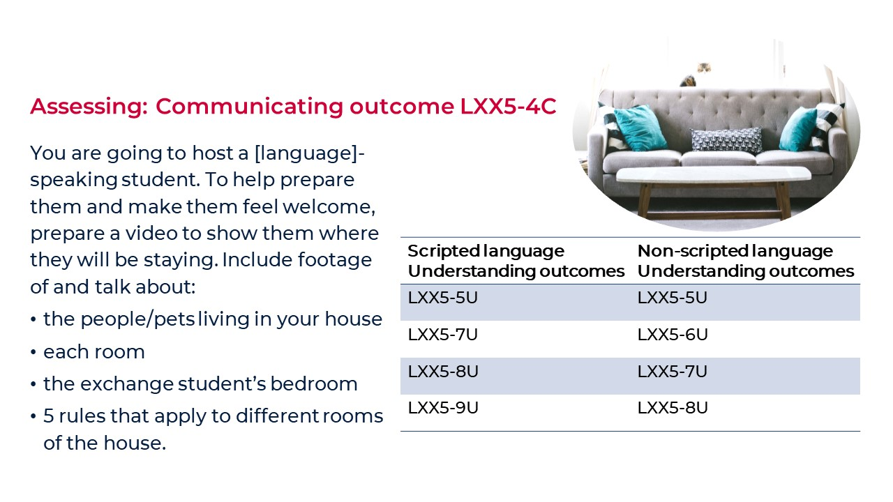

Why we love this task
In order to choose which rules to include, students research daily home life in the target country and discuss what might be different for the exchange student in their home. Some common examples might be times to eat, wake up, sleep, etiquette at the table, chores, public/private spaces, and so on. It provides the opportunity to deeply reflect on customs and practices in their own homes, and to develop their understanding of the role that family culture and identity plays in our own lives and how it shapes the way we view the world.
Students can be given the choice of filming their own home or using Creative Commons images from the internet.

Task 7 – love our town

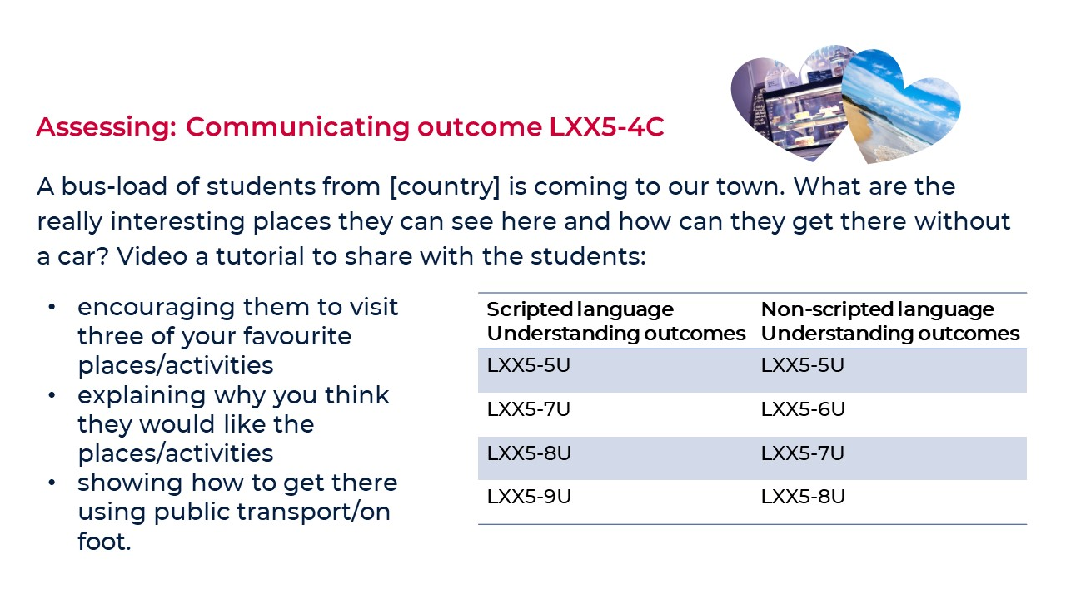

Why we love this task
This one is one of our absolute favourites. It engenders love of local community, fostering positive relationships between people and their place, while exploring the traditional topic of directions. Although tasks pitched at travel can sometimes seem out of reach to some students, this context is local, making it inclusive. We often have students describe places, but this one is encouraging students to visit certain places, and so the use of persuasive language can be brought in, which is much more useful in authentic communication.
An alternative context, purpose and audience could be your local council is running a competition to make a digital brochure, promoting your town to tourists. Then you would not be assessing 5U, but would be assessing 6U if you teach scripted languages.

Task 8 – come out with me!

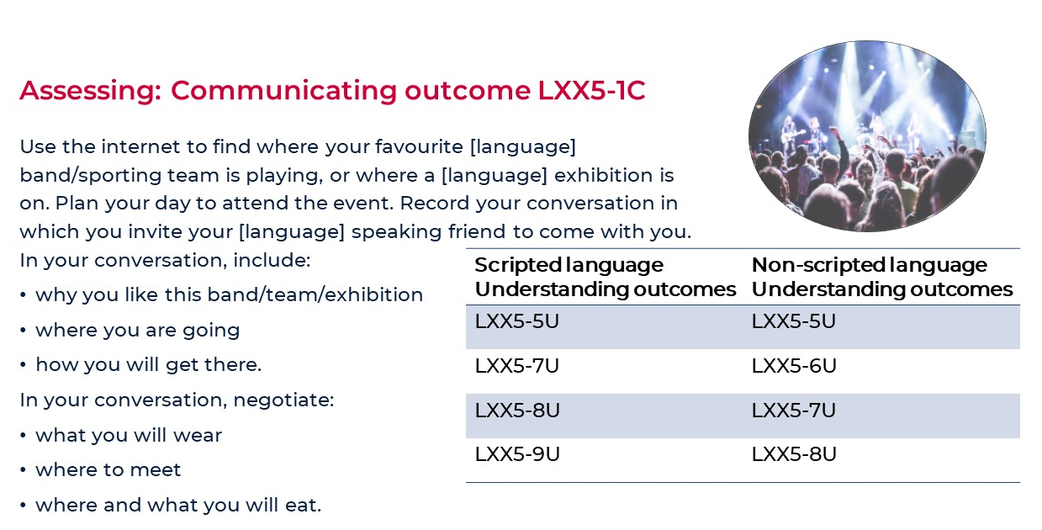

Why we love this task
This is an interesting inquiry-based task, where students can discuss their favourite bands, teams or exhibition. They can use the internet to find out where they are really playing in the target country. This research would also activate outcome 2C, as they would need to understand key information from what they read. It will also activate 3C, as they are taking the information they have read and using it in creating a text – ‘the conversation with a friend’. Please note: We aren’t assessing 3C because to do so teachers would need to have knowledge of the content in the texts students read, and checking if students have accurately used that information. While teachers could request students include the URLs of the source materials they accessed to get their information, the time needed to read all the material to check students have used the information correctly would not be feasible. If teachers wish to assess 3C, to make the task more manageable and valid, teachers would need to provide the source texts to the students. In this way teachers can be sure of the information and will be able to assess students’ demonstration of understanding.

Task 9 – raising our guide dog puppy

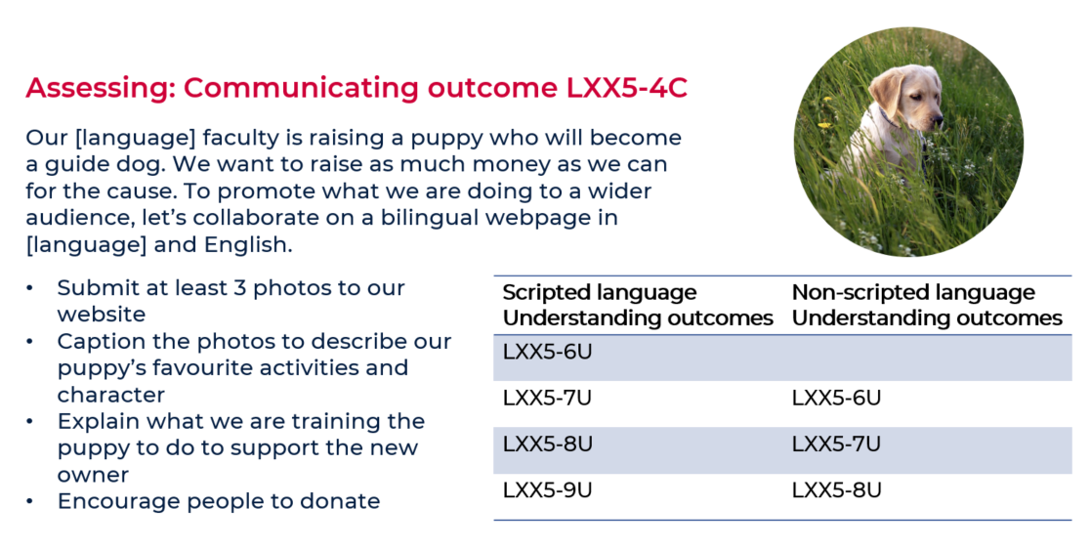

Why we love this task
The faculty is actually raising a guide dog! Talk about real life stimulus and motivation for students. Not to mention all the learning across the curriculum content that can be drawn into this unit – civics and citizenship, difference and diversity, ethical understanding, information and communication technology capability and personal and social capability.

Task 10 – welcome to our school

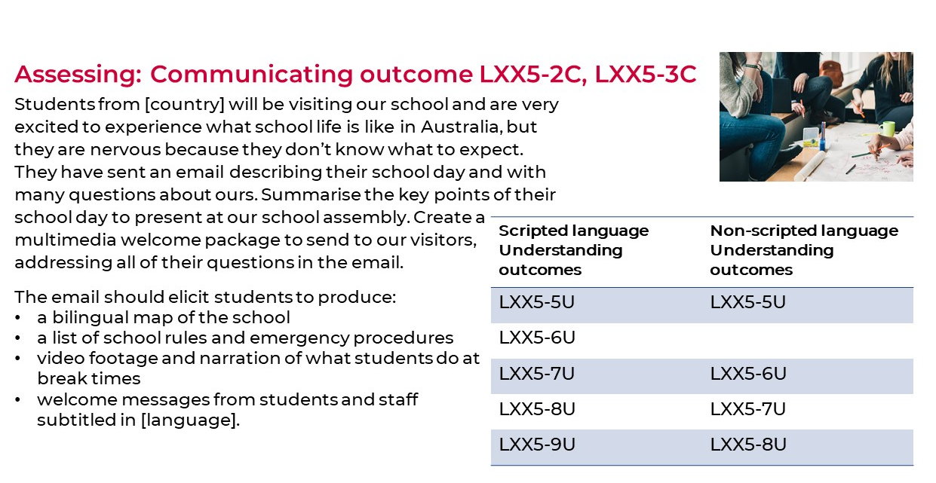

Why we love this task
If you really host students from other countries – how practical is this task! Products from this task could be used on your school’s website and social media accounts to promote the school, show how welcoming it is and make languages visible! This task goes deeper than learning the names of subjects and instead dives into true purposeful language learning. We can explore differences that might make others feel nervous or uncomfortable, and how to make people feel welcome and valued.

