Programming guidelines for modern languages 7-10
Note: This document provides advice only. It is the responsibility of individual school executive and teaching staff to ensure record keeping is compliant with both NSW Education Standards Authority (NESA) and departmental requirements and policies.

Introduction 2
Elements of a program 2
Scope and sequence 2
Units of work 3
Assessment 3
Register 5
Additional considerations for modern languages 7-10 6
A task-based approach 6
Learner groups 6
Values and attitudes objectives 7
Appendix 1 – scope and sequence checklist 8
Appendix 2 – unit of work checklist 9
Appendix 3 – assessment of learning checklist 10

Introduction
Programming is the process through which teachers select and sequence teaching, learning and assessment experiences which cater for the diversity of learners in a particular Stage/year. A program is all of the documents involved in the overall planning for each language and Stage/year that you teach.
Effective programs enable teachers to:
- plan for the delivery of syllabus outcomes and content
- improve student learning outcomes
- respond to student learning needs, school context, self-reflection and evaluation
- record planned learning experiences of how syllabus requirements are met.
A program is to be provided for each subject or course in each year of schooling in order to meet NESA school registration requirements.
The department also sets additional requirements, outlined in the Curriculum planning and programming, assessing and reporting to parents K-12 policy. (Note: If the link does not open, you can access via the policy library in the portal.)
A program allows for continuity of quality learning for students. Programs also allow other teachers to continue teaching your students if required, for example during periods of teacher absence.

Elements of a program
For each Stage/year and language, you need to have a program that includes the elements listed below.
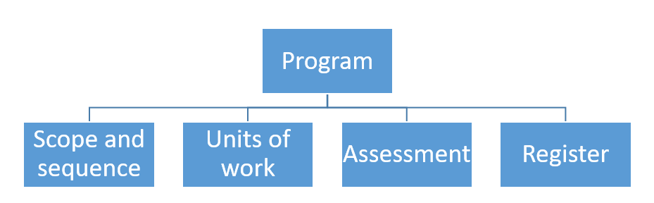

Scope and sequence
A scope and sequence summarises what is to be taught and the sequence in which it will be taught within a year or Stage. It includes the syllabus outcomes that each unit addresses.
See Appendix 1 for a detailed checklist to support you in developing your own scope and sequence documents.

Units of work
Units of work summarise the teaching and learning strategies, resources and assessment (both formal and informal) for a particular set of outcomes and content in the syllabus. They also include adjustments to meeting the learning needs of students, where required, and a section for reflection and evaluation.
In the K-10 modern languages syllabuses, the content provides guidance and examples on how the outcomes are to be interpreted and applied through mandatory content (dot points) and the sample learning tasks (dash points). When designing a unit of work, consider the learner groups in your classroom – you only need to program for the learner group/s you teach.
The following steps may guide you in designing units of work – this is a backward mapping approach.
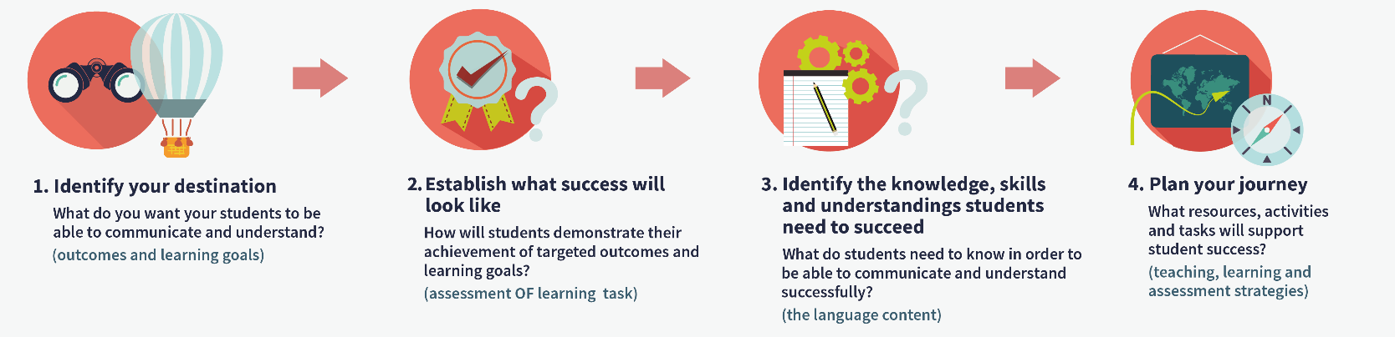
See Appendix 2 for a detailed checklist to support you in developing your own units of work.

Assessment
Assessment provides opportunities for teachers to gather evidence about student achievement in relation to syllabus outcomes, including a range of student work samples.
NESA states:
“Assessment is an integral part of teaching and learning. Well-designed assessment is central to engaging students and should be closely aligned to the outcomes within a Stage. Effective assessment increases student engagement in their learning and leads to enhanced student outcomes.
Assessment for learning, assessment as learning and assessment of learning are 3 approaches to assessment that play an important role in teaching and learning. The NESA K–10 syllabuses particularly promote assessment for learning as an essential component of good teaching.” (from Languages K-10 Framework, © NSW Education Standards Authority (NESA) for and on behalf of the Crown in right of the State of New South Wales, 2018)

Assessment for learning

Assessment for learning aims to close the gap between where a student is now and where they need to be, in order to successfully demonstrate their achievement of the outcomes. Teachers use evidence of students' knowledge, understanding and skills to inform their teaching and to provide feedback to students about their learning and how to improve.

It’s important to plan opportunities which allow for students to discover where there are now and enable them to plan how to move to the next stage of their learning.

For example:
- pre-testing for prior knowledge
- quizzes to monitor progress
- one-to-one feedback
- students plan own next steps to improve.

These activities are often teacher-driven, and have the aim of planning next steps to improve (also known as formative assessment).

Assessment as learning
Assessment as learning occurs when students are their own assessors. Students monitor their own progress, ask questions and practise skills. Students use self-assessment and teacher feedback to reflect on their learning, consolidate their understanding and work towards learning goals.
For example, students:
- provide feedback to peers
- complete online quizzes for immediate feedback
- compare own work against models and analyse differences.
These activities are often student-driven with the aim of planning next steps to improve (also known as formative assessment).

Assessment of learning
Assessment of learning allows teachers to gather evidence of achievement of learning goals and outcomes against standards, thus measuring student success – that is, summative assessment. We ask ourselves: Have the students demonstrated their achievement of the outcome/s and the learning goal?
We must ensure our assessment of learning task will generate the evidence of achieving the new outcomes. Remember, a task is something that focuses on the purposeful use of authentic language in order to achieve a real-world or simulated goal. Can you imagine completing the task in real-life? If not, rethink it. A well-worded task includes context, purpose and audience.
For example:
Imagine you have become separated from your tour group in Indonesia. Ring the tour leader and negotiate where and when you can meet the group to re-join the tour. Your teacher will play the role of the tour leader.
In this task it is clear the students are conducting a conversation. The context is they are travelling in Indonesia as part of a tour group. The audience is the tour leader and the purpose is to re-join the group and no longer be lost.
See Appendix 3 for a detailed checklist to support you in developing effective assessment of learning tasks.

Register
A register is a document which tracks the progress of each unit of work, including any variations made, and allows for evaluation of the strategies and activities used. Teachers may approach this differently. For example, some teachers may annotate units of work, indicating when activities and tasks were completed by each class and noting any adjustments which were required, including a self-reflection. Other teachers may have their register as a separate document. It will depend on your school context.

Additional considerations for modern languages 7-10

A task-based approach
The K-10 modern languages syllabuses are outcomes-based and promote the study of languages in authentic ways. The task-based approach offers students opportunities to display their knowledge by completing meaningful tasks. An authentic and meaningful task happens in contextualised situations where the purpose is articulated and a particular audience identified.
What is the difference between a learning task and a learning activity/exercise?
A learning activity/exercise is a generic term to describe any planned occurrence in the classroom. In the language classroom, learning activities/exercises are designed to rehearse, practise, control and demonstrate particular language structures, forms or features.
Examples include:
- vocabulary drills, for example Quizlet, Duolingo and online spelling activities
- scaffolded role plays, for example ordering food in a restaurant
- workbook activities, for example reading comprehensions, cloze passages, completing captions or speech bubbles
- games, for example Quizlet Live, puzzles
- pair work.
Think of them as the way students learn new language structures.
A learning task is a relevant and significant learning experience that involves purposeful language use. Unlike language activities/exercises, a learning task involves the achievement of a devised or actual goal or purpose. Learning tasks provide opportunities to draw on existing language resources and to experiment with new forms.
Examples include:
- responding to a text message from a friend about plans for this weekend
- prepare a slideshow, with commentary, about your school for your exchange students.
Think of them as the way students can experiment with and showcase new learning.

Learner groups
The K-10 modern languages syllabuses provide various entry points for 3 broad learner groups in Stages 4 and 5 – second or additional language learners, students with prior learning and/or experience in the language and background speakers of the language.
The outcomes are the same for all 3 learner groups, however the syllabus provides differentiated content to guide your programming.
It is not mandatory to program for all 3 learners unless you teach students who belong to these groups. If this is the case, ensure all content dot points are outlined and identified clearly in your teaching programs.

Values and attitudes objectives
The values and attitudes objectives are central to our planning. They are an important reminder of the importance of student engagement.
Students:
- develop an interest in and enjoyment of language learning
- appreciate and value their own heritage, culture and identity
- appreciate and respect the culture, beliefs and values of others through language learning.
(From Languages K-10 Framework, © NSW Education Standards Authority (NESA) for and on behalf of the Crown in right of the State of New South Wales, 2018.)
There are no outcomes associated with these objectives, so therefore we do not assess them. We only assess the objectives under the Communicating and Understanding strands.
However, the values and attitudes should underpin all our teaching, learning and assessment activities and tasks. Each time you design a task, ask yourself: Does this meet the values and attitudes objectives?

Appendix 1 – scope and sequence checklist
- Does your scope and sequence contain all the necessary elements and fit on 1-2 A4 pages?
The necessary elements are:
  - title of each unit
  - sequence of each unit for the year/Stage
  - duration of each unit
  - syllabus outcomes included in each unit (as outcomes codes)
  - learning goal/s * (the outcomes contextualised within the unit)
  - final assessment of learning (summative assessment) task *
  - additional information based on particular school requirements, if needed.
* These elements are not required by NESA for school registration but are recommended by the department.
- Which syllabus outcomes will you focus on in each unit?
You do not need to address every outcome in every unit of work, however it is important to ensure all outcomes are addressed across a Stage of learning. Consider which outcomes each unit of work will target.
- Do you want to base your units on topics, themes, key concepts or something else?
Remember that the focus for the new syllabus is authentic communication, in other words real-life communication.
Does your final task focus on real-life communication, with a purpose, context and audience?
- In what order will you teach your units of work?
The acquisition of a language is a cumulative process therefore a continuous and sequenced approach is essential when developing your units of work. Use a spiral approach which gives students the chance to revisit what they have learned and use their language skills to participate in more complex situations. As a result, their knowledge is deepened and broadened, and they experience a feeling of success by building on prior learning.
- How many weeks will each unit take?
You can plan by weeks or by terms – this is up to you.
- What do the outcomes look like in the context of the unit of work (learning goals)?
How will you express the outcomes as learning goals?
Are your learning goals clear in relation to identified outcomes?
Will the learning goals enact the values and attitudes objectives? (Are they engaging?)
We also recommend you use “student-friendly” language in your scope and sequence and provide a copy to students at the start of the year. By addressing your students in your scope and sequence, you give students a sense of what they may be able to achieve by the end of each Stage/year, which can be motivating.

Appendix 2 – unit of work checklist
- Does your unit of work include all the elements required by NESA?
  - unit description
  - syllabus outcomes
  - duration
  - Stage or year
  - range of relevant syllabus content
  - integrated teaching, learning and assessment activities and tasks
  - differentiation catering to the range of student abilities and interests
  - opportunities to collect evidence of student achievement
  - subject-specific requirements (not relevant for modern languages 7-10)
  - resources
  - reflection and evaluation
  - adjustments for students with disability, where appropriate.
- Macro skills range
When you look at your teaching and learning activities across the unit as a whole, have you incorporated a range of macro skills?
Have you included activities and tasks that incorporate more than one macro skill at a time?
- Unit content
Have you:
  - incorporated students’ prior knowledge? (Ask: What do my students already know and what can they already do? What are their interests? What cultural and background knowledge do they bring?) You can include pre-testing to determine the level of your students prior to starting a unit of work.
  - included all the outcomes and mandatory content (dot points) by the end of the Stage?
  - included content for students with prior learning/and or experience in the language or for students with a background in the language (if these students are in your class)?
  - clearly described the teaching, learning and assessment activities, including differentiation, that will facilitate student attainment of the skills, knowledge and understanding to achieve the learning goal and successfully complete the assessment of learning task?
  - explicitly linked cultural content to communicating in [language]?
  - embedded learning across the curriculum content, where relevant?
- Unit name
Does the name of the unit reflect the learning goal, assessment of learning task and content in the unit of the work?
- Outcomes
What is the evidence in the unit of work that the selected outcomes will be met?

Appendix 3 – assessment of learning checklist
- Have the students been given an authentic (simulated or real) context?
- Is this a task people would realistically complete in their everyday lives – is it purposeful language use instead of something that would only occur in a language classroom?
- Does the task effectively allow students to demonstrate their achievement of Communicating and Understanding outcomes?
- Does the task support the values and attitudes objectives?
- Does the task set high expectations?
- Does the task include explicit marking criteria?
- Have you identified how feedback will be provided?

